|  |  |  |
| --- | --- | --- |
|  | | |
| This cover image shows an above-ground light rail commuter train against a downtown city backdrop. | This cover image is the STOPS logo. It is the word "Stops" with circles and two lines meant to resemble train lines. These lines and stops spell out "Stops." | This cover image shows a highway with cars in the foreground and a commuter rail train in the background. |
|  | | |

|  |  |
| --- | --- |
| 2200 Wilson Boulevard, Ste. 410 Arlington, VA 22201-3324 888.774.5986 **www.rsginc.com** | **Prepared for:** |
| Federal Transit Administration |
| **Submitted by:** |
| RSG |

**Table of Contents**

1.0 Introduction 1

1.1 Version Release Information 3

2.0 Overview of STOPS and Its Application 5

2.1 STOPS Model Structure 5

2.2 Default Model Parameters 11

Transit Path-Building 11

Trip Table Development 14

Mode Choice 15

2.3 National Calibration/Validation of STOPS 18

2.4 Suggested Application Approach 21

2.5 Input Data 22

2.6 Computer Resources 22

2.7 Skill Requirements 23

2.8 Time Requirements 23

3.0 INSTALLING STOPS SOFTWARE 25

3.1 Installation Steps 25

3.2 Specifying Automatic GIS Linkage 27

4.0 SCENARIO SET-UP STEPS 33

4.1 Defining the STOPS Run Parameters 37

4.2 Define STOPS Parameters 41

4.3 Assembling Input Census, MPO, and Route Counts 51

MPO Population/Employment File 52

MPO Highway Skim File 54

Route Count File (Required for Calibration Types 11 and 12, Optional Otherwise) 57

Walk Shape File (Required for GTFS Connector Types 02 and 04, Not Used Otherwise) 59

Census Data for Each State 60

Optional Adjustments to the Census Data 61

4.4 Define the Forecast Year 63

4.5 List and Check GTFS Files 67

4.6 Testing GTFS Files and Preparing Station Inputs 70

4.7 Specify Station Locations 73

Station File Editing For All Options 78

5.0 Data Preparation Steps 81

5.1 Create Station Buffers 82

5.2 Define Districts, Station Groups, and Zonal Data 83

District and Zonal Characteristics File 84

Station Group Information 87

Completed District and Station Groups 88

5.3 Create MPO-TAZ Equivalency and File and Generate Zonal Socioeconomic Forecasts 88

5.4 Prepare Pedestrian Environment Data 89

5.5 Print Transit Path Trace for Selected Origin-Destination Zones (Optional) 89

6.0 Run STOPS Batch Steps 93

7.0 Reporting Results 97

7.1 Report Section 1 – Summary of Key Inputs 102

Report Table 1.01 – Model Inputs and Parameters 102

Report Table 1.02 – Station Listing 103

Report Table 1.03 – Route Count and Group Information 104

Report Table 1.04 – Assignment of GTFS Route_IDs to Route Groups 105

7.2 Report Section 2 – Summary of Existing Scenario Results Before Station Group Calibration 106

Report Table 2.01 – Initial Calibration Statistics 106

Report Tables 2.02 and 2.03 – District - Station Group Results 108

Report Table 2.04 – Station Group Boardings Prior to Adjustment 109

Report Table 2.05 – Station Group Factors 111

Report Table 2.06 – Listing of Stop_IDs Not Found in Station File 113

Report Table 2.07 – Type 10/12 Group-Level Calibration Summary – Stations/Stops 114

Report Table 2.08 – Type 10/12 Group-Level Calibration Summary – Routes 115

7.3 Report Section 3 – Summary of Station Group Calibration Results 116

Report Tables 3.01, 3.02, and 3.03 – Linked Trips and Group-to-Group Ridership for Each Scenario 116

Report Tables 3.04, 3.05, 3.06 and 3.07 – Review of Impact of Station Group Factoring on Build Scenario Trips and Project Linked Trips 119

7.4 Report Section 4 – Summary of Project Results for All Trip Types 124

7.5 Report Section 5 – Summary of Project Results for Fixed Guideway Trips 129

7.6 Report Section 6 – Summary of Project Results for Members of 0-Car Households 129

7.7 Report Section 7 – Summary of Project Results for Fixed Guideway Trips Made by Members of 0-Car Households 129

7.8 Section 8 – Summary of Impacts on Automobile Person Miles of Travel 130

7.9 Report Section 9 – Comparison of Existing, No-Build and Build Station Boardings by Station Mode of Access 131

7.10 Report Section 10 – Comparison of Existing, No-Build and Build Route Boardings by Route Mode of Access 132

7.11 Report Section 11 – Summary of Trips by Submode, Access Mode, Auto Ownership, and Scenario 133

7.12 Report Section 12 – Summary of CTPP Workers and Employees and MPO Estimates of Population and Employment by Scenario 134

7.13 Report Section 13 – Summary of Highway Time, Distance and Speed 135

7.14 Report Section 14 – District-to-District Analysis of Gains and Losses Between No-Build and Build 136

7.15 Report Section 15 – Detailed District-to-District Linked Trips and Selected Station-to-Station Flows 137

8.0 Mapping Results 139

9.0 Querying Zone-to-Zone Impedances and Trips 145

10.0 Advanced STOPS Application Methods 149

10.1 Introduction to the Trip Table Import Function 149

10.2 Incremental Application of STOPS 151

10.3 Synthetic STOPS Supplemented by Special Generators 154

11.0 Overview of GTFS Coding 157

11.1 GTFS File Specifications 160

Calendar.txt (Required unless the calendar_dates file is provided) 160

Calendar_dates.txt (Optional unless the calendar.txt file is not provided then calendar_dates is required) 160

Stops.txt (required) 161

Routes.txt (required) 162

Trips.txt (required) 163

Stop_times.txt (required) 164

Frequencies.txt (optional) 165

Transfers.txt (optional) 166

PNR.txt (optional STOPS extension to GTFS standard) 167

11.2 Managing GTFS Files and Creating Project Scenarios in STOPS 168

Separate Sub-Directories for Representing Multiple GTFS Files 168

Simultaneous Processing of Multiple GTFS Files 169

11.3 Using STOPS to Automatically Edit GTFS Files to Create Alternative Scenarios (Editlist.txt file) 170

Using Editlist 171

11.4 Visualizing GTFS Data 177

11.5 Obtaining GTFS Files 180

12.0 Appendices 181

12.1 State FIPS Codes 181

12.2 Census MPO Codes 183

12.3 CTPP 2000 Geography Types by MPO County 195

**List of Figures**

Figure 1. Overview of STOPS Application 7

Figure 2. STOPS Synthetic Calibration 8

Figure 3. STOPS Synthetic Application 11

Figure 4. Non-Work Trip Rate Adjustment 15

Figure 5. Mode and Access Choices (top of nesting structure) 16

Figure 6. Path Choices (bottom of nesting structure) 16

Figure 7. Comparison of STOPS Ridership to Observed Ridership for Dynamic Validation Test 21

Figure 8. STOPS Program Setup Process 26

Figure 9. STOPS Main Menu When Opened the First Time 27

[Figure 10. STOPS Dialog to Select GIS Executable 28](https://resourcesystemsgroupinc-my.sharepoint.com/personal/william_woodford_rsginc_com/Documents/Documents/FTA%20STOPS2/documentation/STOPS%20User%20Guide%20v2-50%20draft%201.docx#_Toc521663640)

Figure 11. STOPS Main Menu After Selection of TransCAD GIS 29

Figure 12. Setting TransCAD Quick Start and Second Instance Warning Options 30

Figure 13. STOPS Main Menu After Selection of ArcMap GIS 31

Figure 14. Click "No" in TransCAD Map Save Configuration Dialog 32

Figure 15. Initial STOPS Menu 37

Figure 16. Standard Windows File Selection Dialog Used in STOPS 38

Figure 17. Creating a New Folder and Folder Name 39

Figure 18. Creating a New Parameter file 40

Figure 19. Edit Parameter Dialog for New Control File 41

Figure 20. STOPS Parameter Screen After Entry of KC Example 50

Figure 21. STOPS Main Menu After Completion of Parameter File 51

Figure 22. Dialog Showing Required and Optional Files 52

Figure 23 MPO Population Employment File for Kansas City 54

Figure 24. Sample Auto Skim File for Kansas City 56

Figure 25. Sample Auto Skim File with Current and 20-Year Distance and Time 57

Figure 26. Example Route Count File for Kansas City 59

Figure 27 STOPS Menu After All TAZ and CTPP Files Have Been Found 63

Figure 28. Year Definition File Dialog Before User Entries 66

Figure 29. Year Definition File After User Entries for Kansas City Example 66

Figure 30. STOPS Main Menu Before GTFS Files Are Identified 68

Figure 31. GTFS File Names and Locations for Existing Scenario 69

Figure 32. GTFS File Names and Locations for No-Build Scenario 69

Figure 33. GTFS File Names and Locations for Build Scenario 70

Figure 34. Main Menu After All GTFS Files Loaded into Proper Folders 71

Figure 35. First Confirmation of Test Step 72

Figure 36. Second Confirmation of Test Step 72

Figure 37. Option to Review Stop IDs 73

Figure 38. Sample Stop_ID Listing from GTFS Test 73

Figure 39. Sample STOPSStationInputs.txt File 78

Figure 40. Sample Station file in GIS 80

Figure 41. TransCAD Confirmation After Station Editing 80

Figure 42. STOPS Main Menu at the Beginning of Data Preparation 81

Figure 43. Sample District System in Kansas City, KS (Before Districts Defined by User) 84

Figure 44. Districts and Station Groups After User Definition 88

Figure 45. Dialog to Select Origin and Destination Zones for Path Trace Printing 90

Figure 46. Path Trace Dialog with Origin and Destination Zones Entered 90

Figure 47. Sample Path Trace Report 91

Figure 48. STOPS Main Menu Before Batch Steps 94

Figure 49. Dialog to Select Batch Steps to Run 96

Figure 50. STOPS Main Menu After Completion of Batch Steps 97

Figure 51. Example Report File and Index (Part 1) 99

Figure 52. Example Report File and Index (Part 2) 100

Figure 53. Example Report File and Index (Part 3) 101

Figure 54. Report Table 1.01 – Run Parameters 103

Figure 55. Report Table 1.02 – Station Listing 104

Figure 56. Report Table 1.03 – Route Count and Group Information 105

Figure 57. Report Table 1.04 – Assignment of GTFS Route_IDs to Route Groups 106

Figure 58. Report Table 2.01 – Initial Calibration Statistics (beginning) 107

Figure 59. Report Table 2.01 – Initial Calibration Statistics (Continuation) 108

Figure 60. Report Table 2.02 – Production District - Station Group Results 109

Figure 61. Report Table 2.04 – Station Group Boardings Prior to Station or Route Adjustment 110

Figure 62. Report Table 2.05 – Station Group Boarding Factors 111

Figure 63. Report Table 2.06 – Listing of Stop_IDs Not Found in Station File 113

Figure 64. Report Table 2.07 – Group Calibration Summary-Stations/Stops 114

Figure 65. Report Table 2.08 – Group Calibration Summary-Routes 115

Figure 66. Report Table 3.01 – Station Group Boardings After Adjustment - Existing Scenario 117

Figure 67. Report Table 3.02 – Station Group Boardings After Adjustment - No-Build Scenario 118

Figure 68. Report Table 3.03 – Station Group Boardings After Adjustment - Build Scenario 118

Figure 69. Report Table 3.04 – Station Group Utilization for Build Scenario (Left Side) 120

Figure 70. Report Table 3.04 – Station Group Utilization for Build Scenario (Right Side) 120

Figure 71. Report Table 3.05 – Station Group Utilization Added by Station Group Factors for Build Scenario (Left Side) 121

Figure 72. Report Table 3.05 – Station Group Utilization Added by Station Group Factors for Build Scenario (Right Side) 121

Figure 73. Report Table 3.06 – Group Utilization by Project Trips (Left Side) 122

Figure 74. Report Table 3.06 – Group Utilization by Project Trips (Right Side) 122

Figure 75. Report Table 3.07 – Group Utilization by Project Trips Added By Station Factors (Left Side) 123

Figure 76. Report Table 3.07 – Group Utilization by Project Trips Added By Station Factors (Right Side) 123

Figure 77. Report Table 4.01 – Linked Transit Trips (All Auto Ownership Levels) For Build Scenario (Left Side) 124

Figure 78. Report Table 4.01 – Linked Transit Trips (All Auto Ownership Levels) For Build Scenario (Right Side) 125

Figure 79. Report Table 4.02 – Incremental Linked Transit Trips (All Auto Ownership Levels) For Build Scenario (Left Side) 126

Figure 80. Report Table 4.02 – Incremental Linked Transit Trips (All Auto Ownership Levels) For Build Scenario (Right Side) 126

Figure 81. Report Table 4.03 – Linked District-to-District Project Trips (All Auto Ownership Levels) (Left Side) 127

Figure 82. Report Table 4.03 – Linked District-to-District Project Trips (All Auto Ownership Levels) (Right Side) 128

Figure 83. Report Table 4.04 – Origin Station to Destination Station Project Trips 129

Figure 84. Report Table 8.01 – Incremental Automobile PMT 130

Figure 85. Report Table 9.01 – Station Boardings by Mode of Access for Existing, No-Build, and Build Scenarios 131

Figure 86. Report Table 10.01 – Comparison of Route Ridership by Scenario and Mode of Access 132

Figure 87. Report Table 11.01 – Summary of Linked Transit Trips by Submode, Access Mode, Auto Ownership, and Scenario 134

Figure 88. Report Table 12.01 – Summary of District Level CTPP, Population, and Employment 135

Figure 89. Report Table 13.01 – Average District-to-District Highway Time for Existing Scenario 136

Figure 90. Dialog for Selecting Mapping Options 141

Figure 91. Map of Project Trips to All Destinations 142

Figure 92. Map of Walk Access Project Trips to the CBD 143

Figure 93. Using the Z2Z Query Function 146

Figure 94. Example Z2Z Query Report 147

Figure 95. Zone Naming Convention and Impact on Trip Table Source 150

Figure 96. Example Imported Trip Table File 150

Figure 97. CTPP Geography File LSAD_TRANS Coding for Incremental Mode 152

Figure 98. Sample Import Trip Table File for Incremental STOPS 153

Figure 99. Split Zone to Separate Special Market Area From CTPP Area 155

Figure 100. Sample Import Trip Table File for STOPS with Special Generators 156

Figure 101. Sample Trip File with Long Trip IDs 159

Figure 102. Sample GTFS Calendar File 160

Figure 103. Sample Calendar_Dates File 161

Figure 104. Sample GTFS Stops File 162

Figure 105. Sample GTFS Routes File 163

Figure 106. Sample GTFS Trip File 164

Figure 107. Sample Stop_Times File 165

Figure 108. Sample GTFS Frequencies File 166

Figure 109. Sample PNR File 168

Figure 110. Sample GTFS Editlist file 174

Figure 111. Output from GTFS Feed Validator 178

Figure 112. GTFS Schedule Viewer Console Window 179

Figure 113. GTFS Schedule Viewer Window Showing Error in Route 12 Re-Routing 180

**List of Tables**

Table 1. Default Trips per JTW Flow 14

Table 2. Fixed Guideway-Only Path Choice Constants (in minutes of equivalent in-vehicle time) 17

Table 3. Bus-Only Path Choice Constants (in minutes of equivalent in-vehicle time) 17

Table 4. Fixed Guideway and Bus Path Choice Constants (in minutes of equivalent in-vehicle time) 17

Table 5. Survey Data Sources for STOPS Static Calibration 19

Table 6. Survey Data Sources for STOPS Dynamic Validation 20

Table 7. STOPS Directory Structure 36

Table 8. Required Fields in Station File 74

Table 9. Clone_TAZ Coding in DistrictZone File 87

This page intentionally blank

# Introduction

The Simplified Trips-on-Project Software (STOPS) is a series of programs designed to quickly and accurately estimate transit project ridership using readily available census data, transit ridership and schedule information, and metropolitan planning organization forecasts of demographic growth.

In its basic form, STOPS performs many of the same computations of transit level-of-service and market share found in model sets maintained by Metropolitan Planning Organizations (MPOs) throughout the United States. Like STOPS, these MPO models start by creating a zone-to-zone matrix of person trips stratified by purpose and socioeconomic class. These trips are then split into separate tables for each travel mode using a nested logit mode choice model. Each of the mode-specific tables are assigned to specific transportation facilities (e.g., transit routes, stations, or bus stops[1]) to determine the traveler volumes.

Key distinctions between the STOPS approach and conventional models include the following:

* + - * 1. Estimates of total origin-to-destination travel are derived from Census data or transit rider surveys rather than elaborate trip generation and destination choice procedures. This avoids the need to calibrate these sub-models to the degree of accuracy required to estimate transit ridership.
        2. Representations of transit levels-of-service are derived from timetable information, bypassing the need to develop detailed transit networks in the planning environment. Timetable information is already available at most agencies and is much more accurate than the representations of travel time and frequencies contained in typical planning networks.
        3. The model adjusts itself to represent current conditions using transit count data including system-wide unlinked trips, boardings by route, and boardings by station. If available, STOPS can also use total linked transit trips by auto ownership and trip purpose to further refine its understanding of transit markets.

Although STOPS represents a significant simplification over existing procedures, it still requires careful development of input information that describes existing transit ridership, existing transit schedules and future transit service scenarios. This document describes the process that should be followed to install STOPS, develop input data, and run the STOPS model to generate estimates of trips on transit projects.

STOPS Version 2.50 has three different operating modes that take advantage of varying levels of input information that may be available in any given metropolitan area. These operating modes are:

* + - * **Synthetic Mode.** The synthetic mode of STOPS is most similar to typical regional models. In this mode of operation, STOPS develops a person trip table based on Census Transportation Planning Products (CTPP) Journey-to-Work (JTW) flows. STOPS then uses a conventional mode choice model to estimate the share of these trips using transit and tally up the number of transit trips using each transit station and route. In this mode STOPS calibrates itself to match CTPP transit shares and ridership counts at the system-, route-, and station/stop-group level-of-detail.
      * **Incremental Mode.** In regions where a detailed transit user survey exists, STOPS can have access to much more detailed transit travel information that supersedes person trip estimates developed from the CTPP. In this mode, STOPS starts with transit trips and estimates calibration year person trips by dividing survey transit trips by the transit share. Transit shares are obtained from a transit mode choice model calibrated to match CTPP shares. When this calibrated model is applied to the existing (calibration) transit networks, the resulting estimates of transit trips generally match the original survey closely[2]. When this model is applied to future scenarios, changes in transit ridership reflect the incremental impact of changes to future demographic assumptions or transit levels-of-service.
      * **Special Market Mode.** In some cases, the synthetic mode of STOPS is unable to represent large, unique markets in the project corridor such as airports or universities. If a full transit survey is unavailable to support incremental analysis, STOPS can read a file of special market trips that supplement the travel information provided in the CTPP. These special market procedures allow users to provide travel information for the unique aspects of the project corridor while relying on synthetic STOPS for estimating the remaining ridership.

The synthetic mode of STOPS is its simplest form and is how most new users are introduced to the software. Chapters 1.0 to 9.0 of this document describe how to use synthetic STOPS with only a brief mention of the incremental or special market options. These chapters describe how STOPS works, how to set up the software, how to assemble input data, how to run STOPS, and how to interpret results. Chapter 10.0 describes how to use the incremental and special market versions of STOPS.

## Version Release Information

This document describes STOPS version 2.50. Key changes in 2.50 as compared to earlier versions of the software include:

* STOPS has been recalibrated to match ridership for projects that have opened since STOPS was first developed. The additional information on actual transit project ridership includes an expanded the range of project types and now includes information on ridership experience with additional inexpensive “BRT-lite” projects and major heavy rail extensions.
* STOPS has been updated to use the expanded memory capabilities of 64-bit operating systems. Other programs have been updated to reduce the required memory and, therefore, operate more reliably with current versions of Windows.
* Enhanced tools have been provided to update station files with new stop_ids coded in existing, no-build, and build GTFS directories. These tools are included in Step 6, Specify Station Locations and can be used to create new station files or update existing files.
* A new GTFS editor, *GTFSed*, is now available to help users code new services in GTFS format. This program is also available from FTA and is described in a stand-alone user guide.

This page left intentionally blank

# Overview of STOPS and Its Application

This section describes the STOPS model and provides guidance on its application. The focus in this chapter is on the synthetic STOPS operating mode. Incremental STOPS and the special market version of STOPS are described in Chapter 10.0.

## STOPS Model Structure

STOPS is designed to estimate transit trips on a project using readily available data and procedures that are calibrated to match both local and national experience related to rail, bus, and BRT ridership. STOPS is similar, in concept, to traditional trip-based four-step travel forecasting models. This structure is more complex than a simple direct-generation model so that STOPS can discern project ridership in a wide range of situations including:

* A fixed guideway starter line
* An extension to an existing fixed guideway line
* A new line added to an existing fixed guideway system
* A gap-filler project in which a new segment connects two previously separated fixed guideway systems

To be able to measure project ridership in all of these situations, STOPS includes the capability to represent the transit system and the project definition so that trips can be identified that benefit from the investment in new fixed guideway services.

In the synthetic version of STOPS, person trip tables (i.e., the results of Steps 1 and 2 of traditional four-step models) are developed from the Census Transportation Planning Products (CTPP) Journey-to-Work (JTW) flows that are available on the FTA web site. Two sets of CTPP data are available:

* + - * 1. The Year 2000 Census Long Form
        2. The 2006-2010 American Community Survey

In either case, the person trip tables are “grown” using demographic growth projections representing the CTPP Year[3] (the base for the adjustment) and four different application years—the current (calibration) year, the project opening year, a 10-year horizon year and a 20-year horizon year. Demographic projections are obtained from the local Metropolitan Planning Organization using the MPO’s own system of Traffic Analysis Zones (TAZs). The user is able to define the year that best fits each of these descriptions.

STOPS uses transit timetable data in General Transit Feed Specification (GTFS) format to develop zone-to-zone estimates of transit, access, and waiting times for three different network scenarios:

* Existing: represents current transit operations and is compared to current ridership counts to calibrate the STOPS application.
* No-build: represents transit services that will exist in the future without the project. In many cases, the transit schedules used for the existing scenario will be used without modification to represent the no-build scenario.
* Build: represents transit services that will exist in the future when the project is in operation.

A traditional nested logit mode choice model computes the transit shares stratified by access mode (walk, kiss-and-ride, and park-and-ride) and sub-mode (fixed guideway-only, fixed guideway and bus, and bus-only). Trips are assigned to stations and routes based on the boarding station/stop, alighting station/stop, and routes used on each access and sub-mode path.

One unique feature of STOPS is that that each model run includes:

* A fully automated calibration run that establishes mode choice constants and other adjustments based on the current year and existing transit network.
* Two application ridership forecasts, representing the no-build and build scenarios for whatever horizon year is selected

This multi-step aspect of STOPS is illustrated in Figure 1.

Application approach for the current year   uses all three network scenarios and current year population and employment forecasts for all scenarios.

1. Ridership Forecast for Current Year

Application approach for the horizon year uses all three network scenarios and current year population and employment forecasts for the existing scenario and horizon year population and employment for the no-build and build scenarios.

1. Ridership Forecast for Horizon Year

Figure 1. Overview of STOPS Application

An overview of the process used to calibrate STOPS in its simplest form (i.e., the synthetic mode) is presented in Figure 2. The key steps are as follows:

STOPS Calibration Flow Chart

Structure of STOPS showing highway supply, transit supply, and travel demand.

Figure 2. STOPS Synthetic Calibration

1. Highway zone-to-zone time and distance. Characteristics of the highway system are supplied to STOPS in the form of zone-to-zone matrices of highway times and distances for the current, opening year, 10-year horizon, and 20-year horizon. STOPS does not directly process information on highway attributes and instead relies on estimates of zone-to-zone highway travel times and distances obtained from regional travel forecasting model sets maintained by Metropolitan Planning Organizations (MPOs). Since MPO models might not use the same geographic (zone) system used in the CTPP, STOPS includes a procedure to convert MPO geography to CTPP geography[4].
2. Transit schedules. Descriptions of current and future transit services are supplied in the form of bus and rail schedule files in General Transit Feed Specification (GTFS) format.
3. Other transit information. Additional transit network information including stations, park-and-ride locations, and walk networks are supplied by the user to supplement the schedule information contained in the GTFS files.
4. Transit path finder. A transit path-finder named GTFPath processes schedule and other transit information to find the shortest zone-to-zone paths for each scenario (existing, no-build and build), two time periods (AM peak and midday), three access modes (walk, kiss-and-ride, and park-and ride) and three paths (fixed guideway only, bus only, and both bus and fixed guideway together)
5. Zone-to-zone transit times/paths. The results of the path-finding procedures are saved in a series of zone-to-zone matrices containing travel times by category (e.g., in-vehicle time, wait time, walk time) and path information (e.g., routes and transit vehicle trips used during the journey).
6. CTPP flows. The Census Transportation Planning Products (CTPP) provides zone-to-zone estimates of workers by their place of work and place of employment.
7. Current population and employment vs. CTPP year population and employment. The differences in population and employment are converted to home-end and employment-end growth factors for each zone.
8. Person-trip builder (initial pass). STOPS builds estimates of person travel by starting with CTPP journey-to-work flows aged-up to the current year based on the relative growth in population and employment between the year of the CTPP and the current year. STOPS generates person trips from the current CTPP flows for three purposes: home-based work (HBW), home-based other (HBO), and non-home-based (NHB). Trips are generated based on simple trip rates, a distance decay function for non-work purposes, and a process that scales trip productions to match attractions for NHB travel.
9. Person trips (initial pass). The results of the person trip-builder are stored in a series of zone-to-zone matrices containing trips for each scenario, purpose, and auto ownership category.
10. CTPP transit%. The CTPP also provides an estimate of transit share for each residential zone and for each employment zone. This estimate is aggregated to user-defined districts for use in model calibration.
11. Mode choice (initial pass). An initial version of the mode choice model reads the highway and transit zone-to-zone time matrices and the initial estimate of person trips to generate estimates of transit trips by purpose, auto ownership, access mode, and path type. The model is calibrated for each user-defined district using transit shares from the CTPP.
12. Predicted transit trips (initial pass). The outcome of mode choice is a zone-to-zone matrix of transit trips by purpose, auto ownership, access mode, and path type.
13. Assignment (initial pass). Path information on station/stops and transit vehicle trips used for each journey are combined with transit trips to generate an initial estimate of ridership for each station, bus stop, and route.
14. Transit count information is supplied by the user to provide additional information on transit ridership for each station, bus stops, and transit route.
15. Person-trip builder (adjusted). STOPS compares the initial-pass assignment results to transit counts to determine where the initial estimates show too much or too little demand. Since the weakest element of the proceeding process is the person-trip builder, the discrepancy between modeled and observed ridership is resolved by factoring the person trip table up or down so that modeled ridership matches observed ridership.
16. Person trips (adjusted). The results of the adjusted person-trip builder are stored as a refined estimate of zone-to-zone person trips.
17. Mode choice (adjusted). The calibrated mode choice model from the previous iteration is used with the adjusted person-trip table to generate a revised estimate of zone-to-zone transit trips by purpose, automobile ownership, access mode, and path.
18. Predicted transit trips (adjusted). The adjusted mode choice model generates a refined estimate of transit person trips that represents the information on travel demand from two sources: the CTPP and the transit count database.
19. Assignment (adjusted). The adjusted transit trip table combined with the path information from GTFpath is used to generate a refined estimate of ridership by station, bus stop, and route.
20. Predicted transit volumes. The output of the adjusted assignment is information on ridership by station, bus stop, and route for each trip purpose, auto ownership level, access mode, and path type.

In the application mode, a similar process is followed as illustrated in Figure 3. The principal distinction between the application and calibration approaches are:

* GTFS files reflecting the alternative service (e.g., the no-build, or build alternatives) are used rather than the existing service which is always used in the calibration case.
* Horizon year (current or future) population and employment are used rather than current year population and employment which are used in the calibration case.
* Modal constants that were saved during the calibration step are used in the mode choice model during application.
* Trip table adjustments (to match ridership counts) that were determined during the calibration step are used by the person trip builder during application.

STOPS Application Flow Chart

Structure of STOPS for application is similar to the calibration.  In each case, the model uses highway supply, transit supply, and travel demand to generate estimates of transit ridership.

Figure 3. STOPS Synthetic Application

## Default Model Parameters

This section describes some of the key model parameters.

### Transit Path-Building

Transit paths are built directly from transit schedule data provided in General Transit Feed Specification (GTFS) format. For the existing scenario, this information can generally be read directly from the transit agency’s GTFS database with three potential exceptions.

* + - * 1. If the transit rider parking is available at one or more transit stops, then park-and-ride locations must be coded in “pnr.txt,” a supplemental GTFS file that provides information on parking latitude/longitude, capture area, and other park-and-ride impedances
        2. If some full fixed-guideway services such as LRT are coded as route_type 0 (zero, defined as streetcar or tram) in the routes.txt file, then the user may elect to recode these routes as route_type 1 (one, defined as subway or metro) so that these services get the full benefit of being a fixed guideway transit mode.
        3. If a bus rapid transit (BRT) line is coded as route type 3 (bus), and it has significant fixed guideway attributes, then the user may elect to recode these route as route_type 0 (zero, defined as streetcar or tram but treated inside STOPS like a partial fixed guideway system).

Paths are built with a program named GTFPath.exe. Key path-building parameters include:

* Paths built: Separate paths are built for each combination of scenario (existing, no-build and build), time-of-day (AM peak and midday), access mode (walk, kiss-and-ride, and park-and-ride) and path type (fixed guidway-only paths, bus-only paths, and paths that can use both types of transit together).
* Path-finding criteria: Least weighted travel time required to arrive at the destination at a STOPS-selected arrival time between 8:00 AM and 9:00 AM for AM peak skims or between 1:00 PM and 2:00 PM for midday paths. Path weights are defined as:
  + 1.0 for bus in-vehicle time.
  + 0.8 for fixed guideway mode in-vehicle time. This weight can be adjusted by the user according to the “Full Fixed Guidway Setting” and the “Partial Fixed Guideway Setting” in the parameter file. The full fixed guideway setting applies to route_types 1, 2, 4, 5, 6, and 7. The partial fixed guideway setting applies to route_type 0. If the relevant fixed guideway setting is 1.0, then the default parameter applies. If the setting is 1.2, then the in-vehicle time weight drops to 0.76. If the fixed guideway setting is 0.5, then the in-vehicle time weight set to equal to 0.9. If the fixed guideway setting is 0, then the weight is equal to 1.0.
  + Walk weight defaults to 1.5 but can be adjusted up or down by the Walk Weight setting in the parameter file. If the walk weight parameter is set to 2 (the maximum amount), then the walk path weight is equal to 3.0. If the walk weight parameter is set to 0.5 (the minimum amount), then the walk path weight parameter is equal to 0.75.
  + Wait weight is set to 1.0 and is not adjustable except by a special override procedure that can be provided by FTA staff, if required.
  + Boarding penalty (assessed each time a new transit vehicle is boarded) is set to 5.0 minutes per boarding but can be adjusted up or down by the “Fraction of Transfer Penalty to Apply” setting in the parameter file. If the fraction is set to 1, then the default boarding penalty is applied. If the fraction is set to 2 (the maximum amount), then the boarding penalty is equal to 10.0 minutes per boarding. If the fraction is set to 0.0 (the minimum amount), then the boarding penalty is set to 0.
  + Park-and-Ride and Kiss-and-Ride weights are set to 1.5 to balance between minimizing overall travel time and finding the nearest park-and-ride or kiss-and-ride lot to use.
* Walk access link generation: Defaults to all useful walk links within 1.0 straight-line miles of the zone centroid at a speed of 3 miles per hour. Optionally, if specified in the parameter file, STOPS can read a walk link file in ESRI shape file format (WalkLink.shp) and build connectors within 1.4 miles of distance walked on these links at 3 miles per hour.
* Kiss-and-Ride access link generation. Defaults to 3 straight-line miles at 25 mph. Optionally, speeds can be adjusted to match MPO-generated auto times from the zone-to-zone auto time file.
* Park-and-Ride access link generation. Defaults to 3 to 25 straight-line miles (depending on the PNR type coded in the pnr.txt file) at 25 mph. Optionally, speeds can be adjusted to match MPO-generated auto times from the zone-to-zone auto time file.
* Transfer link generation. Set at 0.25 straight-line miles for both transit-to-transit transfers and park-and-ride lot to transit transfers. These links are traversed at 3 miles per hour.

Characteristics of the schedule-based path-builder include:

* Travel times are based on the departure and arrival time for the specific boarding and alighting locations and the specific buses/trains used for the trip.
* Transfer wait times are based on the difference between the arrival time of the incoming bus/train and the departure time of the outgoing bus/train.
* The absolute value of the difference between actual arrival time at a destination and the target arrival time is used in lieu of the initial waiting time. The traveler can arrive up to 30 minutes after the target arrival time or any amount of time before the target arrival time.
* Feasibility constrains paths—traveling cannot depart a bus stop before the traveler arrives at that stop.

### Trip Table Development

In the synthetic version of STOPS, person trips are generated from the Census Transportation Planning Products datasets using the trip rates shown in Table 1. The initial estimates of home-based work (HBW) trips per journey-to-work (JTW) flow were obtained from NCHRP 716. Initial estimates of non-work trip making came from the ratio of work to non-work trips from the National Household Travel Survey. Non-work trip making was adjusted so that shorter zone-to-zone distances generate relatively more non-work trips and longer distances generate relatively fewer non-work trips based on information from NCHRP Report 365. The curve that shows the distance adjustments is shown in Figure 4. Finally, the default trip rates were adjusted to match the results of the transit survey database assembled for the STOPS development project.

The default trips rates that are used in STOPS can be revised by the user with information specific to each locality in the STOPS parameter file.

Table 1. Default Trips per JTW Flow

|  |  |  |  |
| --- | --- | --- | --- |
| Purpose | Household Auto Ownership | | |
| **0 Car** | **1 Car** | **2+ Cars** |
| Home-Based Work | 1.64 | 1.43 | 1.54 |
| Home-Based Other | 6.58 | 5.65 | 6.04 |
| Non-Home Based[5] | 3.58 | 3.26 | 3.68 |

Non-work trip rate adjustment curve increases trip frequency for shorter (under 7 miles) non-work trips relative to home-based work and decreases non-work trip rates for longer trips.

Figure 4. Non-Work Trip Rate Adjustment

### Mode Choice

STOPS uses a nested logit choice model to determine the share of trips using each transit access and path-choice option. The structure of the nested choice model is shown in Figure 5 and Figure 6. Mode choice coefficient values (and calibration sources) are as follows:

* Coefficient on in-vehicle time = -0.03 (national)
* Weights on other path characteristics aligned with path-building weights (national; walk weight user-adjustable)
* Local HBW constants by autos-owned calibrated vs. CTPP shares (local)
* Access-mode constants by trip purpose and autos-owned – (national, and user-adjustable)
* Path-type constants – from the national calibration (and scaled by the fixed guideway setting (FGS))
* Nesting coefficients (national, scaled by the FGS values)

Main mode choice nesting structure divides person trips into transit and non-transit trips.  Transit trips are further subdivided into three access modes-- walk, kiss-and-ride, and park-and-ride.

Figure 5. Mode and Access Choices (top of nesting structure)

The nesting structure under all three access modes splits transit trips by the path type--fixed guideway only, bus only, and fixed guideway plus bus.

Figure 6. Path Choices (bottom of nesting structure)

STOPS includes a series of path-choice specific constants that affect traveler perceptions about each transit option above and beyond the time-related effects (in-vehicle time, waiting time, access time, egress time, and transfer time) that are outcomes of the path-finding process. Default constants are shown in Table 2 (Fixed Guideway Only), Table 3 (Bus Only), and Table 4 (Fixed Guideway and Bus path).

Table 2. Fixed Guideway-Only Path Choice Constants (in minutes of equivalent in-vehicle time)

|  |  |  |  |
| --- | --- | --- | --- |
| Access Mode | Household Auto Ownership | | |
| **0 Car** | **1 Car** | **2+ Cars** |
| Walk Access | 0 | 0 | 0 |
| Kiss-and-Ride | 0 | 0 | 0 |
| Park-and-Ride | 0 | 0 | 0 |

Table 3. Bus-Only Path Choice Constants (in minutes of equivalent in-vehicle time)

|  |  |  |  |
| --- | --- | --- | --- |
| Access Mode | Household Auto Ownership | | |
| **0 Car** | **1 Car** | **2+ Cars** |
| Walk Access | 20 | 20 | 20 |
| Kiss-and-Ride | 20 | 20 | 20 |
| Park-and-Ride | 20 | 20 | 20 |

Table 4. Fixed Guideway and Bus Path Choice Constants (in minutes of equivalent in-vehicle time)

|  |  |  |  |
| --- | --- | --- | --- |
| Access Mode | Household Auto Ownership | | |
| **0 Car** | **1 Car** | **2+ Cars** |
| Walk Access | 0 | 7.5 | 7.5 |
| Kiss-and-Ride | 15 | 15 | 15 |
| Park-and-Ride | 15 | 15 | 15 |

Selected mode choice parameters can be adjusted by making changes to the parameter file. These include:

* Path choice constants and nesting coefficients are scaled up or down by the value of the full and partial fixed guideway settings
* Kiss-and-Ride usage can be adjusted by the “KNR Transit” parameter which scales the Kiss-and-Ride constants up or down. If the KNR Transit parameter is set to 1.0, STOPS will use the default parameter. If this parameter is greater than 1, then modeled KNR transit usage will increase. If this parameter is less than 1, then modeled KNR transit usage will decrease.
* Park-and-Ride usage can be adjusted by the “PNR Transit” parameter and the “Minutes of PNR” penalty paremeters. The PNR Transit parameter scales the Park-and-Ride constants up or down. If the PNR Transit parameter is set to 1.0, STOPS will use the default parameter. If this parameter is greater than 1, then modeled PNR transit usage will increase. If this parameter is less than 1, then modeled PNR transit usage will decrease. The PNR penalty is an easy way to add a user-selected time penalty to all park-and-ride lots.
* The balance between park-and-ride to bus versus park-and-ride to fixed guideway can be adjusted with the “PNR Bus parameter”. Increasing this parameter increases the penalty on parking and transferring to a bus (as opposed to a fixed guideway route) and therefore reduces the incidence of travelers parking and then riding a bus.

## National Calibration/Validation of STOPS

STOPS was calibrated and validated using a two-stage strategy:

1. Match survey estimates of transit ridership by purpose, access mode, path type, and household auto ownership from 8 cities with modern, high quality transit rider survey data. The purpose of this “static” calibration is to establish reasonable default parameters so that STOPS will generate reasonable results in cities without complete survey information. The cities used in the static calibration are presented in Table 5.
2. Test STOPS for a range of project applications by implementing STOPS to match transit ridership statistics available before the project was opened and then comparing STOPS estimates of project ridership against the ridership that was actually attracted to the project. This “dynamic” validation establishes the effectiveness of STOPS in estimating the impact that building a project will have on the market for transit service. The cities used in the dynamic calibration are presented in Table 6. The comparison of modeled STOPS ridership to actual project ridership is presented in Figure 7.

Table 5. Survey Data Sources for STOPS Static Calibration

|  |  |  |  |  |  |  |
| --- | --- | --- | --- | --- | --- | --- |
| Metro area | Commuter Rail | Heavy Rail | Light Rail | Streetcar | BRT | Local Bus |
| Atlanta |  | ● |  |  |  | ● |
| Charlotte |  |  | ● |  |  | ● |
| Denver |  |  | ● |  |  | ● |
| Kansas City |  |  |  |  |  | ● |
| Norfolk |  |  | ● |  |  | ● |
| Phoenix |  |  | ● |  |  | ● |
| Salt Lake City | ● |  | ● |  | ● | ● |
| St. Louis |  |  | ● |  |  | ● |

Table 6. Survey Data Sources for STOPS Dynamic Validation

|  |  |  |  |  |  |
| --- | --- | --- | --- | --- | --- |
| Metro area | Commuter Rail | Heavy Rail | Light Rail | Streetcar | BRT |
| Norfolk |  |  | ● |  |  |
| Orlando | ● |  |  |  |  |
| Nashville |  |  |  |  | ● |
| Denver West |  |  | ● |  |  |
| Phoenix NW |  |  | ● |  |  |
| Phoenix Mesa |  |  | ● |  |  |
| Grand Rapids |  |  |  |  | ● |
| Seattle |  |  |  | ● |  |
| NY 2nd Ave. Subway |  | ● |  |  |  |
| DC Silver Line |  | ● |  |  |  |
| DC Streetcar |  |  |  | ● |  |

The comparison of STOPS forecasts to actual project ridership shows a good match for projects across a wide range of complexity.  At the lower end of the scale, BRT projects attract several thousand riders and heavy rail extenstions attract over 100,000 daily riders.  STOPS does well across the entire range.

Figure 7. Comparison of STOPS Ridership to Observed Ridership for Dynamic Validation Test

## Suggested Application Approach

STOPS is designed to simplify the process of developing and applying travel forecasting procedures while maintaining much of the internal sophistication of regional travel forecasting models. Nevertheless, there are still a number of implementation and application steps that must be followed to successfully use STOPS to estimate fixed guideway transit ridership.

In order to streamline the process of applying STOPS, the user may wish to employ a step-by-step approach that breaks the STOPS application down into a series of simple tasks including:

* Implement STOPS on the user’s computer.
* Run STOPS for the current year and existing transit services and test the local model calibration. This step tests the local calibration of STOPS with existing transit services and current socioeconomic conditions in the corridor. As mentioned above, STOPS is fundamentally organized around three separate transit service scenarios—(1) the existing, (2) the no-build, and (3) the build conditions. A current year / existing transit scenario run can be created by configuring all three scenarios so that they represent the existing transit schedule.
* Determine the characteristics of transportation system if the project is not built (i.e., the no-build scenario). This scenario is used as a point of comparison for the purpose of computing incremental transportation impacts such as the change in VMT. After defining no-build schedules, STOPS can use the information in the no-build and build scenarios to confirm that the no-build is properly defined.
* Code the full project in the build network and run STOPS for the current year with all three scenarios—existing, no-build, and build. This step will generate current-year project ridership, a key input to the New Starts reporting process.
* If optional future year forecasts are desired, the user can develop future year demographic data and run STOPS for the forecast year. The result of this step is optional future year project ridership.

## Input Data

STOPS is designed to make use of pre-existing data sources on transportation supply and demand for nearly all aspects of the ridership forecasting process. The only required information that must be created specifically for a STOPS application are transit timetables (in GTFS format) representing the no-build and build scenarios.

Data are obtained from four sources:

* Federal Transit Administration: The FTA STOPS website includes copies of the CTPP data used by STOPS. Data is organized by state, and users can download one or more states to represent travel patterns in their corridor. Data in each state file include geographic files in ESRI shape file format describing Census Traffic Analysis Zones, Block Groups, or Tracts (depending on the geographic unit of analysis of CTPP data in the project corridor), Census Blocks, and Parts I, II, and III of the CTPP.
* Local Transit Agencies. Transit timetables in GTFS format for existing conditions and information on existing transit ridership. At a minimum STOPS requires an estimate of existing region-wide unlinked trips. Route-level and stop-level boardings and linked trips by purpose and auto ownership help to improve the calibration of the model.
* Metropolitan Planning Organizations. Geographic files in ESRI shape file format describing the agency’s traffic analysis zone system with information on zone number and current and forecast year population and employment by zone. MPOs also provide zone-to-zone estimates of highway time and distance for the current and forecast year.
* Project Sponsors. Project definition include station locations, station grade level (i.e., at-grade or grade-separated), station presence or absence of park-and-ride, and operating plan at a sufficient level-of-detail to synthesize a transit schedule for the new service.

## Computer Resources

STOPS is designed to run on a computer running a 32- or 64-bit version of Microsoft Windows Version 7 or above. At least 8 GB of installed memory is required. STOPS takes advantage of multi-core processors and large models should be run on computers with 8 or more threads (4 cores) and 16 GB of installed memory. The screen should be have a resolution of 1024x768 pixels or greater.

STOPS generates large tables of zone-to-zone travel times and output summary files. The size of these files is related to the number of zones contained in the metropolitan area’s Census Traffic Analysis Zone (TAZ) system and the number of different forecast years that are generated. In practice the storage required for each scenario ranges from 20 GB to 100 GB. A USB external hard drive is recommended for storing scenario results and can also be used for running STOPS.

STOPS uses ESRI Shape files to describe the geographic relationships between Census TAZs (or block groups or tracts, depending on the availability of CTPP data), MPO TAZs, and station locations. The user should have access to Geographic Information System (GIS) software to update these files to define station locations and zonal district aggregations. Any GIS software that can read ESRI Shape files can be used; however, STOPS automates the linkage to two of the most common GIS packages used in transportation analysis and modeling: TransCAD Version 5.0/6.0. and ArcMap Version 10.1 or later.

## Skill Requirements

STOPS is designed for use by technical staff with a basic understanding of the principles of travel forecasting and model application. Skill requirements include:

* Experience using one or more GIS packages and the ability to create GIS layers in ESRI shape file format representing station locations and MPO zone systems.
* Understanding of the mechanics of travel forecasting including the concept of a “run”, the types of data used as input to the travel forecasting process, and techniques for reviewing model outputs.
* Familiarity with the regional transit system including the different agencies providing service and the nature of the scheduled service in the region.

## Time Requirements

STOPS is designed to dramatically reduce the time required to prepare forecasts of transit trips on a project. The traditional process required to prepare a fully operational local transit forecasting model often exceeds a year if the full range of model development activities is required. These steps include a comprehensive transit passenger survey, model calibration, and refinements required to generate a reasonable representation of existing transit patterns while conforming to best practices regarding model structure and parameters.

In its most simple application mode, STOPS utilizes data from a variety of sources to represent travel flows and transit supply, bypassing the need to calibrate these challenging model elements. It utilizes relatively conventional procedures for estimating mode shares and then calibrates these results to match estimated home-to-work transit shares attracted to each zone (from the CTPP), local regional transit boardings (from the National Transit Database or other sources), and station- and route-level ridership data.

STOPS requires carefully-developed input information and this data takes time to obtain and prepare. In general, STOPS can be used in a mid-sized metropolitan area to generate estimates of project ridership within the following timeline:

* Prepare data and run model for current/existing conditions—1 to 2 weeks. In some regions, all information required to run STOPS is available on-line and 1 to 2 days are required to download the data files and reformat these data to the structure expected by STOPS. In other areas, these data must be obtained from transit agencies and MPOs and a greater amount of time will be required to request and obtain the needed input files.
* Developing data for build scenarios—1 to 2 weeks. The amount of time required to prepare a build scenario will depend on the complexity of the alternative. A new fixed guideway line that is introduced into a corridor with relatively minor changes to the local bus service can be coded in as little as a day. A more complex project in which a new fixed guideway line is integrated into an existing system with significant changes to feeder and/or competing bus lines could take up to a week to code.
* Running STOPS—3-8 hours. After the initial data preparation tasks are completed, STOPS can run unattended so the process of actually running of STOPS can occur overnight.
* Reviewing results – 1 to 2 weeks. As is true of any forecasting application, the time spent reviewing results is a critical part of the process of generating ridership forecasts. At least a day should be anticipated for reviewing every aspect of the forecasting process including the characteristics of both the transportation supply and transit demand to make sure that every aspect of the model aligns with the intended definition of the project. STOPS may need to be re-run, if changes to the transportation supply, demographic forecasts, or calibration parameters are required. This process of code, run, and review may need to be repeated several times over the course of several weeks to generate a final estimate of trips on a transit project.

# INSTALLING STOPS SOFTWARE

This section describes the steps required to install STOPS on a new computer.

## Installation Steps

STOPS can be downloaded from the FTA STOPS web page. The downloaded file is named STOPSv2.50Install.zip . To install STOPS, create a directory on the computer where STOPS is to reside and copy the distribution file to this directory. Extract the contents of this zip file (STOPS_setup.bat and STOPSPackage.dat) to this directory and then double click on STOPS__setup.bat to complete the installation. The program extraction and setup process is illustrated in Figure 8. If the program is successfully installed, the STOPS program directory should have the application (STOPSMenu.exe) and two subdirectories (STOPSComponents and datatemplates). The user may want to create a short-cut to STOPSMenu.exe and copy it to the desktop for easy access to STOPS.

Copy the Install Zip File to User-Defined Directory

First panel shows the contents of the STOPS program directory after unzip.

The second panel shows the dialog to select the 64-bit version of the software and confirmation to proceed.

The third panel shows the structure of files and subdirectories in the STOPS program directory after installation.


Figure 8. STOPS Program Setup Process

A zip file (KC_example.zip) containing sample data is available on the FTA STOPS website. This zip file includes all of the information necessary to represent a real project in Kansas City, Missouri. This folder can be unzipped to a location on the user’s computer (e.g., e:\STOPSRun\KC) and run to test the implementation of STOPS. The examples in this documentation are mostly based on the results of this project so the reader can run this sample set to generate many of the examples on a local computer.

## Specifying Automatic GIS Linkage

After the STOPS software is installed on the computer it can be opened by double clicking on the STOPSMenu Application (or the shortcut). The first time that STOPS is used after installation, the screen shown in Figure 9 appears.

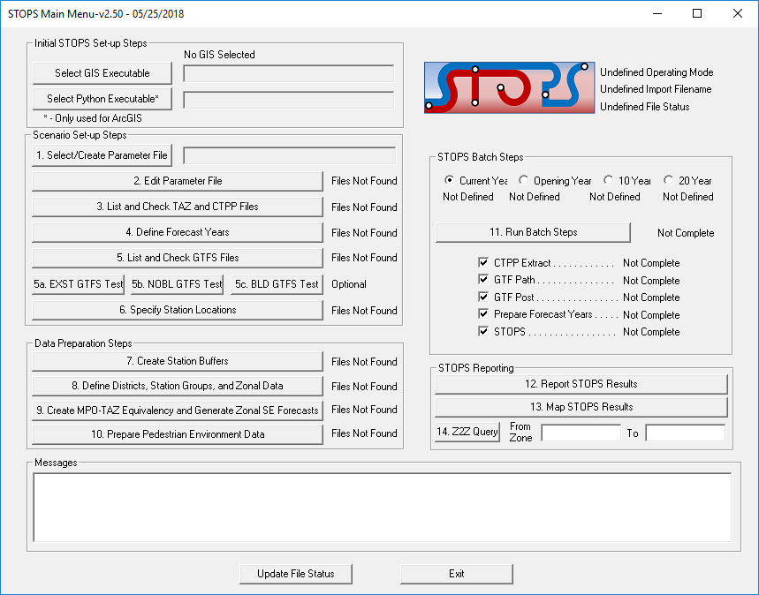

Figure 9. STOPS Main Menu When Opened the First Time

The message “No GIS Selected” appears at the top of the dialog box to remind the user that the automatic GIS linkage has not yet been defined. Until this is updated, that means that STOPS will prompt the user to manually edit station and district shape files.

To define an automatic GIS linkage, the user can click on the button “Select GIS Executable”. When this is done, the standard Windows file selection box appears as shown in Figure 10.

Use the file selection dialog to identify the location of one of the two files shown below:

* TransCAD executable – TCW.exe (typically located at C:\Program files (x86)\TransCAD\tcw.exe); or
* ArcMap executable – ArcMap.exe (typically located at C:\Program files (x86)\ArcGIS10.4\bin\ArcMap.exe))

After the GIS executable is selected, the message at the top of the dialog changes to indicate that STOPS has been properly associated with one of the recognized GIS packages. Figure 11 shows the appearance of the Main Menu after STOPS is successfully associated with the TransCAD GIS package.

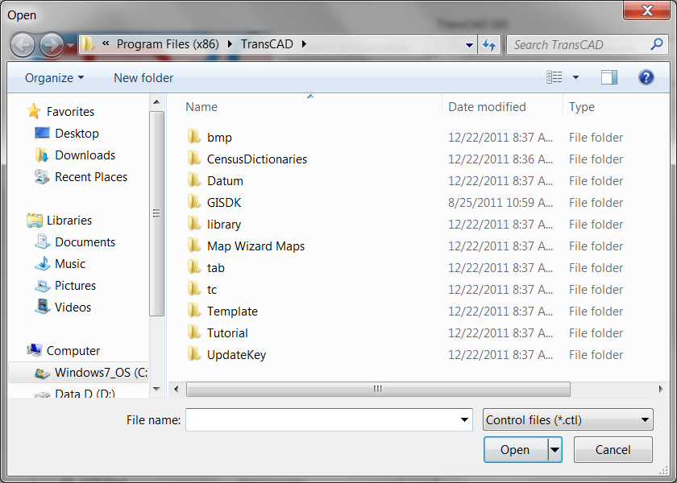

Figure 10. STOPS Dialog to Select GIS Executable

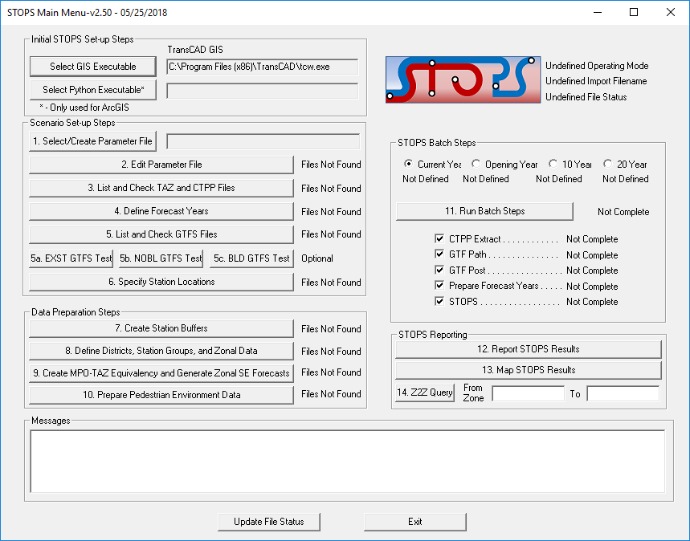

Figure 11. STOPS Main Menu After Selection of TransCAD GIS

Before TransCAD can be used in STOPS, it must be configured to allow it to open without using the quick start window and without warning the user if there is a second instance of TransCAD running. This is done by opening TransCAD and selecting the Edit > Preferences menu option. Unclick the start up and second instance warning options as shown in Figure 12.

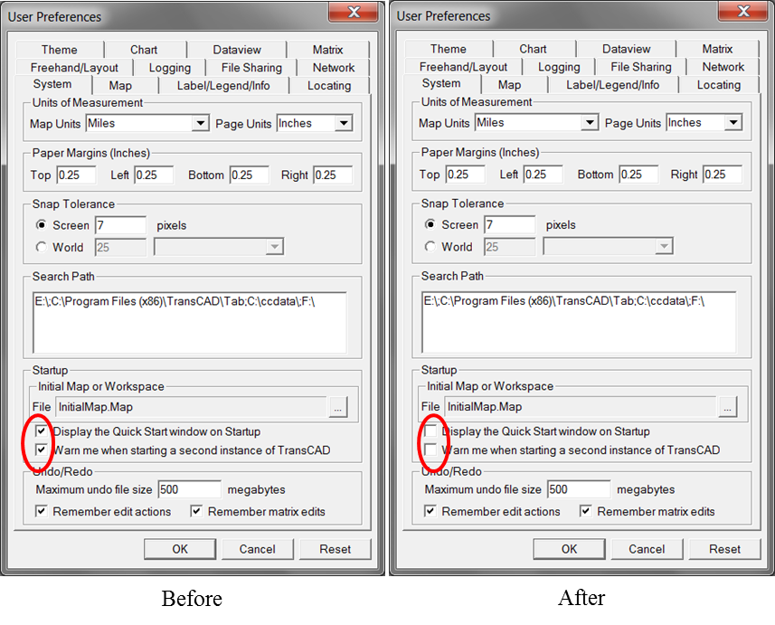

Figure 12. Setting TransCAD Quick Start and Second Instance Warning Options

If the user selects ArcMap, then the python executable file should also be defined. This program is named pythonw.exe and is typically installed at c:\python27\ArcGIS10.4\. When ArcMap is selected the appearance of the main menu is shown in Figure 13.

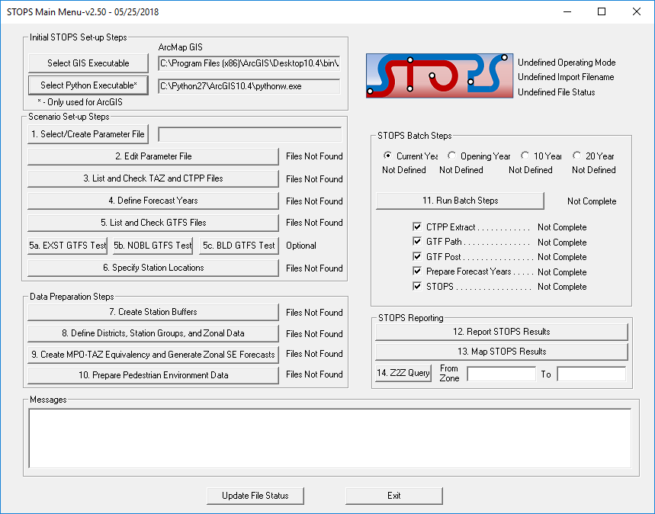

Figure 13. STOPS Main Menu After Selection of ArcMap GIS

For both TransCAD and ARCGIS, the user interface sets up the environment for the user to edit and display various data files. When editing is complete, the user must terminate the GIS using a menu command or clicking on the red “X” at the upper right hand corner of the screen. In some cases, the GIS program will ask if it is OK to save the map (See Figure 14 for an example from TransCAD). The user should click “No” since the GIS system saves data as it is entered; this question is asking if it should save the map display settings which is not necessary since STOPS generates this information each time it is needed.

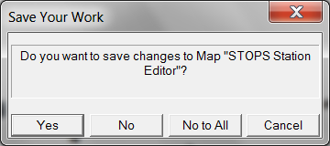

Figure 14. Click "No" in TransCAD Map Save Configuration Dialog

# SCENARIO SET-UP STEPS

STOPS develops predictions of transit fixed guideway ridership based on the experiences of a wide variety of rapid transit, light rail transit, commuter rail, streetcar, and bus rapid transit systems built over the last 40 years in various cities across the United States. This experience is adapted to new settings according to:

* Trip-making characteristics in the corridor as represented in Census Transportation Planning Products (CTPP) Journey-to-Work (JTW) data sets from either the 2006-2010 American Community Survey or the Year 2000 Census long form.
* Information on the density of the street grid conveyed by Census Block definitions.
* Forecasted changes in population and employment from the census year[6] to the current year and future forecast years that are prepared by local Metropolitan Planning Organizations (MPOs). MPO data are also used to characterize travel times on the regional highway system.
* Characteristics of the transit system as represented by automated schedule data and supplemental information on station characteristics, park-and-ride locations, and existing ridership.

Each source of data must be understood and, in many cases, prepared for use by STOPS. This chapter describes the various input data and the steps that must be taken to set-up a STOPS scenario and generate forecasts of transit ridership.

At this stage in the process, the user needs to organize the analysis, collect data from FTA’s STOPS webpage, obtain data on highway travel times and socioeconomic forecasts from the regional MPO, collect existing schedule data in GTFS format, and prepare information related to the transit project to be studied. In some cases (station locations and district definitions), STOPS, itself, is used to prepare input data. Other data (CTPP and Census Data) are downloaded and used “as-is.” In other cases (GTFS scenario definitions), the user must create the input data using a text editor or a specialized GTFS editor such as GTFSed.

Before the user begins, several key decisions must be made based on the availability of Census data and local information that will streamline the process of setting up a STOPS run. These decisions include:

* + - * 1. **What is the geographic scope?** STOPS reads a user-developed station file[7] and processes all CTPP zones within 25 straight-line miles of any coded station or bus stop unless user-defined exceptions are coded. In general, the station file should have one record for each station or bus stop in the region and the model will encompass the entire metropolitan area. In most parts of the country, this is the simplest approach and fits within the STOPS capacity of 9,000 zones and 70,000 transit stops. In some areas (e.g., the Northeastern United States) metropolitan areas are interconnected into mega-regions which exceed the STOPS zone or transit stop limits. In these cases, the user must define a more limited geographic scope by coding a special value in the Census geography files[8].
        2. **What States and MPO regions are included in the project corridor?** CTPP data are organized around states and/or MPO regions so the next step is to identify the states and MPO regions that are included in the modeled geographic region. In most cases, states and regions are obvious and this task is quite simple. If not, a state layer can be added to the GIS view showing stations and all states within 25 miles of a station or stop can be identified. MPO coverage can be determined by identifying the counties that are included in the buffer area and comparing this list to the MPO counties provided in Section 12.3.
        3. **What CTPP version and geography type will be used in the analysis?** STOPS supports the following CTPP versions and geography types[9]:

2006-2010 CTPP from the American Community Survey (AC)

2000 CTPP from the Year 2000 Census Long Form:

Census Traffic Analysis Zones (TZ)

Census Block Groups (BG)

Census Tracts (TR) as the units of geographic analysis.

* + - * 1. **What years will be modeled?**  STOPS allows the user to define up to four different application years.

The current year is used in the local calibration element of the model and may also be used for forecasting. The current year must be supported with information on zonal population and employment and optional information on regional transit boardings, regional linked transit trips, and fixed guideway station boarding counts.

Optional forecast years include: opening year, 10-year, and 20-year forecasts and (if defined) require just population and employment data for each MPO zone in the corridor.

* + - * 1. **What are the definitions of the existing, no-build, and build scenarios?** STOPS expects the user to define 3 distinct transportation scenarios[10]:

**Existing scenario (EXST).** The “EXST” scenario represents the existing transit system and is used with current year socioeconomic data to calibrate the local application of STOPS to observed current year ridership. The resulting calibration parameters are applied to all other scenarios.

**No-build scenario (NOBL).** The no-build scenario represents the future year network that is to be used for any statistic requiring information on incremental impacts of the project as compared to what would happen if the project were not built. Incremental statistics include changes in linked transit trips or vehicle miles of travel. The no-build scenario includes the existing system together with relevant transit elements that are already committed for construction and operation.

**Build scenario (BLD-).** The build scenario represents conditions after the project is constructed and in operation.

* + - * 1. **How is automated schedule data structured in the corridor?** STOPS uses data organized in General Transit Feed Specification (GTFS) format. Nearly every large transit agency in the United States has this data available and it is possible to convert manual schedule information into this format if GTFS files are not already available. In some cities with multiple transit operators, each transit operator creates its own separate GTFS files. STOPS allows the user to combine up to twenty independent datasets to make up a regional schedule. STOPS introduces two extensions to the specification to allow the user to code Park-and-Ride (PNR) locations and to introduce simple changes to the GTFS files to represent new services.

STOPS uses a predefined directory structure that is shown in Table 7. The STOPS project root directory can have any legal Windows name and can be a subdirectory to the drive’s root directory or a subdirectory of any other folder. At the beginning of a run, the STOPS directory will only have one file, a parameter file, and a series of subdirectories. Both the parameter file and the directory structure are created by the STOPS program and no manual steps are required. The user may also copy data from another folder to serve as the starting point for a new run. If this is done, the user needs only to copy the inputs\ subdirectory and the parameter file. STOPS will add the required additional directories.

Table 7. STOPS Directory Structure

|  |  |  |
| --- | --- | --- |
| Directory | Example | Contents |
| STOPS project root | C:\STOPSProject\ | Parameter (control) file |
| Inputs | C:\STOPSProject\Inputs\ | Input data. |
| Logfiles | C:\STOPSProject\Logfiles\ | STOPS program logfiles that determine the completion status of each step. |
| GTFS subdirectories of Inputs that contain information for a particular agency and/or scenario | C:STOPSProject\Inputs\[Dir 1]\  C:STOPSProject\Inputs\[Dir 2]\  C:STOPSProject\Inputs\[Dir 3]\  Etc. | GTFS schedule data for agency and scenario defined by Directory 1, Directory 2, Directory 3, etc. Note these directories are not created by STOPS; They are created by the user when a new GTFS file set is created for each agency and/or scenario. [Dir 1], [Dir 2], [Dir 3], etc., can be any user-defined Windows-supported subdirectory name. |
| Districts | C:\STOPSProject\Districts\ | District definition |
| Scratch | C:\STOPSProject\Scratch\ | Temporary working files that can be deleted by the user after each STOPS run is complete and checked. |

The directory name is not strictly limited in length. However, the user should note that Windows may limit the length of file names (drive, directory, name, and extension) to 255 characters and many STOPS displays are not wide enough to display very long filenames. STOPS maximum suggested filename lengths are as follows:

* Maximum length of the control file name (including drive letter, colon, directory names, backslashes, filename, and extension) is 80 characters and fewer than 40 characters are recommended.
* Maximum length of individual GTFS subdirectory names (excluding the root directory or “inputs\”) is 20 characters and fewer than 10 characters are preferred. If more than 4 GTFS filesets are used, then even shorter directory names (i.e., 2-character codes) may be required.

***STOPS periodically tests the lengths of key file names to confirm that the directory names will not generate file name lengths that are too long. Nevertheless, the user should keep file name lengths under these guidelines to minimize the chance of problems in later steps.***

## Defining the STOPS Run Parameters

The STOPS menu screen (after the GIS software is selected) looks like the example shown in Figure 15. Each aspect of a STOPS run is labeled as “Files Not Found” or “Not Complete” at the beginning of a run. Each item on the left side of the menu (Set-up and Data Preparation Steps) will switch to “FILES FOUND!” when STOPS detects that the necessary files have been properly assembled.

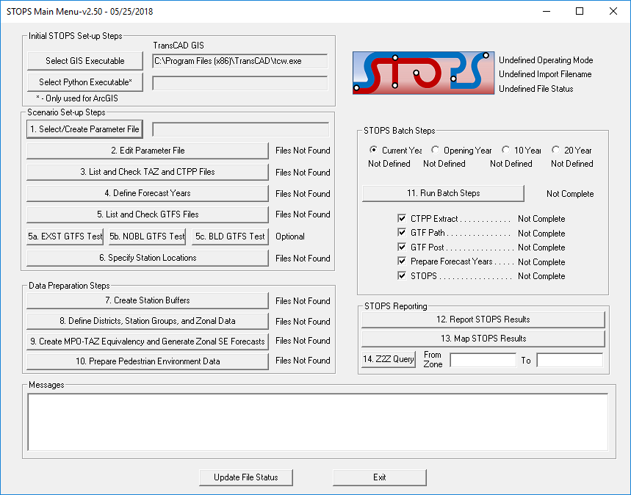

Figure 15. Initial STOPS Menu

Please note that in some cases a “FILES FOUND!” status label does not necessarily mean that the file is ready for use. In many cases a user might defer data entry for one or more elements of a data file (e.g., GTFS file parameters before the GTFS files have been constructed). STOPS does not know if the various files have been fully populated with accurate data, only that the files appear to be complete and suitable for running STOPS. The user is responsible for completing data entry for files that are only partly populated.

On the right side of the main menu (Batch Steps), the label switches to “COMPLETE!” to indicate that the batch step successfully ran to completion and generated the necessary information to proceed to the next step.

To create or select an existing parameter file (also known as a “control” file) that will control a STOPS model run, click on “1. Select/Create Parameter File”. This will open a standard windows dialog for selecting a file (see Figure 16). If the parameter file has been previously created, use the dialog to select the directory and filename containing the parameter file.

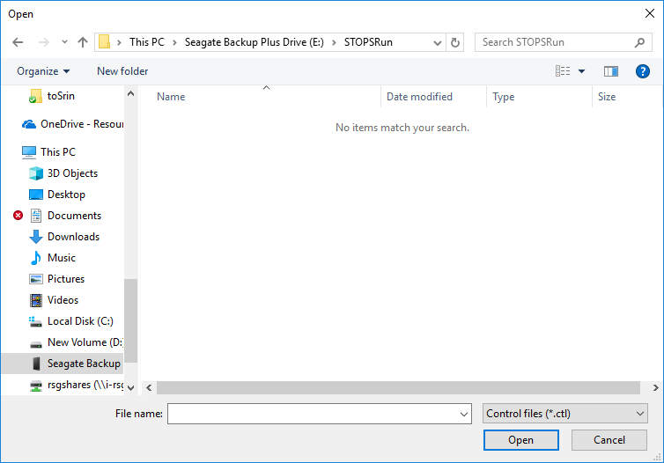

Figure 16. Standard Windows File Selection Dialog Used in STOPS

If this is the first time that you are using STOPS or if you are starting a new project, this dialog can be used to create a new folder (using the “New Folder” Button, see Figure 17) where the project will reside. Please note that just like all Windows applications, the “New Folder” Button creates the new folder at the location that is highlighted in the body of the dialog so the user should first point to the main folder where the project should reside (e.g., e:\STOPSRun in this example) before pressing the “New Folder” button. The user should rename the folder to describe the project (“KC” in the example for “Kansas City”). Double click on the new folder to open it and then type the name of the desired parameter filename in the line labeled “File name:”. It is not necessary to enter the file extension (“.ctl”), just the name is required (ProspectMAX-baseforecasts in the example). If this is a new file, then STOPS will ask you to confirm that you want to create a new parameter file. Click “Yes” to proceed or “No” to select another filename.

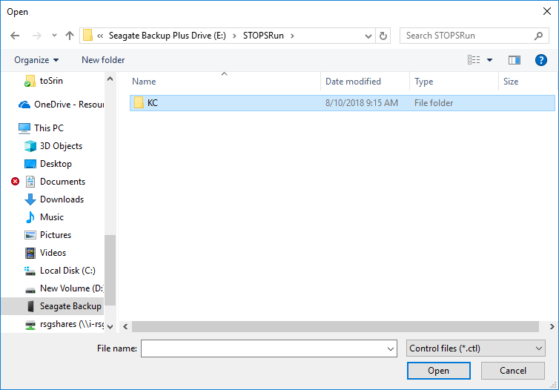

Figure 17. Creating a New Folder and Folder Name

If “Yes” is clicked, STOPS will ask the user if the new scenario should be created by copying another scenario. If “Yes” is clicked in response to this question, then a dialog will open that asks the user to select the control filename of the scenario to be copied. If “No” is clicked, then STOPS will create a blank scenario. This dialog is illustrated in Figure 18.

This action will result in STOPS creating the STOPS sub-directory structure that will provide a home for the STOPS input and output data files. All directories are created except those which relate to individual GTFS file sets which are manually created by the user as those files are prepared.

Creating a New Parameter file (3 steps)

Step 1: Type the name of the parameter file in the File name box.

Step 2: Click "Yes" if it is OK to create a new control file.

Step 3: Click "Yes" if it is OK to copy an existing STOPS model set.  "No" means create the control file from scratch.


Figure 18. Creating a New Parameter file

## Define STOPS Parameters

In this step, the user opens the STOPS parameter file and enters the information that controls the operation of STOPS. This step begins by clicking on “2. Edit Parameter File” in the main menu. This action opens the parameter file dialog shown in Figure 19. As this figure shows, the dialog is mostly blank except for fields that have STOPS default values.

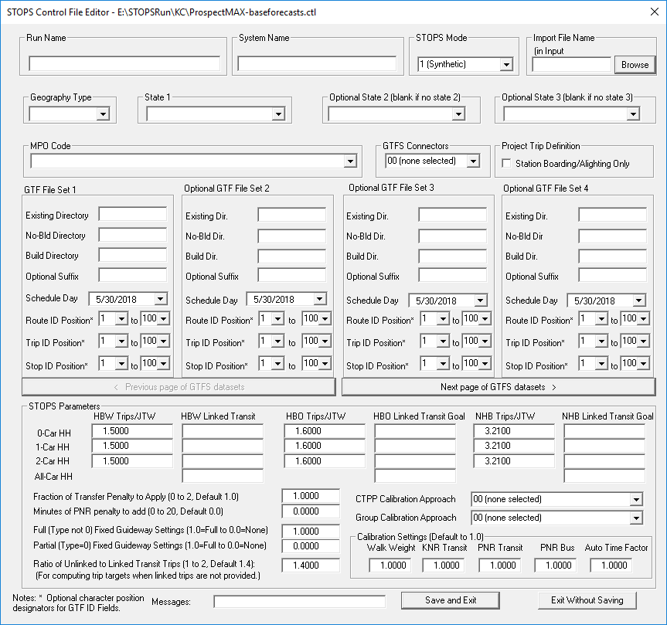

Figure 19. Edit Parameter Dialog for New Control File

Information entered into this screen includes:

* **Run Name.** A descriptive label that is included in the header of the STOPS report to help identify the model run. This parameter has no effect on STOPS processing or forecast results.
* **System Name.** A descriptive label that is included in the header of the STOPS report to help identify the transit system that is being represented. This parameter has no effect on STOPS processing or forecast results.
* **STOPS Mode.** This parameter controls the type of model that STOPS uses to forecast transit ridership the options are:
  + 1 (Synthetic). This is the default mode and means that STOPS generates estimates of transit ridership from travel patterns contained in the CTPP, transit service characteristics from transit schedules, and transit usage obtained from count databases. This form of the model is most similar to conventional ridership forecasting procedures.
  + 2 (Special Markets). The mode is similar to the Synthetic Mode but adds travel demand estimates for special markets that are not well-represented by the CTPP JTW flows. Example special markets include air passengers and university students. When this option is selected, the user should also specify the Import File Name in the next block. The input data and processing associated with the Special Markets version of the model is described in Section 10.3.
  + 3 (Incremental). In this mode, the user provides an import file containing transit trip table information (and optionally, person travel information). STOPS uses this information to develop person trips and transit trips that closely match the input transit trips for the existing scenario. Forecasts for different years and transit scenarios represent the impact that incremental changes in population, employment, and transit levels-of-service have on transit ridership. The input data and processing associated with the incremental version of STOPS is described in Section 10.3.
* **Import File Name.** If STOPS mode 2 or 3 (special markets or incremental) are selected, an import file name must be specified to indicate where the special market or transit trip tables are found. More about the nature of this file is presented in Chapter 10.0.
* **Geography Type.** The geography type options are:
  + AC – Year 2006-2010 American Community Survey Zones
  + BG – Year 2000 Census Block Groups
  + TR – Year 2000 Census Tracts
  + TZ – Year 2000 Census CTTP Traffic Analysis Zones
* **States.** Up to three states that define the market area for the metropolitan transit system.
* **MPO Code.** Select the MPO code that corresponds to the main MPO covering the modeling area.
* **GTFS connectors.** This drop-down box determines how access connectors are built in the path-building steps. The default 00 (none selected) or 01 (default) uses the original STOPS approach of building all connectors according to straight-line distances. Option 02 reads a user-provided street file (described in Section 4.3, Walk Shape File) to generate walk connectors. Option 03 uses MPO skims to develop a better estimate of Kiss-and-Ride and Park-and-Ride travel times. Option 04 combines Options 02 and 03.
* **Project Trip Definition.** By default, STOPS assumes that any transit trip boarding, alighting, or traveling through a new station/stop constitutes a project rider. This approach is appropriate for the majority of transit projects and makes the assumption that even through passengers (e.g., on a BRT route) will benefit from the improved speed and reliability associated with a new section of fixed guideway. For some projects (e.g., an infill commuter rail station on an existing line), this assumption is not appropriate. In these cases, the project trip definition can be set to include new station boardings and alightings only. This change is made by clicking on the box labeled “Station Boarding/Alighting Only.”
* **GTFS schedule files.** Up to 20 (4 per page) GTFS files that, together, describe the transit services available in the STOPS modeling area. Each column grouping is designed to represent a separate operator. The first three rows represent the GTFS file directory[11] for the existing, no-build, and build scenarios. Each grouping also shows information on:
  + **Suffix.** The suffix is an optional 1-character string that is used in the event that different GTFS files use duplicate stop, trip, or route IDs. STOPS adds an ampersand “&” and the character coded in the suffix end of these ID fields to create a unique identifier for each GTFS file and each stop, trip, or route.
  + **Schedule Day.** This field defines the exact day to use from the selected GTFS schedule.
  + **Route, Trips and Stop ID positions.** STOPS assumes that nearly all ID fields will be 25 characters or less[12]. If any of the GTFS IDs are longer than this limit, STOPS will truncate the ID to be 25 (including the &suffix) characters. This action may cause a duplicate ID error. The Route, Trips, and Stop ID position fields helps resolve the problem by providing the option to define a substring of the ID in which a unique 25 character ID is defined. For instance, if the Route positions are defined as 26 and 50, then STOPS will translate the route ID as follows:
    - Route ID in GTFS file: MetroTransitAuthorityRoute 17x
    - STOPS translation: 17X
  + **Previous and Next Page of GTFS datasets.** These buttons allow the user to scroll through the GTFS datasets in groups of four. STOPS allows users to code up to 20 GTFS file sets.
* **STOPS Parameters.** This block presents the following information:
  + **HBW, HBO, and NHB Trips/JTW by Auto Ownership.** These fields are pre-populated with STOPS defaults for the number of person trips by purpose that are generated for each Census Journey-to-Work record. These default values are based on analyses of the surveys used in the original STOPS calibration. If better local information exists, the user can enter these values on the parameter screen and STOPS will generate person trips according to this refined local information. Each time STOPS runs, it checks to see that each of these values lies within the range of 0.001 and 20. If not, then STOPS resets these trip rates back to the defaults shown in the example.
  + **HBW, HBO, and NHB Linked Transit Goals.** If a local survey is available, the user can code linked transit person trip targets by purpose or by auto ownership level for the calibration year. If this information is coded, STOPS calibrates the mode choice model for each purpose and auto ownership level to match these person-trip targets. If these values are not coded, STOPS generates its own estimate of transit linked trips based on the unlinked trip targets entered on the “Define Forecast Years” dialog. STOPS then proceeds with the calibration as above.
  + **Fraction of Transfer Penalty to Apply.** This parameter allows the user to specify how much of the nationally-calibrated boarding penalty to apply in the particular case being modeled. This value can range from 0 to 2 with a default of 1.0. When this parameter is 1, the full boarding penalty (5 minutes) is applied during path building. When the value is 0.5, only 50 percent of the penalty is applied. The first time that STOPS is run in a new area, this parameter should be set to 1.0. As initial runs are made, the modeled ratio of unlinked-to-linked trips should be compared to local information from surveys or farebox registers. The penalty should be increased if the unlinked-to- linked trip ratio is too high (i.e., too many transfers). The penalty should be decreased if this ratio is too low.
  + **Fixed Guideway Settings.** STOPS employs several mechanisms to represent the fact that fixed guideway systems can attract higher levels of ridership than would be predicted on the basis of its service characteristics alone. This higher level of ridership occurs because fixed guideway systems are often more visible to occasional travelers, may be more reliable, and may offer important amenities such as protection from the weather while waiting. Within STOPS, all of these factors are combined into a single parameter (the “setting,” known in earlier versions of STOPS as the “visibility factor”) that was calibrated using survey results from several cities across the United States. Two settings are available: one for full fixed guideway facilities such as LRT, commuter rail, and rail rapid transit, and a second for partial fixed guideway systems such as streetcars and some BRT lines. STOPS distinguishes partial fixed guideway systems from full fixed guideway systems based on the route_type field coded in the GTFS schedule files (in the file routes.txt). Partial fixed guideway systems are coded with route_type equal to zero. Full fixed guideway systems are coded with a route_type equal to 1, 2, 4, 5, 6, or 7. (The remaining route_type is 3 is bus which is not considered by STOPS to be a fixed guideway mode. The value coded for the fixed guideway setting defines the proportion of the fixed guideway benefit to apply. In metropolitan areas with existing fixed guideway services, STOPS should be calibrated to match existing ridership before using Group Calibration (i.e., set the Group Calibration Approach to 0 as described below). In areas contemplating new transit modes, the Fixed Guideway Setting should set as follows:
    - 1.0 for most LRT and heavy rail systems
    - 0.1 for BRT (if BRT coded as route_type 0)
    - 0.3 for streetcar
    - If a given model area has both fixed-guideway BRT and streetcar services, then contact FTA for more detailed guidance.
  + **Ratio of Unlinked to Linked Transit Trips.** This parameter controls how STOPS estimates the regional linked transit trip targets if the purpose- and auto ownership-specific linked transit trips described above are not entered. This ratio must be between the values of 1.0 and 2.0 and defaults to 1.4. If linked trip targets are not specified for each purpose, then the regional number of unlinked transit trips (entered in Step 4) are divided by this ratio to generate an estimate of linked trips as part of the mode choice model calibration process in the STOPS phase of Step 11.
  + **CTPP Calibration Approach.** By default, STOPS calibrates itself to match district-level transit shares from the CTPP for each attraction district. The default calibration approach does not force STOPS to match production district shares since this might unrealistically constrain STOPS in rapidly growing regions where the nature of outlying (typically more residential) areas change rapidly. Many projects, however, are in more stable areas where the nature of travel is less likely to change (except in response to the project, itself). In such cases, this field allows the user to select option 2 – Production and Attraction calibration. Otherwise, either option 0 (none selected) or option 1 (Attraction District Only) will cause STOPS to apply the default approach of calibrating to Attraction Districts only.
  + **Group Calibration Approach.** STOPS has the option of reading station/stop- or route-level count data and using this information to refine the model calibration. This parameter allows the user to select the calibration approach. Options include:
    - **00 – None Selected** **(Default and recommended for the initial STOPS run)** this run does not do any group calibration.
    - **01 – No Group Calibration (same as option 00)**
    - **06 – Static Group Calibration (Obsolete)** Adjusts station group ridership outputs for each origin-destination pair in the Existing scenario and applies the same result to all scenarios based on origin and destination zone numbers.
    - **07 – District Ks-limited (Obsolete)** Adjusts mode choice production and attraction constants to match counts to maximum extent possible. Maximum and minimum adjustment constants are limited in scale.
    - **08 – District Ks-full (Obsolete)** Adjusts mode choice production and attraction constants to match counts to maximum extent possible. Maximum and minimum adjustment constants are not limited in scale.
    - **09 – Full Group Calibration (Obsolete)** Adjusts station group ridership outputs for each origin-destination pair in the Existing scenario and applies the same result to all scenarios based on station group usage.
    - **10 – OD Adjustment (Recommended after initial STOPS Run is complete in cases where full bus and fixed guideway stop/station count data are available)** This option adjusts the person OD trip table based on a comparison of modeled and observed stop/station group ridership.
    - **11 – OD Adjustment Route** **(Recommended after initial STOPS Run is complete in cases where full bus and fixed guideway stop/station count data are NOT available)** This option adjusts the person OD trip table based on a comparison of modeled and observed route-level ridership.
    - **12 – OD Adjustment Route and Stop (Recommended after initial STOPS Run is complete in cases where full bus and fixed guideway stop/station count data are available but route level ridership results still require adjustment)** This option adjusts the person OD trip table based on a comparison of modeled and observed stop/station group ridership and route level ridership.
* **Calibration Settings.** This section contains several adjustment parameters that define how important different components of time are to the path-finding and demand models. Each adjustment is designed as a factor between 0.0 and 2.0 (or 0.5 and 2 for some settings) that either turn up or turn down the importance of the time component to the traveler. In each case, a value of 1.0 is used to indicate that the default value of the underlying parameter should be used. The following parameters are defined:
  + **Walk Weight.** The walk weight setting is multiplied by 1.5 to generate the estimate of perceived impedance of each minute of walking as compared to time spent traveling in a transit vehicle. A walk weight setting of 1.0 (the default) results in walking being 1.5 times as onerous as riding in a bus. Setting this parameter of 0.67 means that each minute of walking is equivalent to 1.0 minutes of riding in a bus. The resulting weight on walk time is used during both the path-finding and mode choice steps in STOPS.
  + **KNR Transit.** The KNR Transit Setting affects how much of the nationally-calibrated KNR constants are applied to KNR trips in the mode choice element of STOPS. The default for the KNR Transit Setting is 1.0 which uses the nationally-calibrated constants without adjustment. To increase KNR usage, set the KNR Transit Setting to a value greater than 1. The upper limit on this setting is 2.0, which multiplies the KNR constants by 0.25. This has the effect of reducing absolute value of these negative constants and increasing transit KNR usage. The lower limit on this setting is 0.0, which multiples the KNR constants by 2.92. This is the effect of increasing the absolute value of these negative constants and decreasing KNR usage.
  + **PNR Density.** The PNR Density Factor scales the nationally-calibrated effect of employment density on PNR utilization up or down. This parameter affects the mode choice model only. If the PNR Density is set to 1.0, then the national-calibrated impact of density on PNR usage is applied with out modification. A value of 2 (the upper limit of this parameter) doubles the effect and a value of 0.5 (the lower limit) reduces the effect of density by 50 percent on PNR usage. Note that the PNR density applies to all types of PNR usage (i.e., fixed-guideway only, fixed-guideway and bus, and bus only).
  + **PNR Bus.** The PNR Bus Penalty Setting scales the nationally-calibrated PNR-to-bus constants up or down. If a value of 1.0 is used, then the nationally-calibrated PNR-to-bus constants are used. The PNR Bus Penalty Setting must be between 0 and 2.0.
  + **Auto Time Factor.** The Auto Time Factor is a multiplicative scaling factor that adjusts the zone-to-zone automobile time from the MPO model to more accurately reflect highway travel time. This adjustment can be helpful in improving estimates of PNR usage which, in STOPS, are highly sensitivity to the relative time of driving to the destination versus driving to transit, parking in a PNR lot and taking transit. The Auto Time Factor defaults to 1.0 (no adjustment) and must be in the range between 0.5 and 2.0).

An example of the parameter dialog after control information is entered for the Kansas City example is presented in Figure 20. After all information is entered into this screen, the user should click Save and Exit to save this information to the control file. Figure 21 shows the STOPS main menu after this step is complete. As needed, the user can return to the Edit Parameter File step to make any necessary corrections or updates.

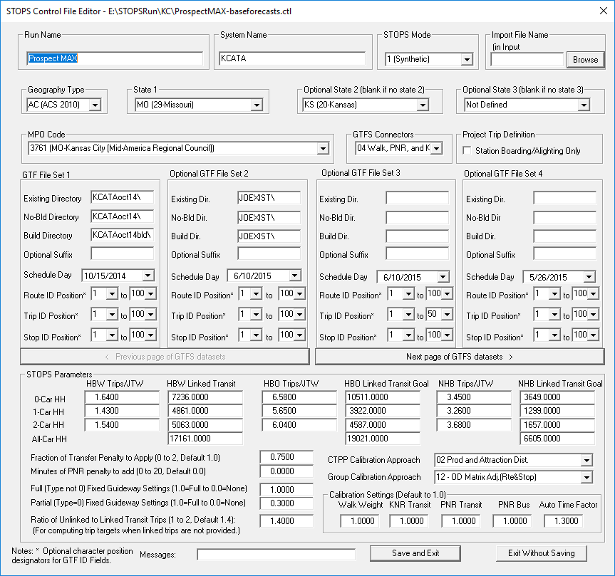

Figure 20. STOPS Parameter Screen After Entry of KC Example

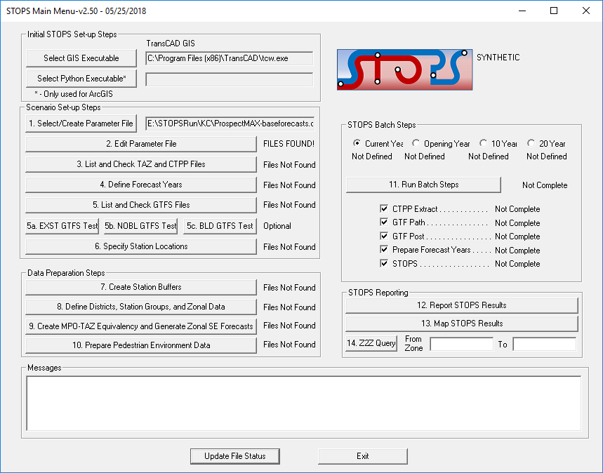

Figure 21. STOPS Main Menu After Completion of Parameter File

## Assembling Input Census, MPO, and Route Counts

This section discusses the process of assembling all input census, MPO, and route count data that are used by STOPS for forecasting project transit ridership.

A listing of required and optional files that correspond to the user selections in the parameter file can be generated by clicking on “3. List and Check TAZ and CTPP files.” When this is done, the screen shown in Figure 22 appears. Each file is described in the subsections that follow.

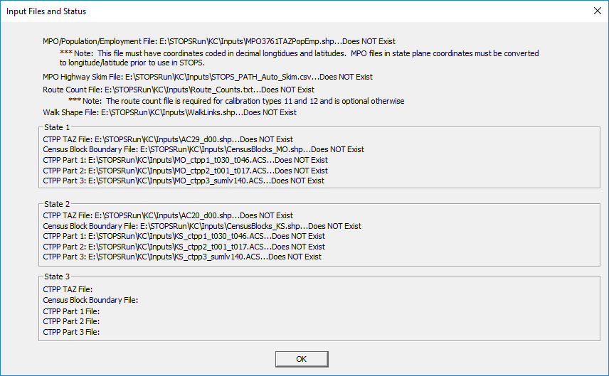

Figure 22. Dialog Showing Required and Optional Files

### MPO Population/Employment File

The MPO population/employment file is an ESRI shape file that conveys information about the MPO zone geography[13] and MPO estimates of existing and future population and employment.

This file should be constructed using a GIS package (e.g., TransCAD or ArcMap) and saved as an ESRI shape file. Its name must match the STOPS-generated file name specified in the “TAZ and CTPP Files” Dialog. (MPO3761TAZPopEmp.shp in the Kansas City example). Coordinates must be expressed as degrees of longitude and latitude. It must, at a minimum, include the fields described below. Other fields may exist in this file (and will be ignored) although some field names (“District”) are not allowed.

* Required geographic information
  + Boundary of each zone in the MPO modeling system.
* Coordinate system
  + Decimal degrees of longitude and latitude
* Required data fields
  + Model TAZ zone number (integer[14]). Any user-selected field name.
  + Census[15] Year Population (numeric[16]). Any user-selected field name.
  + Census Year Employment (numeric). Any user-selected field name.
  + Current Year Population (numeric). Any user-selected field name.
  + Current Year Employment (numeric). Any user-selected field name.
* Optional data fields
  + Opening Year Population (numeric). Any user-selected field name.
  + Opening Year Employment (numeric). Any user-selected field name.
  + 10-Year Horizon Population (numeric). Any user-selected field name.
  + 10-Year Horizon Employment (numeric). Any user-selected field name.
  + 20-Year Horizon Population (numeric). Any user-selected field name.
  + 20-Year Horizon Employment (numeric). Any user-selected field name.

In some cases, MPOs will provide a TAZ layer with a coordinate system other than longitude and latitude. This can be easily checked in either TransCAD or Arc Map by opening the shape file and observing whether or not coordinates are reported in degrees of longitude and latitude. If the coordinates are reported in some other system (e.g., state plane feet or meters), then the file must be converted to use latitude and longitude.

The MPO zone file for the Kansas City example is shown in Figure 23. Fields in this file include:

* ZONE. The zone number assigned to each area in the MPO forecasting model
* POP10, POP15, POP20, etc. Population estimates for 2010 through 2040 in 5 year increments
* EMP10, EMP15, EMP20, etc. Employment estimates for 2010 through 2040 in 5 year increments

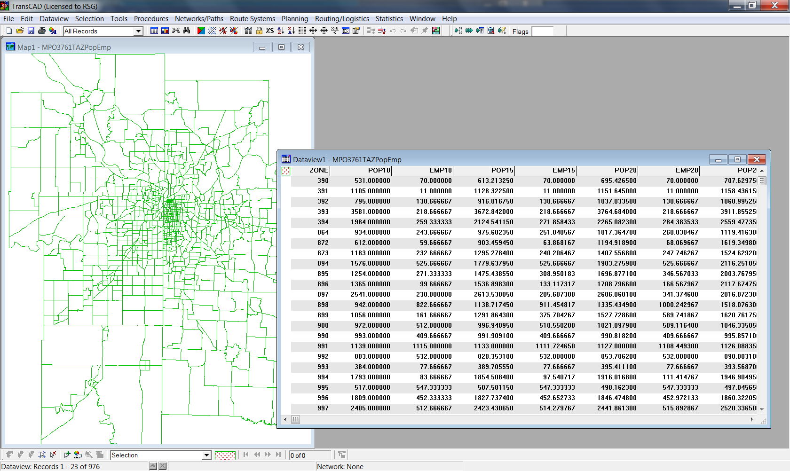

Figure 23 MPO Population Employment File for Kansas City

### MPO Highway Skim File

The MPO auto time matrix is obtained by extracting zone-to-zone current year (and horizon years, if available) peak period automobile travel times and distances from the regional travel demand forecasting model and saving this information in a comma-separated value (.csv) file. Its name must match the STOPS-generated file name specified in the “TAZ and CTPP Files” Dialog. (STOPS_PATH_Auto_Skim.csv).

The file is organized with one line for each origin-destination zone pair containing the following fields in the order presented below:

* Integer[17] origin zone number from the travel model
* Integer destination zone number
* Real automobile distance for the current year (in miles)
* Real automobile time for the current year (in minutes)
* Real automobile distance for the opening year (in miles)
* Real automobile time for the opening year (in minutes)
* Real automobile distance for the mid-range forecast year (10-year forecast) (in miles)
* Real automobile time for the mid-range forecast year (10-year forecast) (in minutes)
* Real automobile distance for the long-range forecast year (20-year forecast) (in miles)
* Real automobile time for the long-range forecast year (20-year forecast) (in minutes)

If highway travel time data for the opening or forecast years are not available, then these fields may be left empty by coding consecutive commas. Commas after the last real data field may be left off. Any times or distances that are left blank or set to zero are given the same time or distance values that were entered for the current year.

A portion of a Kansas City auto time matrix file appears in Figure 24. This example shows the format for the case in which auto highway time information is only available for the current year. The first row shows that the trip from zone 1 to zone 2 is 0.96 miles long and takes 3.025 minutes. Since future year information is not included in this file, all analysis years are assumed to use the same information.

Figure 25 shows an example automobile skim file for a case where current and 20-year horizon information are available. As this example shows, empty fields (two consecutive commas) appear for distances and times for the opening year and 10-year horizon slots.

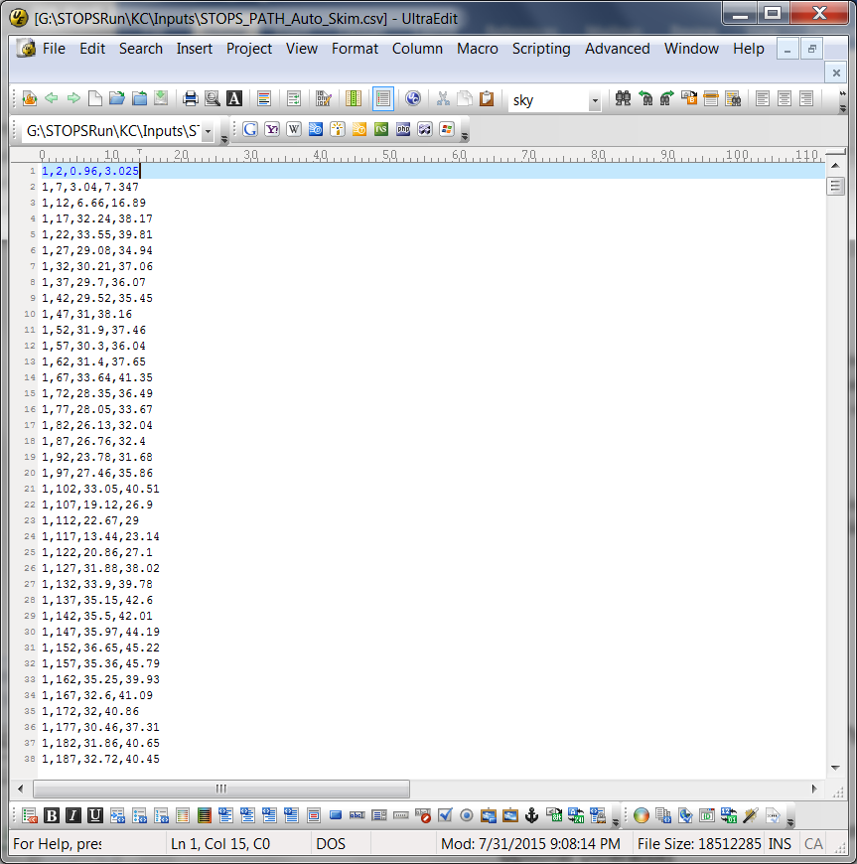

Figure 24. Sample Auto Skim File for Kansas City

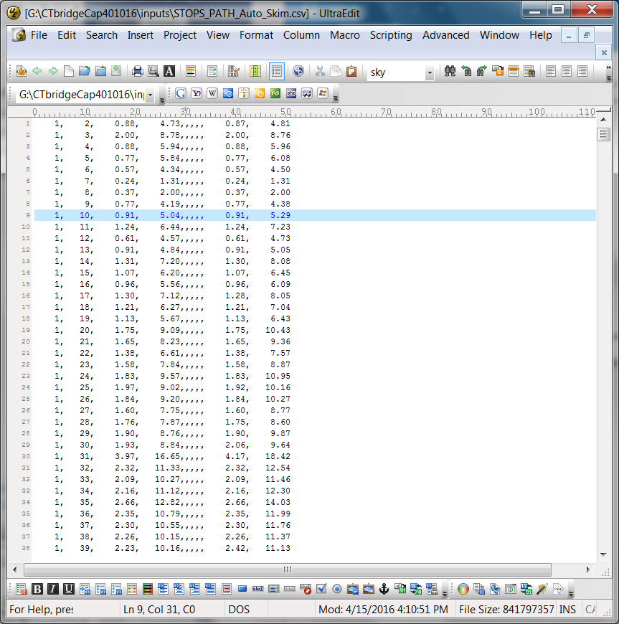

Figure 25. Sample Auto Skim File with Current and 20-Year Distance and Time

### Route Count File (Required for Calibration Types 11 and 12, Optional Otherwise)

The route count file is used for Calibration Types 11 and 12 to adjust the STOPS model so that it replicates ridership on a route-by-route basis. The file is named route_counts.txt and is organized as a text file with a header row showing the defined fields separated by commas. Data records follow the header record. Fields that must appear in this file include:

* Route_id. The first 25 characters of the GTFS route_id. If a GTFS suffix was specified in the parameter file, then the last 2 characters of the route_id are an ampersand (“&”) followed by the suffix. If the route_id is longer than 23 characters, the &suffix appears in character positions 24 and 25 even if it overwrites portions of the original route_id.
* Group. A user-defined integer between 1 and 250 indicating how the routes should be summarized. In most cases, each route will be assigned its own route group unless two routes share a market and should be calibrated together.
* Ridership. The average daily ridership for the route.

The file can also have two optional fields:

* Route_long_name. This field shows the full name of the route associated with each route_id.
* Group_name. This field shows the name that will be assigned to each route group in the STOPS report.

Figure 26 presents an example route count file for Kansas City. The first two records after the header show route counts[18] that were created for this example for two routes with a “J” as a suffix. Route 661 has a route_id that is than 23 characters so the entire route_id is coded, followed by “&J”. Route 670 is longer than 23 characters so the route_id is truncated to 23 characters and then followed by “&J”.

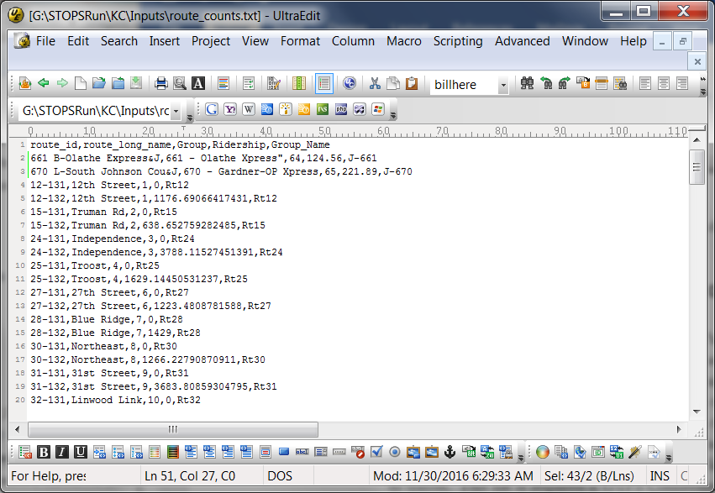

Figure 26. Example Route Count File for Kansas City

### Walk Shape File (Required for GTFS Connector Types 02 and 04, Not Used Otherwise)

The path building component of STOPS (GTF Path) is able to generate zone-to-walk connector links using two different techniques—straight line distances (the default) or by walking over a street database. In most cases, straight-line connectors are sufficiently precise to generate good estimates of walk access to the transit system. In some cases, waterways, highways, or other barriers result in straight-line connectors are not a realistic representation of access to the transit system. In this case, the user can provide a ESRI shape file with all street links that can be used for walk access to transit. This file is required if GTFS Connector Option 02 or 04 is selected. When used, this file is named WalkLinks.shp. No data fields are required. If an integer “DIR” field appears in the file, the following codes are used:

* 0 (default) = travelers can walk along this link in both directions
* 1 = one-way walk link in the direction that the link is coded
* 2 = travelers can walk along this link in both directions (same as 0)
* -1 = one-way walk link in the direction opposite to the direction that the link is coded.

A field named “LENGTH” must be present in the walk link database and must contain the link distance in miles. This value is used by STOPS to estimate the walk time required to traverse the link assuming an average walk speed of 3 miles per hour.

This file can be prepared by the user from locally-available street databases. The file must be saved in ESRI shape file format with latitude and longitude coordinates.

### Census Data for Each State

Census data to support the STOPS analysis are identified in the TAZ and CTPP file listing. The exact file names depend on which version of the Census is being used (2006-2010 ACS or 2000 long form) and on the selected Geography Type. All Year 2000 files are in the original Census format. The ACS files (files that begin with “AC”) have been specially prepared by FTA for STOPS and are only available from FTA. File names are as follows:

* CTPP boundary files in ESRI shape file format. These filenames begin with a prefix of AC (ACS), TZ (TAZ from 2000 CTPP), BG (Block Group from 2000 Census) or TR (Tract from the 2000 Census) followed by the two-digit numeric FIPS state code (see Section 12.1 for definitions) and a name denoting a CTPP boundary file. For the Kansas City example, Missouri ACS zones are in the file named: AC29_d00.shp
* CTPP Part I files begin with the Alpha FIPS state code following by a string that defines the file type. ACS files have a “.ACS” extension. The Year 2000 Census files have a “.DAT” extension. For the Kansas City example, Missouri CTPP Part I data are in the file named: MO_ctpp1_t030_t046.ACS.
* CTPP Part II files begin with the Alpha FIPS state code following by a string that defines the file type. ACS files have a “.ACS” extension. The Year 2000 Census files have a “.DAT” extension. For the Kansas City example, Missouri CTPP Part II data are in the file named: MO_ctpp2_t030_t046.ACS.
* CTPP Part III files are organized differently depending on the CTPP version and geography type. Options are:
  + ACS: Name is structured as the Alpha state code followed by “_ctpp3_sumlv140.ACS”
  + Tracts from CTPP 2000: Name is structured as the Alpha state code followed by “_ctpp3_sumlv140.DAT”
  + TAZs or Block Groups: MPO designation (MPO3761 in Kansas City) following by “_ctpp3_sumlv944.DAT”. Note in this case, only the first state has a Part III file identified since the MPO file includes all trips within its area regardless of the state of residence of the traveler.

### Optional Adjustments to the Census Data

In most situations, the Census data obtained from the FTA STOPS website can be used without alteration. In some cases, however, the user may wish to adjust these files to improve the performance of STOPS. These changes are made using a GIS package to make adjustments to one of the census block or TAZ boundary files in ESRI shape file format. Potential adjustments include:

* **Edit the state block boundary files to exclude all blocks outside of the STOPS analysis area.** The state-level block files are often quite large and include detailed block data for areas of the state outside of the metropolitan area being modeled. STOPS processing speeds may be noticeably improved by updating the block shape file to delete these blocks. This editing step is optional and users should take care to delete only those blocks that are well beyond the limits of the regional transit service area. If there is any doubt whether a block is or is not part of a metropolitan area, then the blocks should be left in the data set.
* **Providing a User-Name to Zones in the CTPP Geographic Files.** The CTPP Zone Shape files include an empty field named LSAD_TRANS which can be filled with a user-defined name up to 6 characters long. This name, in conjunction with the FIPS state and county codes, is used in all subsequent processing. This capability may be used to give one or more zones a more easily remembered name for use in the zone or path query options. In two cases, a user name is required in LSAD_TRANS:
  + When zones are split (see below), an alternate name must be specified so that each zone is uniquely identified.
  + When import trip table data is used (Incremental and Special Generator STOPS modes), some or all zones must be given a special name that controls how the trips are to be used. If the first character of the zone name in LSAD_TRANS is coded as a “$”, the zone is identified as being a special zone and trips to and from this location are obtained from the imported trip table rather than the CTPP. A tilde (“~”) in the first character position means that the zone uses CTPP records but the import file can use a shorter version of the zone identification. See Section 10.1 for more detail.
* **Splitting CTPP Geography.** In some cases, the CTPP geography will be too coarse to support detailed analysis of transit ridership potential. To improve (to some degree) the geographic precision of the model, STOPS allows users to split Census geography. This is done by using a GIS package to edit the census boundary files in ESRI shape file format (i.e., split large zones into several smaller zones). The user must take care to ensure that the original FIPS state, county, and TAZ (or tract or block group) designations appear in each split zone. That way, STOPS knows to associate the proper CTPP Journey-to-Work records with each of the split zones. CTPP Journey-to-Work flows are allocated to split zones based on:
  + The relative population and employment of underlying MPO zones (if the MPO zone system has detail comparable to the split zones); or
  + The relative area of each split zone

The user is responsible for assigning a new and unique zone identifier (up to 6 characters) for each split zone and coding this identifier in the LSAD_TRANS field.

* **Controlling the Geographic Extent of the Analysis.** Special coding can also be used to control the geographic extent of the analysis. By default, STOPS processes all CTPP zones within 25 miles of a coded station/bus stop in the station file. In some cases, this rule extends the STOPS analysis into nearby regions that are not served by the modeled transit agency. To limit STOPS to a specific service area for the modeled transit agencies, STOPS allows users to enter special codes in the LSAD field of the Census geographic files. These codes are defined as follows:
  + <blank>: The default value which tells STOPS to include the zone and trips as long as the zone centroid is within 25 miles of an active station or stop.
  + YY: Include this zone in the STOPS analysis area but only process CTPP Journey-to-Work trips that travel to/or from a zone coded with a blank in LSAD. If both ends have "YY" in LSAD, then do not process any CTPP trips for this zone-to-zone interchange[19] .
  + XX : Exclude this zone from the STOPS analysis

## Define the Forecast Year

When all files containing the census, TAZ and other related information have been defined, the status for Step 3 “List and Check TAZ and CTPP Files” changes to “FILES FOUND!” as shown in Figure 27.

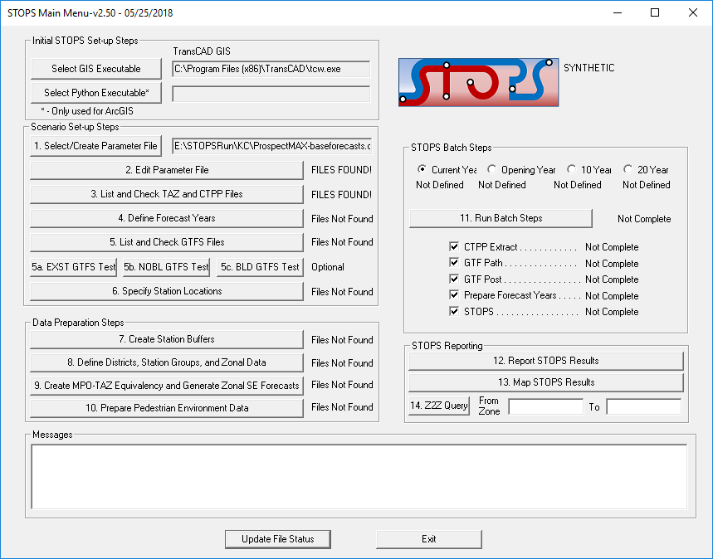

Figure 27 STOPS Menu After All TAZ and CTPP Files Have Been Found

The next step is to define the Forecast Years. This is done by clicking on “4. Define Forecast Years”. If this is the first time you have clicked on this option, STOPS will ask if it can create a new year definition control file. If the user answers “Yes”, then the screen shown in Figure 28 appears.

This dialog defines each of the analysis years, variables in the MPO zone layer file, and other related ridership information. Most items relate to the MPO zone layer file described in Section 4.3 – MPO Population/Employment File. The user must identify the field names in this file that correspond to the different data items used by STOPS to adjust CTPP trips to represent future years. Field names are selected using drop down lists containing the available field names in the MPO zone data file. Year fields are character strings that should contain the year numbers that are used in reports and file names to identify the year being modeled. The unlinked trip field is a numeric quantity that is entered by the user and read by STOPS as part of its self-calibration routine. The following data are entered in this dialog:

* Numeric TAZ Field Name (required). The field in the MPO zone layer file containing the numeric MPO TAZ number used to identify origins and destinations in the auto skim file.
* CTPP Year (2008 or 2000 depending on the CTPP version selected in the Parameter File) Population Field Name (required). The field in the TAZ layer file containing the MPO estimate of CTPP Year population.
* CTPP Year (2008 or 2000) Employment Field Name (required). The field in the TAZ layer file containing the MPO estimate of CTPP Year employment.
* Current Year (required). A character string identifying the current year for the model calibration and application.
* Current Population Field Name (required). The field in the TAZ layer file containing the MPO estimate of current year population.
* Current Employment Field Name (required). The field in the TAZ layer file containing the MPO estimate of current year employment.
* Current Year Regional Transit Unlinked Transit Trips (weekday transit boardings, optional in STOPS but required by FTA for Capital Investment Grant (CIG) reporting). If this number is entered, then STOPS will self-calibrate to match the number of regional transit boardings. STOPS will adjust the modeled number of unlinked trips traveling within the 25-mile corridor and using the coded GTFS services to match this entry. It is very important that the coded number reflect both the geographic corridor definition and the GTFS systems included in the model run. If a significant portion of transit operations included in the GTFS inputs serve areas outside of the 25-mile corridor radius then any trips occurring in whole or in part outside of the corridor should be excluded from the unlinked trip estimate. Likewise, travel on smaller operators that are not represented by the GTFS files should be excluded from the estimate of regional ridership.
* Optional Years and Field Names for Opening Year, 10-Year, and 20-Year Forecasts. STOPS allows definition of up to 3 additional years that represent the project opening year, a medium-term horizon year, and a long-term horizon year. These entries are optional.
* Growth Factor Geography. This radio button selection indicates whether STOPS will factor trips on a zone-by-zone basis or on a district-by-district basis. Generally, zone-level factoring is preferred unless the estimates of zone-level population and employment are not consistent between years and should not be used for updating the CTPP. District-level factoring will generate much more consistent growth between the zones in the corridor while zone-level factoring will show greater differences in growth among zones. The decision of which to use depends on the nature of the MPO forecasts. If the MPO estimates of zone-specific growth assumptions are thought to be representative of future plans, then zone factoring should be used. If the zonal variation is thought to represent spurious differences in data sources then district factoring should be used.

Figure 29 shows the Year Definition Dialog after information for the Kansas City example is entered.

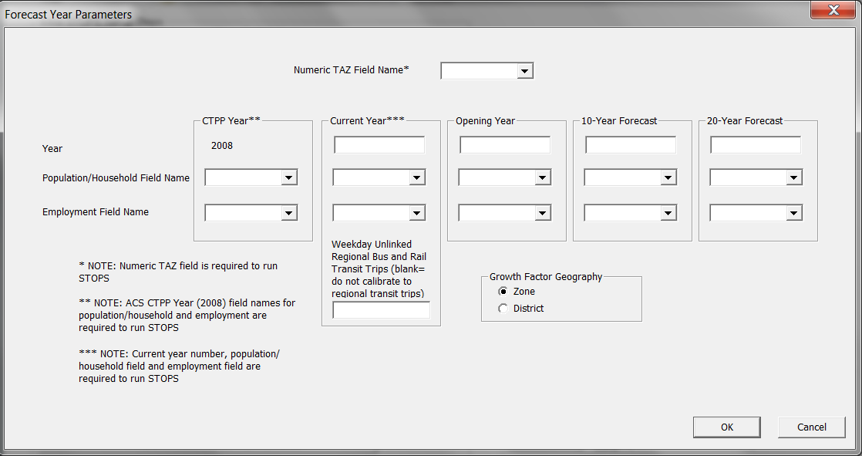

Figure 28. Year Definition File Dialog Before User Entries

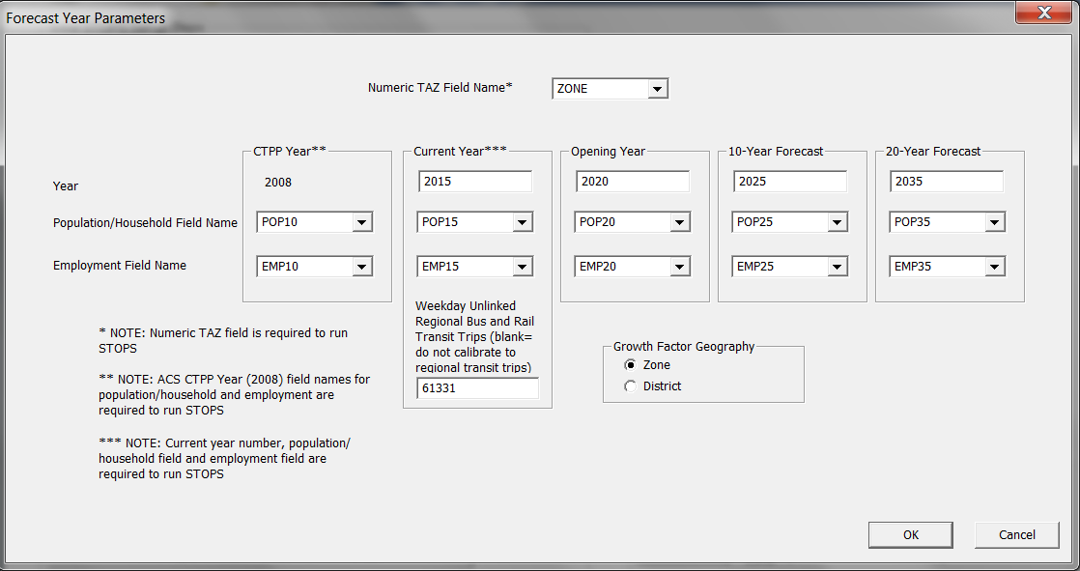

Figure 29. Year Definition File After User Entries for Kansas City Example

## List and Check GTFS Files

The next step in the scenario set-up process is to place the required transit schedule files in General Transit Feed Specification (GTFS) format in the proper folders. At the beginning of this step, the main menu appears as shown in Figure 30. The user can click on “5. List and Check GTFS Files” to obtain a complete list of GTFS file names and locations. STOPS shows the GTFS file names separately for the Existing, No-Build, and Build scenarios as shown in Figure 31, Figure 32, and Figure 33. If a scenario has more than 4 GTFS file sets, STOPS will show additional screens so that all GTFS file names are identified to the user.

All GTFS files are organized as subfolders to the inputs\ folder in the STOPS run directory. Each GTFS file set (e.g., each agency or each operating division) appears in a separate subfolder. In each of these subfolders the following files must be defined:

* Agency.txt. Information on the agency operating the GTFS file set.
* Calendar.txt or calendar_dates.txt. At least one of these files and must exist (both files are also allowed). Together, these files define a series of “service_id” records. Each service_id is given a starting and ending date and the days-of-the-week that the service operates. Calendar_dates is used to override the standard definitions to account for service changes on holidays or other special cases.
* Routes.txt defines the different routes operated by the agency. From the perspective of STOPS, one of the most important pieces of information in the routes.txt file is the route_type. STOPS uses this field to distinguish bus routes (type 3) from streetcar or other fixed guideway systems operating in mixed traffic (type 0) and all other fixed guideway routes (types 1, 2, 4, 5, 6, and 7).
* Trips.txt. Defines a series of transit vehicle trips. Information in the trips.txt file includes the trip_id that identifies the trip, the route_id that identifies the route name and route type, and the service_id that identifies the days that this trip operates.
* Stops.txt. Defines all bus stops and transit stations in the system. This file defines the stop_id and the name, and the latitude and longitude of each bus stop or rail station.
* Stop_times.txt. Defines the time at which each trip arrives and departs from each stop. This file, optionally, can include information on whether boardings or alightings are prohibited at the stop.
* Freqencies.txt. Instead of defining separate trips and stop_time records for each bus trip, GTFS allows agencies to create an optional frequencies.txt file the describes how user-selected trips are repeated over the course of the day. This capability is most helpful for services which are operated on a set frequency or headway over a period of time.
* PNR.txt. This file is an extension to the original GTFS specification and defines locations with park-and-ride facilities. PNR records include the latitude and longitude of the facility, the ability of the facility to attract users from a large or small area, and the generalized cost of using the facility (both dollar and time costs) expressed in terms of minutes.
* Editlist.txt. Another extension of the original GTFS specification that gives a series of programmatic overrides to simplify the process of coding alternatives.

A more complete description of the GTFS standard and its usage in STOPS is presented in Section 11.0.

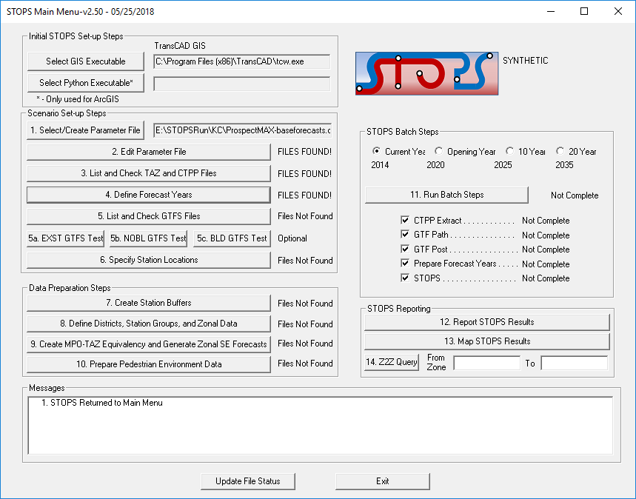

Figure 30. STOPS Main Menu Before GTFS Files Are Identified

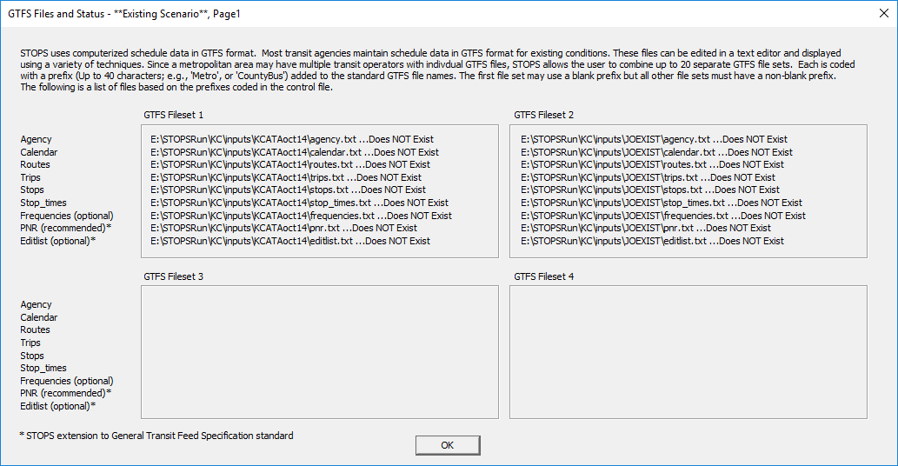

Figure 31. GTFS File Names and Locations for Existing Scenario

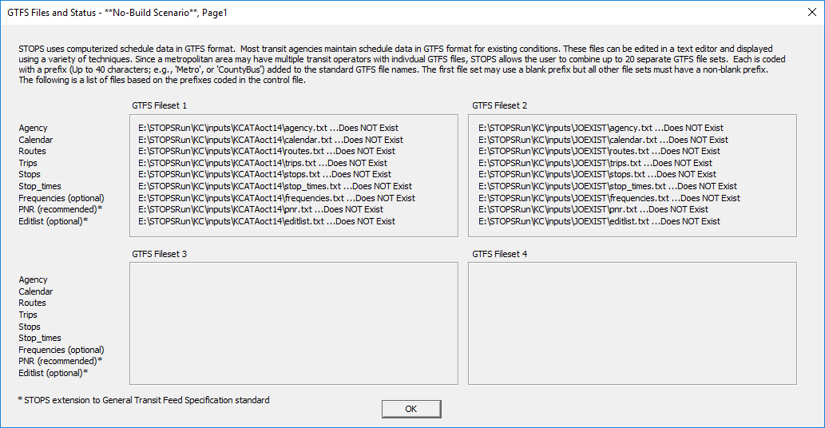

Figure 32. GTFS File Names and Locations for No-Build Scenario

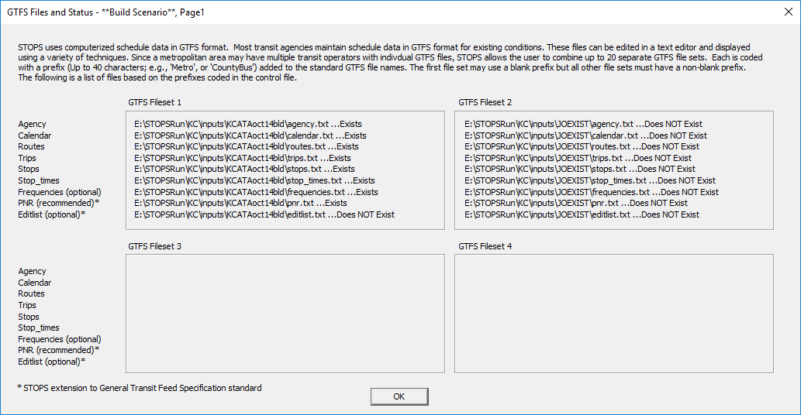

Figure 33. GTFS File Names and Locations for Build Scenario

## Testing GTFS Files and Preparing Station Inputs

When all GTFS files are copied to the proper directories, the screen appears as shown in Figure 34.

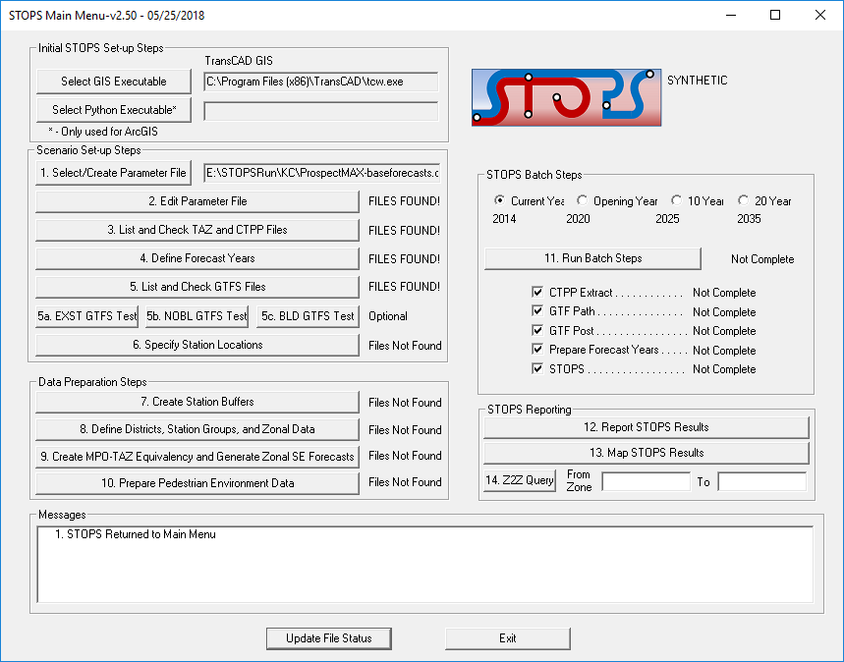

Figure 34. Main Menu After All GTFS Files Loaded into Proper Folders

The next step is to test these files to:

* Confirm that the GTFS files can be successfully read by STOPS and contain no errors such as duplicate ID fields, unreadable numeric information, or other coding that violates the GTFS standard.
* Provide a listing of stations and stops that can be helpful in the next step, preparing a station file.
* Generate an output GTFS directory combining all of the input GTFS files in one location.

This step is accomplished by clicking:

* “5a. EXST GTFS Test” – all GTFS files for the Existing Scenario
* “5b. NOBL GTFS Test” – all GTFS files for the No-Build Scenario
* “5c. BLD GTFS Test” – all GTFS files for the Build Scenario

If you are planning on using the GTFS files to prepare the starting station file, then all three GTFS test steps should be run. It is always possible to add stations later if the build stations have not been defined or if the build alternative test is not run.

When each test step is run, STOPS will confirm that the user wants to run the operation with the dialogs shown in Figure 35 and Figure 36[20]. To run the test, click “Yes” in response to both confirmation questions. Next, a dialog box appears that asks the user to confirm the scenarios to run. The user should accept STOPS’s defaults and click “OK.”

Each test step generates a complete output GTFS file in the GTFSOutput folder. This folder has 6 sub folders for the peak and off-peak periods, and for the existing, no-build, and build GTFS schedules.

This step also gives the user the option to see all stop_ids used in each run as shown in Figure 37. If the user clicks Yes, then STOPS opens the report shown in Figure 38. The information in this report can be used by STOPS to develop the initial version of the station file as described in the next step.

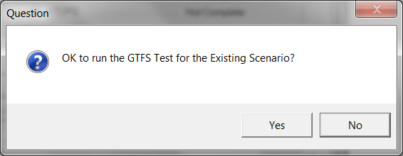

Figure 35. First Confirmation of Test Step

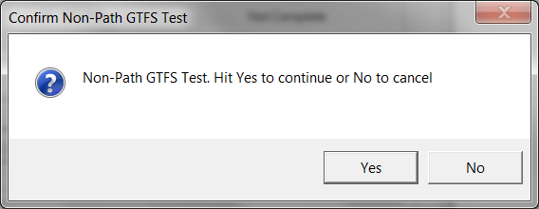

Figure 36. Second Confirmation of Test Step

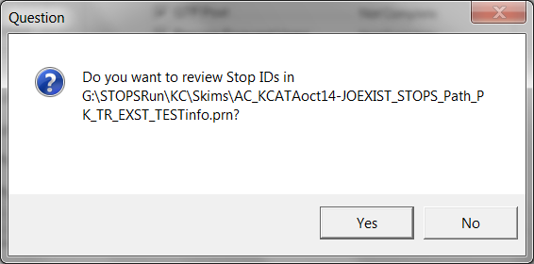

Figure 37. Option to Review Stop IDs

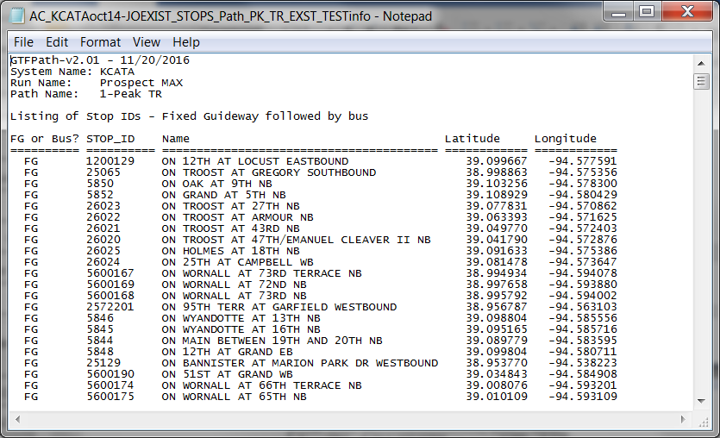

Figure 38. Sample Stop_ID Listing from GTFS Test

## Specify Station Locations

The last step in the scenario set-up process is to create a station location file. This file is an ESRI shape file and must, at a minimum, have one point for each existing or future fixed guideway station in the regional transit system. Ideally, this file will also include a record for each bus stop in the system since these additional records will allow the demand models to use bus stop-level ridership during the calibration phase.

The station file can be developed in one of four ways:

* + - * 1. Manually copy a station file from another setup and edit in a GIS package to represent the current scenarios.
        2. Prepare an input station data text file with a text editor and then import this table into the station file.
        3. Use the GTFS tests (run in the previous step) to generate a starting station file. This file is then edited in a GIS package to add additional information for each stop.
        4. Use STOPS to generate a partially-populated table of rail stations and then complete the table in a GIS package.

No matter which of these options is selected, the STOPS station file must include the following fields:

Table 8. Required Fields in Station File

| Field Name | Data Type | Width | Description |
| --- | --- | --- | --- |
| STATIONSEQ | Integer | 6 | A sequence number used to sort the stations for reporting in STOPS. |
| STATION | Character | 35 | Station name. |
| STAT_CODE | Character | 9 | A shorter code used for some reporting. |
| STAT_GRP | Integer | 8 | A number group number (generally 1 to 50, but may be as high as 250) used for aggregating stops for calibration purposes. |
| GRP_NAME | Character | 6 | The name of the station group. Only one station in each group needs to be named. All stations with the same stat_grp is assigned the same non-blank grp_name. |
| DAILYBOARD | Integer | 8 | Number of daily boardings counted at this station or stop. If no riders use this stop in the count period, code a zero. If ridership is unknown for this station or stop and is also unknown for every other station in this group, code a 0. For special cases where ridership is known for other stations in the group but not this particular station, code a number less than 0 (e.g., -1). A negative number flags STOPS to add its own estimate of ridership at this station prior to performing station group calibration. |
| STOP_ID1 | Character | 25 | Up to 4 GTFS STOP_IDs that represent this station or stop. Up to 25 characters can be used. If the GTFS file uses a GTFS suffix, then an ampersand and the suffix is added to the end of the GTFS STOPS_ID. The total length including the suffix is limited to 25 characters. |
| STOP_ID2 | Character | 25 |
| STOP_ID3 | Character | 25 |
| STOP_ID4 | Character | 25 |
| STOPSTYPE | Integer | 6 | Code to indicate usage of this station:  0 = not used in this STOPS run  1= At grade station/ no PNR  2= At-grade station/ PNR  3= One grade level up or down/ no PNR. Adds 0.5 minutes of access/egress time  4= One grade level up or down/ PNR. Adds 0.5 minutes of access/egress time  5= Two grade levels up or down/ no PNR. Adds 1.0 minutes of access/egress time  6= Two grade levels up or down/ PNR. Adds 1.0 minutes of access/egress time  7= Three grade levels up or down/ no PNR. Adds 1.5 minutes of access/egress time  8= Three grade levels up or down/ PNR. Adds 1.5 minutes of access/egress time |
| NEWSTATION | Integer | 8 | Code to identify stations/stops associated with a project. Codes are:  0=Not a project station  1=New (project) station  2=[Rarely Used] Indicates stations on one side of a project to represent run-through trips[21]. STOPS now does this computation automatically.  3=[Rarely Used] Indicates stations on the other side of a project to represent run-through trips. STOPS now does this computation automatically.  4=Station that is not a project station but should still be reported in station-to-station matrices |
| WALK_PEN | Real Number | 10.2 | Additional (penalty) time (in minutes) to add to all centroid-to-station walk access/egress links. This penalty is added to the times already computed from horizontal separation (latitude and longitude) and vertical separation (STOPSTYPE). This penalty may represent actual walking times or other contributors to impedance (e.g., fare or perceptions of the service). |
| KNR_PEN | Real Number | 10.2 | Similar to WALK_PEN but applied to centroid-to-station kiss-and-ride access/egress connections |
| PNR_PEN | Real Number | 10.2 | Similar to WALK_PEN but applied to centroid-to-station park-and-ride access/egress connections |
| SAMEGTFX | Real Number | 10.2 | Similar to WALK_PEN but applied to stop-to-stop transfer links generated by STOPS when the stops appear in the same GTFS file[22]. |
| DIFFGTFX | Real Number | 10.2 | Similar to WALK_PEN but applied to stop-to-stop transfer links when the stops appear in the different GTFS files. |

The details regarding each option for preparing the station file are described below.

#### Station File Preparation Option 1: Copy the Station File from Another Scenario

In cases where a region is creating a new STOPS setup from a pre-existing STOPS run, then it is often easiest to copy the STOPSSTATIONS shape files[23] from the old inputs\ directory to the new inputs\directory. If this option is desired, the user should copy the station file into the new directory prior to running Step 6, Specify Station Locations. As long as a STOPSSTATIONS.SHP file exists in the inputs\ subdirectory, Step 6 will open the existing the station shape file and use the selected GIS executable to create a map with the station file. The user can then use GIS editing tools to add, delete and modify the stations and stops required for the new STOPS run.

#### Station File Preparation Option 2: Import Station Text File

If the STOPSSTATIONS.SHP file is not in the inputs directory when Step 6 is clicked, STOPS looks to see if the inputs\ directory has a file named “STOPSStationInputs.txt.” If so, the user is asked if STOPS should read this file and use it to create a new STOPSTATIONS.SHP file.

A sample of the import station text file is shown in Figure 39.

This file begins with a header record describing the fields that appear in the file, followed by one record for each station to be added to the station file. The fields can be in any order as long as the header and the data records are consistent. The latitude and longitude fields are required and must appear in the file. Other fields are optional and if they are omitted from the header or left blank in the data records, the shape file field will be created but these data items will beleft blank for later editing with a GIS.

Data fields have the same names and contents as described for the ESRI shape file. The names are not case sensitive and will be converted to all capitals as part of the process that creates the shape file.

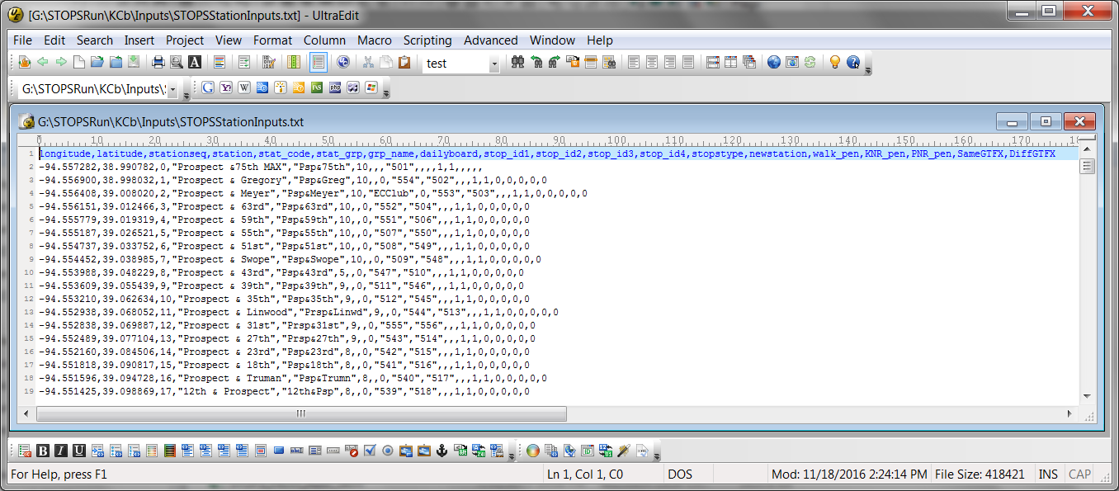

Figure 39. Sample STOPSStationInputs.txt File

#### Station File Preparation Option 3: Create Station File from GTFS

If Step 6, doesn’t find the STOPSSTATIONS file in the inputs directory and if the import file does not exist, the GTFS files identified in the parameter file can be used to generate an initial version of the station file. This can only be done after the GTFS files have been identified in the parameter file and tested with Steps 5a, 5b, and 5c. These testing steps generate a special file that contains sufficient information for STOPS to generate a shape file representing all transit stops and stations with information on location, station name and stop_id. After this station file is created, the user must use a GIS package to enter the required information for all other fields.

#### Station File Preparation Option 4: Generate a Partial Rail Station File and Manually Add Stations and Stops

If Step 6, doesn’t find the STOPSSTATIONS file in the inputs directory and if no other option was selected, then STOPS can create a blank station file using a national database of rail stations. The user can then supplement the data in this file using the selected GIS executable.

### Station File Editing For All Options

After the file has been created, STOPS will ask the user the following question each time Step 6 is clicked:

StationFile <directory>\Inputs\STOPSStations.shp already exists. Do you want to check output of steps 5a/5b/5c to see if new stations should be added?

If the answer to this question is “Yes” then STOPS will keep all records in the existing STOPSStation file as long as the sequence number is greater than or equal to -99. Then, STOPS will look in all of the GTFPath test runs to identify any new STOP_IDs that should be added. All newly added STOPS IDs will be given a sequence of -1 to make the new records easy to find for final editing in a GIS package.

***Since STOPS does not copy records coded with a sequence number of -99 or less, this is an easy way to remove unused station ids from the station file (as long as the stop_id does not appear in any of the GTFS files).***

If the answer is “No”, then STOPS goes straight to the GIS package to allow manual editing of the file. No matter which option is selected, STOPS uses the selected GIS executable to open the shape file and allows users to add, delete, or modify stations. An example of the station map and underlying database are shown in Figure 40.

Depending on which technique was used to create the station file, the user may have to populate any field that is empty or has obsolete information. The station file is a critical input to STOPS and must be carefully completed with data that describe:

* The station and stop names that are to be reported in the summary report.
* The grouping of stations and stops for purposes of calibration and reporting.
* The GTFS stop_ids (up to 4) that, together, should be treated as a station.
* Boarding counts to indicate the ridership (boardings) attracted to each station or bus stop.
* The STOPS_type and newstation values to indicate whether the station is to be used, the degree of grade separation and whether the station is new to the project.
* Any additional time penalties that are required to represent impedances associated with the station.

If you are using TransCAD to edit stations, then STOPS created an editable TransCAD geographic database from the ESRI shape file that is used as the input to STOPS. After the user closes TransCAD, STOPS asks if it is OK to copy this file back to the ESRI shape file format. Click “Yes” to copy this data back to ESRI Shape File format or “No” to skip this step and lose the changes entered into TransCAD. This dialog is shown in Figure 41.

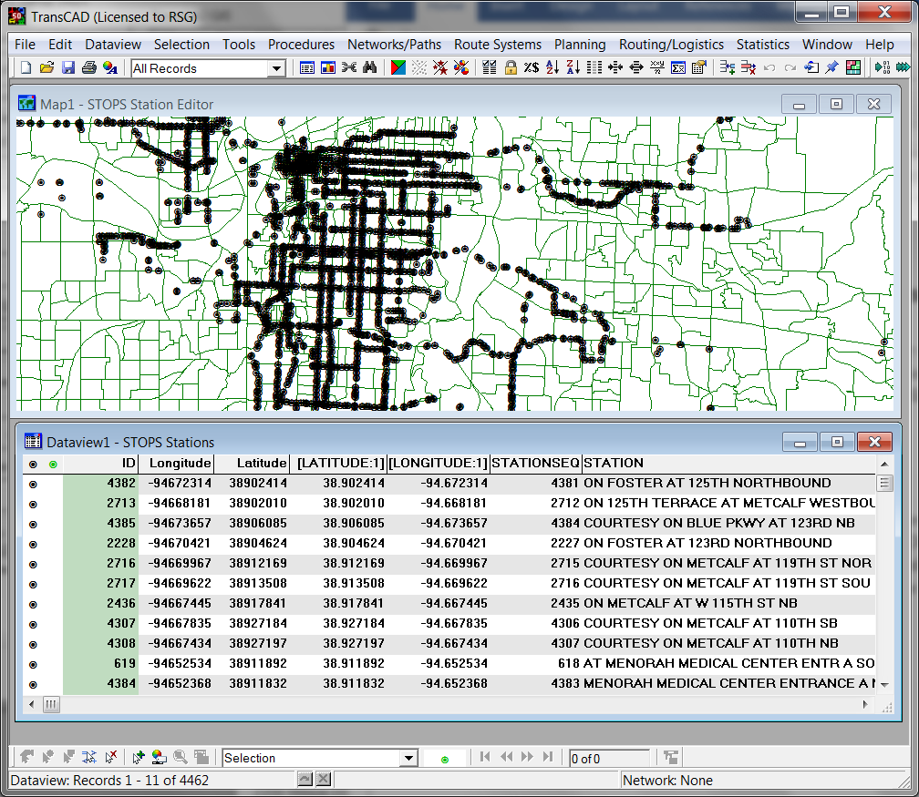

Figure 40. Sample Station file in GIS

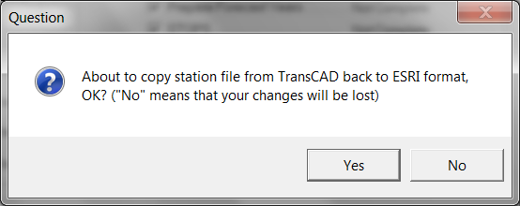

Figure 41. TransCAD Confirmation After Station Editing

# Data Preparation Steps

In the previous chapter, the user defined the STOPS run and prepared input information that will be used to estimate project ridership. If every initial set-up step was successfully completed, then the STOPS Main Menu should show the status as being “FILES FOUND!” through Step 6 as shown in Figure 42.

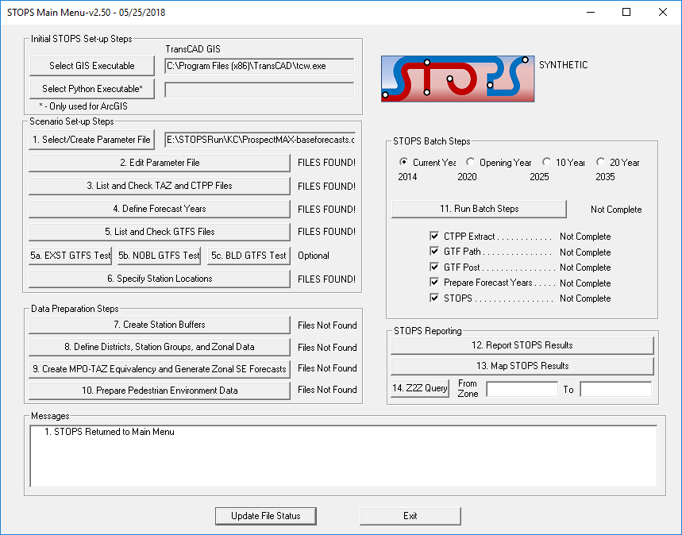

Figure 42. STOPS Main Menu at the Beginning of Data Preparation

This chapter describes the next round of STOPS preparation steps, focusing on additional data that is required to generate estimates of project boardings. Four steps must be accomplished to complete data preparation and are described in the remainder of this chapter.

These steps are different from the steps in Chapter 4.0 (Scenario Set-up) in a very important way. In the previous Chapter, the steps involve setting up the model run and the steps need not be accomplished sequentially[24]. The user may go back and forth between editing stations, specifying parameters, and coding GTFS scenarios until all files are fully defined.

***Beginning with this section, STOPS steps are sequential. Any change to an earlier step may affect downstream steps. If it becomes necessary to recode a data item in an earlier step (including Scenario Setup), then all later elements of Data Preparation generally should be re-run to ensure that all data is properly updated throughout STOPS. Some key exceptions to this general rule are as follows:***

***1. If the station file is updated but without changing the station time penalties), the user only needs to re-run the STOPS step (last option in Step 11) as long as the station file revisions do not affect the geographic scope of the project. This may happen if the user updates station groups, group names, or ridership. If the user adds a new station within the geographic range of existing stations, the user need only re-run the STOPS step.***

***2. Likewise, if the District file is updated, then the user need only re-run the STOPS step.***

## Create Station Buffers

This step is a completely automated process that builds a series of buffers around the stations that were specified in the station shape file and compares them to the CTPP geography file(s) selected in the parameter file. The principal result is a file containing a listing of each CTPP zone (AC, TZ, BG, or TR) to be included in the modeling file. This program also creates a blank district file in ESRI shape format that is pre-populated with district=99 (i.e., unknown district) or whatever districts were assigned after an earlier run of this program. The next section has more information about the process of defining districts.

The step is initiated by clicking on “7. Create Station Buffers”. This command will call the program “StatBuffZone” which runs for several minutes without any need for user intervention. When done, the program will return to the STOPS Main Menu.

It is possible that you will receive an error message that says:

“Error: Duplicate zone names found. Split Zones (or duplicate zones form the original census files) must have alternate name specified in LSAD_TRANS field of CTPP Zone File.

A follow-up message will direct you to a file that contains a list of duplicate names.

When this happens, open up your census geography file and code a unique override zone label in the LSAD_TRANS field. (see the discussion on split zones in Section 4.3, Optional Adjustments to the Census Data, for a more complete discussion of this process). As long as the LSAD_TRANS value is unique, it can be any 6- character string. When all necessary changes have been made, re-run the Create Stations Buffer step. Once all duplicates have been resolved, the error message will not be generated and this step will be labeled with “FILES FOUND!”

## Define Districts, Station Groups, and Zonal Data

In this step, users define a series of zone and station aggregations that STOPS uses for calibration and reporting. Optionally, the user can also define additional zonal information that helps STOPS understand “greenfield” development areas and “brownfield” redevelopment sites. The information defined in this step includes:

* + - * 1. Districts, which are groups of one or more zones[25] that are used by STOPS to aggregate travel data to a level suitable for model calibration and reporting. Depending on the type of growth factoring selected by the user, districts also define the unit of geographic analysis used to update the base year CTPP to represent current and forecast year population and employment. Districts should be defined that represent groups of similar geographic areas along the project and other key transit markets. Districts should represent areas with levels of walk and drive accessibility to stations that are relatively close to one-another and share similar levels of transit service.
        2. Station groups, which are aggregations of stations or bus stops used for calibration. In most cases, station groups are defined according to the geographic district in which the station is located.
        3. Optional zone-related inputs include information on whether the zone should be cloned from another nearby location to reflect the fact that the area is expected to change substantially in the coming years.

Figure 43 shows the District and Station Group screen for the Kansas City example before any districts or station groups are defined[26].

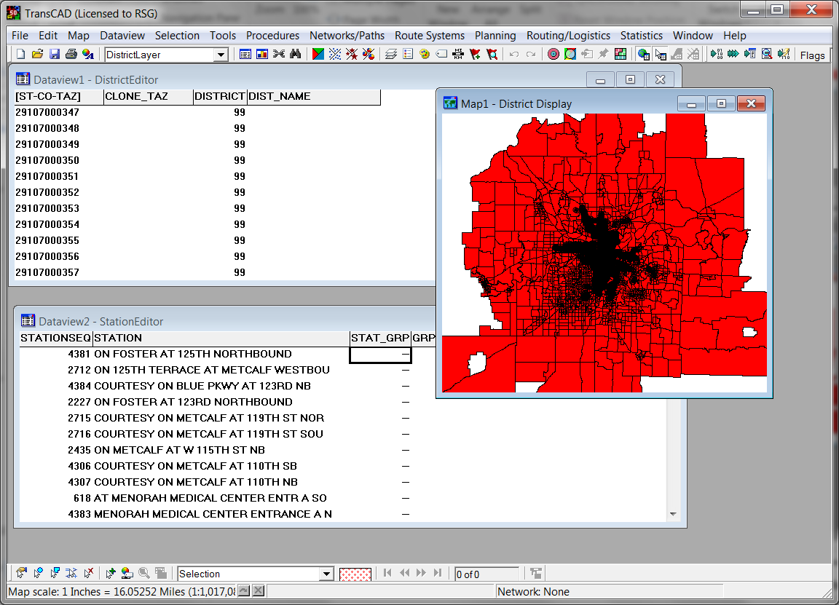

Figure 43. Sample District System in Kansas City, KS (Before Districts Defined by User)

This process begins when the user clicks on “8. Define Districts, Station Groups, and Zonal Data.” This causes STOPS to open a map with:

* District and Zonal Characteristics File
* Station File

The adjustments that the user must make to each of these files is described in the sections that follow.

### District and Zonal Characteristics File

Districts and zonal characteristics are defined in an ESRI shape file located in the Districts\ folder. This file is named AC_DistrictZone.shp[27] and contains one record for each zone in the modeling area. This file is created in Step 7, Create Station Buffers. The first time Step 7 is run, STOPS generates a “starter” district file with all districts set to “99” (defined as the “Other” district). If Step 7 is re-run, then it copies all previously defined districts over the new DistrictZone file

The user is responsible for updating all elements of this file except for the zone name found in the first field. The contents of the file are as follows:

* **ST-CO-TAZ – the full name of the TAZ (or block group or tract).** This field is the full name of each zone as is prepopulated in the data file and should not be changed. This name is used by STOPS in all subsequent steps to describe the zone. Any user interactions that require a zone number will use this number. These interactions include: the imported trip table (see special rules for zones beginning with “$” or “~” in Section 10.1); the path trace options in Steps 5a, 5b, and 5c; and the Z2Z query option.
* **DISTRICT – District number (required and entered for every zone).** This integer must be between 1 and 98 and is used to identify the geographic district used for data summarization and mapping. District 99 is a special value used by STOPS to identify zones that have not been assigned to any district. This is the initial value of the district field before the user has defined districts. After the user has established district definitions, no zones should be left in district 99.

*Typical districts might include the CBD and a system of wedge-shaped districts that relate to key transportation corridors radiating outward from the CBD. The wedges may also be segmented by the characteristics of the area (e.g., urban, suburban, and exurban).*

* **DIST_NAME - Description (required but entered once for each district—most zones left blank).**  This district name field serves two purposes:
  + **Assigns a name to each district.** This field is used to assign a short name to each District. The names can have as many as 18 characters. However, the district-to-district reports in STOPS only show the first 6 characters in the district headings so it is generally preferred to limit the district name to 6 characters.
  + **Identifies the middle of each district for path reporting purposes.** The most representative zone in each district should be the only zone with a non-blank DIST_NAME. STOPS automatically generates trace messages for any zone (up to a preset limit) with a non-blank DIST_NAME. ***Users should take care to only provide DIST_NAME for one zone per district. Otherwise, the path reporting feature is disabled.***
* **CLONE_TAZ - CloneTAZ (optional and only coded in cases where a zone completely changes its character).** When forecasting the CTPP JTW into the future, STOPS grows demand according the relative size of base year[28] and forecast year population and employment in each zone or district. In areas with existing development and growth that reflects “more of the same”, this is sufficient to generate a reasonable estimate of future travel. This approach is less successful in areas that are projected to change their character dramatically (e.g., from farm land to suburban activity center). The zone cloning process is a mechanism for overcoming this problem by allowing the user to tell STOPS that an undeveloped or re-developing zone will become more like another nearby zone (that already had development at the time of the CTPP). The process for specifying clones is as follows:
  + **Step 1.** Define and name a clone group. A clone group is a series of one or more “donor” zones that establish the travel patterns that existed at the time of the CTPP that should be transferred to one or more “recipient” zones. In regions with multiple redevelopment areas, multiple clone groups can be defined. Each should be given a 4-character name (e.g., GRPA, GRPB, or GRPC)
  + **Step 2.** For each zone in the DistrictZone file that is either a donor or recipient, enter a code into the CLONE_TAZ field that is defined as follows: <group that this zone contributes to as a donor>,<group that the zone borrows from as a recipient>. In some cases, the zone only contributes to a clone group. In that case, CLONE_TAZ is blank after the comma. In other cases, the zone only receives from a clone group. In this case, CLONE_TAZ is blank before the comma. When a zone contributes to and borrows from a group, then CLONE_TAZ is non-blank before and after the comma. When the zone is not involved with the cloning process, the entire CLONE_TAZ field is left blank.

*Example: assume that zone “08012 1201” “the borrower zone” had an employment of 10 in 2008 but is expected to have 2,000 employees in 2015. Assume another “borrower zone” is Zone “08012 1204, which had no employment in 2008. Also assume that zones “08012 1202” and “08012 1203” (the “contributor” zones) are nearby and together had a Year 2008 employment of 10,000. In that case, the user might define clone Clone Group A in which zones “08012 1201” and “08012 1204” borrow the characteristics of clone zones “08012 1201”, “08012 1202” and “08012 1203”. The coding of Clone_TAZ for this situation is shown in* Table 9*.*

Table 9. Clone_TAZ Coding in DistrictZone File

|  |  |
| --- | --- |
| ST-CO-TAZ | CLONE_TAZ |
| 08012 1201 | GRPA,GRPA |
| 08012 1202 | GRPA, |
| 08012 1203 | GRPA, |
| 08012 1204 | ,GRPA |

*Hint: Clone “donor” zones should be selected that had development patterns in the CTPP Year similar to what the “borrower” zone will have in the forecast years. If the borrower zone will have dense employment and no population then the donor zones should be a set of nearby zone(s) that had significant employment levels in the CTPP Year. If the borrower zone will have little employment but significant population in the future then the donor zones should be a set of nearby zone(s) with significant population in the CTPP Year but little employment. If the borrower zone will have significant levels of population and employment in the future, then the clone group should have donor zones with significant levels of population and employment in the CTPP Year. It is also important that the borrower and donor zones be near to one another since the trip patterns (including the other end of each trip) will be copied from the donor zones to the borrower zones.*

*The total population or employment of the donor zones need not match those values for the borrower zones. After cloning, STOPS will adjust the trips to and from each borrower zone to match the future year population and employment.*

### Station Group Information

Station groups are the other principal aggregation used in STOPS for controlling the calibration process. The initial definition of station groups should be consistent with the geographic districts that contain each stop. Step 8 can be used to update station group definitions since both the station and DistrictZone layers are present in the same GIS map. GIS tools such as posting an area attribute to a point attribute can be used to ensure that all station groups are defined according to the district that contains them.

Depending on the particular needs of the application, different station group coding schemes can also be employed. Station groups can be any value up to 250 (as compared to district values of up to 98) so that more detailed station groups can be defined if needed to refine the calibration of STOPS.

### Completed District and Station Groups

Figure 44 shows the appearance of the district and station group coding after the user defines these items.

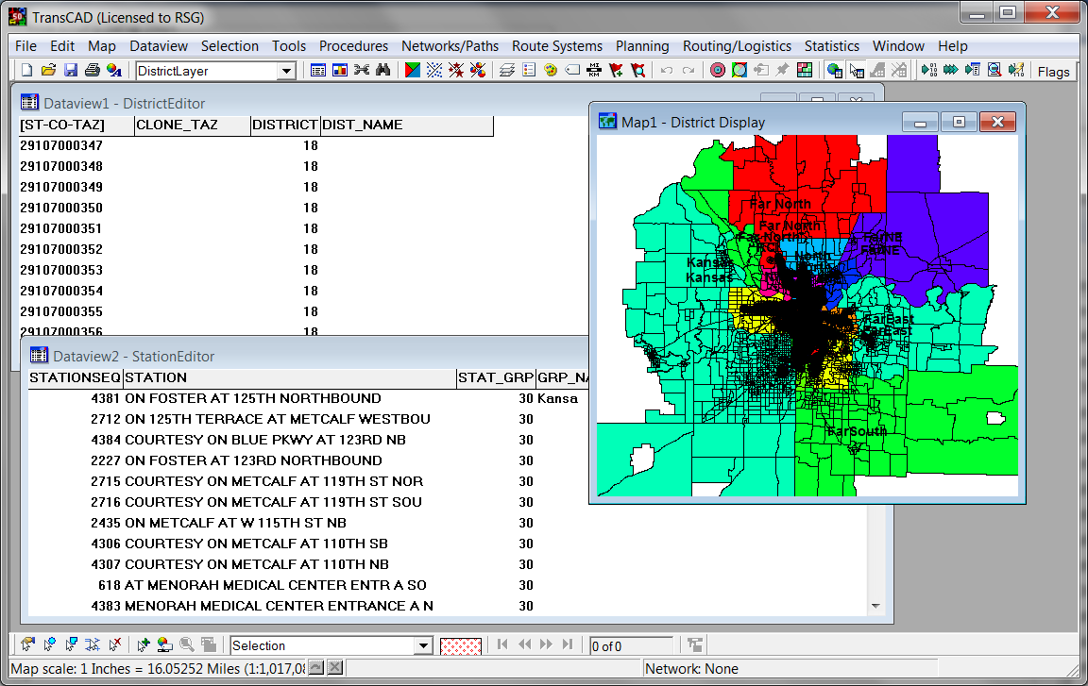

Figure 44. Districts and Station Groups After User Definition

## Create MPO-TAZ Equivalency and File and Generate Zonal Socioeconomic Forecasts

This is a fully automated step that (1) creates an equivalency file between the CTPP geography and the MPO zone system and (2) generates a file with one record for each unit of CTPP geography containing MPO forecasts of population and employment for each year defined in the forecast year parameter file. It is important that this program be re-run any time the MPO zone file or the forecast year definitions are changed.

This step is initiated by clicking on “9. Create MPO-TAZ Equivalency and Generate Zonal SE Forecasts”. This procedure will start a program that will run for several minutes and return to the STOPS Main Menu. No user actions are required during this process.

## Prepare Pedestrian Environment Data

This is a fully automated step that generates an estimate of the number of Census blocks contained in each unit of CTPP geography. This statistic is used to provide an indication of the completeness of the street grid in a zone which is often indicative of the walkability of an area. This step is initiated by clicking on “10. Prepare Pedestrian Environment Data”. This action will start a program that will run for several minutes and return to the STOPS Main Menu.

## Print Transit Path Trace for Selected Origin-Destination Zones (Optional)

When all of the data preparation tasks are complete, STOPS can generate transit paths for a user-selected origin and destination zone pair. This capability can be helpful prior to a STOPS run to confirm that all of the GTFS coding for each alternative is working as intended. This step can also be used after the run is complete to investigate specific paths that are of interest.

The path tracing option is invoked by clicking on Step 5a, 5b, or 5c (existing, no-build and build scenarios, respectively). These steps were previously described in Section 4.5 before the setup and data preparation steps were complete. At that time in the process, STOPS just checks the transit networks to confirm that the GTFS schedules are coded properly. Once all of the data preparation steps are complete, centroids and station penalties have been defined and, with this information, STOPS can generate full transit paths and a path trace report.

When path tracing is possible, the GTFS tests in steps (5a, 5b, and 5c) will open the dialog box shown Figure 45. If the user leaves one or both zone fields blank, STOPS will only test the GTFS schedules, just like the earlier process. If the user codes an entry in both zones, as shown in Figure 46, STOPS will generate a path trace for the selected zone pair. Note that the zone identifications must be the full STOPS zone name, which is structured as state code+county code+TAZ.

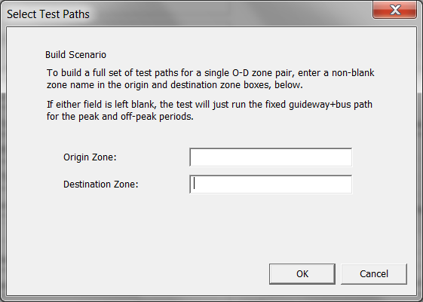

Figure 45. Dialog to Select Origin and Destination Zones for Path Trace Printing

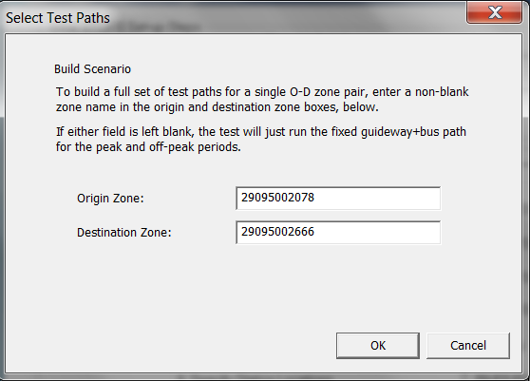

Figure 46. Path Trace Dialog with Origin and Destination Zones Entered

After a confirmation screen, STOPS runs the transit path-builder and generates six path files:

* 2 time periods--PK or OP (peak/off peak)
* 3 path type—TR, FG or BS (best transit, Fixed Guideway Only and Bus only)

STOPS will ask the user if it should open each of these files for review. If the user answers “Yes”, the path file will be opened in Notepad for display. A snapshot of one of these files appears in Figure 47.

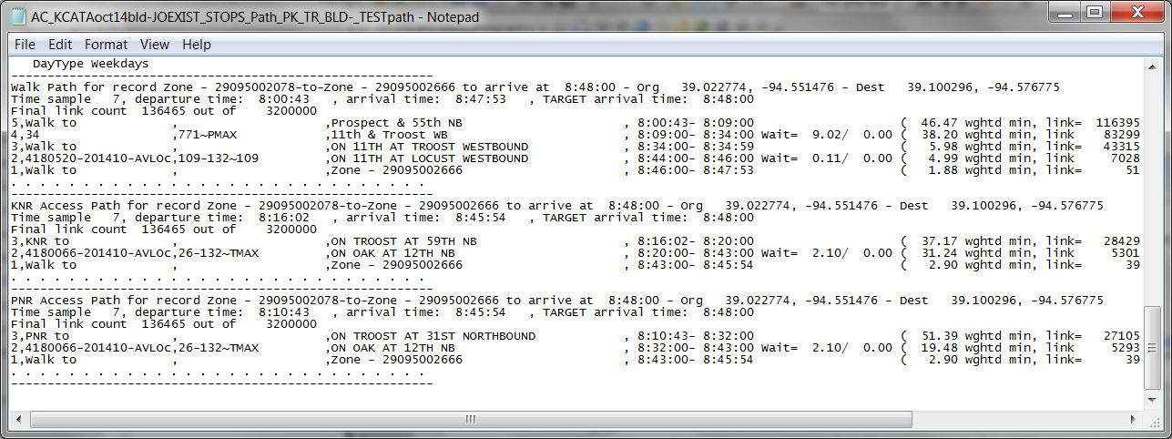

Figure 47. Sample Path Trace Report

This page intentionally blank

# Run STOPS Batch Steps

After all set-up and data preparation steps are finished, the STOPS Main Menu should indicate “FILES FOUND!” for all steps in the left hand column (see Figure 48). The next step is to run the batch steps. This part of the STOPS process may take between one and twelve hours depending on the speed of the computer, the number of regional zones, and the complexity of the regional transit system.

This step is performed by:

Selecting a year to model (any of the previously defined years: Current, Opening Year, 10-Year Forecast or 20-Year Forecast)

Clicking on “11. Run Batch Steps”

The user can optionally select which batch steps are run using the check boxes. STOPS defaults to running all of the following steps:

* 1. CTPP Extract. This step calls the *CTPPExtract* program which reads the CTPP files and prepares an output dataset with one record for each zone-to-zone pair containing the number of CTPP JTW flows. This file also contains space for later posting of zone-to-zone travel times and other data. A separate zone-to-zone file is created for each scenario (existing, no-build, and build). Until travel time data is posted (in GTF Post, below), these three files are identical to one-another. If STOPS is configured for special markets or as an incremental transit model, CTPP Extract also prepares these files for later processing.

***Hint: This step can be skipped if CTPP Extract has already been run and nothing in the parameter file, special market/transit trip table, or station ESRI shape file[29] has changed. The advantage of not re-running CTPP Extract is that if the GTF Path file can be skipped, the GTF Post step can also be skipped, saving considerably on STOPS execution times. This will frequently occur when the user wishes to re-run STOPS with a different forecast year or if the user wishes to change clone zones or other socioeconomic data.***

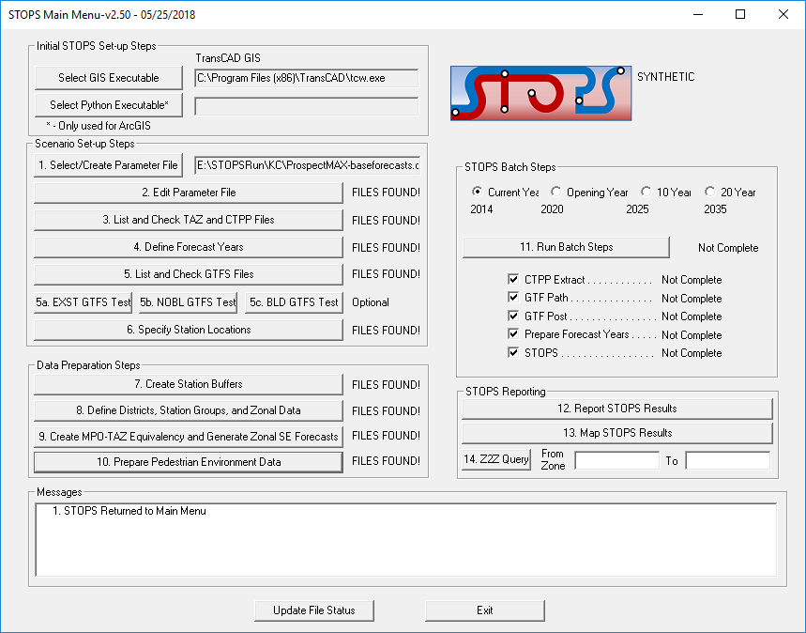

Figure 48. STOPS Main Menu Before Batch Steps

1. GTF Path. This step calls the *GTFPath* program which reads the GTFS files and generates estimates of zone-to-zone transit travel times. This program is called 18 times—once for each combination of:
   * 1. Peak (PK) and off-peak (OP) times-of-day
     2. All transit (TR), fixed guideway transit only (FG), and bus transit only (BS) service type combinations
     3. Existing (EXST), no-build (NOBL), and build (BLD-) scenarios

***Hint: The GTF Path step can be skipped if GTF Path has already been run for the current zone system, the current definition of GTFS subdirectories, and if the contents of the GTFS subdirectories have not been changed since GTF Path was originally run. This could save considerable processing time and is most useful if the user wishes to re-run STOPS with a different forecast year or for a different set of clone zones or SE data.***

1. GTF Post. This step calls *GTFPost* which reads each zone-to-zone JTW flow file and posts the appropriate travel times to each record.

***Hint: The GTF Post step can be skipped if GTF Post has already been run for the current set of skims and CTPP Extract tables. Skipping this step will save considerable time. It needs to be re-run only after CTPP Extract is re-run (since that program clears the posting) and any time the GTF Path skims are updated.***

1. Prepare Forecast Years. This step calls the program that reads each zone-to-zone JTW flow file (with posted time estimates) and grows the file to represent the user-selected forecast year.
2. Run STOPS. This step calls *STOPS*, the program that generates estimates of fixed guideway ridership for each scenario for the year specified at the beginning of this phase.

After the user selects the steps to run, STOPS will ask for confirmation that it is OK to run Batch steps. If the user clicks “OK”, STOPS gives the user the opportunity to de-select the current, no-build, or build elements of CTPP Extract, GTF Path, GTF Post, and preparing forecast years (see Figure 49). The option to de-select these steps is only active if STOPS detects the presence of the appropriate files generated by an earlier run. It is the responsibility of the user to confirm that these earlier results are still correct for the intended run. The de-select option is provided since in many analyses, the existing and no-build runs are unchanged from earlier runs and skipping these steps can save considerable time.

No user action is required during the remainder of the process. A series of similar windows will open that describe the progress of each step. When all steps are done, the program returns to the main menu.

STOPS can be re-run for each of the defined years by selecting each one of the radio buttons (Current, Opening Year, 10 Year and 20 Year) and re-running the batch processes. As suggested in the hints above, after the first run is complete, the user can save considerable processing time by unchecking “CTPP Extract”, “GTFPath”, and GTFPost”. Unless the user changes the GTFS directories or edits the GTFS files, the only steps that differ from year-to-year are the steps associated with “Prepare Forecast Years” and “STOPS”.

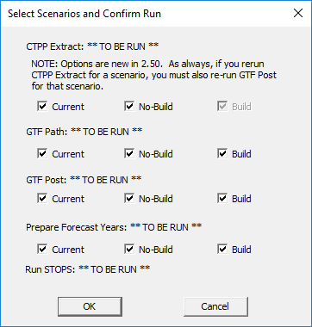

Figure 49. Dialog to Select Batch Steps to Run

# Reporting Results

When STOPS is finished with the batch processing steps, the STOPS Main Menu will show that all steps are complete as shown in Figure 50. Once this milestone has been achieved, the user can open up a report describing STOPS results. This chapter describes the contents of the STOPS results report.

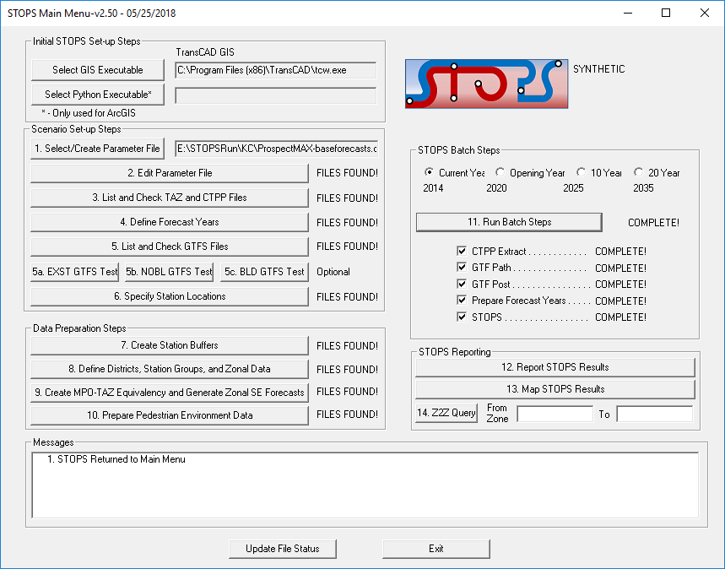

Figure 50. STOPS Main Menu After Completion of Batch Steps

The STOPS results are found in the “reports\” subdirectory in a text file with a name that indicates the nature of the run represented in the report. In the Kansas City example, this file is named:

AC_KCATAoct14-JOEXIST# KCATAoct14-JOEXIST# KCATAoct14bld-JOEXIST _STOPSY2014Results.PRN

This filename has the following components:

* Whether the analysis was conducted at the ACS TAZ, Census 2000 TAZ, Block Group, or Tract Level (“AC”, “TZ”, “BG”, “TR”). *“AC” in the Kansas City example.*
* Underscore (“_”) as a separator.
* The GTFS subdirectory name (or names separated by a hyphen) that make up the Existing Scenario. *KCATAoct14-JOEXIST* *(to represent that this scenario includes both the KCATAoct14 and JOEXIST GTFS subdirectories).*
* “#” as a separator.
* The GTFS subdirectory name (or names separated by a hyphen) that make up the No-Build Scenario. *KCATAoct14-JOEXIST.*
* “#” as a separator.
* The GTFS subdirectory name(or names separated by a hyphen) that make up the Build Scenario. *KCATAoct14BLD-JOEXIST.*
* Underscore “_” as a separator.
* “STOPS”.
* The Analysis Year. *Y2014.*
* Results.prn”.

The report can be opened by clicking on “12. Report STOPS Results”. STOPS will open up a notepad window and display the report for the selected year. The beginning of this report is shown in Figure 51, Figure 52, and Figure 53. The report file begins with a table of contents describing the 15 sections of the report and the tables that are provided in each section. In Sections 1 to 14, the table title and table number are provided. This allows the user to find the table name of interest and then search for the table in the body of the report. The easiest way to find the proper table is to use a search string that begins with a blank followed by the table number that is desired. To find table “2.04”, search on “ 2.04”.

The index in Section 15 also shows table numbers. Every report in listed Section 15 is a matrix of either district-to-district or station-to-station trips in production-attraction format. The index, itself, is a matrix. Each column represents the type of trip that is being reported:

* Transit Trips
  + Transit Path Type
    - FGO – Fixed guideway only
    - FGB – Fixed guideway and bus on the same path
    - BUS – Bus only
    - TRN – Any transit (sum of FGO, FGB, and Bus)
    - FG – Any fixed guideway (sum of FGO and FGB)
  + Access Mode
    - WLK – Walk
    - KNR – Kiss-and-ride
    - PNR – Park-and-ride

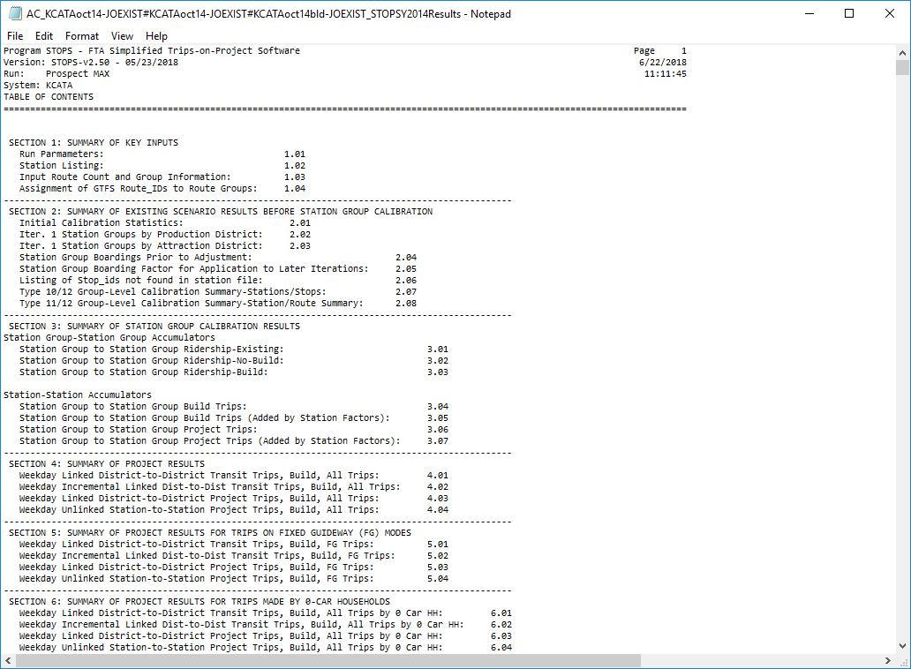

Figure 51. Example Report File and Index (Part 1)

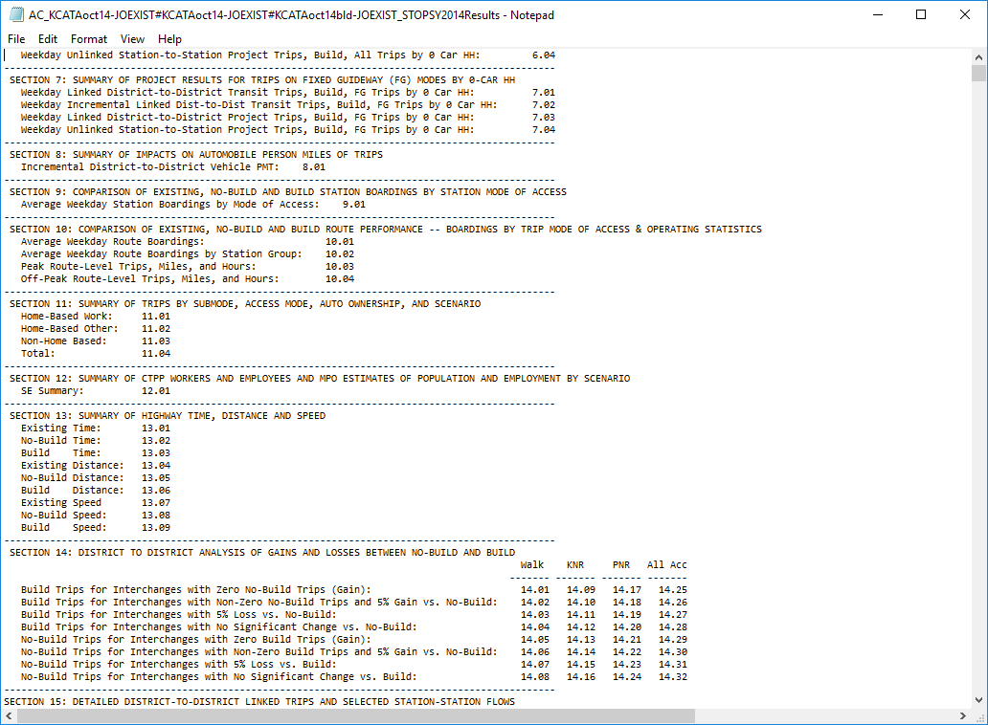

Figure 52. Example Report File and Index (Part 2)

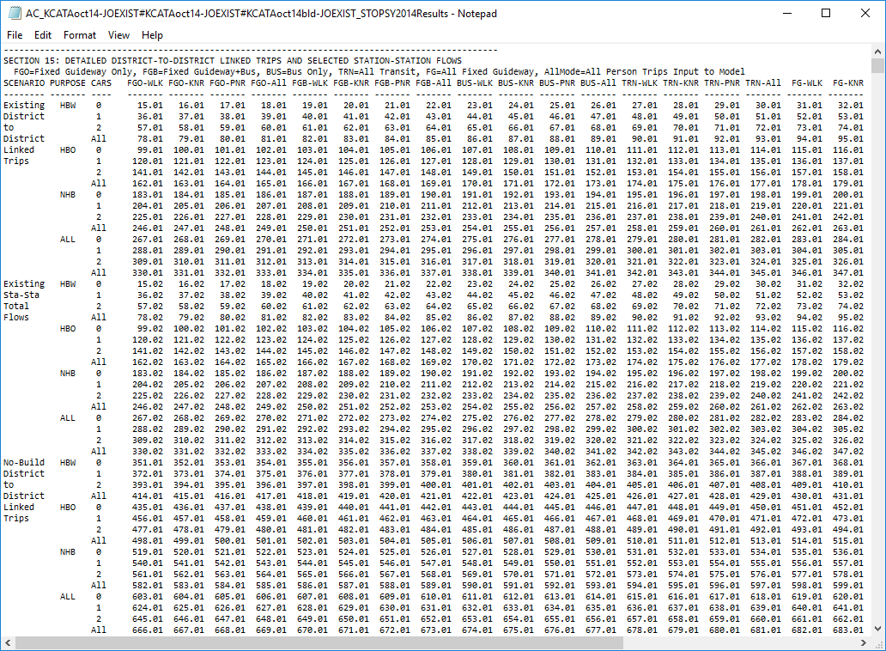

Figure 53. Example Report File and Index (Part 3)

* + - All – Any access mode (sum of WLK, KNR, and PNR)
* Total Person Trips
  + All Mode – The estimate of person trips used to generate the estimate of transit trips.

The rows in the Section 15 index represent the statistic, trip purpose, and auto ownership levels that are included in each table:

* Statistic
  + Scenario
    - Existing
    - No-build
    - Build
  + Matrix Type
    - District-to-district linked trips
    - Station-to-station total flows
  + Other
    - Incrmtl. – Incremental (Build-No-Build) district-to-district linked trips
    - Linked Trips on project – district-to-district table of linked trips that use the project
    - Station-to-station project flows. Station usage by project trips
* Trip Purpose
  + HBW – Home-based work
  + HBO – Home-based other
  + NHB – Non-home based
  + ALL – All trip purposes (sum of HBW, HBO, and NHB)
* Household Auto Ownership
  + 0 – 0 cars in the household
  + 1 – 1 car in the household
  + 2 – 2 or more cars in the household
  + All - All households (sum of 0, 1, and 2)

Each report section is described in the paragraphs below.

## Report Section 1 – Summary of Key Inputs

Section 1 of the STOPS report file presents a summary of key inputs that were used in this STOPS run.

### Report Table 1.01 – Model Inputs and Parameters

Table 1.01 provides a summary of key model and run parameters including:

* Years for the demand matrices that are associated with the base, no-build, and build scenarios
* Key STOPS model coefficients
* Key parameters associated with each scenario
* Overview of input base-year transit trip tables (if incremental version of STOPS is used)
* Overview of input special market trip table (if special market trips were provided)

A sample of the run parameters in Section 1 is shown in Figure 54.

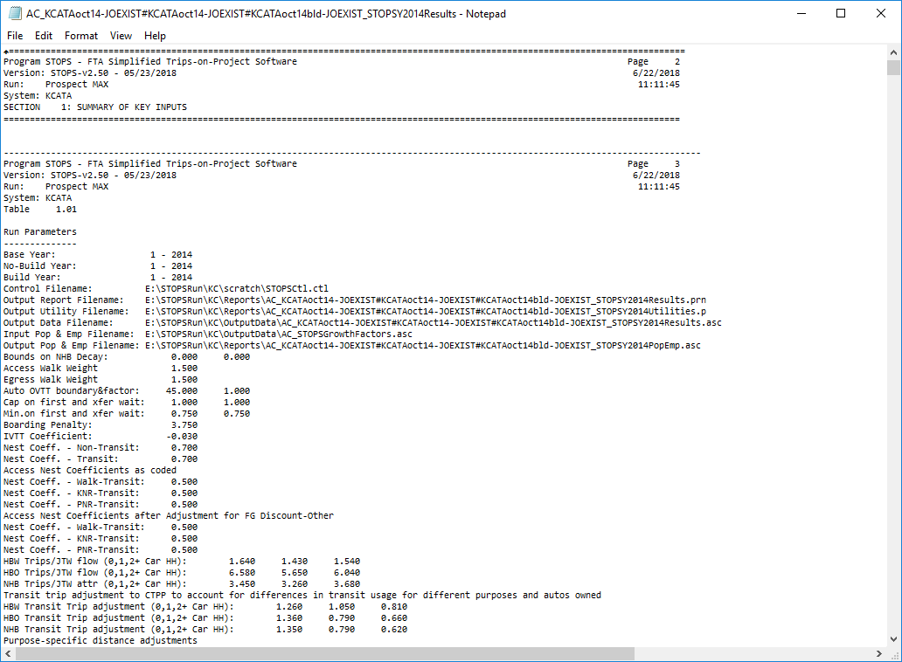

Figure 54. Report Table 1.01 – Run Parameters

### Report Table 1.02 – Station Listing

Table 1.02 contains a summary of the input station information that was used in this this model run (example shown in Figure 55). This table reports the name, station group, counted ridership, station time penalties, and stop_ids for each station in the input station shape file.

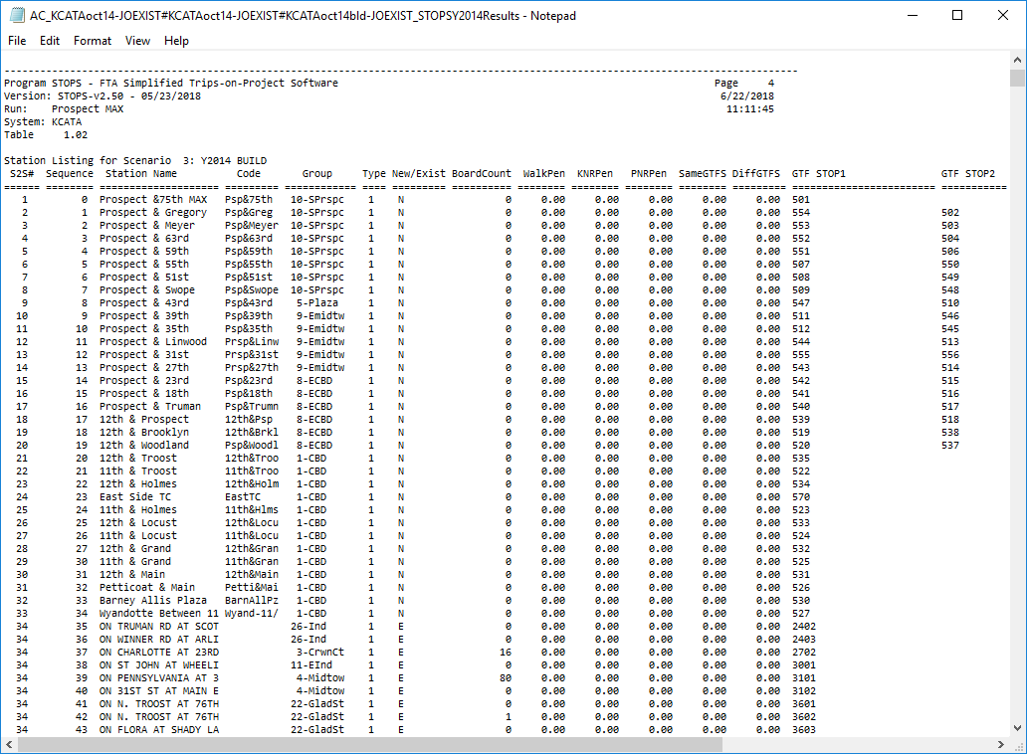

Figure 55. Report Table 1.02 – Station Listing

### Report Table 1.03 – Route Count and Group Information

If the user provided information on counted route ridership, STOPS summarizes these inputs in Table 1.03. An example is presented in Figure 56. Information provided in this report includes the GTFS route_id, the route_name, the group that was assigned to this route for calibration, and the route ridership.

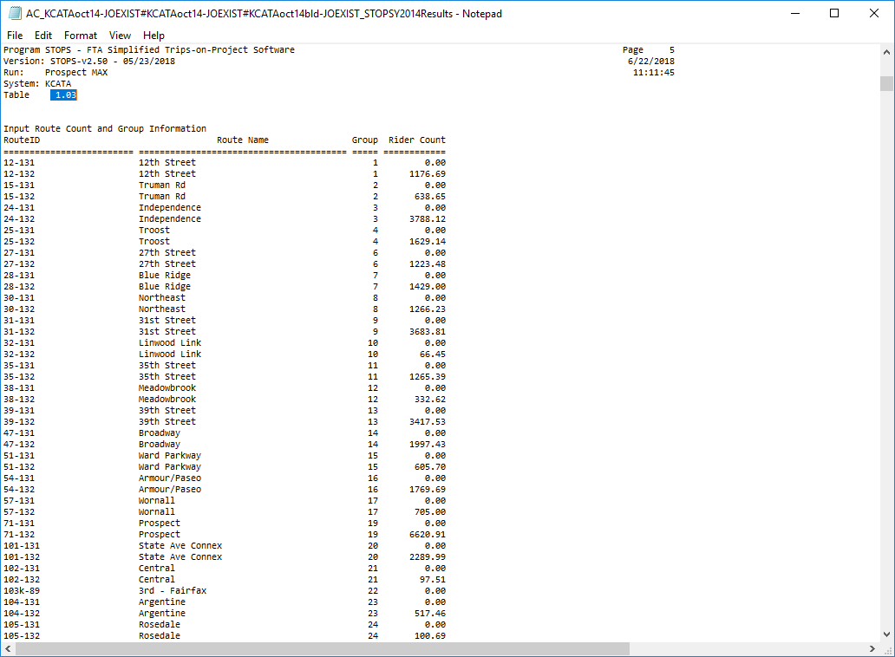

Figure 56. Report Table 1.03 – Route Count and Group Information

### Report Table 1.04 – Assignment of GTFS Route_IDs to Route Groups

If input route information was provided, then Report Table 1.04 summarizes the linkage that STOPS makes between the two input files with route information:

* GTFS trip file. These are the actual routes operated on the calendar day selected for the STOPS analysis. These trips are reported in the transit impedance files used by STOPS to estimate ridership.
* Route count file. This is the information provided by the user and previously summarized in Report Table 1.03.

An example of Report Table 1.04 is shown in Figure 57. When the GTFS Trip File and the Route Count File use consistent route_ids, each route from the trip file is linked to a route from the count file and the sum of the counted ridership matches the number provided in Table 1.03.

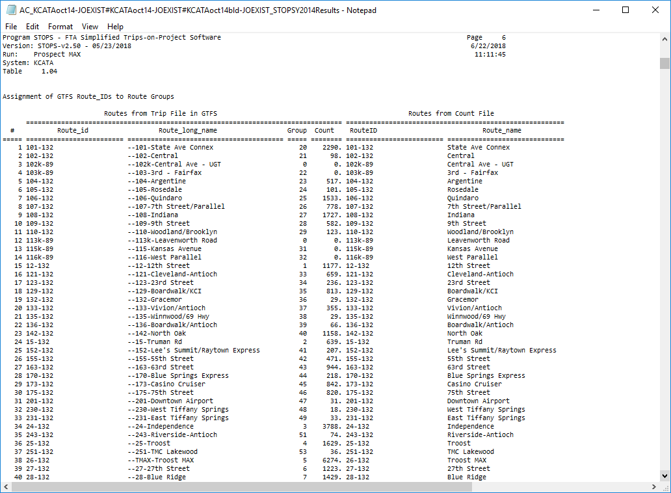

Figure 57. Report Table 1.04 – Assignment of GTFS Route_IDs to Route Groups

## Report Section 2 – Summary of Existing Scenario Results Before Station Group Calibration

Section 2 summarizes STOPS results for the existing scenario before the station group calibration process begins. The information in this section provides an indication of how well STOPS can calibrate itself to local conditions using just CTPP estimates of attraction district transit share, regional unlinked trips, and linked trips by purpose, (if provided). This information can be helpful in determining how well STOPS understands the particular markets being modeled and may provide an indication that additional refinement to the inputs are required before STOPS is used to forecast project ridership.

### Report Table 2.01 – Initial Calibration Statistics

Table 2.01 (see Figure 58) provides a summary of the user-provided HBW linked transit trip targets as compared to estimated CTPP person trip tables (as adjusted by special market/transit trip table inputs). In the event that the user did not provide any estimate of HBW linked trips, STOPS infers the linked HBW trips from total unlinked transit trips using CTPP estimates of the HBW transit mode share.

Next, Table 2.01 presents a district summary of HBW transit and total trip targets for each production and attraction district (bottom section of Figure 58) followed by the results of the district calibration in Figure 59. District calibration results include computed district-level trips and the resulting mode-specific constants.

Trip targets and calibration results for HBO and NHB purposes are also provided.

Since the district level calibration is only one of several calibration steps, these results are preliminary and are only useful for understanding the degree to which the district-level calibration achieved the trip goals. Final trip table information is provided in Sections 3 and higher.

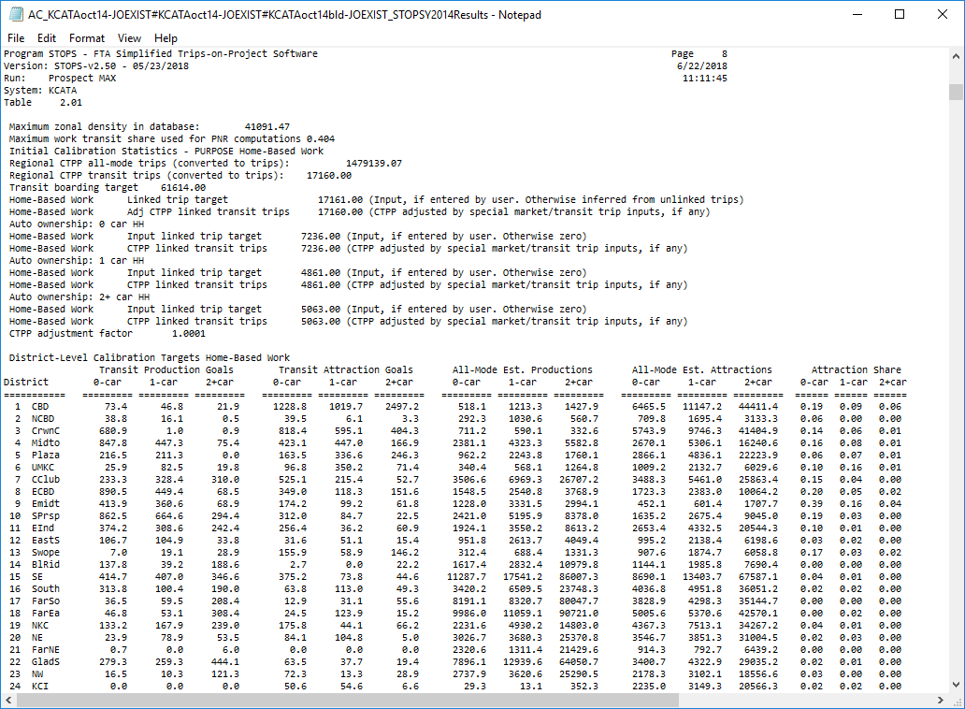

Figure 58. Report Table 2.01 – Initial Calibration Statistics (beginning)

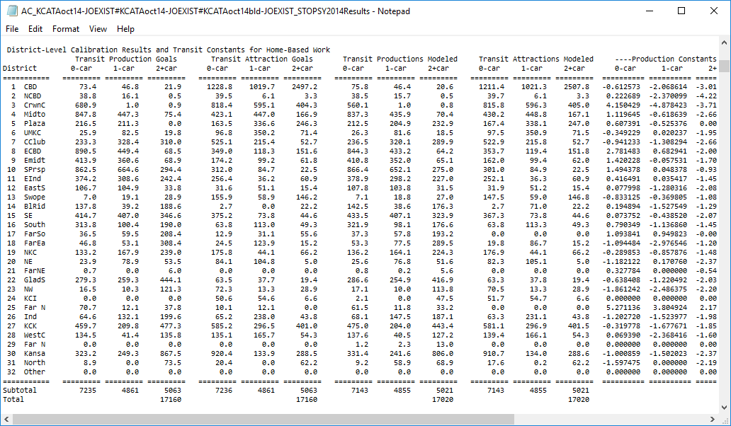

Figure 59. Report Table 2.01 – Initial Calibration Statistics (Continuation)

### Report Tables 2.02 and 2.03 – District - Station Group Results

Table 2.02 (Figure 60), provides a listing of trips by production district and station group. Table 2.03 provides a similar table for trips by attraction district. Together these two tables can be useful in determining the relationship between districts and station groups. If stations and districts are coded with similar geographic definitions, then the majority of trips will appear on the diagonal where the district sequence number equals the station group sequence. If significant numbers of trips are off of this diagonal and if the distance between the districts and groups is large, then either a different district/station group coding convention was used or there is a problem with one or more district or station codes.

***Note***: ***If calibration Types 7 or 8 are selected, Tables 2.02 and 2.03 are repeated 5 more times for each iteration of the district calibration process.***

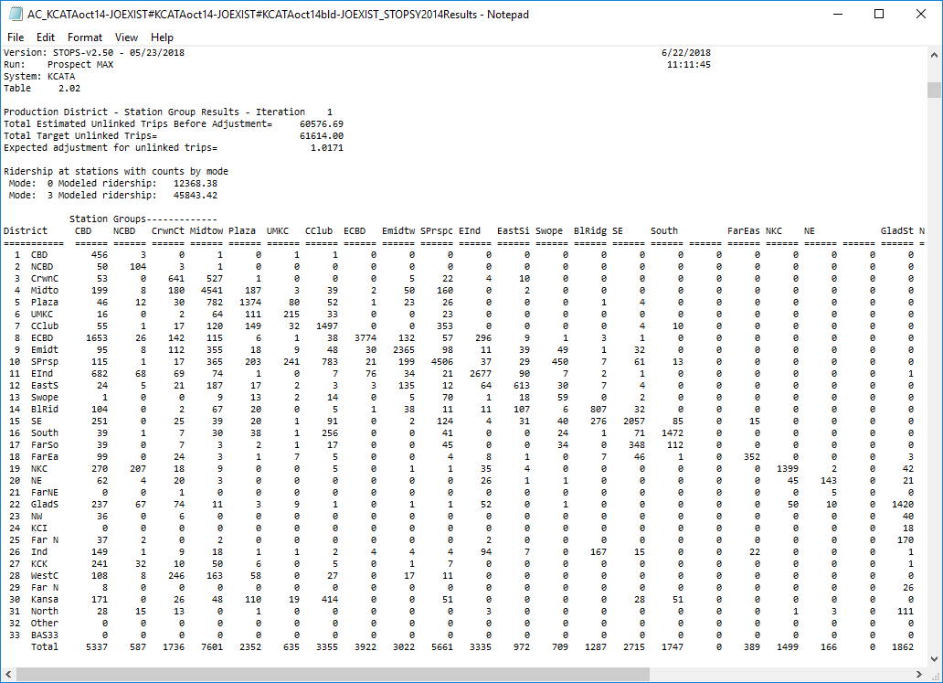

Figure 60. Report Table 2.02 – Production District - Station Group Results

### Report Table 2.04 – Station Group Boardings Prior to Adjustment

Table 2.04[30] is shown in Figure 61 and presents the station group-to-station group ridership for the existing scenario and current year prior to group calibration. The table should be carefully reviewed by the user to confirm that STOPS has a good initial understanding of the ridership market for the project corridor and to confirm that there are no obvious errors in the input information supplied to STOPS.

This table shows station group-to-station group ridership and sums the STOPS estimate in the row and column labeled “TOTAL”. For use in assessing the reasonableness of this total, the total counted station group ridership (coded by the user in the station file) is shown in the row and column labeled “COUNT”. STOPS also shows the calibration target for the station group calibration in the row and column labeled “GOAL”. Generally, the count and the goal are equal except in cases where a station has a missing count denoted in the station file with a ridership value less than zero. When this happens, STOPS increases the ridership for this station group by the amount of pre-calibration ridership for that station so that the remaining stations will calibrate to the correct values.

One important use of Table 2.04 is to compare the initial pre-station group calibration results shown in the “TOTAL” row of Table 2.04 to the user-provided counts shown in the “COUNTS” and “GOAL” rows to confirm that the model appears to reflect the same patterns as the counts. This review should focus on big picture observations (i.e., does the largest modeled ridership occur in the same groups that have the largest counts) rather than a strict review of percentage differences.

As shown in the Kansas City example, the model properly represents the fact that the CBD is, by far, the most important attraction location and other major attraction locations include Midtown, Crown Center, and East Country Club. The East Midtown attraction group is lower than is desirable and might deserve additional review. Nevertheless, all areas have sufficient numbers of transit trips so that the last calibration step can correct volumes to match route and/or station group counts.

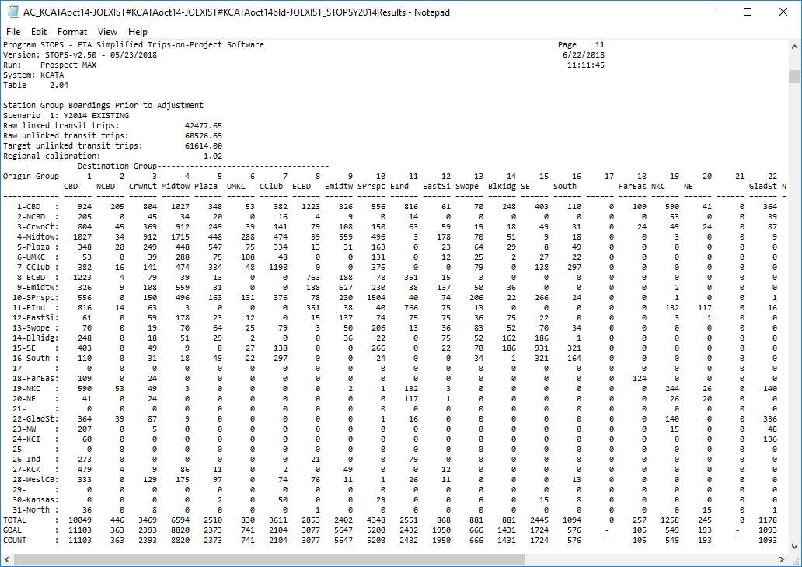

Figure 61. Report Table 2.04 – Station Group Boardings Prior to Station or Route Adjustment

### Report Table 2.05 – Station Group Factors

Table 2.05 shows the station group-to-station group adjustment factors that are computed during the station group calibration process. These factors show the results of an Iterative Proportional Factoring (IPF) process in which the station group-to-station group table shown in Table 2.04 are balanced to the station group goals. Table 2.05 presents the ratio of the factored estimate of ridership to the original values of station group ridership presented in Table 2.04. An example of Table 2.05 is presented in Figure 62. Factors close to 1.0 indicate that the station group calibration process is relatively modest. Factors greater than 2.0 or less than 0.5 indicate that more significant adjustments are required. Users should review these cases to determine whether all input information is being properly interpreted by STOPS and whether additional adjustments are required.

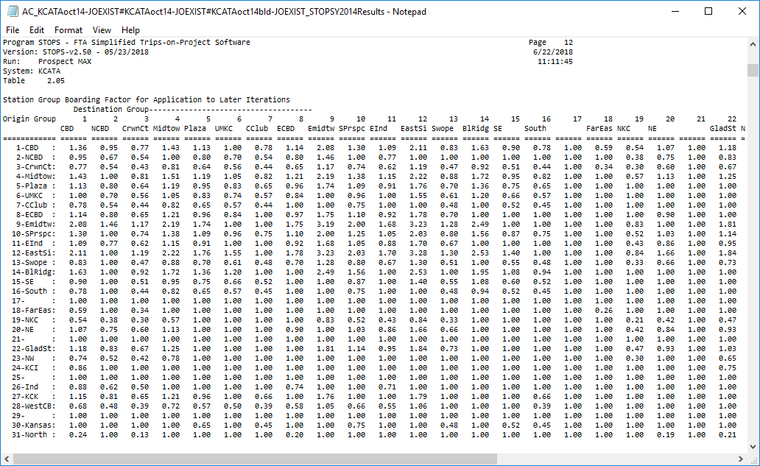

Figure 62. Report Table 2.05 – Station Group Boarding Factors

Two calibration methodologies (Type 6 and 9) also use these factors in adjusting all STOPS outputs.

Calibration Type 6, computes station group-to-station group factors for each zone-to-zone interchange for each access mode (walk, KNR, and PNR) and each transit path type (fixed guideway only, bus only and all transit). These factors are fixed as constant and used to adjust all output transit trip estimates for the existing, no-build, and build case. This calibration technique is currently obsolete and should only be used to maintain consistency with prior STOPS runs.

Calibration Type 9 is similar in operation to Type 6 except that the factors are not fixed for each zone-to-zone interchange and, instead, change for the no-build and build alternatives depending on the station groups used in each scenario. Calibration Type 9 is also obsolete and should only be used to maintain consistency with prior STOPS runs.

If calibration types 10, 11, or 12 are used, then the station calibration process is discussed below in Report Tables 2.07 and 2.08.

### Report Table 2.06 – Listing of Stop_IDs Not Found in Station File

Table 2.06 presents a list of all stop_ids that are present in the GTFS schedule files and appear in the transit paths that are read by STOPS, but were *not* found in the station file[31]. Figure 63 presents a sample report for Kansas City. In this example, APC counts were not available for The Jo, so many of the missing stop_ids are bus stops for that system (any stop with the “&J” suffix). A few KCATA stop_ids are also shown. These are stops which KCATA counted as individual stations but later consolidated into a single bus stop. An example of a consolidated bus stop is “11002_merged_71000178”. The list presented in Table 2.06 should be carefully reviewed and any station for which APC counts are available should be added to the station file. If the station file is updated to add missing stop_ids and no other changes are made, then the STOPS step can be re-run without running any other data preparation or batch step.

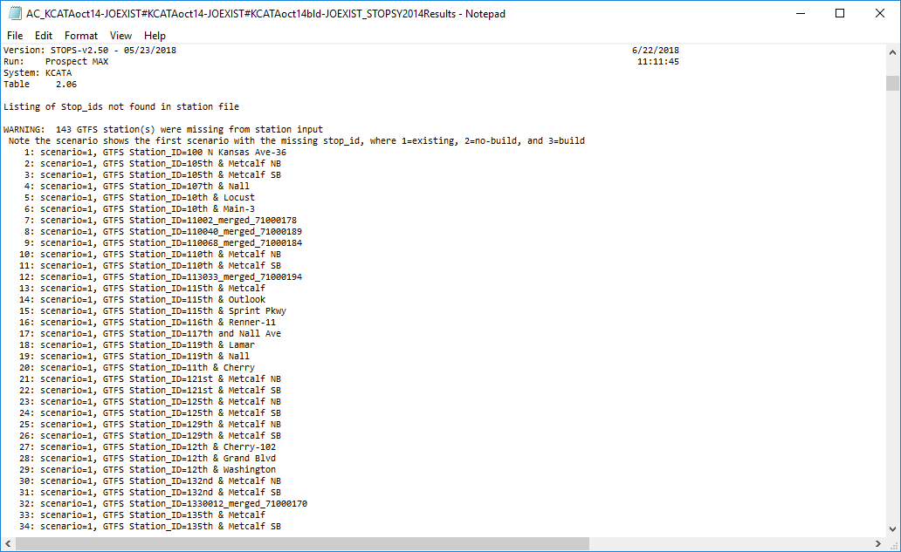

Figure 63. Report Table 2.06 – Listing of Stop_IDs Not Found in Station File

### Report Table 2.07 – Type 10/12 Group-Level Calibration Summary – Stations/Stops

When calibration type 10 or 12 is selected, Report Table 2.07 presents a summary of the process that adjusts person trips so that modeled stop group ridership matches counted stop group ridership. Figure 64 presents an example of Table 2.07 that shows the initial STOPS estimate of pre-group calibration ridership, the station/stop group counts, the target ridership for the group[32], and the resulting post-group calibration estimate of ridership.

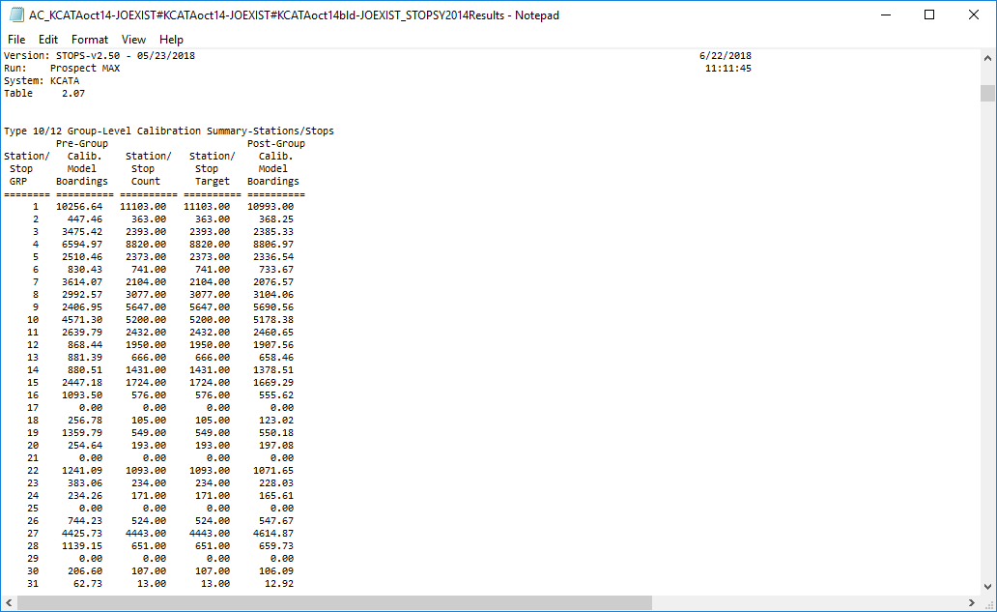

Figure 64. Report Table 2.07 – Group Calibration Summary-Stations/Stops

### Report Table 2.08 – Type 10/12 Group-Level Calibration Summary – Routes

When calibration type 11 or 12 is selected, Report Table 2.08 presents a summary of the process that adjusts person trips so that modeled route group ridership matches counted route group ridership. Figure 65 presents an example of Table 2.08 that shows in initial estimate of pre-group calibration ridership, the route group counts, the target ridership for the route group, and the resulting post-group calibration estimate of ridership.

This report summarizes the initial boardings, the count, the target and the resulting calibrated estimate of ridership by route.

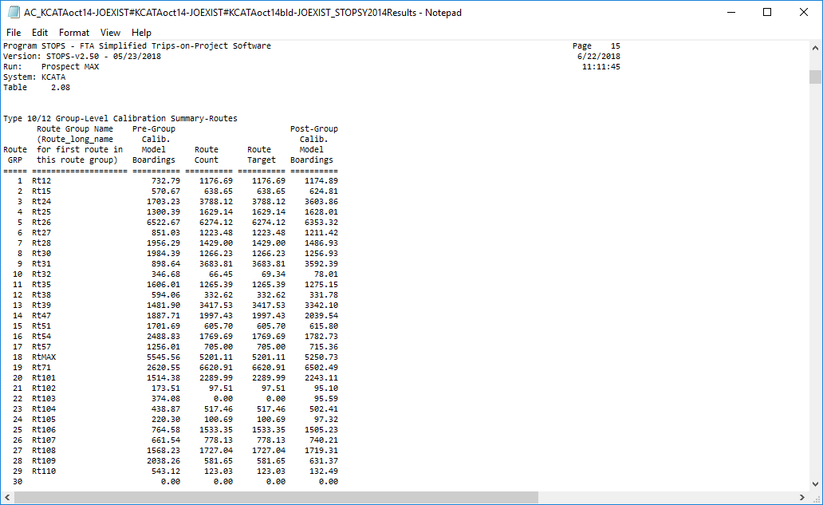

Figure 65. Report Table 2.08 – Group Calibration Summary-Routes

## Report Section 3 – Summary of Station Group Calibration Results

Section 3 summarizes the results of the station group calibration process and its effects on the final estimate of ridership for three cases: the existing, no-build, and build scenarios.

### Report Tables 3.01, 3.02, and 3.03 – Linked Trips and Group-to-Group Ridership for Each Scenario

Tables 3.01, 3.02, and 3.03 (Figure 66, Figure 67, and Figure 68) show the final estimate of regional linked trips, unlinked trips, and group-to-group ridership for the existing, no-build, and build scenarios. In the Kansas City example, the regional transit system serves 43,618 daily linked transit trips in both the existing and no-build cases. These trips result in 62,688 daily transit boardings (unlinked trips).

The linked and unlinked trip estimates are the same for the existing and no-build scenarios because:

* + - * 1. This particular report shows results for the current year for all alternatives. A different forecast year can be selected with the year radio buttons on the main menu. If the year is changed, the user need only re-run the last two batch steps (Prepare Forecast Years and STOPS) to generate a revised forecast. If this is done, then the no-build will reflect the new forecast year. The existing scenario is always linked to the current year.
        2. In the Kansas City example, the no-build scenario is identical to the existing scenario.

The build scenario shows growth in both statistics as compared to the no-build (or existing) case. The build scenario serves 44,190 linked trips and attracts 63,466 daily boardings. These tables also show growth in alightings (the column totals) in the project corridor including CBD, East CBD, and East Midtown station groups. Alightings in some parallel areas decline slightly as the project redirects trips to the project corridor.

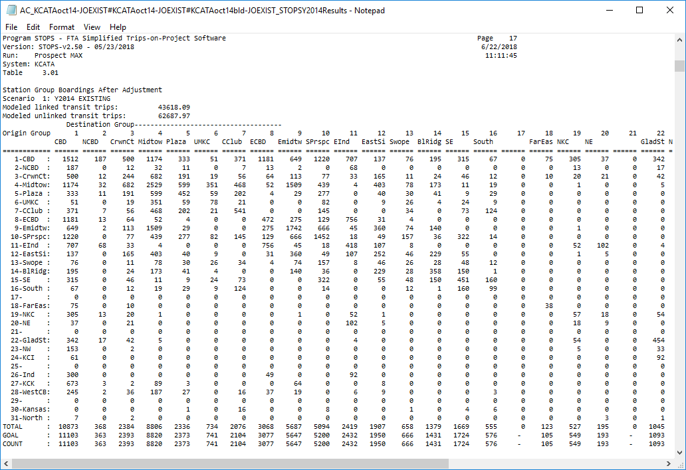

Figure 66. Report Table 3.01 – Station Group Boardings After Adjustment - Existing Scenario

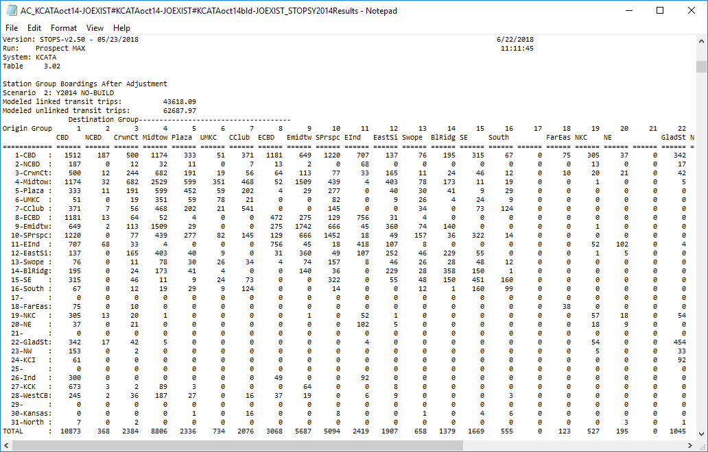

Figure 67. Report Table 3.02 – Station Group Boardings After Adjustment - No-Build Scenario

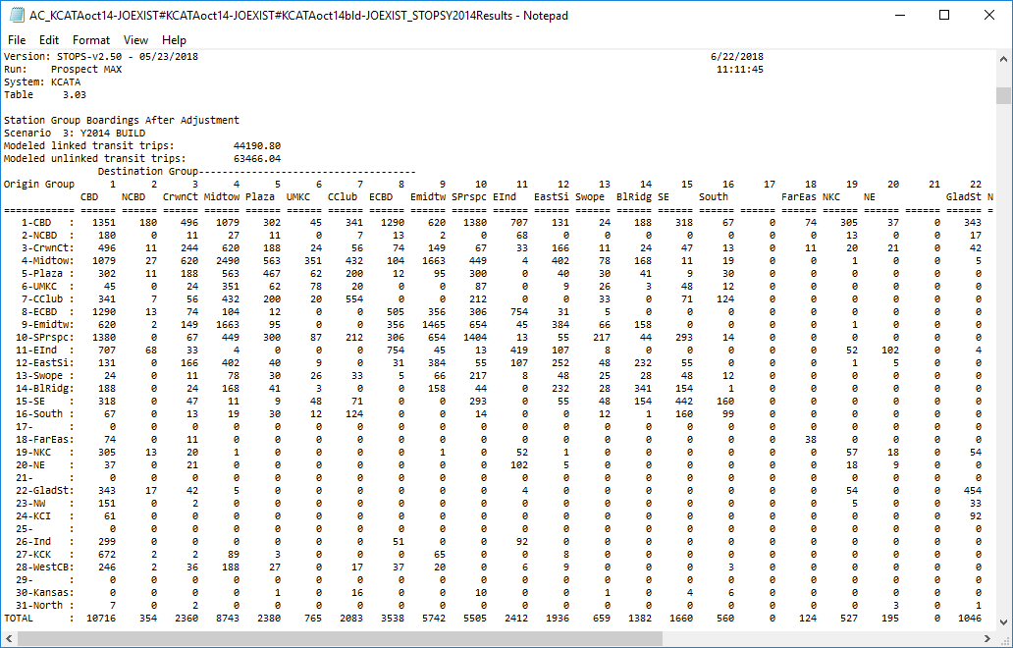

Figure 68. Report Table 3.03 – Station Group Boardings After Adjustment - Build Scenario

### Report Tables 3.04, 3.05, 3.06 and 3.07 – Review of Impact of Station Group Factoring on Build Scenario Trips and Project Linked Trips

This section presents a series of 4 reports that, together, illustrate the impact that station group factoring had on build scenario and project ridership. The following tables are presented:

* Table 3.04 – Group-to-Group Unlinked Transit Trips for Build Scenario. Example shown in Figure 69 and Figure 70 (left and right side of the table, respectively). This table is similar to Table 3.03 but formatted and aggregated like tables 3.05, 3.06, and 3.07 for easier comparison)
* Table 3.05 – Group-to-Group Build Unlinked Transit Trips (Trips added by Group Factors). Example shown in Figure 71 and Figure 72 (left and right side of the table, respectively).
* Table 3.06 – Group-to-Group Project Unlinked Transit Trips. Example shown in Figure 73 and Figure 74 (left and right side of the table, respectively).
* Table 3.07 – Station-to-Station Project Unlinked Transit Trips (Trips added by Group Factors). Example shown in Figure 75 and Figure 76 (left and right side of the table, respectively).

Together these tables show that in the build scenario in 2015, transit stop_ids included in the station database will attract a total of 58,885 transit boardings (Table 3.04). Of this amount, 2,497 are the result of station or route count factoring as shown in Table 3.05.

Of greater interest is the fact that project trips will account for 9,180 transit boardings on all services[33] as shown in Table 3.06. Of this amount, 4,106 are the result of station and route factors. This relatively high proportion indicates the need to carefully review all inputs and output results to confirm the proper operation of the model. In this case, the route that most nearly matches the proposed BRT route is the #71 Prospect route. This route was assigned to Route Group 19 which had a pre-calibration ridership of 2,621 compared to a count of 6,621 (see Report Table 2.08). The route calibration process corrected this substantial underestimate and results in modeled ridership on Route #71 of 6,502.

The heavy adjustment that was required to match #71 ridership, appears also to be needed to properly estimate BRT ridership on the same street. After confirming the fact that STOPS was properly configured and the input data is correct, it appears that this adjustment is an important part of estimating ridership for the proposed BRT.

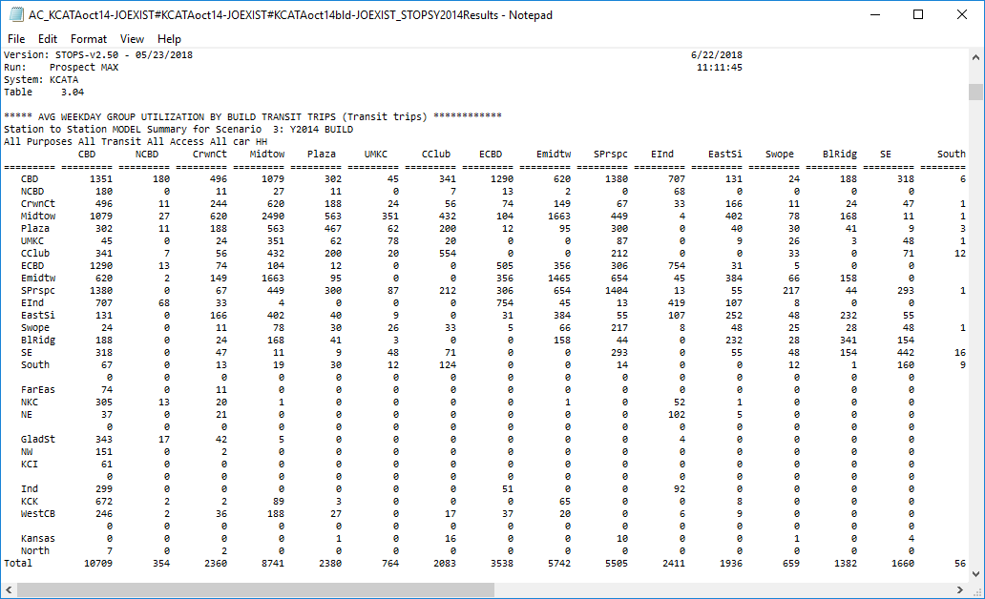

Figure 69. Report Table 3.04 – Station Group Utilization for Build Scenario (Left Side)

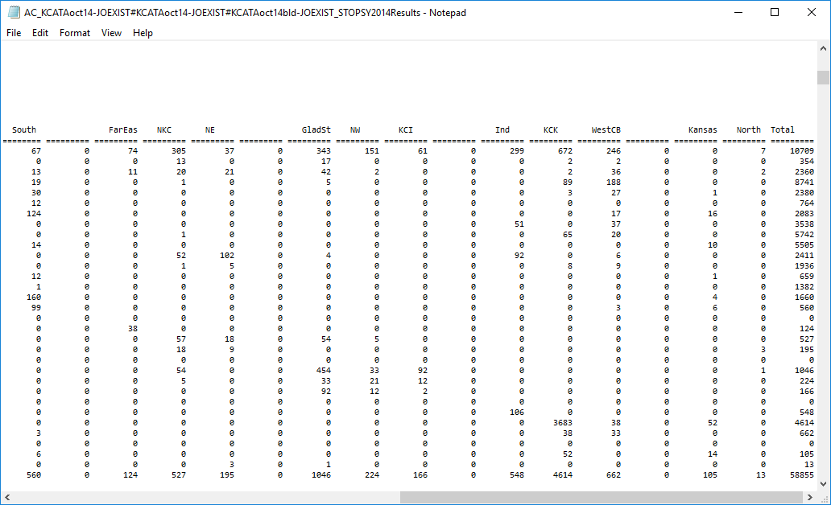

Figure 70. Report Table 3.04 – Station Group Utilization for Build Scenario (Right Side)

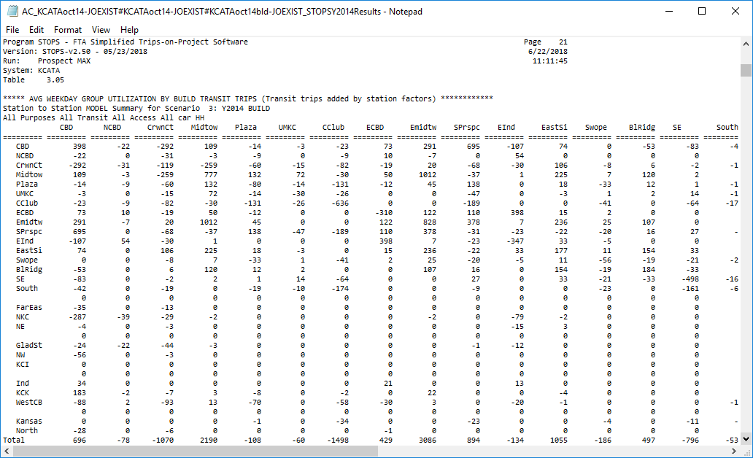

Figure 71. Report Table 3.05 – Station Group Utilization Added by Station Group Factors for Build Scenario (Left Side)

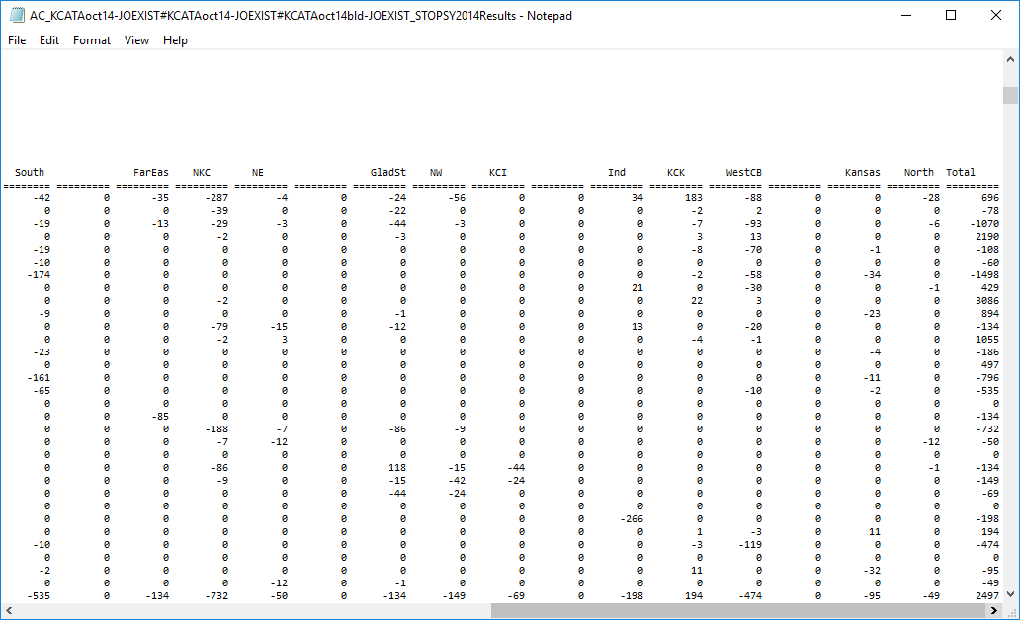

Figure 72. Report Table 3.05 – Station Group Utilization Added by Station Group Factors for Build Scenario (Right Side)

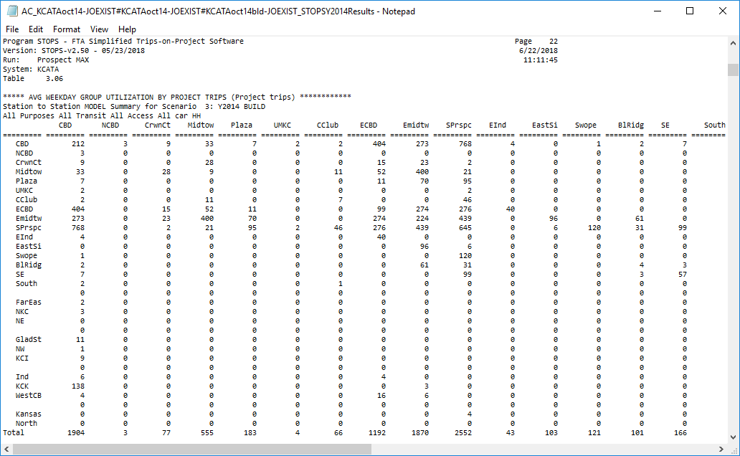

Figure 73. Report Table 3.06 – Group Utilization by Project Trips (Left Side)

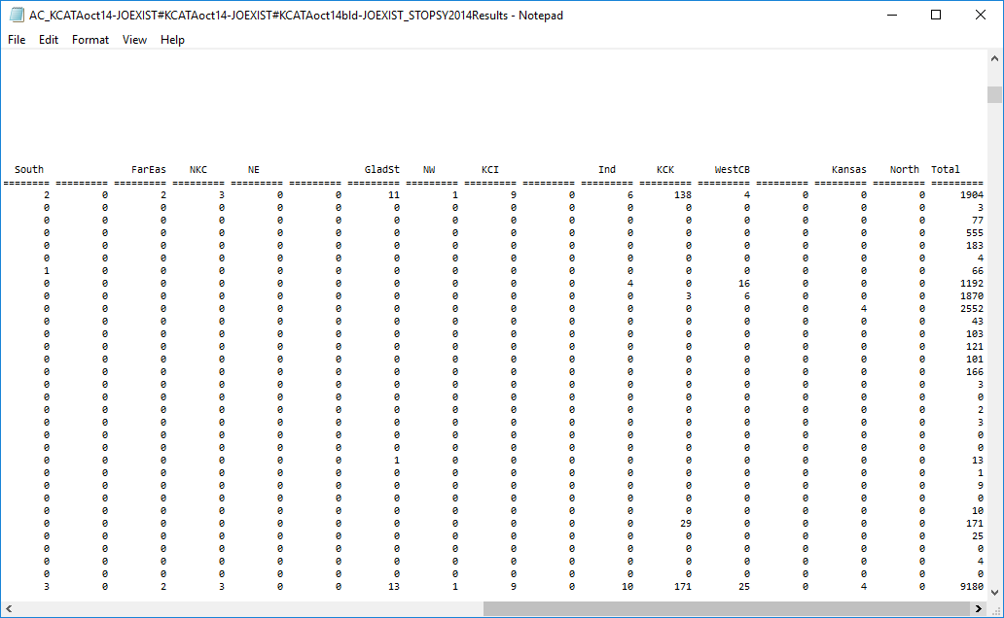

Figure 74. Report Table 3.06 – Group Utilization by Project Trips (Right Side)

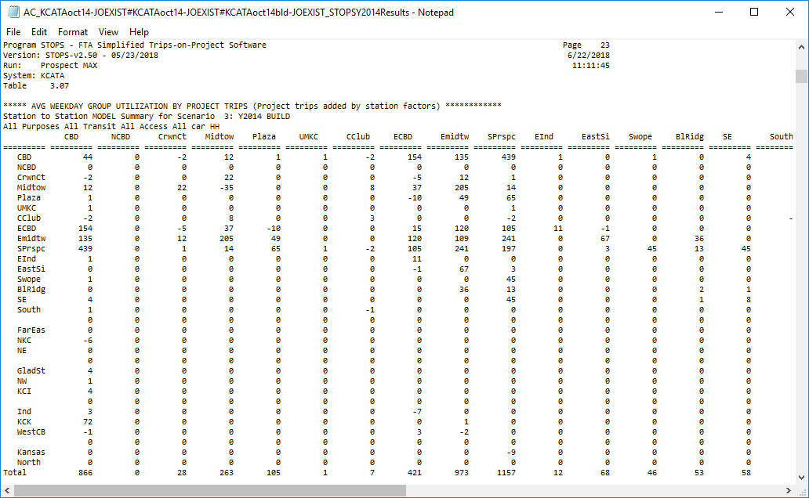

Figure 75. Report Table 3.07 – Group Utilization by Project Trips Added By Station Factors (Left Side)

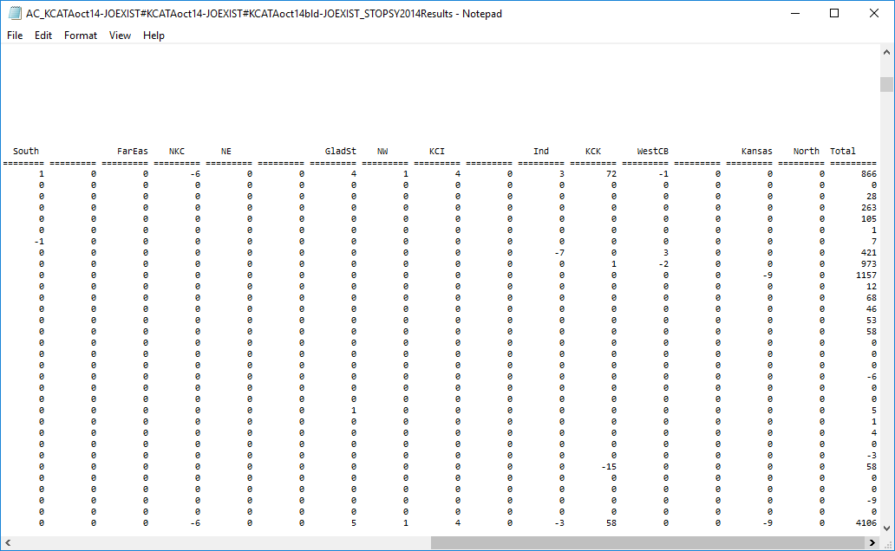

Figure 76. Report Table 3.07 – Group Utilization by Project Trips Added By Station Factors (Right Side)

## Report Section 4 – Summary of Project Results for All Trip Types

Section 4 of the report presents the trips on the project made by travelers from all household types using all modes of transit. Table 4.01 (Figure 77 and Figure 78) presents district-to-district flows (in production/attraction format) for all transit trips in the Build scenario in the forecast year. In this example, the Kansas City Transit system will attract 44,191 daily linked transit trips in the build alternative. This total is the same (within the limits of rounding) as reported at the top of Table 3.03[34].

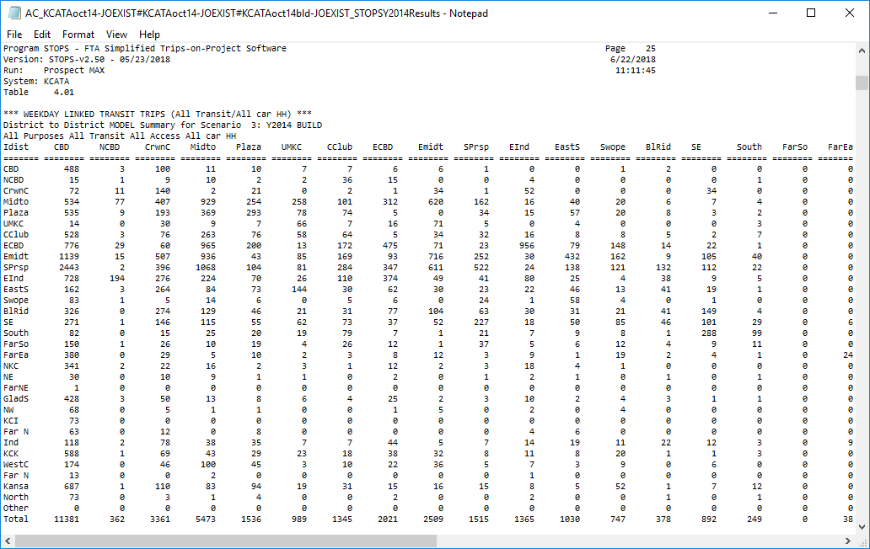

Figure 77. Report Table 4.01 – Linked Transit Trips (All Auto Ownership Levels) For Build Scenario (Left Side)

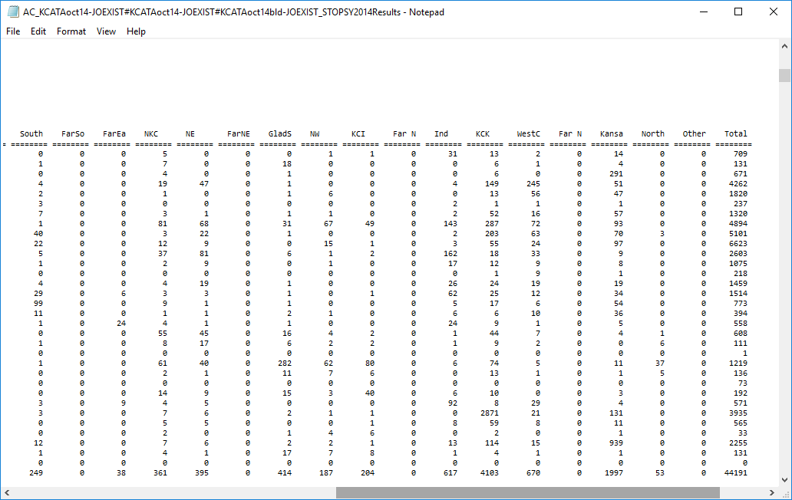

Figure 78. Report Table 4.01 – Linked Transit Trips (All Auto Ownership Levels) For Build Scenario (Right Side)

Table 4.02 presents the number of incremental linked transit trips (build – no-build). As shown in Figure 79 and Figure 80 the project results in 573 additional linked transit trips.

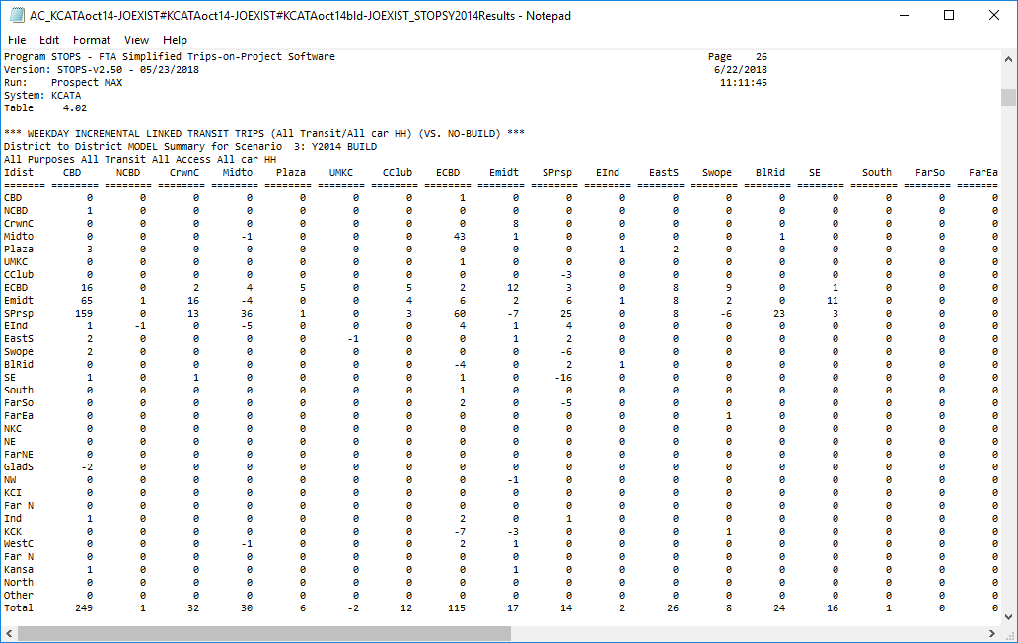

Figure 79. Report Table 4.02 – Incremental Linked Transit Trips (All Auto Ownership Levels) For Build Scenario (Left Side)

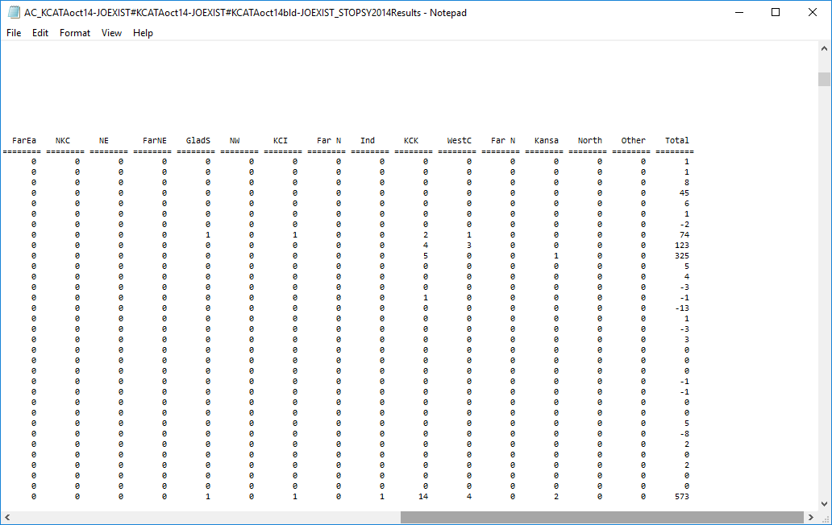

Figure 80. Report Table 4.02 – Incremental Linked Transit Trips (All Auto Ownership Levels) For Build Scenario (Right Side)

Table 4.03 presents the district-to-district linked transit flows for just those trips that use the project at some point during the journey. As shown in the example in Figure 81 and Figure 82, the Kansas City BRT is expected to attract 5,862 linked project trips. Major attraction locations include the Kansas City CBD (District 1), and other districts near the CBD such as Midtown, the East CBD, East Midtown, and South Prospect.

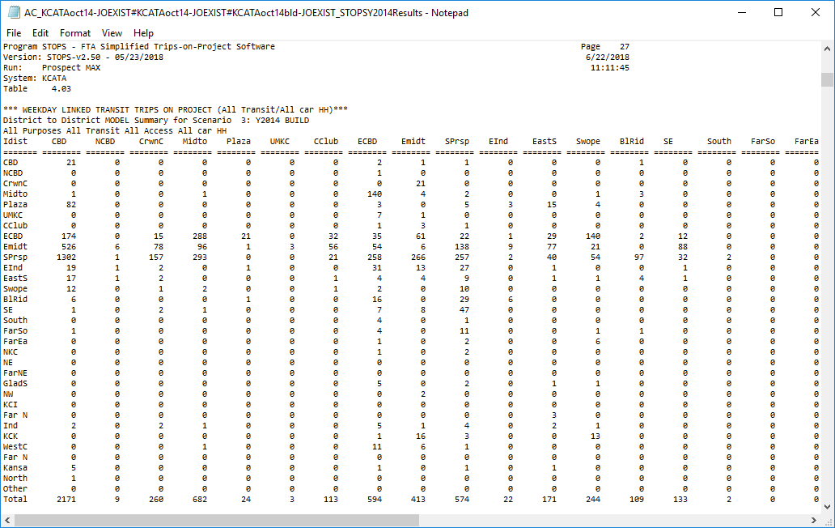

Figure 81. Report Table 4.03 – Linked District-to-District Project Trips (All Auto Ownership Levels) (Left Side)

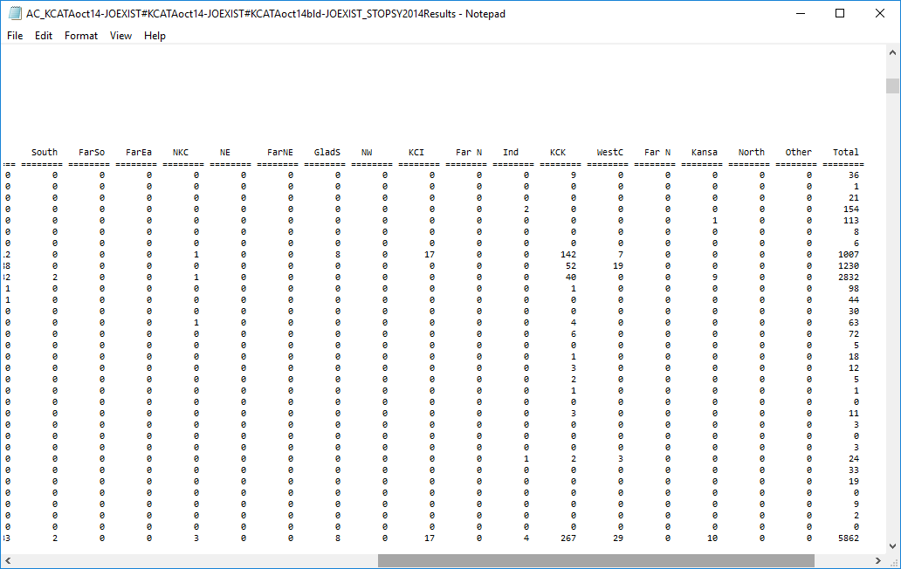

Figure 82. Report Table 4.03 – Linked District-to-District Project Trips (All Auto Ownership Levels) (Right Side)

The next table, (Table 4.04 shown in Figure 83) shows the origin (boarding) and destination (alighting) station for project trips. This report includes just stations for which Newstation is set to 1 or above. In the Kansas City example, the all project stations were set with a Newstation of 1. All other stations are set with a New Station of 0. This coding, which is typical practice, results in a table which sums to total project ridership.

In some cases, users may wish to see how project riders connect to other transit stations in the system. This can be accomplished by setting Newstation equal to 4 for those other stations. When this is done, the sum of all boardings and alightings in this table will equal project linked trips, plus all transfers made by project riders to the other transit stops included in the list.

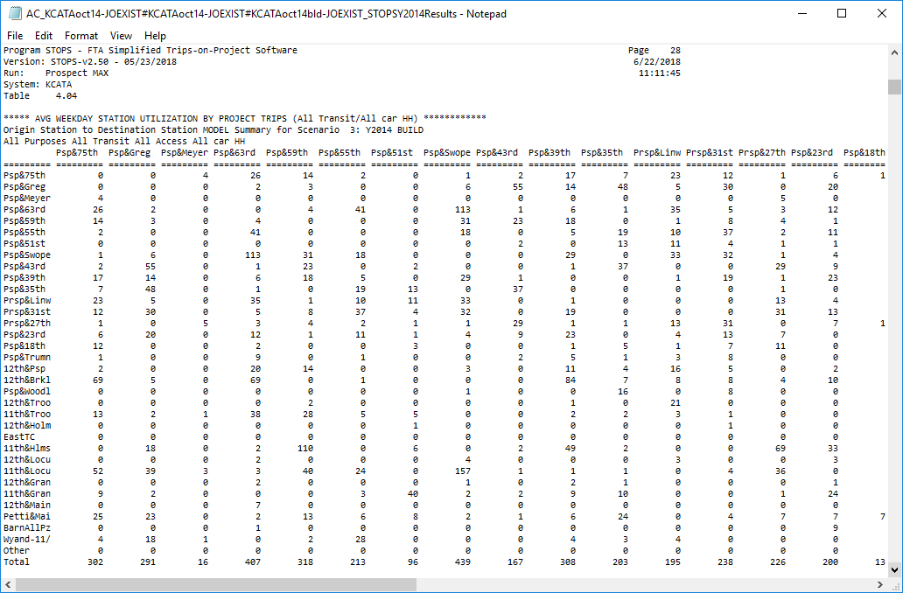

Figure 83. Report Table 4.04 – Origin Station to Destination Station Project Trips

## Report Section 5 – Summary of Project Results for Fixed Guideway Trips

Section 5 repeats the tables in Section 4 but includes just those trips that are attracted to the fixed guideway portion of the system.

## Report Section 6 – Summary of Project Results for Members of 0-Car Households

Section 6 repeats the tables in Section 4 but includes just those that are made by members of 0-car households only.

## Report Section 7 – Summary of Project Results for Fixed Guideway Trips Made by Members of 0-Car Households

Section 7 repeats the tables in Section 4 but includes just those that are made on fixed guideway modes by members of 0-car households only.

## Section 8 – Summary of Impacts on Automobile Person Miles of Travel

Section 8 summarizes the impact of the transit project on automobile person miles of travel. This section has just one table, 8.01 (see Figure 84), which presents the incremental (build minus no-build) estimate of automobile person miles of travel that are a result of the project. These results are displayed on a district-to-district (production/attraction) basis. This statistic can be converted to vehicle miles of travel saved by the project by using locally-derived estimates of vehicle occupancy to convert person miles to vehicle miles.

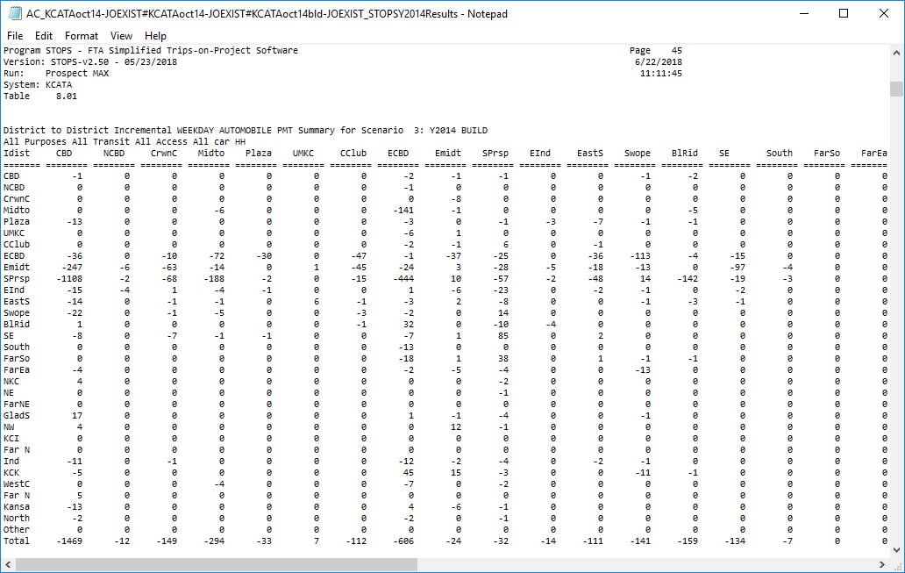

Figure 84. Report Table 8.01 – Incremental Automobile PMT

## Report Section 9 – Comparison of Existing, No-Build and Build Station Boardings by Station Mode of Access

Section 9 of the report presents a side-by-side comparison of station boardings stratified by mode of access. This section has one table, 9.01 (shown in Figure 85), which shows the station boardings by mode of access for each station in the station database. Boardings are shown for the existing, no-build, and build scenarios.

This table represents the mode-of-access for trips boarding at each particular station[35]. A similar number of trips will alight at each station over the course of a day and use a similar mode-of-egress to reach their destination. Because this table represents boardings, the estimates of PNR trips are similar to the number of vehicles entering the station complex each day seeking a parking place. This estimate needs only to be adjusted for vehicle occupancy and parking turnover to estimate the necessary number of spaces required at the station to meet the parking demand.

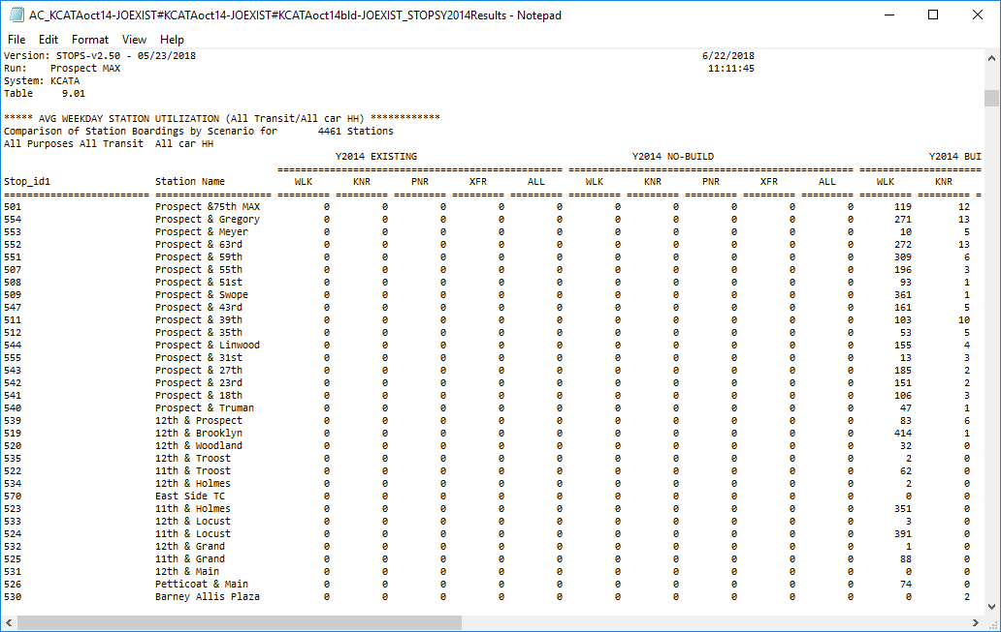

Figure 85. Report Table 9.01 – Station Boardings by Mode of Access for Existing, No-Build, and Build Scenarios

## Report Section 10 – Comparison of Existing, No-Build and Build Route Boardings by Route Mode of Access

Section 10 begins with two tables (10.01 and 10.02) which shows usage of each route by production-end mode of access.[36] Table 10.01 (shown in Figure 86) presents a condensed table with one line in the report for each route. Table 10.02 presents an expanded table with routes broken out by station groups so that the contribution of each station group to each route can be understood.

Tables 10.03 and 10.04 summarize route-level operating statistics (revenue vehicle miles and vehicle hours) by alternative and analysis time period.

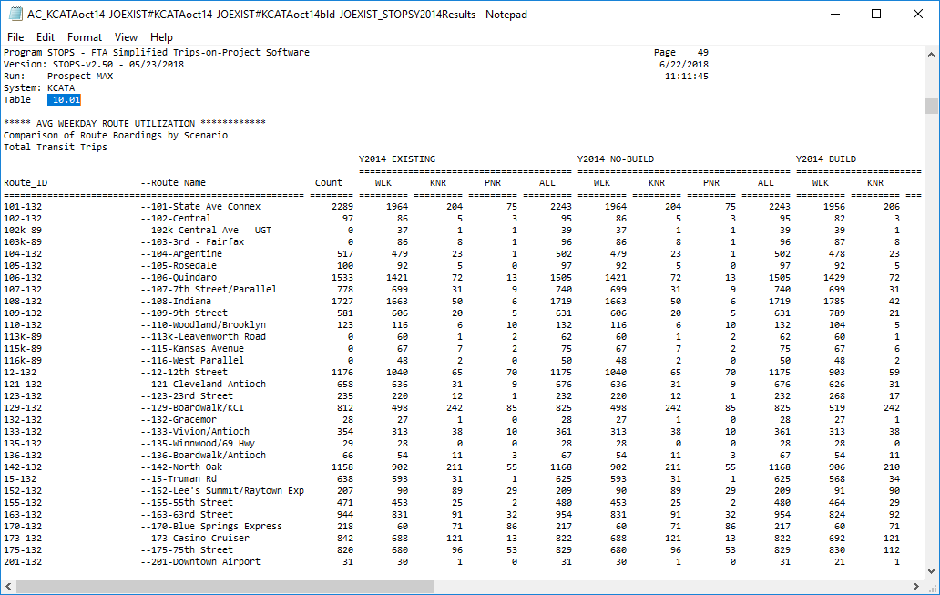

Figure 86. Report Table 10.01 – Comparison of Route Ridership by Scenario and Mode of Access

## Report Section 11 – Summary of Trips by Submode, Access Mode, Auto Ownership, and Scenario

Section 11 presents a summary of linked transit trips by submode, access mode and auto ownership for each scenario (existing, no-build, and build) and for build trips that are identified as linked trips using the project. Four tables are provided:

* Table 11.01: home-based work trips (sample shown in Figure 87)
* Table 11.02: home-based other trips
* Table 11.03: non-home based trips
* Table 11.04: all-purpose trips

All model results (including access mode) are presented in production/attraction format.

Linked trips are reported in separate columns for the existing, no-build, and build scenarios. The last column group reports project trips which are defined as any build trips boarding, alighting, or passing through[37] a new station.

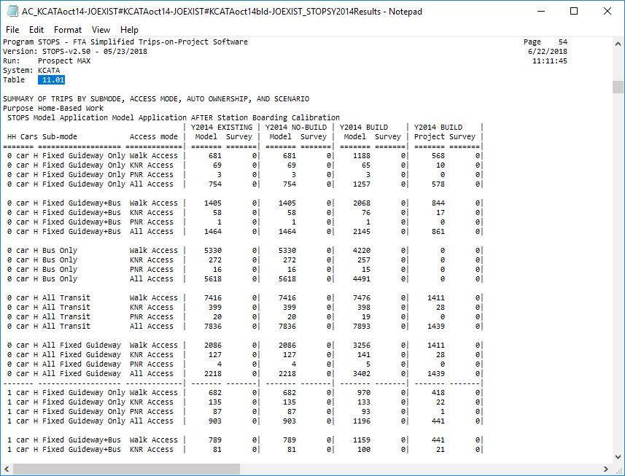

Figure 87. Report Table 11.01 – Summary of Linked Transit Trips by Submode, Access Mode, Auto Ownership, and Scenario

## Report Section 12 – Summary of CTPP Workers and Employees and MPO Estimates of Population and Employment by Scenario

Section 12 has one table, 12.01 (shown in Figure 88), which presents a district-level summary of the CTPP and the population and employment projections that were used to grow the CTPP to represent current and horizon years. The CTPP columns report the workers (the number of employed persons living in each district) and employment (employed persons working in each district). The MPO columns report the CTPP year (2008 or 2000, depending on CTPP version) estimates of population and employment and also show the estimates/forecasts for the existing, no-build, and build scenarios that were used to create the demand tables for each scenario.

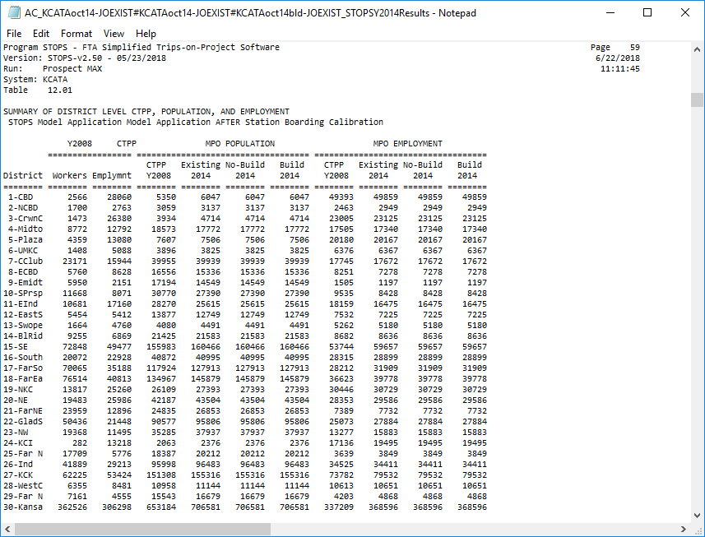

Figure 88. Report Table 12.01 – Summary of District Level CTPP, Population, and Employment

## Report Section 13 – Summary of Highway Time, Distance and Speed

Section 13 reports highway times, distances and speeds for each district-to-district pair. The following tables are provided:

* Table 13.01 – Existing scenario, district-to-district highway time (in minutes)
* Table 13.02 – No-build scenario, district-to-district highway time (in minutes)
* Table 13.03 – Build scenario, district-to-district highway time (in minutes)
* Table 13.04 – Existing scenario, district-to-district highway distance (miles)
* Table 13.05 – No-Build scenario, district-to-district highway distance (miles)
* Table 13.06 – Build scenario, district-to-district highway distance (miles)
* Table 13.07 – Existing scenario, district-to-district highway speed (mph)
* Table 13.08 – No-Build scenario, district-to-district highway speed (mph)
* Table 13.09 – Build scenario, district-to-district highway speed (mph)

A sample report (existing scenario highway time) is shown in Figure 89.

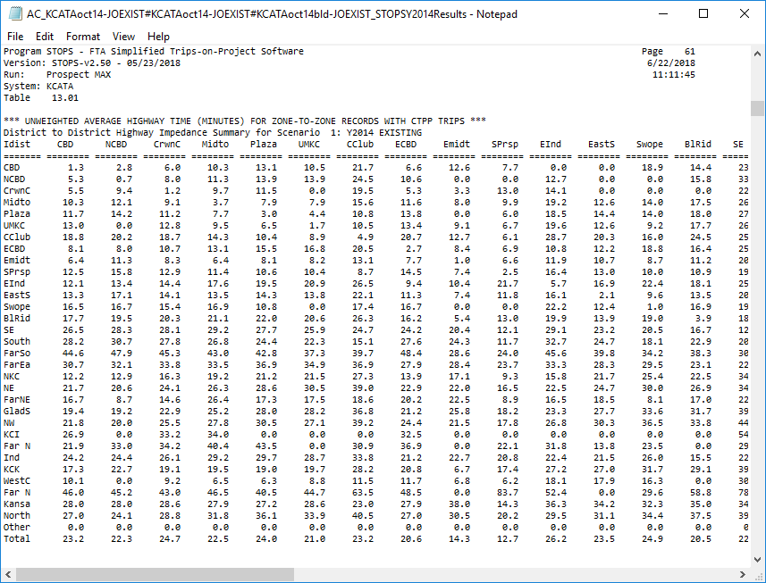

Figure 89. Report Table 13.01 – Average District-to-District Highway Time for Existing Scenario

## Report Section 14 – District-to-District Analysis of Gains and Losses Between No-Build and Build

Section 14 provides a number of tables that help the user understand the degree to which the project appears to change the level of transit coverage or reduce service to existing customers. Each table shows linked transit trips on a district-to-district basis. The following tables are provided:

* Table 14.01. Build Walk Access Transit Trips on Interchanges with Significant Transit Gain (>5%) and Zero No-Build trips. This table shows the number of build transit trips occurring in situations where no one uses transit in the no-build (presumably because no transit is provided). The presence of trips in this category suggests a change in transit service coverage has occurred.
* Table 14.02. Build Walk Linked Transit Trips on Interchanges with Significant Transit Gain (>5%) and Non-Zero No-Build trips. This table is the shows cases where transit grows significantly off of a non-zero base. Generally, trips in this table will be located in geographic proximity to the project or other service enhancements. If not, this table may help the user understand where unintended changes were made to the transit system.
* Table 14.03 Build Walk Access Linked Transit Trips on Interchanges with Significant Transit Loss (>5%). This table shows the number of build trips occurring in places where the number of transit linked trips declines between the no-build and build scenarios.
* Table 14.04 Build Walk Access Linked Transit Trips on Interchanges with no-significant change in transit. This table shows the remaining linked transit trips in the build alternative for cases where the project had little impact on ridership.
* Tables 14.05 through 14.08 repeat Tables 14.01-14.04 but shows no-build trips in the same categories.

These eight tables are repeated in Tables 14.09-14.16 for KNR trips, in Tables 14.17-14.24 for PNR trips, and 14.25-14.32 for All Access Mode trips.

## Report Section 15 – Detailed District-to-District Linked Trips and Selected Station-to-Station Flows

Section 15 provides a complete set of district-to-district linked trips for each combination of scenario, access mode, auto ownership, trip purpose, and submode. The index provided at the top of the report provides the table number for each condition. For some cases, station-to-station or project trips are also reported.

This page left intentionally blank

# Mapping Results

STOPS includes the capability to map many of the results generated by the demand and path-finding models. This option is selected by clicking on “13. Map STOPS Results”. When this is done, the dialog shown in Figure 90 appears. The program allows the user to select what types of trips to map including:

* Transit sub-modes. Fixed guideway only, fixed guideway and bus, bus only and all (default).
* Transit access modes. Walk, kiss-and-ride, park-and-ride, and all (default).
* Trip purpose: Home-based work, home-based other, non-home based, and all (default).
* Household auto ownership: 0 car, 1 car, 2+ car and all (default).
* Production (home) location of trips or attraction (non-home) location.
* Destination district (for Production Plots) or origin district (for attraction plots): Any one district or all (drop down list with the default of blank meaning all districts).
* Scenario: existing, no-build, build (map all transit trips associated with the project scenario), project (map project trips, default), trip gains (increases in linked trips for build vs. no-build), or trip losses (decreases in linked trips for build vs. no-build).
* Travel times to plot:
  + Fixed Guideway Time (default)
  + Bus Time
  + All In-Vehicle time
  + Out-of-Vehicle time
  + Total time
* Incremental time (default) or time for the selected scenario.

When the defaults are selected, a GIS screen appears showing the origin location for all trips using the project (shown as black dots in Figure 91). For reference, the map also includes all stations defined in the station file. GIS tools can be used to hide this layer or highlight project stations. This example shows a manual adjustment made to project stations so that they appear as medium-large red circles and other stations as very small green circles. No times are plotted with the default parameters since no specific origin or destination location was selected.

When a district, a submode, and an access mode are selected, STOPS also displays the travel times to a specific zone in the destination district (the zone in the district definition file where the district label is coded).

A sample map showing project walk access trips to the CBD is shown in Figure 92. This map also shows the incremental in-vehicle travel time (Build vs. No-Build) for each production zone to the destination zone. A small black square marks the destination zone for the travel time estimates. Blue, green and gray shading is used to denote travel times that increased from the no-build to the build scenario. Orange, yellow and red are used to denote travel times that decreased (improved) from the no-build to the build scenario. The user can adjust the thematic mapping of the time variable as needed to clearly indicate the impact of the project on the transit service quality.

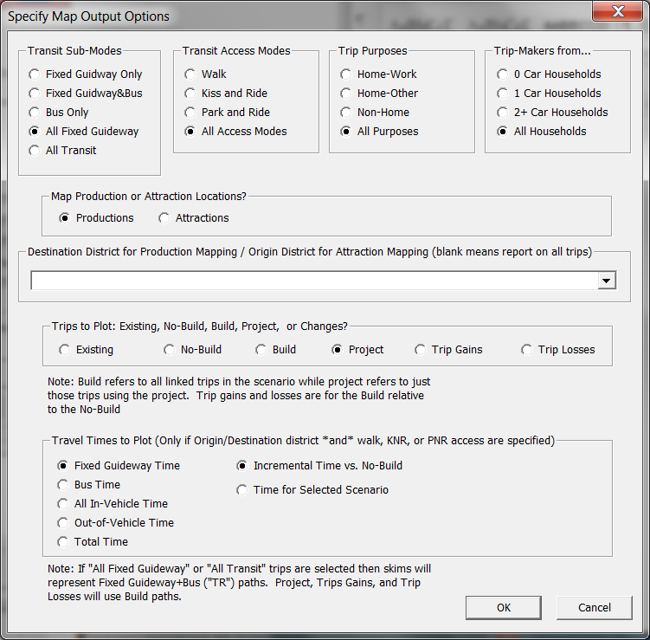

Figure 90. Dialog for Selecting Mapping Options

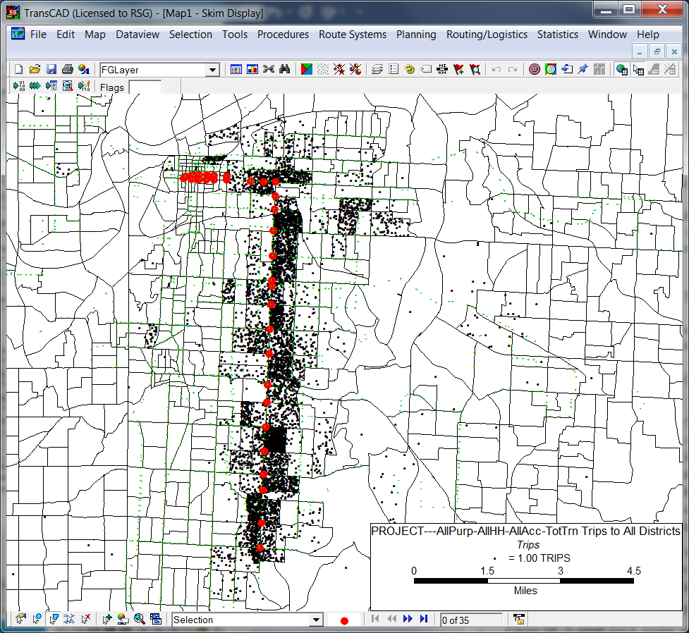

Figure 91. Map of Project Trips to All Destinations

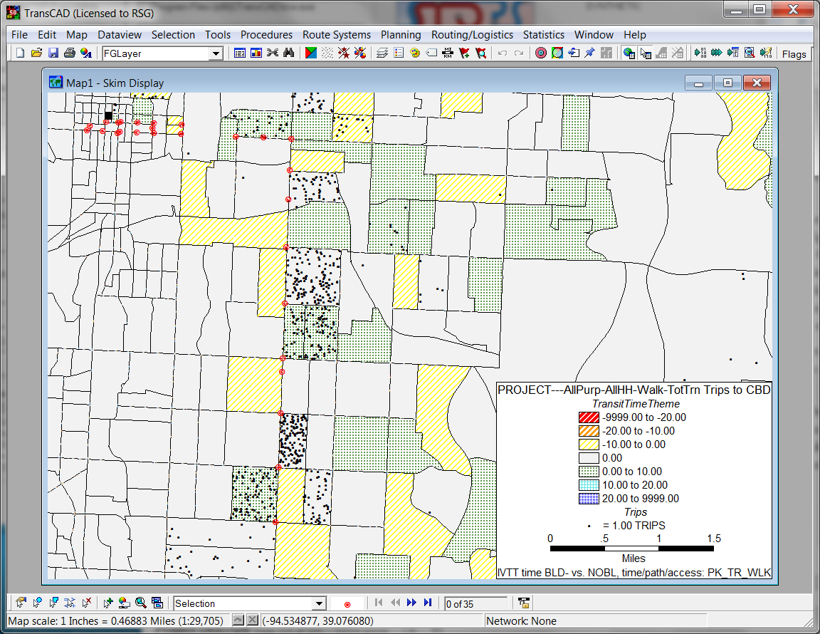

Figure 92. Map of Walk Access Project Trips to the CBD

This page intentionally blank

# Querying Zone-to-Zone Impedances and Trips

Option 14 (“Z2Z Query”) allows the user to prepare a report summarizing travel times and trips by mode for a specific zone-to-zone interchange.

To use the query function, the user must type a valid zone name in both the “From Zone” and “To” text boxes and then click “14. Z2Z Query.” When typing a zone name, remember to enter the full STOPS zone identification as it appears in the ST-CO-TAZ field in the District file.

When the Z2Z Query button is clicked, STOPS will read the datasets that were prepared by the most recent run and report on impedances and times for each combination of:

* Scenario (no-build, build, and build)
* Access mode (walk, kiss-and-ride, and park-and-ride)
* Path (fixed guideway+bus [all transit path], fixed guideway only, and bus-only)

An illustration of the Main Menu is shown in Figure 93 with zones 29095002078 to 29095002666 selected for query. To generate the query report, click “14. Z2Z Query”. This process will run for several minutes as STOPS assembles the requested information. When complete, STOPS will open a report in Notepad summarizing the results. This report is shown in Figure 94.

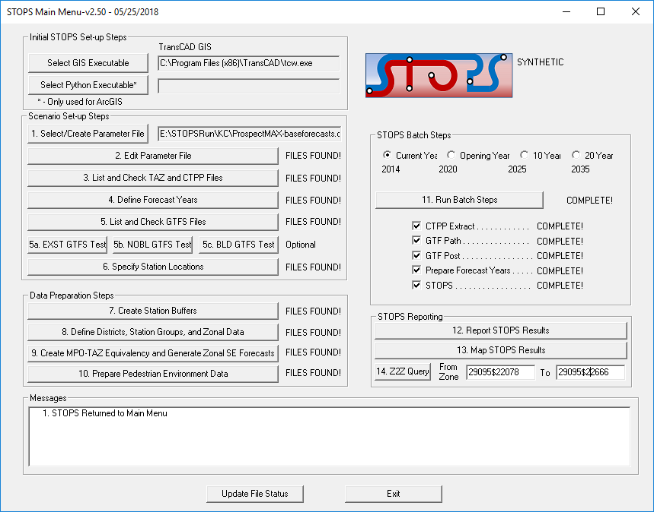

Figure 93. Using the Z2Z Query Function

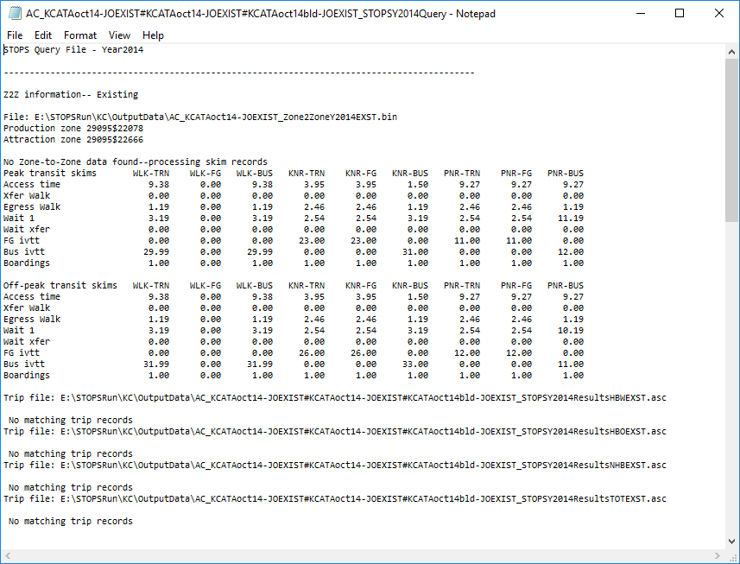

Figure 94. Example Z2Z Query Report

This page intentionally blank

# Advanced STOPS Application Methods

Up to this point, the traditional (synthetic) method for running STOPS has been described with brief references to additional capabilities such as importing trip tables or different operating modes. This chapter discusses in greater detail the nature of the imported person trip table and how this table can be used in conjunction with two advanced STOPS operating modes—incremental mode and synthetic trip table mode.

## Introduction to the Trip Table Import Function

The trip table import function is key to both advanced STOPS operating modes. This function reads a user-supplied person trip table text file that contains information on the production zone, attraction zone, and trips by various categories.

The usage of imported trip table information is controlled by user names for each zone in the CTPP boundary layer (e.g., AC29_d00.shp for the Missouri portion of the Kansas City example). As described in Section 4.3 – Optional Adjustments to the Census Data, if the first character of the user-coded zone name in LSAD_TRANS is a “$”, then the trips will be read from imported trip table for all trips to and from that zone. If neither the production nor attraction zone begins with a “$”, then trips are obtained from the CTPP using the same procedures as synthetic STOPS.

The full STOPS zone name is comprised of the 2-character state numeric FIPS code plus the 3-character state county FIPS code plus a 6-character zone[38] name. Since this name would be awkward to code in an imported trip table, zone numbers are shortened when the first character in LSAD_TRANS is a “$” or a “~”. In such cases, the zone name coded in the imported trip table is just that part of the zone name that was coded in LSAD_TRANS.

The effect of the LSAD_TRANS field on the both of these concepts (zone names and the source of trip information) illustrated in Figure 95.

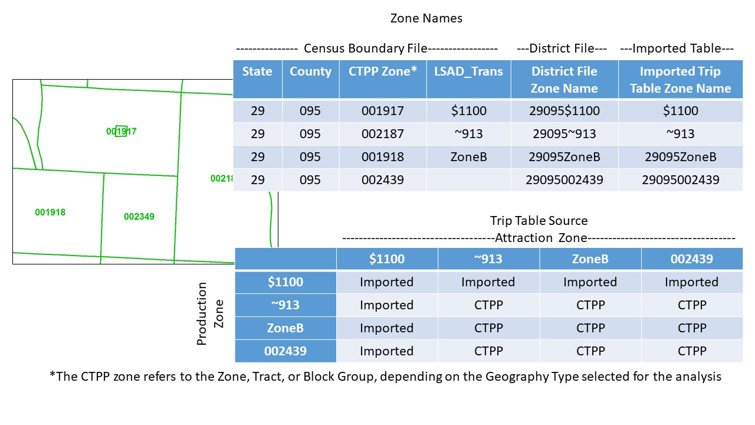

Figure 95. Zone Naming Convention and Impact on Trip Table Source

The imported trip table file a comma separated value file with a “.csv” extension. The actual name of the file is selected by the user and set in the parameter file as described in Section 4.1. A sample imported trip table file is presented in Figure 96.

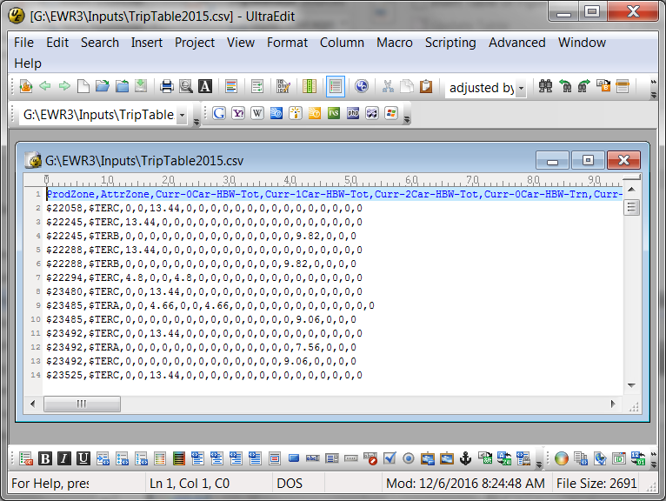

Figure 96. Example Imported Trip Table File

The first line of the file must be a header record. The fields described in the header record may be in any order as long as the header and the data contents are consistent. The header record has two required fields (ProdZone, and AttrZone). All other fields are optional. Any fields that are not present are treated as missing values.

Fields are defined as follows:

* ProdZone. (Required) The production zone identification code, as described earlier in this section. If the zone identification starts with “$” or “~”, this identification is identical to the contents of the LSAD_TRANS field in the Census boundary file.
* AttrZone. (Required) The attraction zone identification code, as described above.
* A series of one or more trip codes built-up as follows:
  + Year: (“Curr”, “OpYr”, “10yr”, “20yr”)[39]
  + Hyphen (“-”)
  + Auto Ownership (“0car”, “1car”, “2car”)
  + Hyphen (“-”)
  + Trip Purpose (“HBW”, “HBO”, or “NHB”)
  + Hyphen (“-”)
  + Transit trips or total person trips (“Trn” or “Tot”)

As an example: opening year, 1-car household, home-based other total person trips would have a field named “OpYr-1car-HBO-Tot”.

The specific application of the imported trip tables in the incremental version of STOPS and the special generator version of STOPS is described in the next two sections.

## Incremental Application of STOPS

In the incremental version of STOPS, the imported trip table function is used to load a transit trip table derived from a recent, properly controlled transit user survey. This survey should be processed to convert individual records into a weighted representation of production zone-to-attraction zone transit linked trips stratified by trip purpose (home-based work, home-based other, and non-home based) and household auto ownership (0 car, 1 car, and 2+ cars). The survey should be geo-coded to the CTPP zone system and all CTPP zones should have a unique zone identification coded in the in the LSAD_TRANS field. All zone identifications start with “$”. The label following the “$” can be any character string that is unique and consistent with the coding in in imported trip file.

An example of the Kansas City CTPP geography file is shown in Figure 97.

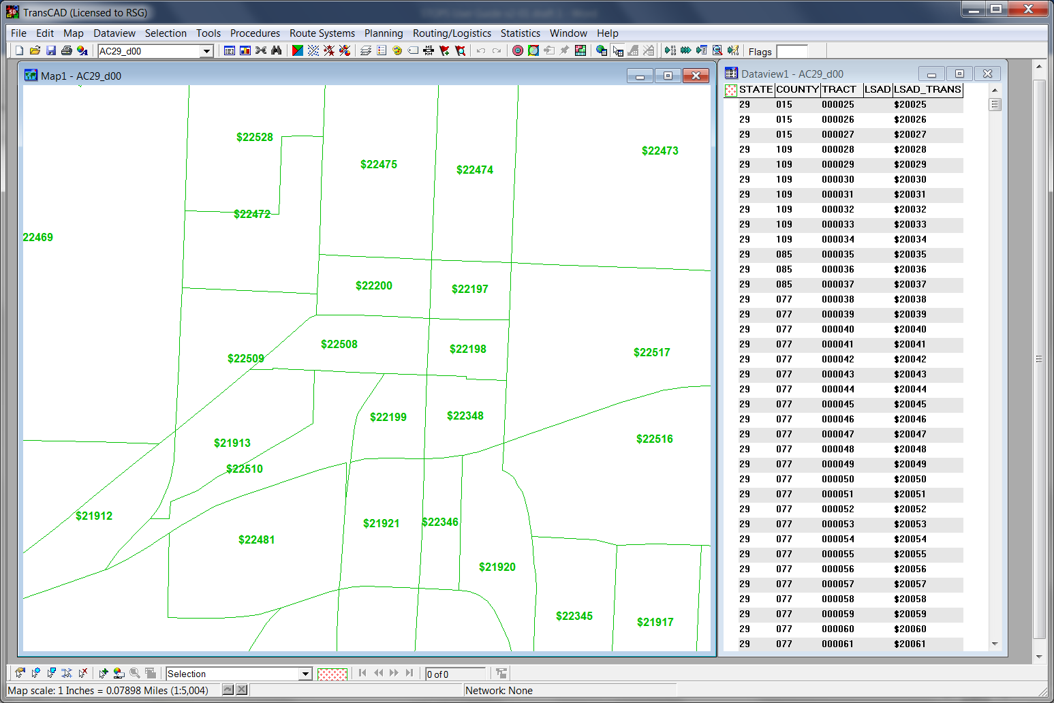

Figure 97. CTPP Geography File LSAD_TRANS Coding for Incremental Mode

The imported trip file is typically coded with the following fields:

* Curr-0car-HBW-Trn
* Curr-1car-HBW-Trn
* Curr-2car-HBW-Trn
* Curr-0car-HBO-Trn
* Curr-1car-HBO-Trn
* Curr-2car-HBO-Trn
* Curr-0car-NHB-Trn
* Curr-1car-NHB-Trn
* Curr-2car-NHB-Trn

An example of the input trip table file for Kansas City is shown in Figure 98.

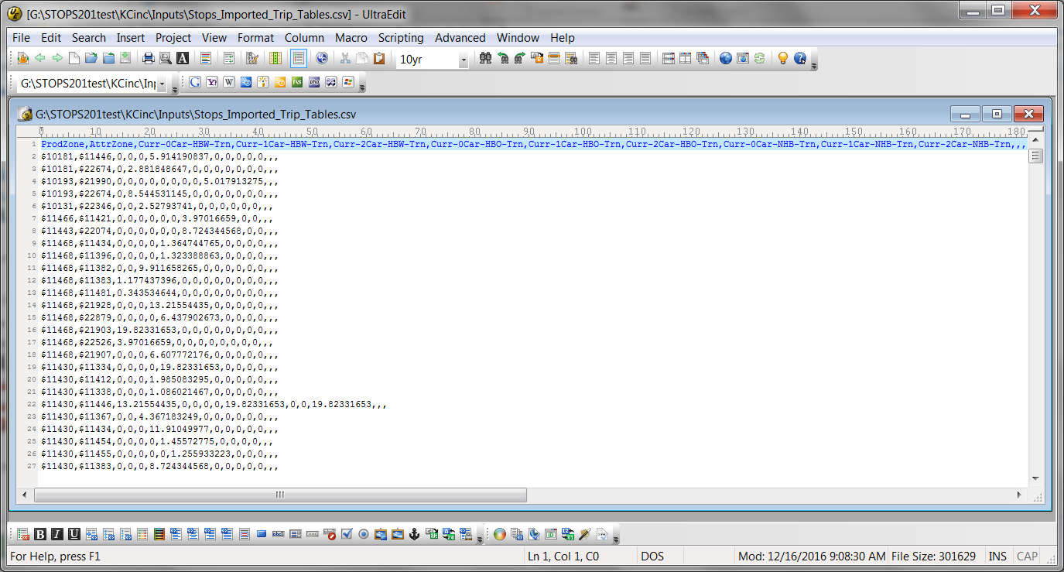

Figure 98. Sample Import Trip Table File for Incremental STOPS

At the user’s option, fields for future transit trips can also be entered. If future year fields are provided (OpYr, 10yr and 20yr), then these estimates of future transit trips are used to represent the future year transit ridership that would exist if the existing service plan is operated in those years. If future year fields are not provided, then STOPS uses its normal “Prepare Forecast Year” procedures to adjust current year trip tables so that they represent future year demographics.

If consistent data on total person trip making exists (e.g., from a very large home interview survey similar to data collected in Toronto, Ottawa, and Montreal in Canada), then that information can be entered using the “Tot” fields. If these data are not available (the most common condition in the United States), then STOPS will infer total trip making using the following logic:

* + - * 1. Total transit trips by purpose (from the transit user survey) are the most reliable set of data available.
        2. Work trip mode shares from the CTPP are the next most reliable source of information.
        3. A properly calibrated home-based work mode choice model can be calibrated that match CTPP shares on a district-to-district basis. The non-work shares can be calibrated using conventional STOPS procedures. This estimate is less reliable than the HBW shares but is still better than other generally available data on non-work transit shares.
        4. Person trips can be estimated by dividing survey transit trips by computed mode share.

In application mode, the person trips from the last step are scaled to represent the desired forecast year and multiplied by computed mode shares. For the current year with the existing transit network, inputs are identical to the calibration case and the model reproduces the input transit trip table closely. For future years, the estimates of total person trips are factored using the same process as in “Prepare Forecast Years” portion of “Step 11. Run Batch Steps”. New mode choice values are computed using level-of-service matrices from the no-build and build alternatives.

This approach is mathematically equivalent to an incremental mode choice model at the transit vs. auto choice level. Access mode (walk, KNR, and PNR) and path type (fixed guideway only, fixed guideway and bus, and bus only) choices are still made using a synthetic process. Likewise, all options to calibrate to route and station ridership counts are available.

## Synthetic STOPS Supplemented by Special Generators

The other use of imported trip tables is to supplement the standard STOPS synthetic model with information on special generators. This capability is particularly useful in cases where:

* + - * 1. A transit user survey is not available and, as a consequence, the incremental version of STOPS is not an option; and
        2. One or more major transit demand production or attraction sites exist in the project corridor that are not well captured by the CTPP. Examples of major transit production / attraction sites might include:

Students traveling to and from a major university

Patients traveling to and from a major hospital complex

Air passengers traveling to and from an airport

Visitors to large entertainment complexes

Foreign residents entering the United States on a daily basis and traveling to employment or other locations

Note that workers at universities, hospitals, airports, and entertainment locations are, for the most part included in the CTPP. The user can opt to provide all travel information to these sites for all purposes or just for non-work purposes.

No foreign residents are included in the CTPP, so a representation of cross-border flows should be developed for all trip purposes.

The first major decision to make when doing a special market analysis is whether or not to use the CTPP for the work purpose. This decision can be made separately for each zone in which special market activity occurs. For example, if a full establishment survey was conducted at a hospital, then a full representation of all transit and total trip making (i.e., all purposes) can be added to the import trip table file. If the hospital occupies the entire zone (i.e., there is no other employment or residential activity in the zone) then LSAD_TRANS for that zone should be given a zone name starting with “$” to denote a special generator where all trips are replaced by the contents of the import trip file.

If, on the other hand, the survey scope included just hospital visitors, then the zone should be split into two parts as shown in Figure 99. One zone (shaded red) is given a LSAD_TRANS value that begins with a “$” to indicate that all trips to and from this zone are to be obtained from the import trip file. The remainder of the zone (the majority) is given a zone name starting with “~”. This indicates that trips should be obtained from the regular CTPP process (unless the other zone begins with “$”).

The relative size of $1102 and ~953 is relevant. In this case, ~953 (the CTPP portion of the zone) occupies the vast majority of the original zone and over 99.8% of the CTPP trips would be retained. Zone $1102 occupies 0.22% of the original zone. This share of the CTPP trips (0.22%) would be replaced by the contents of the import trip file. In essence, the relatively small zone size tells STOPS to keep nearly all CTPP trips and add the special market trips to this quantity. This might be an appropriate when the special generator is located in a large, diverse zone with normal travel activity occurring around it.

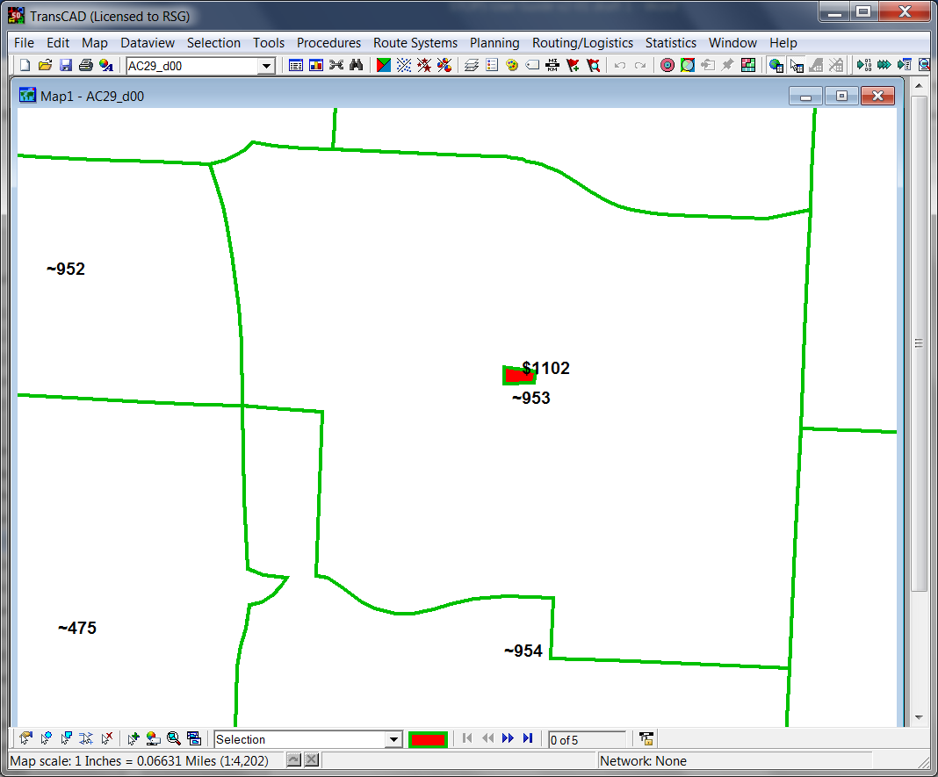

Figure 99. Split Zone to Separate Special Market Area From CTPP Area

The same trip table field options exist for the special market analysis as for the incremental model. Current year transit trips should be provided—otherwise STOPS will conclude that there is no transit activity in the special zones. If available, the user can also provide total person trips or trip tables for future years. If these variables are not provided, then STOPS will infer both quantities using the same process that is used for the regular version of STOPS.

An example of the special markets trip file for Kansas City is provided in Figure 100.

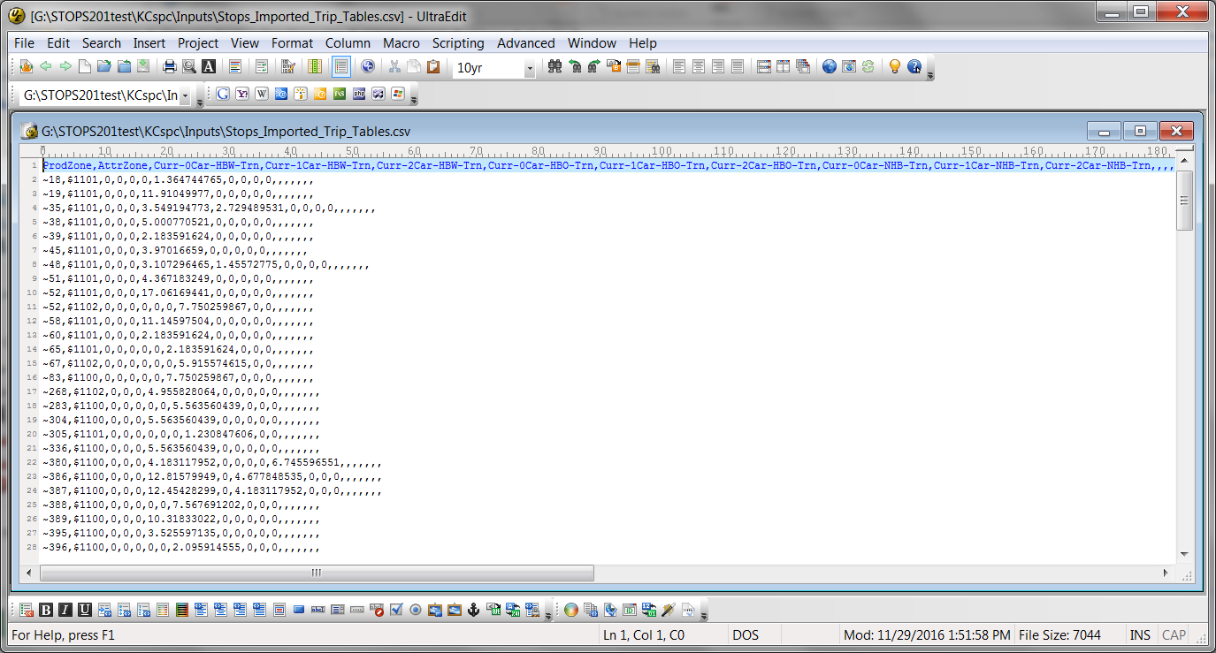

Figure 100. Sample Import Trip Table File for STOPS with Special Generators

# Overview of GTFS Coding

This chapter provides an introduction to transit schedules coded in GTFS format. Full documentation of GTFS is provided at:

<https://developers.google.com/transit/gtfs/reference>.

Transit schedules in GTFS format are coded in a set of files that, together, represent the stops, routes, and scheduled operation of a transit system. These files always have the same name (e.g., stops.txt or trips.txt) and are distinguished by the file folder (directory) in which they reside. In the Kansas City example, two operators provided transit service in the region in the 2014 calibration year (KCATA and The Jo). Furthermore, two KCATA scenarios are provided: (1) the existing/no-build system and (2) the build scenario. The GTFS files needed to represent The Jo, KCATA existing/no-build and KCATA build scenarios are located in three subdirectories. These subdirectories are located in the inputs\ directory and are named: JOEXIST\, KCATAoct14\, and KCATAoct14BLD.

As the Kansas City example shows, it is important for the user to know exactly which services are included in each file so that STOPS has an accurate representation of all transit services in the project corridor. The user must also be aware of the possibility that protocols may shift over time in a region. For example, since 2014, KCATA and The Jo services have been integrated into a single operation and the current KCATA GTFS file sets include both services in a single GTFS file. If the current GTFS file were used as the basis for the no-build and build alternatives, then the user would need to edit the parameter file and remove JOEXIST from the no-build and build scenario specification in STOPS.

Sometimes it is possible for a user to learn about the scope of each GTFS file (and changes over time) by talking to transit agency staff. In other cases, the user may have to explore each GTFS file to make sure that the files include all relevant transit services. Section 11.4 describes a publicly-available visualization tool that can help the user to understand the services coded in a GTFS file set. *GTFSed*, mentioned previously, can also be used to visualize GTFS schedules.

STOPS uses just a sub-set of the GTFS file structure as is briefly described, below. The full documentation (referenced above) provides a more comprehensive description of the full capabilities of GTFS. STOPS processes GTFS data using a program called *GTFPath*. This program reads GTFS data and a set of zone centroids and creates a matrix of zone-to-zone transit times that is similar in concept to transit skim files generated by conventional travel forecasting models.

GTFS uses a fully relational data model that depends on a series of ID fields to store key aspects of the schedule. These ID fields include:

* **Service_id** uniquely identifies a set of dates when service is available for one or more routes. A GTFS file can include routes that operate on Saturdays, Sundays, weekdays or any combination. GTFS files can also include different schedule “picks” so one file might include bus schedules for the spring, summer, and fall. The service_id is used to select just that portion of the schedule that operates on a given day. The “calendar.txt” (if provided) file defines the beginning and ending dates and days of the week that apply to each service_id. The calendar_dates.txt (if provided) can add or subtract service on specific dates. The GTFS file set must include either the calendar.txt or the calendar_dates.txt file. Optionally, it may include both files.
* **Stop_id** uniquely identifies each stop or station boarding location. Multiple routes may use the same stop. Many agencies separately code stops on each side of the street or each platform at a rail station. Stop_IDs are defined in the “stops.txt” file.
* **Route_id** uniquely identifies the route and is defined in the file “routes.txt.” A route is a collection of [bus or rail] “trips” that generally follow the same alignment. All “trips” identified as a single “route” must share the same name, description, and type (e.g., bus, rail, light rail, etc.). Different trips within a route may serve a different series of stops allowing one route to include short-turn trips, route deviations and branches. The route information includes one data item of critical importance to STOPS—the route_type. A Route_type of “3” indicates “bus”. All other route_types are considered by STOPS to be a fixed guideway option. ***Users should carefully consider the most appropriate way to code a BRT project. BRT lines that are operating in a fully grade- separated right-of-way may be perceived as being fixed guideway and might be coded as as route_type=0 (streetcar or tram). BRT routes that represent enhancements to bus service but operate in mixed traffic may be perceived like other bus routed and should probably be coded as route_type=3.***
* **Trip_id** uniquely identifies a [bus or rail] trip. A trip is equivalent to each row [or column] in a typical time table and represents the departure of one bus or train from the originating or turn-back point of the route through to that vehicle’s arrival at the destination terminal for the route (or turn-back point).

In STOPS and GTFPath, the service_id is a string variable that can be up to 100 characters wide. The other ID fields (stop_id, route_id, and trip_id) are character strings of up to 25 characters for processing with STOPS and GTFPath. In some cities, the ID fields are much longer than 25 characters but most of these characters duplicate the service ID or another non-relevant character string. STOPS includes the capability to define a subset of the ID character string that can uniquely identify an ID within the 25-character limit.

Figure 101 presents a portion of the trip file from a GTFS file that represents service operated in the Charlotte, NC area in 2010. The highlighted section of the file shows the trip_ids. Characters 1 to 8 represent the unique part of the trip_id and the remaining characters duplicate the service_id and are not needed to uniquely identify each trip.

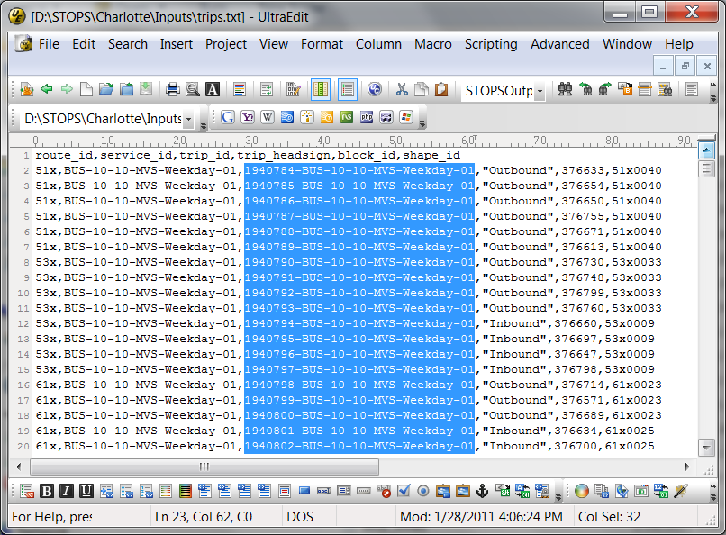

Figure 101. Sample Trip File with Long Trip IDs

In this example, the user could identify a unique 25-character trip_id by limiting the trip_id field to characters 1 to 8. Similar character ranges can also be defined for route_ids and stop_ids if that helps to identify a short, yet unique, string within each ID field.

Figure 101 also illustrates another GTFS concept – GTFS files are structured as comma separated text files (with a .txt extension) that can include data in any order on a record. The contents of each file are defined in a header record. STOPS and GTFPath reads the header record and use this information to determine where in each record the relevant data is found. STOPS and GTFPath can process the required data in any order as long as it is properly identified in the header record. Extra fields can be included in the file and STOPS will ignore this extra information.

## GTFS File Specifications

This section describes the individual GTFS files read by STOPS and GTFPath and used to prepare the level-of-service matrices.

### Calendar.txt (Required unless the calendar_dates file is provided)

This file contains a listing of valid dates and days-of-week for each “Service_ID.” Calendar.txt is a comma separated file with a header displaying the structure of the file followed by one record for each service_id. Each record includes:

* Service_ID: a character ID that uniquely identifies a set of dates that appears at most once in the calendar file.
* Monday, Tuesday, Wednesday, Thursday, Friday, Saturday, and Sunday: A series of binary fields that if set to 1 indicates that the service is operated that day. A 0 (zero) is used to indicate that this service is not operated.
* Start_date and end_date. The starting and ending dates for the service in YYYYMMDD format.

A simple calendar file is shown in Figure 102.

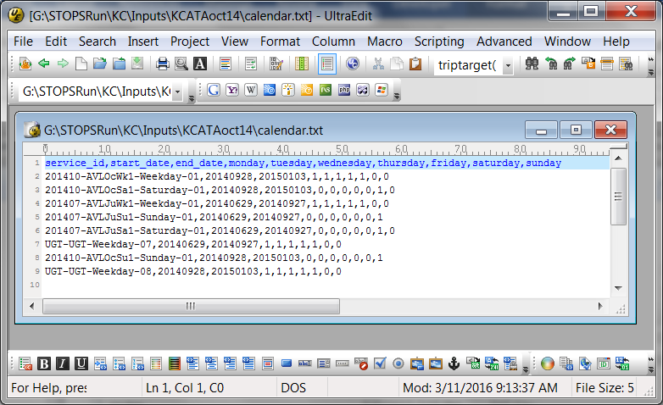

Figure 102. Sample GTFS Calendar File

### Calendar_dates.txt (Optional unless the calendar.txt file is not provided then calendar_dates is required)

This file contains a listing of dates and exceptions to the schedule previously defined in the calendar.txt file. If the calendar.txt file is not provided, then each day of operation is an exception to the schedule and all dates and service_IDs must be coded. Calendar_dates.txt is a comma separated file with a header displaying the structure of the file followed by one record for each combination of day and service_ID for which an exception record is required. Each record includes:

* Service_ID: a character ID that is coded on the trip record to indicate the type of service operated (e.g., weekday, Sunday, holidays).
* Date. The day that this exception applies to
* Exception_type. Equals 1 if the service_ID is to be operated on that day. Equals 2 if the service_ID is not to be operated on that day.

A sample calendar_dates file is presented in Figure 103.

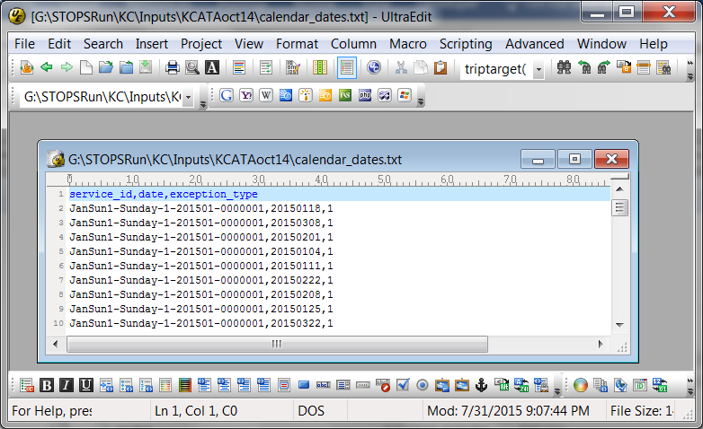

Figure 103. Sample Calendar_Dates File

### Stops.txt (required)

This file contains a list of stop_ids, stop locations, and names to define stops and stations where passengers can board and alight from transit. The file has a header record followed by one record for each station or stop in the system. The following fields are required:

* Stop_id: a unique identifier no more than 25 characters long[40] that identifies the stop or station.
* Stop_name. A character string that names the stop.
* Stop_lat. A real number containing the latitude of the stop.
* Stop_lon. A real number containing the longitude of the stop.

A sample stops.txt file is shown in Figure 104.

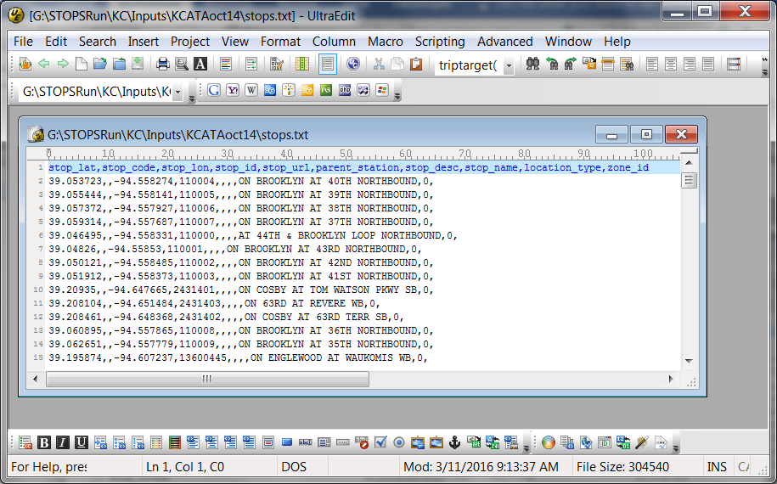

Figure 104. Sample GTFS Stops File

### Routes.txt (required)

This file contains a list of route_ids, route descriptions and route types (transit modes). The file has a header record followed by one record for each route in the system. Each record includes a unique route_id, one or more name fields, and a route_type code.

Routes.txt has the following fields:

* Route_id. A unique id up to 25 characters long[41] used to identify the route.
* Route_short_name. A short description such as the route number which describes the route but not the destination.
* Route_long_name. The full name of the route.
* Route_type: A one-digit integer that best describes the type of transit. The value of 3 is used to denote non-fixed guideway bus routes. All other types are considered to be fixed guideway services. Projects can be comprised of any route type[42]. The full list of potential route-types are:
  + 0 - Tram, streetcar, LRT, (and some high-end BRT services in STOPS)
  + 1 – Subway, Metro
  + 2 – Rail (intercity and long-distance)
  + 3 – Bus
  + 4 – Ferry
  + 5 – Cable car
  + 6 – Gondola or suspended cable car
  + 7 – Funicular

The route_type codes are critically important to STOPS since this code is how STOPS distinguishes between regular bus routes (route type 3), partial fixed guideway systems (route type 0) and full fixed guideway services (all other route types).

In most cases the route_type should be coded according to their standard GTFS definitions as described above. Two common exceptions to this rule are:

* + - * 1. BRT routes operating in an exclusive right-of-way that could be perceived as a partial fixed guideway service might be coded as type 0 (tram or streetcar).
        2. LRT routes that operate in an exclusive right-of-way that could be perceived like a full subway or metro system rather than a streetcar line might be coded as type 1 (subway, metro)

A sample route file appears in Figure 105. Note that in this example, the Troost MAX route (a BRT) has been coded with a route_type of 0.

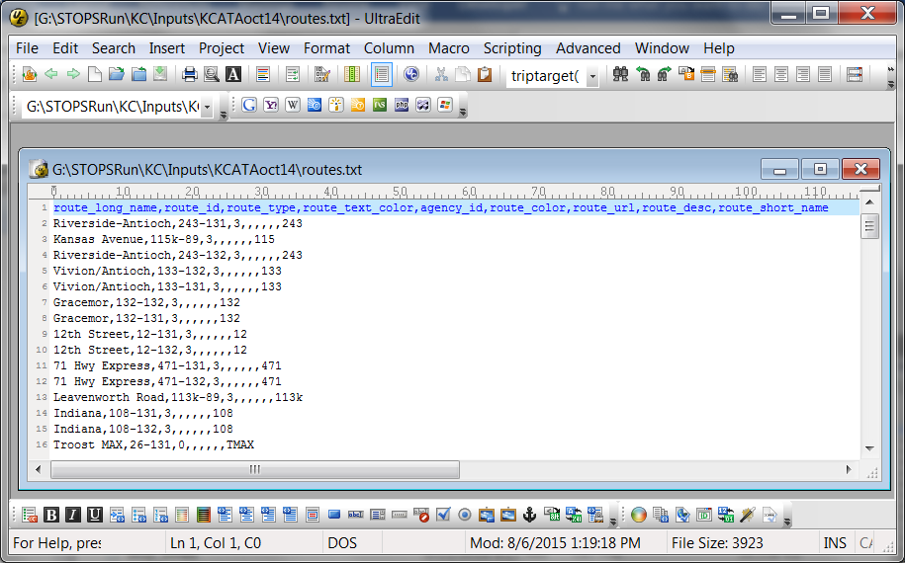

Figure 105. Sample GTFS Routes File

### Trips.txt (required)

This file contains a header record followed by one record for each [bus or rail] trip. A trip in this context refers to a transit vehicle [bus or rail] trip that occurs when a bus or train departs from the route beginning point (or a turnback point) and lasts until it arrives at the destination terminal or turnback. Required fields are as follows:

* + Trip_id. A unique ID up to 25 characters long[43] identifying the trip.
  + Route_id. The ID of the route that describes this trip.
  + Service_id. The ID that describes the days this trip operates in the calendar.txt file.

GTFS trip files can also include an optional block_id field. This field is used to indicate groups of trips that are served by the same vehicle. Passengers are allowed to remain on the bus between trips when the trips share the same block_id. This is particularly important in systems that interline routes. For example, route “A” on the north side of town may continue as route “B” on the south side. In this case, as long as two trips have the same block_id, through passengers have a no-transfer trip even though the route and trip have changed during the course of the journey.

A sample trip file is shown in Figure 106.

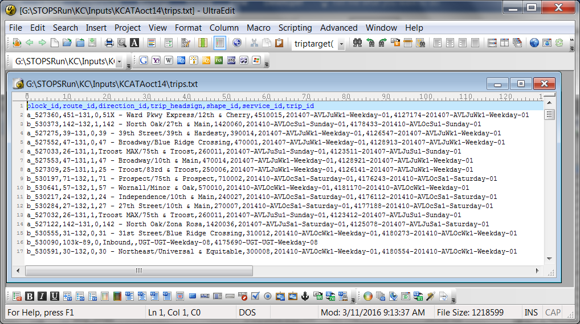

Figure 106. Sample GTFS Trip File

### Stop_times.txt (required)

This file contains one record for each stop served by each trip and defines the times that the trip serves that stop. This file corresponds to each time value in a printed schedule. The key difference between the stop_times.txt file and printed schedules is that each stop on the route has a time record in the stop_times file[44] as compared to most printed time tables in which time values are present for selected stops only (known as time points). The following fields are required:

* Trip_id. The ID of the trip represented by this record.
* Stop_id. The ID of the stop represented by this record.
* Arrival_time. The time that the trip arrives at the stop. This value is left blank if the time is not known and the time is to be interpolated based on preceding and following time points.
* Departure_time. The time that the trip departs from the stop.[45] This value is left blank if the time is not known and the time is to be interpolated based on preceding and following time points.
* Stop_sequence. A sequential number that indicates whether this record is the first, second, third, etc. stop that this trip makes.

Optionally, the stop_times file may include two other fields:

* Pickup_type. A “1” denotes that passengers may not board the vehicle at this stop[46]
* Drop_off_type. A “1” denotes that passengers may not alight the vehicle at this stop

A sample stop_times file appears in Figure 107.

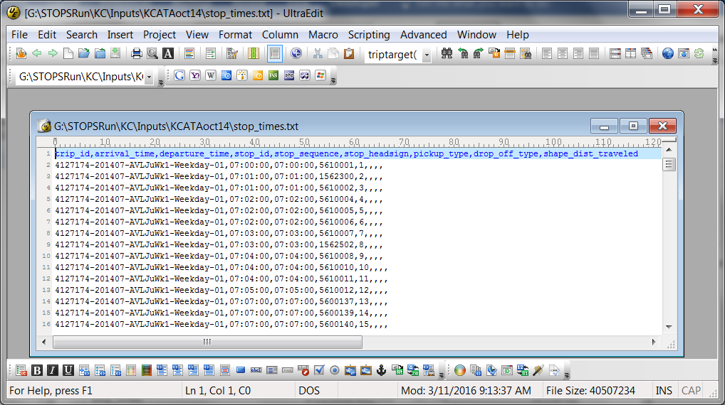

Figure 107. Sample Stop_Times File

### Frequencies.txt (optional)

This is an optional file that, if present, describes how a trip defined in the trips.txt file is repeated over the course of a day. The frequencies file includes a series of records that indicate the trip_id, a start- and end- time interval, and the headway (in seconds) that the trip is repeated during the coded time interval. The frequencies file includes the following fields:

* Trip_id. The ID of the trip to be repeated.
* Start_time. The first departure time from the first stop on the trip.
* End_time. The latest departure time from the first stop on the trip.
* Headway_secs. The headway ***in seconds*** between successive departures[47].

A sample frequencies file appears in Figure 108.

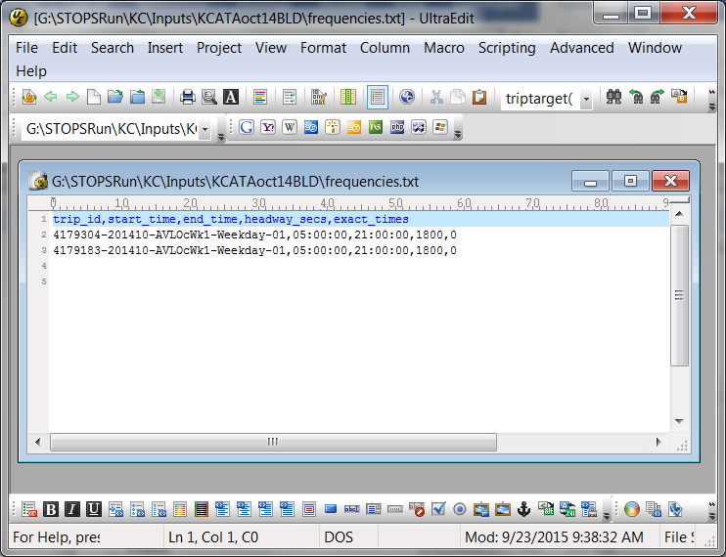

Figure 108. Sample GTFS Frequencies File

### Transfers.txt (optional)

The transfers.txt file contains information on the amount of time required to complete a transfer. If this file is not provided or if a transfer is not coded in this file, then STOPS automatically generates transfers between stops located within 0.25 miles of each other and computes the transfer time based on the straight line distance between the two stops traversed at a speed of 3 miles per hour. Any station grade separation time (0.5 minutes per level) and any transfer penalty time coded in the station file are added[48] to this time estimate. The GTFS station file provides the opportunity to override this estimate in cases where the actual transfer time is known. This file has the following fields

* From_stop_id. The stop_id used to define the stop where the transfer begins
* To_stop_id. The stop_id used to define the stop where the transfer ends
* Transfer_type. A code defined as follows
  + 0 – recommended transfer point (ignored by STOPS)
  + 1 – timed transfer point where the to bus will wait for passengers (ignored by STOPS)
  + 2 – requires a time specified in min_transfer_time to make the connection
  + 3 – transfers not allowed at this location
* Min_transfer_time. (Optional) The number of ***seconds*** required to complete this transfer for transfer_type = 2. If this field is not available, the min_transfer_time is assumed to be zero[49].

### PNR.txt (optional STOPS extension to GTFS standard)

The PNR file is a STOPS-extension to the GTFS standard and allows the user to specify locations where travelers can park their cars prior to making a transit trip. One record is specified for each potential parking location which is defined in terms of latitude and longitude. STOPS and GTFPath compare this location to stops identified in the stops.txt file and all stops within 0.25 miles are connected to the PNR lot. The PNR.txt file has the following required fields:

* Pnrname A character string with the PNR lot name.
* Latitude. A real number with the latitude in degrees.
* Longitude. A real number with the longitude in degrees.
* Pnrtype. An integer that is used to define the scale of the PNR and its likely catchment area. In STOPS, these values are defined as follows:
  + 1 – End-of-line fixed guideway station – attracts trips up to 25 miles away. Also used when a major highway intersects the fixed guideway facility and the station effectively serves as an end-of-line station for these travelers.
  + 2- Formal fixed guideway or bus PNR lot-attracts trips up to 10 miles away.
  + 3 – Officially designated PNR lot in a shared facility – attracts trips up to 6 miles away. This designation is applied to lots in churches, shopping centers and similar settings with posted signage permitting transit PNR.
  + 4 – Unofficial PNR lots. Lots where parking for transit occurs but is not identified by the transit operator as a officially-designated PNR lot. This could include cases where private land owners make their property available for a fee and other cases where parking occurs without permission. Because this usage is dependent on driver knowledge of the local situation, this type of parking is limited to access distances of less than 3 miles.

The pnr.txt file also has an optional field, called “PNRCost” that, if present, contains the amount of additional impedance (in equivalent minutes of travel time) that should be added to the connection between the parking lot and nearby transit stops. PNRCost can be used to represent additional time required for vertical circulation in a parking structure or to represent a shadow price for purposes of constraining modeled parking utilization to parking capacity.

A sample PNR file is presented in Figure 109.

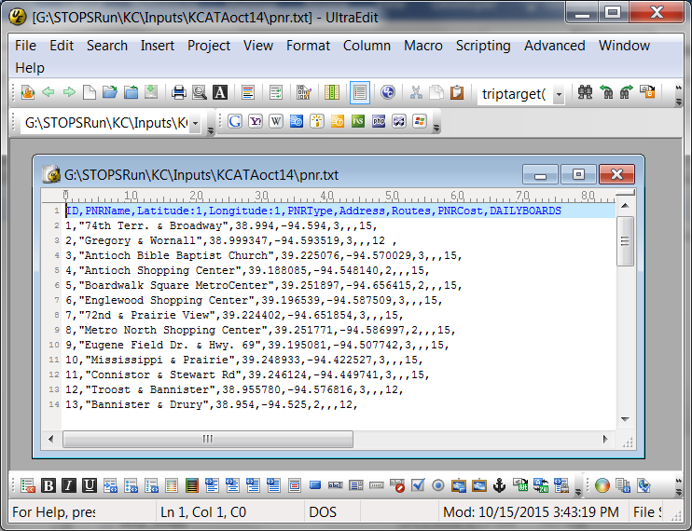

Figure 109. Sample PNR File

## Managing GTFS Files and Creating Project Scenarios in STOPS

The GTFS file format provides a flexible structure for defining an individual transit operating agency’s schedule of service. This is an important foundation for generating estimates of trips on a project but is only the beginning. STOPS must read multiple sets of GTFS files to represent:

* Corridors where transit service is provided by multiple agencies and schedule data is coded into independent GTFS file sets.
* Multiple scenarios representing existing service, future year no-build and project-related service.

This section introduces several of the concepts that make it possible to read multiple GTFS files to cover both circumstances.

### Separate Sub-Directories for Representing Multiple GTFS Files

In GTFS, simple file names such as calendar.txt, trips.txt, and stops.txt are used to define a set of schedules for one agency. With this structure, GTFS file sets for multiple agencies or different scenarios must be stored in different sub-directories.

This requirement is satisfied in STOPS through the concept of a “Subdirectory Prefix” (“Directory” or “Dir”) in the parameter file. The Subdirectory Prefix is a character string that is added to the beginning of each GTFS file name to differentiate subdirectory locations. This capability can be used to do the following:

* Identify a set of subdirectories where each transit operator’s files may reside. In San Diego, two GTFS files are used (Metropolitan Transit System and North County Transit District). In this case, two subdirectories might be used to represent existing schedules:
  + MTS2013\
  + NCTD2013\[50]
* Identify different scenarios. Continuing the San Diego example, assume that NCTD is constructing a project and that both MTS and NCTD have future year no-build scenarios. In that case, the following subdirectories might also be defined
  + MTSNoBuild\
  + NCTDNoBuild\
  + NCTDBuild\

These names are sub-directories of the inputs\ folder which is a subdirectory of the project folder where the control file is located. If the project control file is d:\STOPS\SD\sandiego.ctl, then the GTFS folders described above would be:

* D:\STOPS\SD\Inputs\MTS2013\
* D:\STOPS\SD\Inputs\NCTD2013\
* D:\STOPS\SD\Inputs\MTSNoBuild\
* D:\STOPS\SD\Inputs\NCTDNoBuild\
* D:\STOPS\SD\Inputs\MTSBuild\

***The combination of root directory name and the sum of all of the GTFS subdirectory names may have as many as 200 characters. Much shorter name lengths are recommended for readability of reports and screens.***

### Simultaneous Processing of Multiple GTFS Files

As discussed in the previous section, transit service in some metropolitan areas is provided by multiple agencies and, in some cases, these agencies each generate their own GTFS files. STOPS provides the capability to read multiple GTFS files and generate a single set of paths that considers routes operated by all agencies. The STOPS parameter file editing dialog requires users code at least one non-blank subdirectory name for all scenarios (e.g., existing, no-build, and build). Up to nineteen additional GTFS files with non-blank subdirectory names may also be provided for each scenario to represent multiple operators.

Although a non-blank subdirectory prefix is required for each scenario, it is important to note that the same subdirectory prefix can be used for multiple scenarios. This could happen if the no-build and existing scenarios are the same or if the user wishes to test STOPS to determine “project” ridership for an existing rail line. In such cases, the user might type “MTS2013\” and “NCTD2013\” as the subdirectory prefix for the “Existing”, “No-Build”, and “Build” scenarios.

In many cases, this is all the user needs to do—specify all of the subdirectories that together should be read to generate a complete set of origin to destination paths for the modeling region. In some cases, however, this strategy will lead to an error caused by different agencies using the same stop, route, or trip designation to refer to different things. When this happens, the user can define a 1-character suffix in the parameter file. When this is done, all identification fields (e.g., stop_id, trip_id, or route_id) have an ampersand and the suffix appended to the end of the field.

Example of Suffix and Its Effect on ID fields

If the user defines the suffix for a GTFS file as “A”, then:

* Trip 121 would be renamed as “121&A”
* Stop “65112” would be renamed “65112&A”
* Route “17X” would be renamed “17X&A”

The user does not need to add the suffix to any of contents of the GTFS file set; STOPS does that automatically. The only places where the suffix needs to be hand-coded by the user are:

In the parameter file where other GTFS information is identified.

In the station file (see Section 4.7) in which the user must add the ampersand and suffix to the GTFS stop_id fields.

In the optional route count file (See Section 4.3-Route Count File) in which the user specifies the ridership on each route for purposes of calibration. Here, too, the ampersand and suffix is added to the route_id.

## Using STOPS to Automatically Edit GTFS Files to Create Alternative Scenarios (Editlist.txt file)

GTFS files are highly detailed representations of a transit operator’s service that are designed to allow on-line mapping software to provide directions to potential transit users. In most transit agencies, these files are prepared by the scheduling department using their timetable/run-cutting software systems. The GTFS files are the final product of a complex process to prepare efficient, accurate schedules to be used by drivers, dispatchers, and the traveling public.

STOPS takes advantage of this detailed information to calibrate the model to represent current year conditions. However, STOPS must also read GTFS files representing future year conditions with and without the project.

The simplest approach (for the forecasters) to generate the future no-build and build GTFS files is to engage the agency’s service planning staff to build a future time table using their timetable/run-cutting software systems. This approach has the advantage that the resulting schedules will be based on the experience gained by the scheduling staff over many years and may result in a schedule that is more accurate and more likely to be implemented. Often, however, these staff are too busy to perform this task and it falls to the forecasters to adjust the GTFS files to prepare alternative scenarios.

One alternative for developing a set of future year GTFS files is to use a software packages designed for GTFS editing (e.g., *GTFSed*, available from FTA).

Another option is for the user to construct GTFS files by hand by editing the underlying text files to represent future scenarios. Since GTFS files are extremely complex with many inter-relationships, the resulting files should be carefully checked to confirm that the GTFS files are accurate representations of each scenario. This approach could be practical in cases where the schedule changes are relative simple between the existing GTFS files and the proposed future services.

The final option is to use the STOPS capability to modify a GTFS file set based on a series of editing commands. These commands are stored in a file called “editlist.txt” (located in the same subdirectory as the GTFS files to be edited). This capability is another STOPS extension to the GTFS standard.

### Using Editlist

Even with the editlist function, the user is still responsible for manually editing the relatively simple files in the GTFS standard (stops.txt, routes.txt, trips.txt, and frequencies.txt). Editlist.txt is used to simplify the process of making routing changes to existing services in the stop_times.txt file. An important concept is that the stop_times.txt file contains the service that is offered to the traveling public. The other files (stops.txt, routes.txt, trips.txt, and frequencies.txt file) play a supporting role. If a route or trip exists, but there is no stop_time record, then no transit service is available for a traveler to use.

This means that if the user wishes to discontinue a route, it is sufficient to remove all of the route’s stop_time records. There is no reason to eliminate the route from the route file or trips from the trip file and, depending on how these tools are used, deleting these records could cause errors. It is helpful to bear the following principle in mind:

GTFS files are extremely complex and many opportunities exist to introduce serious errors. ***Therefore, the user should make as few changes as possible to represent potential service changes.*** Nearly always that means adding necessary stops, routes, trips, and stop_times but seldom, if ever, deleting anything directly from the files. Existing services are best modified or deleted using the editlist.txt capability.

The following process can be followed to create a new GTFS file to represent a new scenario.

Copy an existing GTFS file set to a new directory.

Open the calendar.txt file in a simple text editor and make a note of the service_ids that can be used to represent weekday services (often Wednesday offers the most typical representation of a weekday) on a date that is consistent with other routes represented in the GTFS file. In most cases an existing service_id can be used although it is also possible to create a new service_id.

Open the stops.txt file in a simple text editor and add any new bus or fixed guideway stops. In most cases, the user should not delete or move an existing stop since these physical points still exist. Even though the user may delete service in later steps, STOPS still checks the integrity of all routes and stopping patterns and will generate an error if these stop locations do not exist. When adding new points, search the existing stop database to make sure that duplicate stop_ids are not defined. STOPS will flag a duplicate stop_id as an error.

Open the routes.txt file in a simple text editor and add any completely new routes to the route database taking care not to re-use any existing route_id. New routes could include a new fixed guideway line or new feeder bus routes. Do not delete any existing route_ids unless the user also deletes all references to the route in the trips.txt, stop_times.txt, and frequencies.txt files. It is not necessary to change existing routes that are truncated or modified unless the user wants to modify the route description fields to reflect the new name.

Open the trips.txt file in a simple text editor and add a new trip for each new route in each direction. It is only necessary to add one new trip for each new route and direction since the frequencies.txt file can be used to generate the entire schedule over the course of a day. If trips are to be added to existing routes, then the user can either code one new trip for every added trip or to create one new trip and use the frequencies.txt file to add additional runs. The user should not delete trips from the trips.txt file unless all references to the trip in the stop_times.txt and frequencies.txt files are also removed using a text editor.

Open the stop_times.txt file and add all stop_time entries for the new trips. Existing routes that are modified need not be edited here since the editlist.txt command can be used to change existing routes more easily. If the user does modify stop_time entries for existing routes in this file, make sure to change all of the relevant entries since each route can have one record for each trip and each stop unless the frequencies.txt file is used.

Open (or create) the frequencies.txt file and add frequency records for each new trip to specify the peak and off peak frequency of service. STOPS considers waiting times for two periods of the day: Peak (7:00 AM to 8:59 AM) and Off-peak (12:00 noon to 1:59 AM). Since scheduled trips serving these time periods may begin before and extend beyond these time periods, the user should create schedule information for a broader period (e.g., 6-9 AM and 11 AM- 3 PM to make sure that all trips operating in the modeled periods are properly represented.

Open or create the editlist.txt file. This extension to the GTFS standard allows users to update existing services using a series of editing commands that are designed to apply to multiple trips and/or routes and facilitate consistent modification to trip routing.

An example editlist.txt file is shown in Figure 110. This file shows includes the following modifications to an existing GTFS file:

* + - * 1. Two comment lines (begin with an “!”). The remainder of the line (a discarded command) is ignored.
        2. Delete routes 501, 42-44, 55-58, and 60 in their entirety
        3. Reroute all routes that serve stops 29380 and 46443 (in that order, but with possible intermediate stops). The new routing will be 29380, 29320, 29310, 29290, 29270, 29250, 25280, and 45075. Since this replacement never ties back to the original line, 45075 is the new terminus of the line.
        4. Reroute all routes that serve stops 46443 and 29260 (in that order, but with possible intermediate stops). The new routing will be 29380, 29320, 29310, 45047, 25270, and 29260. Since this replacement starts at a different stop from the original line, 45075 is the new origin of the line.

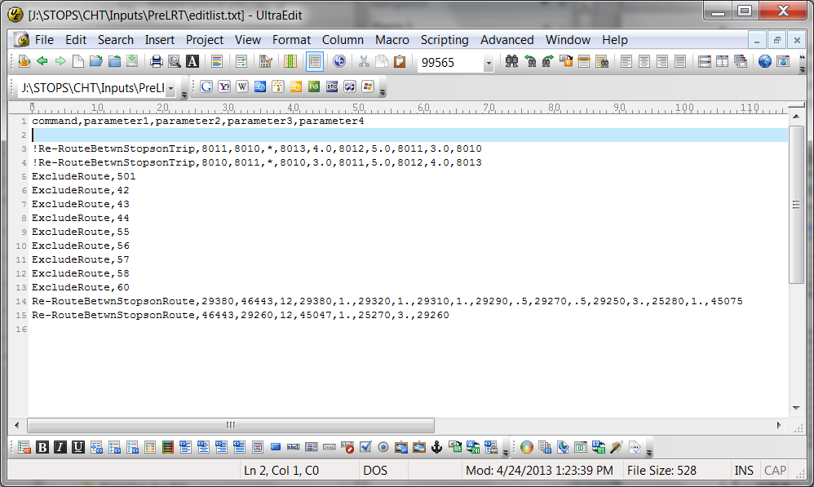

Figure 110. Sample GTFS Editlist file

The format of the editlist file is described in the paragraphs below.

The editlist file begins with a header line that must contain the exact string of characters shown in the example. The first non-blank line following the header begins with a “!” that indicates that this line contains a comment which is skipped by STOPS when processing the editlist file.

All non-comments consist of a command followed by one or more parameters. Each command type can apply to a route, trip, stop or combination that exists in the stop_time file. The command only affects the stop_time file—the stop, route, and trip definitions contained in those files continue to exist without change even after the editlist commands are applied. The editlist commands that are applicable to STOPS are as follows:

* ***ExcludeRoute,[route_id].*** Directs STOPS to exclude all stop_time records for all trips operating with the route indicated by “route_id”. This command is generally used in cases where a route no longer operates in a scenario. This might happen if a parallel route is eliminated when a new fixed guideway system is implemented. If “*” is coded as the route_id, then all routes are excluded but this wildcard should only be used if a later “include route” reinstates some of this service. Otherwise all routes are excluded and no transit paths can be built. In the sample file, route_id 501 (the LRT line) and several bus routes are removed from the schedule.
* ***ExcludeTrip,[trip_id]*.** Directs STOPS to exclude all stop_time records for the trip specified by “trip_id”. This command is used when a new fixed guideway service results in a loss of some trips on an existing route. If “*” is coded then all trips are excluded but this wildcard should only be used if a later “include trip” record reinstates some of this service.
* ***Re-RouteBetwnStopsonRoute,[stop_id-1],[stop_id-2],[route_id],[replacement string].*** ***Re-RouteBetwnStopsonTrip,[stop_id-1],[stop_id-2],[trip_id],[replacement string].*** These commands instruct STOPS to look for cases where a route or trip travels between stop_id-1 and stop_id-2 (with or without intermediate points) and then replaces the sequence of nodes in the original stop_time file with the nodes and travel times contained in the replacement string. This command can be used to code a short turn-back on a route or to define a new deviation off of an existing alignment. In the sample file, Route 12 between 46443 and 29260 is replaced with a new beginning that involves traveling from 45047 to 25270 in one minute and then continuing to 29260 for another 3 minutes of travel time. Re-route commands are subject to the following rules:
  + Both stop_id-1 and stop_id-2 must exist in the stop_time file with stop_id-1 being before stop_id-2 in the order sequence for the trip being modified. Two re-reroute commands are required for 2-way routes to cover each direction of travel.
  + The replacement string consists of a series of stop_ids representing the new sequence of stops. Between each pair of stop_ids, the user must code the transit running time required to travel between the stops.
  + The replacement string must be anchored to the existing stop_id sequence at one or both ends. This means that the first stop_id in the replacement string must match stop_id-1 and/or the last stop_id in the replacement string must match stop_id-2. There are 3 kinds of replacements possible.
    - The first stop ID in the replacement string matches stop_id-1 and the last stop ID in the replacement string matches stop_id-2.
      * Example 1 (new routing between existing stops):

Original Route: Rte1,stopA,stopB,stopC,stopD,stopE

Re-routeBetwnStopsonRoute, stopB,stopE,Rte1,stopB,2,stopF,3,stopE

Revised Route: Rte1,stopA,stopB,stopF,stopE

Times. Original route up to B. Then, 2 minutes B-F, 3 minutes F-E

* + - The first stop ID in the replacement string matches stop_id-1 and the last stop ID in the replacement string *does not* match stop_id-2.
      * Example 2 (extension to the end of the line):

Original Route: Rte1,stopA,stopB,stopC,stopD,stopE

Re-routeBetwnStopsonRoute, stopD,stopE,Rte1,stopD,2,stopE,3,stopF

Revised Route: Rte1,stopA,stopB,stopC,stopD,stopE,stopF

Times. Original route up to D. Then, 2 minutes D-E, 3 minutes E-F

* + - * Example 3 (replacement to the end of the line):

Original Route: Rte1,stopA,stopB,stopC,stopD,stopE

Re-routeBetwnStopsonRoute, stopC,stopE,Rte1,stopC,2,stopF,3,stopG

Revised Route: Rte1,stopA,stopB,stopC,stopF,stopG

Times. Original route up to C. Then, 2 minutes C-F, 3 minutes F-G

* + - * Example 4 (short turn back at end of line):

Original Route: Rte1,stopA,stopB,stopC,stopD,stopE

Re-routeBetwnStopsonRoute, stopC,stopE,Rte1,stopC,2,stopD

Revised Route: Rte1,stopA,stopB,stopC,stopD

Times. Original route up to C. Then, 2 minutes C-D

* + - The first stop ID in the replacement string *does not* match stop_id-1 and the last stop ID in the replacement string matches stop_id-2.
      * Example 5 (extension to the beginning of the line):

Original Route: Rte1,stopA,stopB,stopC,stopD,stopE

Re-routeBetwnStopsonRoute, stopA,stopB,Rte1,stopQ,2,stopA,3,stopB

Revised Route: Rte1,stopQ,stopA,stopB,stopC,stopD,stopE

Times. Original route after B. Prior to B times are computed backwards using 3 minutes A-B, 2 minutes Q-A

* + - * Example 6 (replacement to the beginning of the line):

Original Route: Rte1,stopA,stopB,stopC,stopD,stopE

Re-routeBetwnStopsonRoute, stopB,stopC,Rte1,stopQ,2,stopR,3,stopC

Revised Route: Rte1,stopQ,stopR,stopC,stopD,stopE

Times. Original route after C. Prior to C times are computed backwards using 3 minutes R-C, 2 minutes Q-R

* + - * Example 7 (short turn at beginning of the line):

Original Route: Rte1,stopA,stopB,stopC,stopD,stopE

Re-routeBetwnStopsonRoute, stopA,stopC,Rte1,stopB,2,stopC

Revised Route: Rte1,stopB,stopC,stopD,stopE

Times. Original route after C. Prior to C times are computed backwards using 2 minutes B-C

* + Except in the case of a new beginning to the route, the arrival/departure times in the stop_times file are retained for the section of route prior to the change. Travel times following the insertion of the new stops are updated based on the stop-to-stop travel times contained in the replacement string. When a new beginning is coded, then the stop_times arrival/departure times for the existing route after the insertion point are retained and the arrival/departure times for the new beginning sequence are estimated from the stop-to-stop running times contained in the replacement string.

## Visualizing GTFS Data

GTFS data are very complex and must be carefully checked before using this data as an input to STOPS. Review is particularly important when new files are created to represent proposed services such as a new rail line and the related bus service changes. The Google developers web site includes two tools that can be used to verify and to visualize a GTFS feed.

The following steps are required to use the feed validator and feed visualization tools:

Download the latest version of transitfeed-windows-binary-v.v.vv.zip (v is version information) and extract the contents to a directory on your hard drive. The zip file can be downloaded from https://github.com/google/transitfeed/wiki/FeedValidator. Select the “Windows Standalone Version” link and download and extract the transitfeed binary.

Locate the subdirectories containing GTFS data to be tested and viewed. These subdirectories may be one of the input directories described in Section 11.2 or an output GTFS file generated by STOPS[51]. The end of this section describes the advantages of reviewing output files rather than the input files.

Drag the directory identified in Step 2 to the feedvalidator application located in the directory created in Step 1. The program will open a browser and display the results of the analysis as shown in Figure 111.

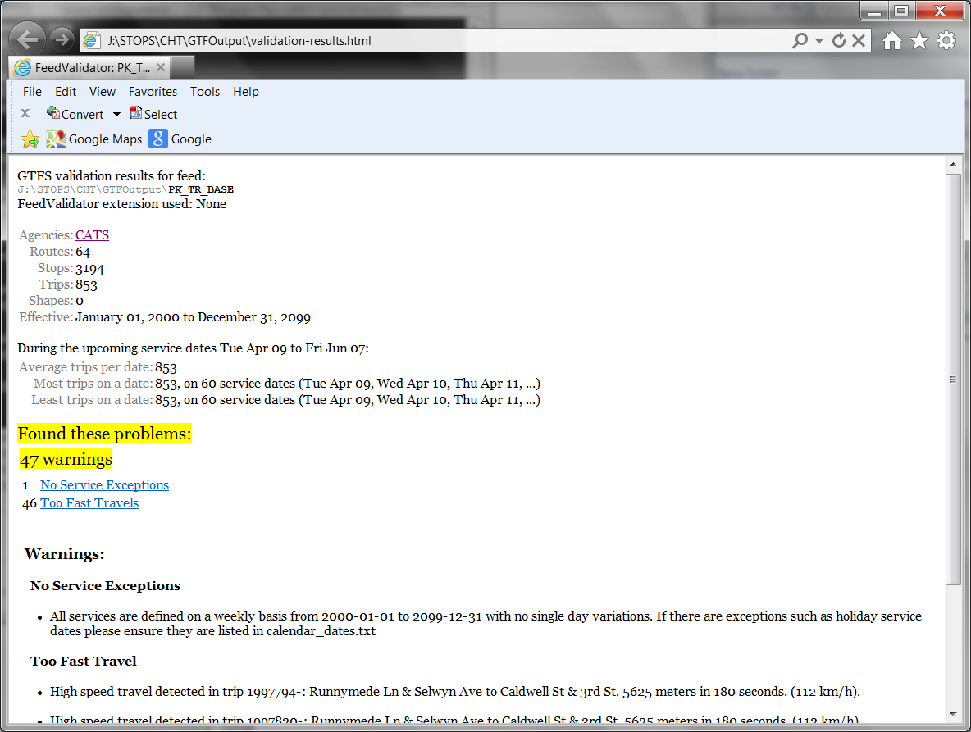

Figure 111. Output from GTFS Feed Validator

Drag the directory identified in Step2 to the schedule_viewer application located in the directory created in Step 1. The program will open a console window as shown in Figure 112 which (after a few minutes) directs the user to open a browser window and type a localhost http: address. After this is done, the window shown in Figure 113 appears. Select a route and a trip time to view that route’s coding. As shown in this example, the re-routing of some trips on Route 12 (using the STOPS editlist capability) was mis-coded leading to an unintended route diversion. When the mis-coded stop was corrected, the route returned to the intended alignment.

Although scheduler_viewer is a powerful tool, the user should be aware of several limitations. First, it is not programmed to handle PNR or editlist files (STOPS extensions to the GTFS standard) so these changes are not displayed. Second, it does not combine GTFS files from multiple agencies, and third, it does not process the frequencies.txt file so the route and trip listing may not be complete.

To work around these limitations, STOPS and the GTFPath program can be used to generate an output GTFS file that includes the capability to combine GTFS from multiple agencies and apply frequency and editlist commands. The use of this command is described in Section 4.5.

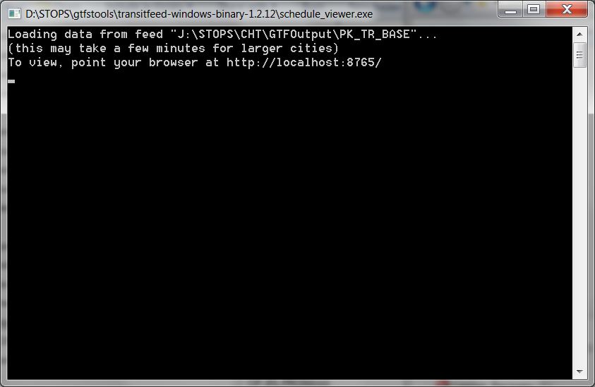

Figure 112. GTFS Schedule Viewer Console Window

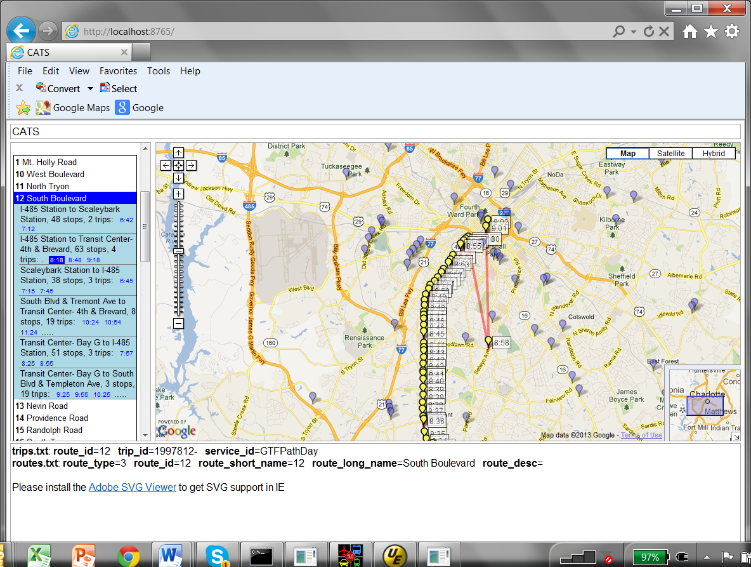

Figure 113. GTFS Schedule Viewer Window Showing Error in Route 12 Re-Routing

## Obtaining GTFS Files

In many cities, GTFS files for the current (and past) transit schedule(s) are available on-line for public use. A good source of publicly-available GTFS files (including feeds from past time periods) is found at:

<https://transitfeeds.com>

Many agencies that do not make their feeds public still create these files so that on-line mapping tools can help customers plan trips. One good way of determining whether an agency generates this data is to go to Google Maps, select “Get Directions” and choose the transit option. Try to build a path between an origin and destination in the corridor to see if the agency has provided Google Maps with a transit feed.

In cases where the transit feed is not publicly available, it might be obtained from the agency’s scheduling department. Even if the agency does not generate a feed, the agency’s scheduling software may be able to generate a GTFS file set for use in STOPS.

# Appendices

## State FIPS Codes

| State Name | Numeric FIPS Code | Alpha  FIPS Code |  | State Name | Numeric FIPS Code | Alpha FIPS Code |
| --- | --- | --- | --- | --- | --- | --- |
| Alabama | 1 | AL |  | Missouri | 29 | MO |
| Alaska | 2 | AK |  | Montana | 30 | MT |
| Arizona | 4 | AZ |  | Nebraska | 31 | NE |
| Arkansas | 5 | AR |  | Nevada | 32 | NV |
| California | 6 | CA |  | New Hampshire | 33 | NH |
| Colorado | 8 | CO |  | New Jersey | 34 | NJ |
| Connecticut | 9 | CT |  | New Mexico | 35 | NM |
| Delaware | 10 | DE |  | New York | 36 | NY |
| District of Columbia | 11 | DC |  | North Carolina | 37 | NC |
| Florida | 12 | FL |  | North Dakota | 38 | ND |
| Georgia | 13 | GA |  | Ohio | 39 | OH |
| Hawaii | 15 | HI |  | Oklahoma | 40 | OK |
| Idaho | 16 | ID |  | Oregon | 41 | OR |
| Illinois | 17 | IL |  | Pennsylvania | 42 | PA |
| Indiana | 18 | IN |  | Rhode Island | 44 | RI |
| Iowa | 19 | IA |  | South Carolina | 45 | SC |
| Kansas | 20 | KS |  | South Dakota | 46 | SD |
| Kentucky | 21 | KY |  | Tennessee | 47 | TN |
| Louisiana | 22 | LA |  | Texas | 48 | TX |
| Maine | 23 | ME |  | Utah | 49 | UT |
| Maryland | 24 | MD |  | Vermont | 50 | VT |
| Massachusetts | 25 | MA |  | Virginia | 51 | VA |
| Michigan | 26 | MI |  | Washington | 53 | WA |
| Minnesota | 27 | MN |  | West Virginia | 54 | WV |
| Mississippi | 28 | MS |  | Wisconsin | 55 | WI |
|  |  |  |  | Wyoming | 56 | WY |

## Census MPO Codes

| MPO Code | MPO Name | Area Name |
| --- | --- | --- |
| 0581 | Auburn-Opelika | Auburn-Opelika, AL |
| 1001 | Birmingham RPC | Birmingham, AL |
| 0451 | Calhoun Area MPO | Anniston, AL |
| 2881 | Gadsden-Etowah MPO | Gadsden, AL |
| 3441 | Huntsville MPO | Huntsville, AL |
| 5241 | Montgomery Division of Planning | Montgomery, AL |
| 2031 | North-Central Alabama Regional COG | Decatur, AL |
| 2651 | Northwest Alabama COG | Florence, AL |
| 5161 | South Alabama RPC | Mobile, AL |
| 2181 | Southeast Wiregrass MPO | Dothan, AL |
| 8601 | West Alabama PDC | Tuscaloosa, AL |
| 0381 | Anchorage MATS | Anchorage, AK |
| 2461 | Fairbanks MATS | Fairbanks, AK |
| 2621 | Flagstaff MPO | Flagstaff, AZ |
| 6201 | Maricopa Association of Governments | Phoenix-Mesa, AZ |
| 8521 | Pima Association of Governments | Tucson, AZ |
| 9361 | Yuma MPO | Yuma, AZ |
| 3341 | Hot Springs MPO | Hot Springs, AR |
| 3701 | Jonesboro MPO | Jonesboro, AR |
| 4401 | Metroplan | Little Rock-North Little Rock, AR |
| 2581 | Northwest AR Regional Planning Commission | Fayetteville-Springdale-Rogers, AR |
| 6241 | Southeast AR Regional Planning Commission | Pine Bluff, AR |
| 8951 | West Memphis Area Transportation Study | West Memphis, AR |
| 2721 | Western Arkansas PDD | Fort Smith, AR-OK |
| 7121 | Association of Monterey Bay Area Governments | Salinas, CA |
| 1621 | Butte County Association of Governments | Chico-Paradise, CA |
| 2841 | Council of Fresno County Governments | Fresno, CA |
| 0681 | Kern County Council of Governments | Bakersfield, CA |
| 4941 | Merced County Association of Governments | Merced, CA |
| 7361 | Metropolitan Transportation Commission-Oakland | San Francisco-Oakland-San Jose, CA |
| 6921 | Sacramento Area COG | Sacramento-Yolo, CA |
| 7321 | San Diego Association of Governments | San Diego, CA |
| 8121 | San Joaquin County COG | Stockton-Lodi, CA |
| 7461 | San Luis Obispo Council of Governments | San Luis Obispo-Atascadero-Paso Robles, CA |
| 7481 | Santa Barbara County Association of Governments | Santa Barbara-Santa Maria-Lompoc, CA |
| 6691 | Shasta County RTPA | Redding, CA |
| 4471 | Southern CA Association of Governments | Los Angeles-Riverside-Orange County, CA |
| 5171 | Stanislaus council of Governments | Modesto, CA |
| 8781 | Tulare County Association of Governments | Visalia-Tulare-Porterville, CA |
| 2081 | Denver Regional COG | Denver-Boulder-Greeley, CO |
| 2996 | Grand Valley MPO | Grand Junction, CO |
| 2671 | North Front Range MPO | Fort Collins-Loveland, CO |
| 1721 | Pikes Peak Area COG | Colorado Springs, CO |
| 6561 | Pueblo Area Council of Governments | Pueblo, CO |
| 0910 | Capitol Region COG | Hartford, CT |
| 0909 | Central Connecticut RPA | Brisol, CT |
| 0905 | Central Naugatuck Valley COG | Waterbury, CT |
| 0912 | Connecticut River Estuary RPA | Old Saybrook, CT |
| 0907 | Greater Bridgeport / Valley MPO | Bridgeport, CT |
| 0902 | Housatonic Valley Council of Elected Officials | Danbury, CT |
| 0904 | Litchfield Hills Council of Elected Officials | Torrington, CT |
| 0911 | Midstate Regional Planning Agency | Middletown, CT |
| 0915 | Northeastern Connecticut COG | Putnam, CT |
| 0903 | Northwestern Connecticut COG | Warren, CT |
| 0908 | South Central Region COG | New Haven, CT |
| 0901 | South Western Regional Planning Agency | Stamford-Norwalk, CT |
| 0913 | Southeastern Connecticut COG | New London-Norwich, CT |
| 0906 | Valley Regional Planning Agency | Derby-Shelton, CT |
| 0914 | Windham Regional Planning Agency | Willimantic, CT |
| 2191 | Dover/Kent County MPO | Dover, DE |
| 9161 | Wilmington Area Planning Council | Wilmington-Newark, DE-MD |
| 8841 | Metropolitan Washington COG | Washington, DC-MD-VA |
| 4901 | Brevard County MPO | Melbourne-Titusville-Palm Bay, FL |
| 2681 | Broward County MPO | Fort Lauderdale, FL |
| 6581 | Charlotte County - Punta Gorda MPO | Punta Gorda, FL |
| 5346 | Collier County MPO | Naples, FL |
| 8281 | District 7 FDOT | Tampa-St. Petersburg-Clearwater, FL |
| 3601 | First Coast MPO | Jacksonville, FL |
| 2751 | Okaloosa-Walton TPO | Fort Walton Beach, FL |
| 2901 | Gainesville Urbanized Area MPO | Gainesville, FL |
| 8701 | Indian River County MPO | Vero Beach, FL |
| 2701 | Lee County MPO | Fort Myers-Cape Coral, FL |
| 8131 | Martin County MPO | Stuart, FL |
| 5961 | Metroplan Orlando | Orlando, FL |
| 5001 | Miami-Dade Metropolitan Planning Organization | Miami, FL |
| 5791 | Ocala-Marion County MPO | Ocala, FL |
| 8961 | Palm Beach County MPO | West Palm Beach-Boca Raton, FL |
| 6016 | Panama City MPO | Panama City, FL |
| 6081 | Pensacola MPO | Pensacola, FL |
| 3981 | Polk Transportation Planning Organization | Lakeland-Winter Haven, FL |
| 7511 | Sarasota-Manatee MPO | Sarasota-Bradenton, FL |
| 2711 | St. Lucie MPO | Fort Pierce-Port St. Lucie, FL |
| 8241 | Tallahassee-Leon County MPO | Tallahassee, FL |
| 2021 | Volusia County MPO | Daytona Beach, FL |
| 0121 | Albany Dougherty County Planning Commission | Albany, GA |
| 0501 | Athens-Clarke County MPO | Athens, GA |
| 0521 | Atlanta Regional Commission | Atlanta, GA |
| 0601 | Augusta Richmond County PC | Augusta-Aiken, GA-SC |
| 7521 | Chatham County-Savannah Metropolitan Planning Comm. | Savannah, GA |
| 1801 | Columbus-Phenix City Transportation Study | Columbus, GA-AL |
| 1251 | Brunswick Area Transportation Study | Brunswick GA |
| 4681 | Macon Area Transportation Study | Macon, GA |
| 6911 | Rome-Floyd County Planning Commission | Rome, GA |
| 8821 | Warner Robins MPO | Warner Robins, GA |
| 3321 | Oahu Metropolitan Planning Organization | Honolulu, HI |
| 6341 | Bannock Planning Organization | Pocatello, ID |
| 3461 | Bonneville MPO | Idaho Falls,ID |
| 1081 | Community Planning Association of Southwest Idaho | Boise City, ID |
| 1961 | Bi-State Regional Commission | Davenport-Moline-Rock Island, IA-IL |
| 1401 | Champaign County RPC | Champaign-Urbana, IL |
| 1601 | Chicago Area Transportation Study | Chicago, IL |
| 3741 | Kankakee County RPC | Kankakee, IL |
| 2041 | Macon County RPC | Decatur, IL |
| 1041 | McLean County RPC | Bloomington-Normal, IL |
| 6881 | Rockford Area Transportation Study | Rockford, IL |
| 7881 | Springfield-Sangamon County RPC | Springfield, IL |
| 6121 | Tri-County Regional Planning Commission--IL | Peoria-Pekin, IL |
| 3921 | Tippecanoe County Area Planning Commission | Lafayette, IN |
| 1021 | Bloomington Area Transportation Study | Bloomington-Normal, IN |
| 5281 | Delaware-Muncie MPC | Muncie, IN |
| 2441 | Evansville Urban Transportation Study | Evansville-Henderson, IN-KY |
| 3481 | Indianapolis MPO | Indianapolis, IN |
| 3851 | Kokomo-Howard County Governmental Coordinating Council | Kokomo, IN |
| 0401 | Madison County COG | Anderson, IN |
| 7801 | Michiana Area Council of Governments | South Bend, IN |
| 2761 | Northeastern Indiana Reg. Coordinating Council | Fort Wayne, IN |
| 2961 | Northwestern Indiana RPC | Gary, IN |
| 8321 | West Central Indiana Economic Development District | Terre Haute, IN |
| 8921 | Black Hawk Metropolitan Area Transportation Policy Board | Waterloo-Cedar Falls, IA |
| 2121 | Des Moines Area MPO | Des Moines, IA |
| 2201 | Dubuque Metropolitan Area Transportation Study | Dubuque, IA |
| 3501 | Johnson County COG | Iowa City, IA |
| 1361 | Linn County Reg. Planning Commission | Cedar Rapids, IA |
| 7721 | Siouxland Interstate Metropolitan Planning Council | Sioux City, IA-NE |
| 4151 | Lawrence-Douglas MPO | Lawrence, KS |
| 8441 | Topeka-Shawnee County MPO | Topeka, KS |
| 9041 | Wichita-Sedgewick County MPO | Wichita, KS |
| 1141 | Bowling Green-Warren County | Bowling Green, KY |
| 3411 | Ashland Urbanized Area | Ashland, KY |
| 5991 | Green River Area Development District | Owensboro, KY |
| 4521 | Kentuckiana Reg. Planning and Development Agency | Louisville, KY-IN |
| 4281 | Lexington-Fayette Urban County Government | Lexington, KY |
| 0761 | Capital Region Planning Commission | Baton Rouge, LA |
| 3961 | Imperial Calcasieu Regional Planning & Dev. Commission | Lake Charles, LA |
| 3881 | Lafayette City - Parish Consolidated Government | Lafayette, LA |
| 5561 | New Orleans RPC | New Orleans, LA |
| 7681 | Northwest Louisiana COG | Shreveport-Bossier City, LA |
| 5201 | Ouachita Council of Governments | Monroe, LA |
| 0221 | Rapides Area Planning Commission | Alexandria, LA |
| 3351 | Houma-Thibodaux MPO | Houma, LA |
| 4241 | Androscoggin Transportation Resource Center | Lewiston-Auburn, ME |
| 0731 | Bangor Area Comprehensive Transportation System | Bangor, ME |
| 6401 | Greater Portland COG | Portland, ME |
| 7471 | Southern Maine RPC | Sanford, ME |
| 0721 | Baltimore Metropolitan Council | Baltimore, MD |
| 1901 | Cumberland Urbanized Area | Cumberland, MD-WV |
| 3181 | Hagerstown-Eastern Panhandle MPO | Hagerstown, MD |
| 6321 | Berkshire County Regional Planning Commission | Pittsfield, MA |
| 1121 | Boston MPO | Boston, MA |
| 0741 | Cape Cod Commission | Barnstable-Yarmouth, MA |
| 9241 | Central Massachusetts RPC | Worcester, MA |
| 1126 | Central Transportation Planning | Boston metro, MA |
| 3101 | Franklin Regional COG | Greenfield, MA |
| 4861 | Marthas Vineyard Commission | Martha's Vineyard, MA |
| 4161 | Merrimack Valley Planning Commission | Lawrence, MA |
| 2601 | Montachusett RPC | Fitchburg-Leominster, MA |
| 5301 | Nantucket Planning and Economic Devp. Commission | Nantucket, MA |
| 4561 | Northern Middlesex COG | Lowell, MA |
| 1201 | Old Colony Planning Council | Brockton, MA |
| 8001 | Pioneer Valley Planning Commission | Springfield, MA |
| 2481 | Southeastern Regional Planning and Economic Dev. | Fall River, MA |
| 0781 | Battle Creek Area Transportation Study | Battle Creek, MI |
| 0801 | Bay City Area Transportation Study | Bay City, MI |
| 2641 | Genesse County MPO | Flint, MI |
| 3001 | Grand Valley Metropolitan Council | Grand Rapids, MI |
| 3721 | Kalamazoo Area Transportation Study | Kalamazoo, MI |
| 3311 | Macatawa Area Coordinating Council | Holland, MI |
| 3521 | Region 2 Planning Commission | Jackson, MI |
| 6961 | Saginaw Co Metro Planning Commission | Saginaw-Bay City-Midland, MI |
| 2161 | Southeast Michigan COG | Detroit-Ann Arbor, MI |
| 0871 | Southwestern Michigan Commission | Benton Harbor, MI |
| 4041 | Tri-County RPC--MI | Lansing-East Lansing, MI |
| 5291 | West Michigan Shoreline RDC | Muskegon, MI |
| 2241 | Arrowhead Regional Development Commission | Duluth-Superior, MN-WI |
| 5121 | Metropolitan Council of the Twin Cities Area | Minneapolis-St. Paul, MN-WI |
| 6821 | Rochester-Olmsted COG | Rochester, MN |
| 6981 | St. Cloud Area Planning Organization | St. Cloud, MN |
| 3561 | Central Mississippi Planning and Development District | Jackson, MS |
| 0921 | Gulf Regional Planning Commission | Biloxi-Gulfport-Pascagoula, MS |
| 3286 | Hattiesburg-Petal-Forrest-Lamar MPO | Hattiesburg, MS |
| 1741 | Columbia Area Transportation Study | Columbia, MO |
| 7041 | East-West Gateway Coordinating Council | St. Louis, MO-IL |
| 3711 | Joplin Area Transportation Study Organization | Joplin, MO |
| 3761 | Mid-America Regional Council | Kansas City, MO-KS |
| 7921 | Springfield Area Transportation Study Org. | Springfield, MO |
| 7001 | St. Joseph Area Transportation Study Organization | St. Joseph, MO |
| 3041 | Great Falls City-County Planning Board | Great Falls, MT |
| 5141 | Missoula Transportation Policy Coordinating Commit | Missoula, MT |
| 0881 | Yellowstone County Board of Planning | Billings, MT |
| 4361 | Lincoln-Lancaster MPO | Lincoln, NE |
| 5921 | Omaha-Council Bluffs Metro Area Planning Agency | Omaha, NE-IA |
| 4121 | Southern Nevada RTC | Las Vegas, NV-AZ |
| 9371 | Tahoe MPO | Zephyr Cove, NV |
| 6721 | Washoe County RTC | Reno, NV |
| 5351 | Nashua Regional Planning Commission | Nashua, NH |
| 7061 | Salem/Plaistow MPO | Salem, NH |
| 6451 | Sea Coast MPO | Portsmouth-Rochester, NH-ME |
| 4761 | Southern NH Planning Commission | Manchester, NH |
| 5641 | North Jersey Transportation Planning Authority | Newark, NJ |
| 0561 | South Jersey Transportation Planning Organization | Atlantic-Cape May, NJ |
| 4101 | Las Cruces MPO | Las Cruces, NM |
| 0201 | Mid Region MPO | Albuquerque, NM |
| 7491 | Santa Fe MPO | Santa Fe, NM |
| 2976 | Adirondack-Glens Falls Transportation Council | Glens Falls, NY |
| 0961 | Binghamton Metropolitan Transportation Study | Binghamton, NY |
| 0161 | Capital District Transportation Committee | Albany-Schenectady-Troy, NY |
| 2336 | Elmira-Chemung Transportation Committee | Elmira, NY |
| 6841 | Genesee Transportation Council | Rochester, NY |
| 1281 | Greater Buffalo Niagara Transportation Commission | Buffalo-Niagara Falls, NY |
| 8681 | Herkimer-Oneida Counties Transportation Study | Utica-Rome, NY |
| 3511 | Ithaca-Tompkins County Transportation Council | Ithaca, NY |
| 3836 | Kingston MPO | Kingston, NY |
| 5601 | New York Metropolitan Transportation Council | New York, NY |
| 5661 | Newburgh/Orange County Transportation Council | Newburgh, NY-PA |
| 2281 | Poughkeepsie-Dutchess County Transportation Council | Dutchess County, NY |
| 8161 | Syracuse Metropolitan Transportation Council | Syracuse, NY |
| 0481 | Asheville Urban Area MPO | Asheville, NC |
| 3111 | Burlington-Graham MPO | Burlington, NC |
| 1861 | Cabarrus-South Rowan MPO | Concord, NC |
| 6641 | Capital Area MPO | Raleigh, NC |
| 3606 | City of Jacksonville | Jacksonville, NC |
| 2261 | Durham-Chapel Hill-Carrboro MPO | Durham-Chapel Hill, NC |
| 2561 | Fayetteville Area Metropolitan Planning Organization | Fayetteville, NC |
| 2966 | Gaston Urban Area MPO | Gastonia, NC |
| 2981 | Goldsboro Urbanized Area MPO | Goldsboro, NC |
| 3121 | Greensboro Urban Area MPO | Greensboro, NC |
| 3151 | Greenville Urban Area MPO | Greenville, NC |
| 3291 | Hickory-Newton-Conover MPO | Hickory-Morganton-Lenoir, NC |
| 1521 | Mecklenburg-Union MPO | Charlotte, NC |
| 6896 | Rocky Mount Urban Area MPO | Rocky Mount, NC |
| 3301 | High Point Urban Area MPO | High Point, NC |
| 9181 | Wilmington Urban Area MPO | Wilmington, NC |
| 9201 | Winston Salem/Forsyth County MPO | Winston-Salem, NC |
| 1011 | Bismarck-Mandan MPO | Bismarck, ND |
| 2521 | Fargo-Moorhead Metropolitan COG | Fargo-Moorhead, ND-MN |
| 2986 | Grand Forks-East Grand Forks MPO | Grand Forks, ND-MN |
| 0081 | Akron Metropolitan Area Transportation Study | Akron, OH |
| 8081 | Brooke-Hancock-Jefferson Metropolitan Planning Com | Steubenville-Weirton, OH-WV |
| 8011 | Clark County-Springfield Transportation Coordinating Committee | Springfield, OH |
| 9321 | Eastgate Regional COG | Youngstown-Warren, OH |
| 5651 | Licking County Area Transportation Study | Newark, OH |
| 4321 | Lima-Allen County RPC | Lima, OH |
| 2001 | Miami Valley Regional Planning Commission | Dayton, OH |
| 1841 | Mid-Ohio RPC | Columbus, OH |
| 1681 | Northeast Ohio Areawide Coordinating Agency | Cleveland, OH |
| 1641 | Ohio-Kentucky-Indiana Regional COG | Cincinnati-Hamilton, OH-KY-IN |
| 4801 | Richland County RPC | Mansfield, OH |
| 1321 | Stark County Area Transportation Study | Canton-Massillon, OH |
| 8401 | Toledo Metropolitan Area COG | Toledo, OH |
| 5881 | Association of Central Oklahoma Governments | Oklahoma City, OK |
| 8561 | Indian Nations COG | Tulsa, OK |
| 4201 | Lawton Metropolitan Area PC | Lawton, OK |
| 2401 | Lane Council of Governments | Eugene-Springfield, OR |
| 6441 | Metro | Portland, OR |
| 7081 | Salem Keizer Area Transportation Study | Salem, OR |
| 4991 | Rogue Valley COG | Medford-Ashland, OR |
| 0281 | Blair County Planning Commission | Altoona, PA |
| 3681 | Cambria County Planning Commission | Johnstown, PA |
| 8051 | Centre Region MPO | State College, PA |
| 6161 | Delaware Valley Regional Planning Commission | Philadelphia-Wilmington-Atlantic City, PA-NJ-DE-MD |
| 2361 | Erie MPO | Erie, PA |
| 7561 | Lackawanna-Luzerne Transportation Study | Scranton--Wilkes-Barre--Hazleton, PA |
| 4001 | Lancaster County Transportation Coordinating Committee | Lancaster, PA |
| 5401 | Lawrence County Planning Department | New Castle, PA |
| 0241 | Lehigh Valley Transportation Study | Allentown-Bethlehem-Easton, PA |
| 9141 | Lycoming County Planning Commission | Williamsport, PA |
| 7611 | Shenango Valley Area Transportation Study | Sharon, PA |
| 6681 | Reading Area Transportation Study | Reading, PA |
| 6281 | Southwestern Pennsylvania Commission | Pittsburgh, PA |
| 3241 | Harrisburg Area Transportation Study | Harrisburg-Lebanon-Carlisle, PA |
| 9281 | York County Planning Commission | York, PA |
| 6481 | RI Statewide Planning Program | Providence, RI |
| 0406 | Anderson MPO | Anderson, SC |
| 1761 | Central Midlands COG | Columbia, SC |
| 1441 | Charleston Area Transportation Study | Charleston, SC |
| 2656 | Florence Area Transportation Study | Florence, SC |
| 3161 | Greenville Area Transportation Study | Greenville, SC |
| 6861 | Rock Hill-Fort Mill Area Trans. Study Policy | Rock Hill, SC |
| 7821 | Spartanburg Area Transportation Study | Spartanburg, SC |
| 8141 | Sumter Area Transportation Study | Sumter, SC |
| 2971 | Waccamaw RPC | Georgetown, SC |
| 6661 | Rapid City Area MPO | Rapid City, SD |
| 7761 | Sioux Falls MPO | Sioux Falls, SD |
| 1161 | Bristol Urban Area MPO | Bristol, TN |
| 1561 | Chattanooga Urban Area MPO | Chattanooga, TN-GA |
| 1661 | Clarksville Urban Area MPO | Clarksville-Hopkinsville, TN-KY |
| 3581 | Jackson MPO | Jackson, TN |
| 3661 | Johnson City MPO | Johnson City, TN |
| 3831 | Kingsport Urban Area MPO | Kingsport, TN |
| 3841 | Knoxville MPO | Knoxville, TN |
| 4921 | Memphis MPO | Memphis, TN-AR-MS |
| 5361 | Nashville Area MPO | Nashville, TN |
| 0041 | Abilene MPO | Abilene, TX |
| 0321 | Amarillo MPO | Amarillo, TX |
| 1241 | Brownsville MPO | Brownsville, TX |
| 1261 | Bryan-College Station MPO | Bryan-College Station, TX |
| 0641 | Capital Area MPO | Austin-San Marcos, TX |
| 1881 | Corpus Christi MPO | Corpus Christi, TX |
| 2321 | El Paso MPO | El Paso, TX |
| 3201 | Harlingen-San Benito MPO | Harlingen-San Benito, TX |
| 4881 | Hidalgo County MPO | McAllen-Edinburg-Mission, TX |
| 3361 | Houston-Galveston Area Council | Houston-Galveston, TX |
| 3811 | Killeen-Temple Urban Transportation Study | Killeen-Temple, TX |
| 4081 | Laredo Urban Transportation Study | Laredo, TX |
| 4421 | Longview MPO | Longview-Marshall, TX |
| 4601 | Lubbock MPO | Lubbock, TX |
| 1921 | North Central Texas COG | Dallas-Fort Worth, TX |
| 5801 | Permian Basin RPC | Odessa-Midland, TX |
| 7201 | San Angelo MPO | San Angelo, TX |
| 7241 | San Antonio-Bexar County MPO | San Antonio, TX |
| 0841 | South East Texas Regional Planning Commission | Beaumont-Port Arthur, TX |
| 7641 | Sherman Denison MPO | Sherman-Denison, TX |
| 8641 | Tyler MPO | Tyler, TX |
| 8751 | Victoria MPO | Victoria, TX |
| 8801 | Waco MPO | Waco, TX |
| 9081 | Wichita Falls MPO | Wichita Falls, TX |
| 8361 | Texarkana MPO | Texarkana, TX-Texarkana, AR |
| 4411 | Cache MPO | Logan, UT |
| 6971 | Dixie MPO | St George, UT |
| 6521 | Mountainland Association of Governments | Provo-Orem, UT |
| 7161 | Wasatch Front Regional Council | Salt Lake City-Ogden, UT |
| 1306 | Chittenden County MPO | Burlington, VT |
| 6141 | Crater Planning District Commission | Petersburg, VA |
| 5721 | Hampton Roads Planning District Commission | Norfolk-Virginia Beach-Newport News, VA-NC |
| 2801 | Fredericksburg Area MPO | Fredericksburg, VA |
| 4641 | Central Virginia MPO | Lynchburg, VA |
| 6761 | Richmond Regional Planning District Commission | Richmond, VA |
| 6801 | Roanoke Valley Area MPO | Roanoke, VA |
| 1541 | Thomas Jefferson Planning District Commission | Charlottesville, VA |
| 1951 | West Piedmont Planning District Commission | Danville, VA |
| 6741 | Benton-Franklin COG | Richland-Kennewick-Pasco, WA |
| 4416 | Longview-Kelso-Rainier MPO | Longview, WA |
| 7601 | Puget Sound Regional Council | Seattle-Tacoma-Bremerton, WA |
| 5261 | Skagit COG | Mount Vernon, WA |
| 8691 | Southwest Washington Regional Transportation Council | Vancouver, WA |
| 7841 | Spokane Regional Transportation Council | Spokane, WA |
| 5911 | Thurston Regional Planning Council | Olympia, WA |
| 8946 | Wenatchee Valley Transportation Council | Wenatchee, WA |
| 0861 | Whatcom COG | Bellingham, WA |
| 9261 | Yakima Valley COG | Yakima, WA |
| 9001 | Bel-O-Mar Regional Council | Wheeling, WV-OH |
| 3401 | KYOVA Interstate Planning Commission | Huntington, WV |
| 5251 | Morgantown, WV MPO | Morgantown, WV |
| 1481 | Regional Intergovernmental Council | Charleston, WV |
| 6021 | WWW Interstate Planning Commission | Parkersburg-Marietta, WV-OH |
| 3081 | Bay-Lake Regional Planning Commission | Sheboygan, WI |
| 3086 | Brown County Planning Commission | Green Bay, WI |
| 0461 | East Central Wisconsin Regional Planning Commission | Appleton-Oshkosh-Neenah, WI |
| 3621 | Janesville Area Transportation Study | Janesville, WI |
| 3871 | La Crosse Area Planning Committee | La Crosse, WI-MN |
| 4721 | Madison Area MPO | Madison, WI |
| 8941 | Marathon County Metro Planning Commission | Wausau, WI |
| 5081 | South East Wisconsin Regional Planning Commission | Milwaukee-Racine, WI |
| 0866 | Stateline Area Transportation Study | Beloit, WI |
| 2291 | West Central Wisconsin RPC | Eau Claire, WI |
| 1351 | Casper Area Transportation Planning Process | Casper, WY |
| 1581 | Cheyenne Area Transportation Planning Process | Cheyenne, WY |

## CTPP 2000 Geography Types by MPO County

| County | FIPS STCOU | MPO Name | MPO Code | 2000 CTPP Geography |
| --- | --- | --- | --- | --- |
| Lee County, AL | 01081 | Auburn-Opelika | 0581 | TAZ |
| Jefferson County, AL | 01073 | Birmingham RPC | 1001 | TAZ |
| Shelby County, AL | 01117 | Birmingham RPC | 1001 | TAZ |
| Calhoun County, AL | 01015 | Calhoun Area MPO | 0451 | TAZ |
| Talladega County, AL | 01121 | Calhoun Area MPO | 0451 | TAZ |
| Lee County, AL | 01081 | Columbus-Phenix City Transportation Study | 1801 | TAZ |
| Russell County, AL | 01113 | Columbus-Phenix City Transportation Study | 1801 | TAZ |
| Calhoun County, AL | 01015 | Gadsen-Etowah MPO | 2881 | BG |
| Etowah County, AL | 01055 | Gadsen-Etowah MPO | 2881 | BG |
| Limestone County, AL | 01083 | Huntsville MPO | 3441 | BG |
| Madison County, AL | 01089 | Huntsville MPO | 3441 | TAZ |
| Autauga County, AL | 01001 | Montgomery Division of Planning | 5241 | BG |
| Elmore County, AL | 01051 | Montgomery Division of Planning | 5241 | BG |
| Montgomery County, AL | 01101 | Montgomery Division of Planning | 5241 | BG |
| Cullman County, AL | 01043 | North Central Alabama Regional COG | 2031 | BG |
| Lawrence County, AL | 01079 | North Central Alabama Regional COG | 2031 | BG |
| Limestone County, AL | 01083 | North Central Alabama Regional COG | 2031 | TAZ |
| Morgan County, AL | 01103 | North Central Alabama Regional COG | 2031 | TAZ |
| Colbert County, AL | 01033 | Northwest Alabama COG | 2651 | TAZ |
| Lauderdale County, AL | 01077 | Northwest Alabama COG | 2651 | TAZ |
| Mobile County, AL | 01097 | South Alabama RPC | 5161 | TAZ |
| Dale County, AL | 01045 | Southeast Wiregrass Area MPO | 2181 | TAZ |
| Henry County, AL | 01067 | Southeast Wiregrass Area MPO | 2181 | TAZ |
| Houston County, AL | 01069 | Southeast Wiregrass Area MPO | 2181 | TAZ |
| Tuscaloosa County, AL | 01125 | West Alabama PDC | 8601 | TAZ |
| Anchorage Municipality, AK | 02020 | Anchorage MATS | 0381 | TAZ |
| Fairbanks North Star Borough, AK | 02090 | Fairbanks MATS | 2461 | BG |
| Coconino County, AZ | 04005 | Flagstaff MPO | 2621 | BG |
| Maricopa County, AZ | 04013 | Maricopa Assn. Of Gov. | 6201 | TAZ |
| Pinal County, AZ | 04021 | Maricopa Assn. Of Gov. | 6201 | TAZ |
| Yavapai County, AZ | 04025 | Maricopa Assn. Of Gov. | 6201 | TAZ |
| Pima County, AZ | 04019 | Pima Assn. Of Gov. | 8521 | TAZ |
| Pinal County, AZ | 04021 | Pima Assn. Of Gov. | 8521 | TAZ |
| Yuma County, AZ | 04027 | Yuma MPO | 9361 | Tract |
| Garland County, AR | 05051 | Hot Springs MPO | 3341 | BG |
| Hot Spring County, AR | 05059 | Hot Springs MPO | 3341 | BG |
| Craighead County, AR | 05031 | Jonesboro MPO | 3701 | BG |
| Cleburne County, AR | 05023 | Metroplan | 4401 | BG |
| Conway County, AR | 05029 | Metroplan | 4401 | BG |
| Faulkner County, AR | 05045 | Metroplan | 4401 | BG |
| Grant County, AR | 05053 | Metroplan | 4401 | BG |
| Hot Spring County, AR | 05059 | Metroplan | 4401 | BG |
| Lonoke County, AR | 05085 | Metroplan | 4401 | BG |
| Perry County, AR | 05105 | Metroplan | 4401 | BG |
| Prairie County, AR | 05117 | Metroplan | 4401 | BG |
| Pulaski County, AR | 05119 | Metroplan | 4401 | BG |
| Saline County, AR | 05125 | Metroplan | 4401 | BG |
| Van Buren County, AR | 05141 | Metroplan | 4401 | BG |
| White County, AR | 05145 | Metroplan | 4401 | BG |
| Benton County, AR | 05007 | Northwest Arkansas RPC | 2581 | BG |
| Carroll County, AR | 05015 | Northwest Arkansas RPC | 2581 | BG |
| Madison County, AR | 05087 | Northwest Arkansas RPC | 2581 | BG |
| Washington County, AR | 05143 | Northwest Arkansas RPC | 2581 | BG |
| Cleveland County, AR | 05025 | Southeast Arkansas RPC | 6241 | BG |
| Jefferson County, AR | 05069 | Southeast Arkansas RPC | 6241 | BG |
| Miller County, AR | 05091 | Texarkana MPO | 8361 | TAZ |
| Crittenden County, AR | 05035 | West Memphis MPO | 8951 | BG |
| Crawford County, AR | 05033 | Western Arkansas PDD | 2721 | TAZ |
| Sebastian County, AR | 05131 | Western Arkansas PDD | 2721 | TAZ |
| Alameda County, CA | 06001 | Association of Monterey Bay Area Governments | 7121 | BG |
| Merced County, CA | 06047 | Association of Monterey Bay Area Governments | 7121 | BG |
| Monterey County, CA | 06053 | Association of Monterey Bay Area Governments | 7121 | BG |
| San Benito County, CA | 06069 | Association of Monterey Bay Area Governments | 7121 | BG |
| San Luis Obispo County, CA | 06079 | Association of Monterey Bay Area Governments | 7121 | BG |
| San Mateo County, CA | 06081 | Association of Monterey Bay Area Governments | 7121 | BG |
| Santa Clara County, CA | 06085 | Association of Monterey Bay Area Governments | 7121 | BG |
| Santa Cruz County, CA | 06087 | Association of Monterey Bay Area Governments | 7121 | BG |
| Butte County, CA | 06007 | Butte County Association of Governments | 1621 | TAZ |
| Fresno County, CA | 06019 | Council of Fresno County Governments | 2841 | TAZ |
| Kern County, CA | 06029 | Kern County Council of Governments | 0681 | TAZ |
| Merced County, CA | 06047 | Merced County Association of Governments | 4941 | TAZ |
| Alameda County, CA | 06001 | Metropolitan Transportation Commission-Oakland | 7361 | TAZ |
| Contra Costa County, CA | 06013 | Metropolitan Transportation Commission-Oakland | 7361 | TAZ |
| Marin County, CA | 06041 | Metropolitan Transportation Commission-Oakland | 7361 | TAZ |
| Napa County, CA | 06055 | Metropolitan Transportation Commission-Oakland | 7361 | TAZ |
| San Francisco County, CA | 06075 | Metropolitan Transportation Commission-Oakland | 7361 | TAZ |
| San Mateo County, CA | 06081 | Metropolitan Transportation Commission-Oakland | 7361 | TAZ |
| Santa Clara County, CA | 06085 | Metropolitan Transportation Commission-Oakland | 7361 | TAZ |
| Solano County, CA | 06095 | Metropolitan Transportation Commission-Oakland | 7361 | TAZ |
| Sonoma County, CA | 06097 | Metropolitan Transportation Commission-Oakland | 7361 | TAZ |
| El Dorado County, CA | 06017 | Sacramento Area COG | 6921 | TAZ |
| Placer County, CA | 06061 | Sacramento Area COG | 6921 | TAZ |
| Sacramento County, CA | 06067 | Sacramento Area COG | 6921 | TAZ |
| Sutter County, CA | 06101 | Sacramento Area COG | 6921 | TAZ |
| Yolo County, CA | 06113 | Sacramento Area COG | 6921 | TAZ |
| Yuba County, CA | 06115 | Sacramento Area COG | 6921 | TAZ |
| San Diego County, CA | 06073 | San Diego Association of Governments | 7321 | TAZ |
| San Joaquin County, CA | 06077 | San Joaquin County COG | 8121 | TAZ |
| San Luis Obispo County, CA | 06079 | San Luis Obispo COG | 7461 | TAZ |
| Santa Barbara County, CA | 06083 | Santa Barbara County Association of Governments | 7481 | TAZ |
| Shasta County, CA | 06089 | Shasta County RTPA | 6691 | BG |
| Imperial County, CA | 06025 | Southern CA Association of Governments | 4471 | BG |
| Los Angeles County, CA | 06037 | Southern CA Association of Governments | 4471 | BG |
| Orange County, CA | 06059 | Southern CA Association of Governments | 4471 | BG |
| Riverside County, CA | 06065 | Southern CA Association of Governments | 4471 | BG |
| San Bernardino County, CA | 06071 | Southern CA Association of Governments | 4471 | BG |
| Ventura County, CA | 06111 | Southern CA Association of Governments | 4471 | BG |
| Stanislaus County, CA | 06099 | Stanislaus COG | 5171 | TAZ |
| El Dorado County, CA | 06017 | Tahoe MPO | 9371 | BG |
| Placer County, CA | 06061 | Tahoe MPO | 9371 | BG |
| Fresno County, CA | 06019 | Tulare County Association of Governments | 8781 | BG |
| Kern County, CA | 06029 | Tulare County Association of Governments | 8781 | BG |
| Kings County, CA | 06031 | Tulare County Association of Governments | 8781 | BG |
| Tulare County, CA | 06107 | Tulare County Association of Governments | 8781 | BG |
| Adams County, CO | 08001 | Denver Regional COG | 2081 | TAZ |
| Arapahoe County, CO | 08005 | Denver Regional COG | 2081 | TAZ |
| Boulder County, CO | 08013 | Denver Regional COG | 2081 | TAZ |
| Clear Creek County, CO | 08019 | Denver Regional COG | 2081 | TAZ |
| Denver County, CO | 08031 | Denver Regional COG | 2081 | TAZ |
| Douglas County, CO | 08035 | Denver Regional COG | 2081 | TAZ |
| Elbert County, CO | 08039 | Denver Regional COG | 2081 | TAZ |
| Gilpin County, CO | 08047 | Denver Regional COG | 2081 | TAZ |
| Jefferson County, CO | 08059 | Denver Regional COG | 2081 | TAZ |
| Park County, CO | 08093 | Denver Regional COG | 2081 | BG |
| Weld County, CO | 08123 | Denver Regional COG | 2081 | TAZ |
| Mesa County, CO | 08077 | Grand Valley MPO | 2996 | TAZ |
| Boulder County, CO | 08013 | North Front Range MPO | 2671 | BG |
| Larimer County, CO | 08069 | North Front Range MPO | 2671 | BG |
| Weld County, CO | 08123 | North Front Range MPO | 2671 | BG |
| El Paso County, CO | 08041 | Pikes Peak Area COG | 1721 | TAZ |
| Park County, CO | 08093 | Pikes Peak Area COG | 1721 | BG |
| Teller County, CO | 08119 | Pikes Peak Area COG | 1721 | BG |
| Pueblo County, CO | 08101 | Pueblo Area Council of Governments | 6561 | TAZ |
| Connecticut | **New England states are shown at the end of this file** | | | |
| New Castle County, DE | 10003 | Delaware Valley RPC | 6161 | Tract |
| Kent County, DE | 10001 | Dover/Kent Co MPO | 2191 | BG |
| Sussex County, DE | 10005 | Dover/Kent Co MPO | 2191 | BG |
| New Castle County, DE | 10003 | Wilmington Planning Council | 9161 | BG |
| District of Columbia, DC | 11001 | Metropolitan Washington COG | 8841 | TAZ |
| District of Columbia, DC | 11001 | Baltimore Metropolitan Council | 0721 | Tract |
| Brevard County, FL | 12009 | Brevard MPO | 4901 | TAZ |
| Broward County, FL | 12011 | Broward County MPO | 2681 | TAZ |
| Charlotte County, FL | 12015 | Charlotte County-Punta Gorda MPO | 6581 | TAZ |
| DeSoto County, FL | 12027 | Charlotte County-Punta Gorda MPO | 6581 | Tract |
| Lee County, FL | 12071 | Charlotte County-Punta Gorda MPO | 6581 | TAZ |
| Sarasota County, FL | 12115 | Charlotte County-Punta Gorda MPO | 6581 | TAZ |
| Collier County, FL | 12021 | Collier County MPO | 5346 | BG |
| Citrus County, FL | 12017 | District 7 FDOT | 8281 | TAZ |
| Hernando County, FL | 12053 | District 7 FDOT | 8281 | TAZ |
| Hillsborough County, FL | 12057 | District 7 FDOT | 8281 | TAZ |
| Manatee County, FL | 12081 | District 7 FDOT | 8281 | TAZ |
| Marion County, FL | 12083 | District 7 FDOT | 8281 | TAZ |
| Pasco County, FL | 12101 | District 7 FDOT | 8281 | TAZ |
| Pinellas County, FL | 12103 | District 7 FDOT | 8281 | TAZ |
| Polk County, FL | 12105 | District 7 FDOT | 8281 | TAZ |
| Duval County, FL | 12031 | First Coast MPO | 3601 | TAZ |
| Alachua County, FL | 12001 | Gainesville Urbanized Area MPO | 2901 | TAZ |
| Indian River County, FL | 12061 | Indian River County MPO | 8701 | TAZ |
| Charlotte County, FL | 12015 | Lee County MPO | 2701 | TAZ |
| Collier County, FL | 12021 | Lee County MPO | 2701 | TAZ |
| Lee County, FL | 12071 | Lee County MPO | 2701 | TAZ |
| Martin County, FL | 12085 | Martin County MPO | 8131 | BG |
| St. Lucie County, FL | 12111 | Martin County MPO | 8131 | BG |
| Orange County, FL | 12095 | Metroplan Orlando | 5961 | BG |
| Osceola County, FL | 12097 | Metroplan Orlando | 5961 | BG |
| Seminole County, FL | 12117 | Metroplan Orlando | 5961 | BG |
| Miami-Dade County, FL | 12086 | Miami-Dade MPO | 5001 | BG |
| Marion County, FL | 12083 | Ocala-Marion County MPO | 5791 | TAZ |
| Okaloosa County, FL | 12091 | Okaloosa-Walton TPO | 2751 | TAZ |
| Walton County, FL | 12131 | Okaloosa-Walton TPO | 2751 | TAZ |
| Palm Beach County, FL | 12099 | Palm Beach County MPO | 8961 | TAZ |
| Bay County, FL | 12005 | Panama City MPO | 6016 | TAZ |
| Escambia County, FL | 12033 | Pensacola MPO | 6081 | TAZ |
| Santa Rosa County, FL | 12113 | Pensacola MPO | 6081 | TAZ |
| Polk County, FL | 12105 | Polk TPO | 3981 | BG |
| Manatee County, FL | 12081 | Sarasota-Manatee MPO | 7511 | TAZ |
| Sarasota County, FL | 12115 | Sarasota-Manatee MPO | 7511 | TAZ |
| St. Lucie County, FL | 12111 | St. Lucie MPO | 2711 | BG |
| Leon County, FL | 12073 | Tallahassee-Leon County MPO | 8241 | TAZ |
| Flagler County, FL | 12035 | Volusia County MPO | 2021 | BG |
| Volusia County, FL | 12127 | Volusia County MPO | 2021 | BG |
| Dougherty County, GA | 13095 | Albany Dougherty Regional Transportation Study | 0121 | TAZ |
| Lee County, GA | 13177 | Albany Dougherty Regional Transportation Study | 0121 | TAZ |
| Clarke County, GA | 13059 | Athens Clarke Oconee Regional Transportation Study | 0501 | TAZ |
| Madison County, GA | 13195 | Athens Clarke Oconee Regional Transportation Study | 0501 | Tract |
| Oconee County, GA | 13219 | Athens Clarke Oconee Regional Transportation Study | 0501 | TAZ |
| Barrow County, GA | 13013 | Atlanta Regional Commission | 0521 | BG |
| Bartow County, GA | 13015 | Atlanta Regional Commission | 0521 | TAZ |
| Butts County, GA | 13035 | Atlanta Regional Commission | 0521 | BG |
| Carroll County, GA | 13045 | Atlanta Regional Commission | 0521 | BG |
| Cherokee County, GA | 13057 | Atlanta Regional Commission | 0521 | TAZ |
| Clayton County, GA | 13063 | Atlanta Regional Commission | 0521 | TAZ |
| Cobb County, GA | 13067 | Atlanta Regional Commission | 0521 | TAZ |
| Coweta County, GA | 13077 | Atlanta Regional Commission | 0521 | TAZ |
| Dawson County, GA | 13085 | Atlanta Regional Commission | 0521 | BG |
| DeKalb County, GA | 13089 | Atlanta Regional Commission | 0521 | TAZ |
| Douglas County, GA | 13097 | Atlanta Regional Commission | 0521 | TAZ |
| Fayette County, GA | 13113 | Atlanta Regional Commission | 0521 | TAZ |
| Forsyth County, GA | 13117 | Atlanta Regional Commission | 0521 | TAZ |
| Fulton County, GA | 13121 | Atlanta Regional Commission | 0521 | TAZ |
| Gwinnett County, GA | 13135 | Atlanta Regional Commission | 0521 | TAZ |
| Hall County, GA | 13139 | Atlanta Regional Commission | 0521 | BG |
| Haralson County, GA | 13143 | Atlanta Regional Commission | 0521 | Tract |
| Heard County, GA | 13149 | Atlanta Regional Commission | 0521 | Tract |
| Henry County, GA | 13151 | Atlanta Regional Commission | 0521 | TAZ |
| Jackson County, GA | 13157 | Atlanta Regional Commission | 0521 | BG |
| Jasper County, GA | 13159 | Atlanta Regional Commission | 0521 | Tract |
| Lamar County, GA | 13171 | Atlanta Regional Commission | 0521 | Tract |
| Meriwether County, GA | 13199 | Atlanta Regional Commission | 0521 | Tract |
| Newton County, GA | 13217 | Atlanta Regional Commission | 0521 | BG |
| Paulding County, GA | 13223 | Atlanta Regional Commission | 0521 | TAZ |
| Pickens County, GA | 13227 | Atlanta Regional Commission | 0521 | BG |
| Pike County, GA | 13231 | Atlanta Regional Commission | 0521 | Tract |
| Polk County, GA | 13233 | Atlanta Regional Commission | 0521 | Tract |
| Rockdale County, GA | 13247 | Atlanta Regional Commission | 0521 | TAZ |
| Spalding County, GA | 13255 | Atlanta Regional Commission | 0521 | BG |
| Troup County, GA | 13285 | Atlanta Regional Commission | 0521 | Tract |
| Upson County, GA | 13293 | Atlanta Regional Commission | 0521 | Tract |
| Walton County, GA | 13297 | Atlanta Regional Commission | 0521 | BG |
| Columbia County, GA | 13073 | Augusta Richmond County PC | 0601 | TAZ |
| Richmond County, GA | 13245 | Augusta Richmond County PC | 0601 | TAZ |
| Glynn County, GA | 13127 | Brunswick Area Transportation Study | 1251 | BG |
| Bryan County, GA | 13029 | Chatham County-Savannah MPC | 7521 | BG |
| Chatham County, GA | 13051 | Chatham County-Savannah MPC | 7521 | TAZ |
| Effingham County, GA | 13103 | Chatham County-Savannah MPC | 7521 | BG |
| Catoosa County, GA | 13047 | Chattanooga Urban Area MPO | 1561 | BG |
| Dade County, GA | 13083 | Chattanooga Urban Area MPO | 1561 | BG |
| Walker County, GA | 13295 | Chattanooga Urban Area MPO | 1561 | BG |
| Muscogee County, GA | 13215 | Columbus-Phenix City Transportation Study | 1801 | TAZ |
| Bibb County, GA | 13021 | Macon Area Transportation Study | 4681 | TAZ |
| Jones County, GA | 13169 | Macon Area Transportation Study | 4681 | TAZ |
| Floyd County, GA | 13115 | Rome-Floyd County PC | 6911 | BG |
| Houston County, GA | 13153 | Warner Robins MPO | 8821 | TAZ |
| Peach County, GA | 13225 | Warner Robins MPO | 8821 | TAZ |
| Honolulu County, HI | 15003 | Oahu MPO | 3321 | BG |
| Bannock County, ID | 16005 | Bannock Planning Organization | 6341 | BG |
| Power County, ID | 16077 | Bannock Planning Organization | 6341 | BG |
| Bonneville County, ID | 16019 | Bonneville MPO | 3461 | TAZ |
| Ada County, ID | 16001 | Community Planning Assoc. of Southwest Idaho | 1081 | TAZ |
| Boise County, ID | 16015 | Community Planning Assoc. of Southwest Idaho | 1081 | Tract |
| Canyon County, ID | 16027 | Community Planning Assoc. of Southwest Idaho | 1081 | TAZ |
| Elmore County, ID | 16039 | Community Planning Assoc. of Southwest Idaho | 1081 | Tract |
| Gem County, ID | 16045 | Community Planning Assoc. of Southwest Idaho | 1081 | Tract |
| Owyhee County, ID | 16073 | Community Planning Assoc. of Southwest Idaho | 1081 | Tract |
| Payette County, ID | 16075 | Community Planning Assoc. of Southwest Idaho | 1081 | Tract |
| Kootenai County, ID | 16055 | Spokane RTC | 7841 | BG |
| Henry County, IL | 17073 | Bi-State Regional Commission | 1961 | TAZ |
| Mercer County, IL | 17131 | Bi-State Regional Commission | 1961 | TAZ |
| Rock Island County, IL | 17161 | Bi-State Regional Commission | 1961 | TAZ |
| Champaign County, IL | 17019 | Champaign County RPC | 1401 | TAZ |
| Boone County, IL | 17007 | Chicago Area Transportation Study | 1601 | TAZ |
| Cook County, IL | 17031 | Chicago Area Transportation Study | 1601 | TAZ |
| DeKalb County, IL | 17037 | Chicago Area Transportation Study | 1601 | Tract |
| DuPage County, IL | 17043 | Chicago Area Transportation Study | 1601 | TAZ |
| Grundy County, IL | 17063 | Chicago Area Transportation Study | 1601 | TAZ |
| Kane County, IL | 17089 | Chicago Area Transportation Study | 1601 | TAZ |
| Kankakee County, IL | 17091 | Chicago Area Transportation Study | 1601 | TAZ |
| Kendall County, IL | 17093 | Chicago Area Transportation Study | 1601 | TAZ |
| Lake County, IL | 17097 | Chicago Area Transportation Study | 1601 | TAZ |
| LaSalle County, IL | 17099 | Chicago Area Transportation Study | 1601 | Tract |
| McHenry County, IL | 17111 | Chicago Area Transportation Study | 1601 | TAZ |
| Will County, IL | 17197 | Chicago Area Transportation Study | 1601 | TAZ |
| Winnebago County, IL | 17201 | Chicago Area Transportation Study | 1601 | TAZ |
| Jo Daviess County, IL | 17085 | Dubuque MATS | 2201 | TAZ |
| Madison County, IL | 17119 | East-West Gateway Coordinating Council | 7041 | TAZ |
| Monroe County, IL | 17133 | East-West Gateway Coordinating Council | 7041 | TAZ |
| St. Clair County, IL | 17163 | East-West Gateway Coordinating Council | 7041 | TAZ |
| Kankakee County, IL | 17091 | Kankakee County RPC | 3741 | TAZ |
| Macon County, IL | 17115 | Macon County RPC | 2041 | BG |
| McLean County, IL | 17113 | McLean County RPC | 1041 | TAZ |
| Cook County, IL | 17031 | Northwestern Indiana RPC | 2961 | TAZ |
| DeKalb County, IL | 17037 | Northwestern Indiana RPC | 2961 | TAZ |
| DuPage County, IL | 17043 | Northwestern Indiana RPC | 2961 | TAZ |
| Grundy County, IL | 17063 | Northwestern Indiana RPC | 2961 | TAZ |
| Kane County, IL | 17089 | Northwestern Indiana RPC | 2961 | TAZ |
| Kankakee County, IL | 17091 | Northwestern Indiana RPC | 2961 | TAZ |
| Kendall County, IL | 17093 | Northwestern Indiana RPC | 2961 | TAZ |
| Lake County, IL | 17097 | Northwestern Indiana RPC | 2961 | TAZ |
| McHenry County, IL | 17111 | Northwestern Indiana RPC | 2961 | TAZ |
| Will County, IL | 17197 | Northwestern Indiana RPC | 2961 | TAZ |
| Boone County, IL | 17007 | Rockford Area Transportation Study | 6881 | TAZ |
| DeKalb County, IL | 17037 | Rockford Area Transportation Study | 6881 | BG |
| Ogle County, IL | 17141 | Rockford Area Transportation Study | 6881 | BG |
| Stephenson County, IL | 17177 | Rockford Area Transportation Study | 6881 | BG |
| Winnebago County, IL | 17201 | Rockford Area Transportation Study | 6881 | TAZ |
| Sangamon County, IL | 17167 | Springfield-Sangamon County RPC | 7881 | TAZ |
| Winnebago County, IL | 17201 | Stateline Area Transportation Study | 0866 | TAZ |
| Peoria County, IL | 17143 | Tri-County Regional Planning Commission | 6121 | TAZ |
| Tazewell County, IL | 17179 | Tri-County Regional Planning Commission | 6121 | TAZ |
| Woodford County, IL | 17203 | Tri-County Regional Planning Commission | 6121 | TAZ |
| Monroe County, IN | 18105 | Bloomington Area Transportation Study | 1021 | BG |
| Lake County, IN | 18089 | Chicago Area Transportation Study | 1601 | TAZ |
| Porter County, IN | 18127 | Chicago Area Transportation Study | 1601 | TAZ |
| Delaware County, IN | 18035 | Delaware-Muncie MPC | 5281 | TAZ |
| Randolph County, IN | 18135 | Delaware-Muncie MPC | 5281 | BG |
| Gibson County, IN | 18051 | Evansville Urban Transportation Study | 2441 | TAZ |
| Posey County, IN | 18129 | Evansville Urban Transportation Study | 2441 | TAZ |
| Vanderburgh County, IN | 18163 | Evansville Urban Transportation Study | 2441 | TAZ |
| Warrick County, IN | 18173 | Evansville Urban Transportation Study | 2441 | TAZ |
| Boone County, IN | 18011 | Indianapolis MPO | 3481 | TAZ |
| Hamilton County, IN | 18057 | Indianapolis MPO | 3481 | TAZ |
| Hancock County, IN | 18059 | Indianapolis MPO | 3481 | TAZ |
| Hendricks County, IN | 18063 | Indianapolis MPO | 3481 | TAZ |
| Johnson County, IN | 18081 | Indianapolis MPO | 3481 | TAZ |
| Marion County, IN | 18097 | Indianapolis MPO | 3481 | TAZ |
| Morgan County, IN | 18109 | Indianapolis MPO | 3481 | TAZ |
| Shelby County, IN | 18145 | Indianapolis MPO | 3481 | TAZ |
| Clark County, IN | 18019 | Kentuckiana Regional Planning and Development Agency | 4521 | TAZ |
| Floyd County, IN | 18043 | Kentuckiana Regional Planning and Development Agency | 4521 | TAZ |
| Howard County, IN | 18067 | Kokomo-Howard County Governmental Coordinating Council | 3851 | TAZ |
| Madison County, IN | 18095 | Madison County COG | 0401 | BG |
| Elkhart County, IN | 18039 | Michiana Area COG | 7801 | TAZ |
| Fulton County, IN | 18049 | Michiana Area COG | 7801 | BG |
| Kosciusko County, IN | 18085 | Michiana Area COG | 7801 | TAZ |
| LaGrange County, IN | 18087 | Michiana Area COG | 7801 | BG |
| LaPorte County, IN | 18091 | Michiana Area COG | 7801 | TAZ |
| Marshall County, IN | 18099 | Michiana Area COG | 7801 | TAZ |
| Noble County, IN | 18113 | Michiana Area COG | 7801 | TAZ |
| Pulaski County, IN | 18131 | Michiana Area COG | 7801 | BG |
| St. Joseph County, IN | 18141 | Michiana Area COG | 7801 | TAZ |
| Starke County, IN | 18149 | Michiana Area COG | 7801 | BG |
| Wabash County, IN | 18169 | Michiana Area COG | 7801 | BG |
| Whitley County, IN | 18183 | Michiana Area COG | 7801 | TAZ |
| Adams County, IN | 18001 | Northeastern Indiana Reg. Coordinating Council | 2761 | TAZ |
| Allen County, IN | 18003 | Northeastern Indiana Reg. Coordinating Council | 2761 | TAZ |
| DeKalb County, IN | 18033 | Northeastern Indiana Reg. Coordinating Council | 2761 | TAZ |
| Huntington County, IN | 18069 | Northeastern Indiana Reg. Coordinating Council | 2761 | TAZ |
| Noble County, IN | 18113 | Northeastern Indiana Reg. Coordinating Council | 2761 | TAZ |
| Steuben County, IN | 18151 | Northeastern Indiana Reg. Coordinating Council | 2761 | TAZ |
| Wells County, IN | 18179 | Northeastern Indiana Reg. Coordinating Council | 2761 | TAZ |
| Whitley County, IN | 18183 | Northeastern Indiana Reg. Coordinating Council | 2761 | TAZ |
| Lake County, IN | 18089 | Northwestern Indiana RPC | 2961 | TAZ |
| LaPorte County, IN | 18091 | Northwestern Indiana RPC | 2961 | TAZ |
| Porter County, IN | 18127 | Northwestern Indiana RPC | 2961 | TAZ |
| Dearborn County, IN | 18029 | Ohio-Kentucky-Indiana Regional COG | 1641 | TAZ |
| Ohio County, IN | 18115 | Ohio-Kentucky-Indiana Regional COG | 1641 | TAZ |
| Benton County, IN | 18007 | Tippecanoe County Area Planning Commission | 3921 | Tract |
| Carroll County, IN | 18015 | Tippecanoe County Area Planning Commission | 3921 | Tract |
| Clinton County, IN | 18023 | Tippecanoe County Area Planning Commission | 3921 | Tract |
| Fountain County, IN | 18045 | Tippecanoe County Area Planning Commission | 3921 | Tract |
| Montgomery County, IN | 18107 | Tippecanoe County Area Planning Commission | 3921 | Tract |
| Tippecanoe County, IN | 18157 | Tippecanoe County Area Planning Commission | 3921 | TAZ |
| Warren County, IN | 18171 | Tippecanoe County Area Planning Commission | 3921 | Tract |
| White County, IN | 18181 | Tippecanoe County Area Planning Commission | 3921 | Tract |
| Vigo County, IN | 18167 | West Central Indiana Economic Development District | 8321 | BG |
| Muscatine County, IA | 19139 | Bi-State Regional Commission | 1961 | TAZ |
| Scott County, IA | 19163 | Bi-State Regional Commission | 1961 | TAZ |
| Black Hawk County, IA | 19013 | Black Hawk Metropolitan Area Transp. Policy Board | 8921 | TAZ |
| Bremer County, IA | 19017 | Black Hawk Metropolitan Area Transp. Policy Board | 8921 | TAZ |
| Buchanan County, IA | 19019 | Black Hawk Metropolitan Area Transp. Policy Board | 8921 | TAZ |
| Butler County, IA | 19023 | Black Hawk Metropolitan Area Transp. Policy Board | 8921 | TAZ |
| Chickasaw County, IA | 19037 | Black Hawk Metropolitan Area Transp. Policy Board | 8921 | TAZ |
| Grundy County, IA | 19075 | Black Hawk Metropolitan Area Transp. Policy Board | 8921 | TAZ |
| Boone County, IA | 19015 | Des Moines Area MPO | 2121 | BG |
| Dallas County, IA | 19049 | Des Moines Area MPO | 2121 | TAZ |
| Jasper County, IA | 19099 | Des Moines Area MPO | 2121 | BG |
| Madison County, IA | 19121 | Des Moines Area MPO | 2121 | BG |
| Marion County, IA | 19125 | Des Moines Area MPO | 2121 | BG |
| Marshall County, IA | 19127 | Des Moines Area MPO | 2121 | BG |
| Polk County, IA | 19153 | Des Moines Area MPO | 2121 | TAZ |
| Story County, IA | 19169 | Des Moines Area MPO | 2121 | BG |
| Warren County, IA | 19181 | Des Moines Area MPO | 2121 | TAZ |
| Clinton County, IA | 19045 | Dubuque MATS | 2201 | TAZ |
| Delaware County, IA | 19055 | Dubuque MATS | 2201 | TAZ |
| Dubuque County, IA | 19061 | Dubuque MATS | 2201 | TAZ |
| Jackson County, IA | 19097 | Dubuque MATS | 2201 | TAZ |
| Johnson County, IA | 19103 | Johnson County COG | 3501 | TAZ |
| Johnson County, IA | 19103 | Linn County RPC | 1361 | TAZ |
| Linn County, IA | 19113 | Linn County RPC | 1361 | TAZ |
| Mills County, IA | 19129 | Omaha-Council Bluffs Metro Area Planning Agency | 5921 | BG |
| Pottawattamie County, IA | 19155 | Omaha-Council Bluffs Metro Area Planning Agency | 5921 | TAZ |
| Plymouth County, IA | 19149 | Siouxland Interstate MPC | 7721 | TAZ |
| Woodbury County, IA | 19193 | Siouxland Interstate MPC | 7721 | TAZ |
| Douglas County, KS | 20045 | Lawrence/Douglas County MPO | 4151 | TAZ |
| Douglas County, KS | 20045 | Mid-America Regional Council | 3761 | TAZ |
| Johnson County, KS | 20091 | Mid-America Regional Council | 3761 | TAZ |
| Leavenworth County, KS | 20103 | Mid-America Regional Council | 3761 | TAZ |
| Miami County, KS | 20121 | Mid-America Regional Council | 3761 | TAZ |
| Wyandotte County, KS | 20209 | Mid-America Regional Council | 3761 | TAZ |
| Doniphan County, KS | 20043 | St. Joseph Area Transportation Study | 7001 | TAZ |
| Shawnee County, KS | 20177 | Topeka-Shawnee County MPO | 8441 | BG |
| Butler County, KS | 20015 | Wichita-Sedgwick County MPO | 9041 | BG |
| Cowley County, KS | 20035 | Wichita-Sedgwick County MPO | 9041 | BG |
| Harvey County, KS | 20079 | Wichita-Sedgwick County MPO | 9041 | BG |
| Kingman County, KS | 20095 | Wichita-Sedgwick County MPO | 9041 | BG |
| Reno County, KS | 20155 | Wichita-Sedgwick County MPO | 9041 | BG |
| Sedgwick County, KS | 20173 | Wichita-Sedgwick County MPO | 9041 | BG |
| Sumner County, KS | 20191 | Wichita-Sedgwick County MPO | 9041 | BG |
| Boyd County, KY | 21019 | Ashland Urbanized Area | 3411 | BG |
| Greenup County, KY | 21089 | Ashland Urbanized Area | 3411 | BG |
| Warren County, KY | 21227 | Bowling Green-Warren County | 1141 | TAZ |
| Christian County, KY | 21047 | Clarksville Urban Area MPO | 1661 | BG |
| Henderson County, KY | 21101 | Evansville Urban Transportation Study | 2441 | TAZ |
| Daviess County, KY | 21059 | Green River Area Development District | 5991 | TAZ |
| Bullitt County, KY | 21029 | Kentuckiana Regional Planning and Development Agency | 4521 | TAZ |
| Jefferson County, KY | 21111 | Kentuckiana Regional Planning and Development Agency | 4521 | TAZ |
| Oldham County, KY | 21185 | Kentuckiana Regional Planning and Development Agency | 4521 | TAZ |
| Fayette County, KY | 21067 | Lexington Area MPO | 4281 | TAZ |
| Jessamine County, KY | 21113 | Lexington Area MPO | 4281 | TAZ |
| Boone County, KY | 21015 | Ohio-Kentucky-Indiana Regional COG | 1641 | TAZ |
| Campbell County, KY | 21037 | Ohio-Kentucky-Indiana Regional COG | 1641 | TAZ |
| Gallatin County, KY | 21077 | Ohio-Kentucky-Indiana Regional COG | 1641 | BG |
| Grant County, KY | 21081 | Ohio-Kentucky-Indiana Regional COG | 1641 | BG |
| Kenton County, KY | 21117 | Ohio-Kentucky-Indiana Regional COG | 1641 | TAZ |
| Pendleton County, KY | 21191 | Ohio-Kentucky-Indiana Regional COG | 1641 | BG |
| Ascension Parish, LA | 22005 | Capital Region PC | 0761 | TAZ |
| East Baton Rouge Parish, LA | 22033 | Capital Region PC | 0761 | TAZ |
| Iberville Parish, LA | 22047 | Capital Region PC | 0761 | BG |
| Livingston Parish, LA | 22063 | Capital Region PC | 0761 | TAZ |
| West Baton Rouge Parish, LA | 22121 | Capital Region PC | 0761 | TAZ |
| Assumption Parish, LA | 22007 | Houma-Thibodaux MPO | 3351 | BG |
| Jefferson Parish, LA | 22051 | Houma-Thibodaux MPO | 3351 | TAZ |
| Lafourche Parish, LA | 22057 | Houma-Thibodaux MPO | 3351 | BG |
| St. Charles Parish, LA | 22089 | Houma-Thibodaux MPO | 3351 | BG |
| St. James Parish, LA | 22093 | Houma-Thibodaux MPO | 3351 | BG |
| St. John the Baptist Parish, LA | 22095 | Houma-Thibodaux MPO | 3351 | BG |
| St. Mary Parish, LA | 22101 | Houma-Thibodaux MPO | 3351 | BG |
| Terrebonne Parish, LA | 22109 | Houma-Thibodaux MPO | 3351 | TAZ |
| Calcasieu Parish, LA | 22019 | Imperial Calcasieu Regional Planning & Dev. Comm. | 3961 | TAZ |
| Acadia Parish, LA | 22001 | Lafayette Consolidated Government | 3881 | BG |
| Iberia Parish, LA | 22045 | Lafayette Consolidated Government | 3881 | BG |
| Lafayette Parish, LA | 22055 | Lafayette Consolidated Government | 3881 | TAZ |
| St. Landry Parish, LA | 22097 | Lafayette Consolidated Government | 3881 | BG |
| St. Martin Parish, LA | 22099 | Lafayette Consolidated Government | 3881 | BG |
| Vermilion Parish, LA | 22113 | Lafayette Consolidated Government | 3881 | BG |
| Jefferson Parish, LA | 22051 | New Orleans RPC | 5561 | TAZ |
| Orleans Parish, LA | 22071 | New Orleans RPC | 5561 | TAZ |
| Plaquemines Parish, LA | 22075 | New Orleans RPC | 5561 | TAZ |
| St. Bernard Parish, LA | 22087 | New Orleans RPC | 5561 | TAZ |
| St. Charles Parish, LA | 22089 | New Orleans RPC | 5561 | TAZ |
| St. James Parish, LA | 22093 | New Orleans RPC | 5561 | BG |
| St. John the Baptist Parish, LA | 22095 | New Orleans RPC | 5561 | BG |
| St. Tammany Parish, LA | 22103 | New Orleans RPC | 5561 | TAZ |
| Bossier Parish, LA | 22015 | Northwest Louisiana COG | 7681 | TAZ |
| Caddo Parish, LA | 22017 | Northwest Louisiana COG | 7681 | TAZ |
| Ouachita Parish, LA | 22073 | Ouachita COG | 5201 | TAZ |
| Rapides Parish, LA | 22079 | Rapides Area PC | 0221 | TAZ |
| Maine | **New England states are shown at the end of this file** | | | |
| Anne Arundel County, MD | 24003 | Baltimore Metropolitan Council | 0721 | TAZ |
| Baltimore County, MD | 24005 | Baltimore Metropolitan Council | 0721 | TAZ |
| Carroll County, MD | 24013 | Baltimore Metropolitan Council | 0721 | TAZ |
| Cecil County, MD | 24015 | Baltimore Metropolitan Council | 0721 | Tract |
| Charles County, MD | 24017 | Baltimore Metropolitan Council | 0721 | Tract |
| Frederick County, MD | 24021 | Baltimore Metropolitan Council | 0721 | Tract |
| Harford County, MD | 24025 | Baltimore Metropolitan Council | 0721 | TAZ |
| Howard County, MD | 24027 | Baltimore Metropolitan Council | 0721 | TAZ |
| Montgomery County, MD | 24031 | Baltimore Metropolitan Council | 0721 | Tract |
| Prince George's County, MD | 24033 | Baltimore Metropolitan Council | 0721 | Tract |
| Queen Anne's County, MD | 24035 | Baltimore Metropolitan Council | 0721 | Tract |
| Baltimore city, MD | 24510 | Baltimore Metropolitan Council | 0721 | TAZ |
| Allegany County, MD | 24001 | Cumberland Urbanized Area | 1901 | BG |
| Cecil County, MD | 24015 | Delaware Valley RPC | 6161 | Tract |
| Washington County, MD | 24043 | Hagerstown-Eastern Panhandle MPO | 3181 | TAZ |
| Anne Arundel County, MD | 24003 | Metropolitan Washington COG | 8841 | TAZ |
| Baltimore County, MD | 24005 | Metropolitan Washington COG | 8841 | TAZ |
| Calvert County, MD | 24009 | Metropolitan Washington COG | 8841 | TAZ |
| Carroll County, MD | 24013 | Metropolitan Washington COG | 8841 | TAZ |
| Charles County, MD | 24017 | Metropolitan Washington COG | 8841 | TAZ |
| Frederick County, MD | 24021 | Metropolitan Washington COG | 8841 | TAZ |
| Harford County, MD | 24025 | Metropolitan Washington COG | 8841 | TAZ |
| Howard County, MD | 24027 | Metropolitan Washington COG | 8841 | TAZ |
| Montgomery County, MD | 24031 | Metropolitan Washington COG | 8841 | TAZ |
| Prince George's County, MD | 24033 | Metropolitan Washington COG | 8841 | TAZ |
| Queen Anne's County, MD | 24035 | Metropolitan Washington COG | 8841 | TAZ |
| St. Mary's County, MD | 24037 | Metropolitan Washington COG | 8841 | TAZ |
| Washington County, MD | 24043 | Metropolitan Washington COG | 8841 | TAZ |
| Baltimore city, MD | 24510 | Metropolitan Washington COG | 8841 | TAZ |
| Cecil County, MD | 24015 | Wilmington Planning Council | 9161 | BG |
| Massachusetts | **New England states are shown at the end of this file** | | | |
| Calhoun County, MI | 26025 | Battle Creek Area Transportation Study | 0781 | TAZ |
| Bay County, MI | 26017 | Bay City Area Transportation Study | 0801 | TAZ |
| Genesee County, MI | 26049 | Genesee County MPO | 2641 | TAZ |
| Lapeer County, MI | 26087 | Genesee County MPO | 2641 | TAZ |
| Livingston County, MI | 26093 | Genesee County MPO | 2641 | TAZ |
| Oakland County, MI | 26125 | Genesee County MPO | 2641 | TAZ |
| Saginaw County, MI | 26145 | Genesee County MPO | 2641 | TAZ |
| Shiawassee County, MI | 26155 | Genesee County MPO | 2641 | TAZ |
| Tuscola County, MI | 26157 | Genesee County MPO | 2641 | TAZ |
| Kent County, MI | 26081 | Grand Valley Metro Council | 3001 | TAZ |
| Ottawa County, MI | 26139 | Grand Valley Metro Council | 3001 | TAZ |
| Allegan County, MI | 26005 | Kalamazoo Area Transportation Study | 3721 | TAZ |
| Barry County, MI | 26015 | Kalamazoo Area Transportation Study | 3721 | TAZ |
| Calhoun County, MI | 26025 | Kalamazoo Area Transportation Study | 3721 | TAZ |
| Kalamazoo County, MI | 26077 | Kalamazoo Area Transportation Study | 3721 | TAZ |
| Kent County, MI | 26081 | Kalamazoo Area Transportation Study | 3721 | TAZ |
| Van Buren County, MI | 26159 | Kalamazoo Area Transportation Study | 3721 | TAZ |
| Allegan County, MI | 26005 | Macatawa Area Coordinating Council | 3311 | TAZ |
| Kent County, MI | 26081 | Macatawa Area Coordinating Council | 3311 | TAZ |
| Muskegon County, MI | 26121 | Macatawa Area Coordinating Council | 3311 | TAZ |
| Ottawa County, MI | 26139 | Macatawa Area Coordinating Council | 3311 | TAZ |
| Berrien County, MI | 26021 | Michiana Area COG | 7801 | TAZ |
| Cass County, MI | 26027 | Michiana Area COG | 7801 | TAZ |
| Hillsdale County, MI | 26059 | Region 2 Planning Commission | 3521 | BG |
| Jackson County, MI | 26075 | Region 2 Planning Commission | 3521 | TAZ |
| Lenawee County, MI | 26091 | Region 2 Planning Commission | 3521 | BG |
| Bay County, MI | 26017 | Saginaw Metropolitan Area Transportation Study | 6961 | BG |
| Genesee County, MI | 26049 | Saginaw Metropolitan Area Transportation Study | 6961 | BG |
| Gratiot County, MI | 26057 | Saginaw Metropolitan Area Transportation Study | 6961 | BG |
| Midland County, MI | 26111 | Saginaw Metropolitan Area Transportation Study | 6961 | BG |
| Saginaw County, MI | 26145 | Saginaw Metropolitan Area Transportation Study | 6961 | TAZ |
| Shiawassee County, MI | 26155 | Saginaw Metropolitan Area Transportation Study | 6961 | BG |
| Tuscola County, MI | 26157 | Saginaw Metropolitan Area Transportation Study | 6961 | BG |
| Livingston County, MI | 26093 | Southeast Michigan COG | 2161 | TAZ |
| Macomb County, MI | 26099 | Southeast Michigan COG | 2161 | TAZ |
| Monroe County, MI | 26115 | Southeast Michigan COG | 2161 | TAZ |
| Oakland County, MI | 26125 | Southeast Michigan COG | 2161 | TAZ |
| St. Clair County, MI | 26147 | Southeast Michigan COG | 2161 | TAZ |
| Washtenaw County, MI | 26161 | Southeast Michigan COG | 2161 | TAZ |
| Wayne County, MI | 26163 | Southeast Michigan COG | 2161 | TAZ |
| Berrien County, MI | 26021 | Southwestern Michigan Commission | 0871 | BG |
| Cass County, MI | 26027 | Southwestern Michigan Commission | 0871 | BG |
| Van Buren County, MI | 26159 | Southwestern Michigan Commission | 0871 | BG |
| Monroe County, MI | 26115 | Toledo Metropolitan Area COG | 8401 | TAZ |
| Clinton County, MI | 26037 | Tri-County RPC | 4041 | TAZ |
| Eaton County, MI | 26045 | Tri-County RPC | 4041 | TAZ |
| Ingham County, MI | 26065 | Tri-County RPC | 4041 | TAZ |
| Muskegon County, MI | 26121 | West Michigan Shoreline RDC | 5291 | TAZ |
| Ottawa County, MI | 26139 | West Michigan Shoreline RDC | 5291 | TAZ |
| St. Louis County, MN | 27137 | Arrowhead RDC | 2241 | TAZ |
| Clay County, MN | 27027 | Fargo-Moorhead Metropolitan COG | 2521 | TAZ |
| Polk County, MN | 27119 | Grand Forks-East Grand Forks MPO | 2986 | TAZ |
| Houston County, MN | 27055 | La Crosse Area Planning Committee | 3871 | TAZ |
| Winona County, MN | 27169 | La Crosse Area Planning Committee | 3871 | TAZ |
| Anoka County, MN | 27003 | Metropolitan Council of the Twin Cities Area | 5121 | TAZ |
| Carver County, MN | 27019 | Metropolitan Council of the Twin Cities Area | 5121 | TAZ |
| Chisago County, MN | 27025 | Metropolitan Council of the Twin Cities Area | 5121 | TAZ |
| Dakota County, MN | 27037 | Metropolitan Council of the Twin Cities Area | 5121 | TAZ |
| Goodhue County, MN | 27049 | Metropolitan Council of the Twin Cities Area | 5121 | TAZ |
| Hennepin County, MN | 27053 | Metropolitan Council of the Twin Cities Area | 5121 | TAZ |
| Isanti County, MN | 27059 | Metropolitan Council of the Twin Cities Area | 5121 | TAZ |
| Le Sueur County, MN | 27079 | Metropolitan Council of the Twin Cities Area | 5121 | TAZ |
| McLeod County, MN | 27085 | Metropolitan Council of the Twin Cities Area | 5121 | TAZ |
| Mille Lacs County, MN | 27095 | Metropolitan Council of the Twin Cities Area | 5121 | TAZ |
| Ramsey County, MN | 27123 | Metropolitan Council of the Twin Cities Area | 5121 | TAZ |
| Rice County, MN | 27131 | Metropolitan Council of the Twin Cities Area | 5121 | TAZ |
| Scott County, MN | 27139 | Metropolitan Council of the Twin Cities Area | 5121 | TAZ |
| Sherburne County, MN | 27141 | Metropolitan Council of the Twin Cities Area | 5121 | TAZ |
| Sibley County, MN | 27143 | Metropolitan Council of the Twin Cities Area | 5121 | TAZ |
| Washington County, MN | 27163 | Metropolitan Council of the Twin Cities Area | 5121 | TAZ |
| Wright County, MN | 27171 | Metropolitan Council of the Twin Cities Area | 5121 | TAZ |
| Olmsted County, MN | 27109 | Rochester-Olmsted COG | 6821 | TAZ |
| Benton County, MN | 27009 | St. Cloud Area Planning Organization | 6981 | BG |
| Sherburne County, MN | 27141 | St. Cloud Area Planning Organization | 6981 | BG |
| Stearns County, MN | 27145 | St. Cloud Area Planning Organization | 6981 | BG |
| Hinds County, MS | 28049 | Central Mississippi Planning & Development District | 3561 | BG |
| Madison County, MS | 28089 | Central Mississippi Planning & Development District | 3561 | BG |
| Rankin County, MS | 28121 | Central Mississippi Planning & Development District | 3561 | BG |
| Hancock County, MS | 28045 | Gulf RPC | 0921 | BG |
| Harrison County, MS | 28047 | Gulf RPC | 0921 | BG |
| Jackson County, MS | 28059 | Gulf RPC | 0921 | BG |
| Forrest County, MS | 28035 | Hattiesburg-Petal-Forrest-Lamar MPO | 3286 | TAZ |
| Lamar County, MS | 28073 | Hattiesburg-Petal-Forrest-Lamar MPO | 3286 | TAZ |
| DeSoto County, MS | 28033 | Memphis MPO | 4921 | BG |
| Boone County, MO | 29019 | Columbia Area Transportation Study | 1741 | TAZ |
| Franklin County, MO | 29071 | East-West Gateway Coordinating Council | 7041 | TAZ |
| Jefferson County, MO | 29099 | East-West Gateway Coordinating Council | 7041 | TAZ |
| St. Charles County, MO | 29183 | East-West Gateway Coordinating Council | 7041 | TAZ |
| St. Louis County, MO | 29189 | East-West Gateway Coordinating Council | 7041 | TAZ |
| St. Louis city, MO | 29510 | East-West Gateway Coordinating Council | 7041 | TAZ |
| Jasper County, MO | 29097 | Joplin Area Transportation Study Organization | 3711 | BG |
| Newton County, MO | 29145 | Joplin Area Transportation Study Organization | 3711 | BG |
| Cass County, MO | 29037 | Mid-America Regional Council | 3761 | TAZ |
| Clay County, MO | 29047 | Mid-America Regional Council | 3761 | TAZ |
| Clinton County, MO | 29049 | Mid-America Regional Council | 3761 | TAZ |
| Jackson County, MO | 29095 | Mid-America Regional Council | 3761 | TAZ |
| Lafayette County, MO | 29107 | Mid-America Regional Council | 3761 | TAZ |
| Platte County, MO | 29165 | Mid-America Regional Council | 3761 | TAZ |
| Ray County, MO | 29177 | Mid-America Regional Council | 3761 | TAZ |
| Christian County, MO | 29043 | Springfield Area Transportation Study Organization | 7921 | TAZ |
| Greene County, MO | 29077 | Springfield Area Transportation Study Organization | 7921 | TAZ |
| Andrew County, MO | 29003 | St. Joseph Area Transportation Study | 7001 | TAZ |
| Buchanan County, MO | 29021 | St. Joseph Area Transportation Study | 7001 | TAZ |
| Cascade County, MT | 30013 | Great Falls City-County Planning Board | 3041 | BG |
| Missoula County, MT | 30063 | Missoula Transportation Policy Coordinating Committee | 5141 | BG |
| Yellowstone County, MT | 30111 | Yellowstone County Board of Planning | 0881 | Tract |
| Lancaster County, NE | 31109 | Lincoln-Lancaster MPO | 4361 | TAZ |
| Douglas County, NE | 31055 | Omaha-Council Bluffs Metro Area Planning Agency | 5921 | TAZ |
| Sarpy County, NE | 31153 | Omaha-Council Bluffs Metro Area Planning Agency | 5921 | TAZ |
| Washington County, NE | 31177 | Omaha-Council Bluffs Metro Area Planning Agency | 5921 | TAZ |
| Dakota County, NE | 31043 | Siouxland Interstate MPC | 7721 | TAZ |
| Clark County, NV | 32003 | Southern Nevada RTC | 4121 | Tract |
| Douglas County, NV | 32005 | Tahoe MPO | 9371 | BG |
| Washoe County, NV | 32031 | Tahoe MPO | 9371 | BG |
| Carson City, NV | 32510 | Tahoe MPO | 9371 | BG |
| Washoe County, NV | 32031 | Washoe County RTC | 6721 | TAZ |
| New Hampshire | **New England states are shown at the end of this file** | | | |
| Atlantic County, NJ | 34001 | Delaware Valley RPC | 6161 | TAZ |
| Burlington County, NJ | 34005 | Delaware Valley RPC | 6161 | TAZ |
| Camden County, NJ | 34007 | Delaware Valley RPC | 6161 | TAZ |
| Cumberland County, NJ | 34011 | Delaware Valley RPC | 6161 | TAZ |
| Gloucester County, NJ | 34015 | Delaware Valley RPC | 6161 | TAZ |
| Hunterdon County, NJ | 34019 | Delaware Valley RPC | 6161 | Tract |
| Mercer County, NJ | 34021 | Delaware Valley RPC | 6161 | TAZ |
| Middlesex County, NJ | 34023 | Delaware Valley RPC | 6161 | Tract |
| Monmouth County, NJ | 34025 | Delaware Valley RPC | 6161 | Tract |
| Ocean County, NJ | 34029 | Delaware Valley RPC | 6161 | Tract |
| Salem County, NJ | 34033 | Delaware Valley RPC | 6161 | TAZ |
| Somerset County, NJ | 34035 | Delaware Valley RPC | 6161 | Tract |
| Bergen County, NJ | 34003 | New York MTC | 5601 | BG |
| Essex County, NJ | 34013 | New York MTC | 5601 | BG |
| Hudson County, NJ | 34017 | New York MTC | 5601 | BG |
| Hunterdon County, NJ | 34019 | New York MTC | 5601 | BG |
| Mercer County, NJ | 34021 | New York MTC | 5601 | BG |
| Middlesex County, NJ | 34023 | New York MTC | 5601 | BG |
| Monmouth County, NJ | 34025 | New York MTC | 5601 | BG |
| Morris County, NJ | 34027 | New York MTC | 5601 | BG |
| Ocean County, NJ | 34029 | New York MTC | 5601 | BG |
| Passaic County, NJ | 34031 | New York MTC | 5601 | BG |
| Somerset County, NJ | 34035 | New York MTC | 5601 | BG |
| Sussex County, NJ | 34037 | New York MTC | 5601 | BG |
| Union County, NJ | 34039 | New York MTC | 5601 | BG |
| Warren County, NJ | 34041 | New York MTC | 5601 | BG |
| Bergen County, NJ | 34003 | North Jersey Transportation Planning Authority | 5641 | BG |
| Essex County, NJ | 34013 | North Jersey Transportation Planning Authority | 5641 | BG |
| Hudson County, NJ | 34017 | North Jersey Transportation Planning Authority | 5641 | BG |
| Hunterdon County, NJ | 34019 | North Jersey Transportation Planning Authority | 5641 | BG |
| Middlesex County, NJ | 34023 | North Jersey Transportation Planning Authority | 5641 | BG |
| Monmouth County, NJ | 34025 | North Jersey Transportation Planning Authority | 5641 | BG |
| Morris County, NJ | 34027 | North Jersey Transportation Planning Authority | 5641 | BG |
| Ocean County, NJ | 34029 | North Jersey Transportation Planning Authority | 5641 | BG |
| Passaic County, NJ | 34031 | North Jersey Transportation Planning Authority | 5641 | BG |
| Somerset County, NJ | 34035 | North Jersey Transportation Planning Authority | 5641 | BG |
| Sussex County, NJ | 34037 | North Jersey Transportation Planning Authority | 5641 | BG |
| Union County, NJ | 34039 | North Jersey Transportation Planning Authority | 5641 | BG |
| Warren County, NJ | 34041 | North Jersey Transportation Planning Authority | 5641 | BG |
| Atlantic County, NJ | 34001 | South Jersey Transportation Planning Organization | 0561 | Tract |
| Cape May County, NJ | 34009 | South Jersey Transportation Planning Organization | 0561 | Tract |
| Cumberland County, NJ | 34011 | South Jersey Transportation Planning Organization | 0561 | Tract |
| Salem County, NJ | 34033 | South Jersey Transportation Planning Organization | 0561 | Tract |
| Doña Ana County, NM | 35013 | El Paso MPO | 2321 | TAZ |
| Doña Ana County, NM | 35013 | Las Cruces MPO | 4101 | TAZ |
| Bernalillo County, NM | 35001 | Mid Region COG | 0201 | TAZ |
| Sandoval County, NM | 35043 | Mid Region COG | 0201 | TAZ |
| Torrance County, NM | 35057 | Mid Region COG | 0201 | TAZ |
| Valencia County, NM | 35061 | Mid Region COG | 0201 | TAZ |
| Santa Fe County, NM | 35049 | Santa Fe MPO | 7491 | BG |
| Saratoga County, NY | 36091 | Adirondack-Glens Falls Transportation Council | 2976 | TAZ |
| Warren County, NY | 36113 | Adirondack-Glens Falls Transportation Council | 2976 | TAZ |
| Washington County, NY | 36115 | Adirondack-Glens Falls Transportation Council | 2976 | TAZ |
| Broome County, NY | 36007 | Binghamton Metropolitan Transportation Study | 0961 | TAZ |
| Tioga County, NY | 36107 | Binghamton Metropolitan Transportation Study | 0961 | TAZ |
| Albany County, NY | 36001 | Capital District Transportation Committee | 0161 | TAZ |
| Rensselaer County, NY | 36083 | Capital District Transportation Committee | 0161 | TAZ |
| Saratoga County, NY | 36091 | Capital District Transportation Committee | 0161 | TAZ |
| Schenectady County, NY | 36093 | Capital District Transportation Committee | 0161 | TAZ |
| Chemung County, NY | 36015 | Elmira-Chemung Transportation Council | 2336 | TAZ |
| Genesee County, NY | 36037 | Genesee Transportation Council | 6841 | Tract |
| Livingston County, NY | 36051 | Genesee Transportation Council | 6841 | TAZ |
| Monroe County, NY | 36055 | Genesee Transportation Council | 6841 | TAZ |
| Ontario County, NY | 36069 | Genesee Transportation Council | 6841 | TAZ |
| Orleans County, NY | 36073 | Genesee Transportation Council | 6841 | Tract |
| Seneca County, NY | 36099 | Genesee Transportation Council | 6841 | Tract |
| Wayne County, NY | 36117 | Genesee Transportation Council | 6841 | TAZ |
| Wyoming County, NY | 36121 | Genesee Transportation Council | 6841 | Tract |
| Yates County, NY | 36123 | Genesee Transportation Council | 6841 | Tract |
| Erie County, NY | 36029 | Greater Buffalo Niagara Transportation Commission | 1281 | TAZ |
| Niagara County, NY | 36063 | Greater Buffalo Niagara Transportation Commission | 1281 | TAZ |
| Herkimer County, NY | 36043 | Herkimer-Oneida Counties Transportation Study | 8681 | TAZ |
| Oneida County, NY | 36065 | Herkimer-Oneida Counties Transportation Study | 8681 | TAZ |
| Tompkins County, NY | 36109 | Ithaca-Tompkins County Transportation Council | 3511 | TAZ |
| Ulster County, NY | 36111 | Kingston MPO | 3836 | BG |
| Bronx County, NY | 36005 | New York MTC | 5601 | BG |
| Dutchess County, NY | 36027 | New York MTC | 5601 | BG |
| Kings County, NY | 36047 | New York MTC | 5601 | BG |
| Nassau County, NY | 36059 | New York MTC | 5601 | BG |
| New York County, NY | 36061 | New York MTC | 5601 | BG |
| Orange County, NY | 36071 | New York MTC | 5601 | BG |
| Putnam County, NY | 36079 | New York MTC | 5601 | BG |
| Queens County, NY | 36081 | New York MTC | 5601 | BG |
| Richmond County, NY | 36085 | New York MTC | 5601 | BG |
| Rockland County, NY | 36087 | New York MTC | 5601 | BG |
| Suffolk County, NY | 36103 | New York MTC | 5601 | BG |
| Sullivan County, NY | 36105 | New York MTC | 5601 | BG |
| Ulster County, NY | 36111 | New York MTC | 5601 | BG |
| Westchester County, NY | 36119 | New York MTC | 5601 | BG |
| Orange County, NY | 36071 | Newburgh-Orange County Transportation Council | 5661 | TAZ |
| Columbia County, NY | 36021 | Poughkeepsie-Dutchess County Transportation Council | 2281 | BG |
| Dutchess County, NY | 36027 | Poughkeepsie-Dutchess County Transportation Council | 2281 | BG |
| Orange County, NY | 36071 | Poughkeepsie-Dutchess County Transportation Council | 2281 | BG |
| Putnam County, NY | 36079 | Poughkeepsie-Dutchess County Transportation Council | 2281 | BG |
| Rockland County, NY | 36087 | Poughkeepsie-Dutchess County Transportation Council | 2281 | BG |
| Ulster County, NY | 36111 | Poughkeepsie-Dutchess County Transportation Council | 2281 | BG |
| Westchester County, NY | 36119 | Poughkeepsie-Dutchess County Transportation Council | 2281 | BG |
| Madison County, NY | 36053 | Syracuse Metropolitan Transportation Council | 8161 | BG |
| Onondaga County, NY | 36067 | Syracuse Metropolitan Transportation Council | 8161 | TAZ |
| Oswego County, NY | 36075 | Syracuse Metropolitan Transportation Council | 8161 | BG |
| Buncombe County, NC | 37021 | Asheville Urban Area MPO | 0481 | BG |
| Haywood County, NC | 37087 | Asheville Urban Area MPO | 0481 | BG |
| Henderson County, NC | 37089 | Asheville Urban Area MPO | 0481 | BG |
| Madison County, NC | 37115 | Asheville Urban Area MPO | 0481 | BG |
| Transylvania County, NC | 37175 | Asheville Urban Area MPO | 0481 | BG |
| Alamance County, NC | 37001 | Burlington-Graham MPO | 3111 | BG |
| Guilford County, NC | 37081 | Burlington-Graham MPO | 3111 | BG |
| Orange County, NC | 37135 | Burlington-Graham MPO | 3111 | BG |
| Cabarrus County, NC | 37025 | Cabarrus-South Rowan MPO | 1861 | TAZ |
| Rowan County, NC | 37159 | Cabarrus-South Rowan MPO | 1861 | TAZ |
| Chatham County, NC | 37037 | Capital Area MPO | 6641 | BG |
| Franklin County, NC | 37069 | Capital Area MPO | 6641 | TAZ |
| Harnett County, NC | 37085 | Capital Area MPO | 6641 | TAZ |
| Johnston County, NC | 37101 | Capital Area MPO | 6641 | TAZ |
| Wake County, NC | 37183 | Capital Area MPO | 6641 | TAZ |
| Onslow County, NC | 37133 | City of Jacksonville | 3606 | TAZ |
| Alamance County, NC | 37001 | Durham-Chapel Hill-Carrboro MPO | 2261 | BG |
| Chatham County, NC | 37037 | Durham-Chapel Hill-Carrboro MPO | 2261 | TAZ |
| Durham County, NC | 37063 | Durham-Chapel Hill-Carrboro MPO | 2261 | TAZ |
| Franklin County, NC | 37069 | Durham-Chapel Hill-Carrboro MPO | 2261 | TAZ |
| Granville County, NC | 37077 | Durham-Chapel Hill-Carrboro MPO | 2261 | TAZ |
| Harnett County, NC | 37085 | Durham-Chapel Hill-Carrboro MPO | 2261 | TAZ |
| Johnston County, NC | 37101 | Durham-Chapel Hill-Carrboro MPO | 2261 | TAZ |
| Orange County, NC | 37135 | Durham-Chapel Hill-Carrboro MPO | 2261 | TAZ |
| Person County, NC | 37145 | Durham-Chapel Hill-Carrboro MPO | 2261 | TAZ |
| Wake County, NC | 37183 | Durham-Chapel Hill-Carrboro MPO | 2261 | TAZ |
| Cumberland County, NC | 37051 | Fayetteville Area MPO | 2561 | TAZ |
| Harnett County, NC | 37085 | Fayetteville Area MPO | 2561 | TAZ |
| Hoke County, NC | 37093 | Fayetteville Area MPO | 2561 | BG |
| Gaston County, NC | 37071 | Gaston Urban Area MPO | 2966 | TAZ |
| Wayne County, NC | 37191 | Goldsboro Urbanized Area MPO | 2981 | TAZ |
| Guilford County, NC | 37081 | Greensboro Urban Area MPO | 3121 | BG |
| Pitt County, NC | 37147 | Greenville Urban Area MPO | 3151 | TAZ |
| Alexander County, NC | 37003 | Hickory-Newton-Conover MPO | 3291 | TAZ |
| Burke County, NC | 37023 | Hickory-Newton-Conover MPO | 3291 | TAZ |
| Caldwell County, NC | 37027 | Hickory-Newton-Conover MPO | 3291 | TAZ |
| Catawba County, NC | 37035 | Hickory-Newton-Conover MPO | 3291 | TAZ |
| Davidson County, NC | 37057 | High Point Urban Area MPO | 3301 | BG |
| Forsyth County, NC | 37067 | High Point Urban Area MPO | 3301 | BG |
| Guilford County, NC | 37081 | High Point Urban Area MPO | 3301 | BG |
| Randolph County, NC | 37151 | High Point Urban Area MPO | 3301 | BG |
| Mecklenburg County, NC | 37119 | Mecklenburg-Union MPO | 1521 | TAZ |
| Union County, NC | 37179 | Mecklenburg-Union MPO | 1521 | TAZ |
| Edgecombe County, NC | 37065 | Rocky Mount Urban Area MPO | 6896 | BG |
| Nash County, NC | 37127 | Rocky Mount Urban Area MPO | 6896 | BG |
| Brunswick County, NC | 37019 | Wilmington Urban Area MPO | 9181 | BG |
| New Hanover County, NC | 37129 | Wilmington Urban Area MPO | 9181 | TAZ |
| Pender County, NC | 37141 | Wilmington Urban Area MPO | 9181 | Tract |
| Davidson County, NC | 37057 | Winston Salem/Forsyth County MPO | 9201 | BG |
| Davie County, NC | 37059 | Winston Salem/Forsyth County MPO | 9201 | BG |
| Forsyth County, NC | 37067 | Winston Salem/Forsyth County MPO | 9201 | TAZ |
| Stokes County, NC | 37169 | Winston Salem/Forsyth County MPO | 9201 | BG |
| Burleigh County, ND | 38015 | Bismarck-Mandan MPO | 1011 | BG |
| Morton County, ND | 38059 | Bismarck-Mandan MPO | 1011 | BG |
| Cass County, ND | 38017 | Fargo-Moorhead Metropolitan COG | 2521 | TAZ |
| Grand Forks County, ND | 38035 | Grand Forks-East Grand Forks MPO | 2986 | TAZ |
| Ashtabula County, OH | 39007 | Akron Metropolitan Area Transportation Study | 0081 | TAZ |
| Carroll County, OH | 39019 | Akron Metropolitan Area Transportation Study | 0081 | Tract |
| Columbiana County, OH | 39029 | Akron Metropolitan Area Transportation Study | 0081 | Tract |
| Cuyahoga County, OH | 39035 | Akron Metropolitan Area Transportation Study | 0081 | TAZ |
| Geauga County, OH | 39055 | Akron Metropolitan Area Transportation Study | 0081 | TAZ |
| Lake County, OH | 39085 | Akron Metropolitan Area Transportation Study | 0081 | TAZ |
| Lorain County, OH | 39093 | Akron Metropolitan Area Transportation Study | 0081 | TAZ |
| Mahoning County, OH | 39099 | Akron Metropolitan Area Transportation Study | 0081 | TAZ |
| Medina County, OH | 39103 | Akron Metropolitan Area Transportation Study | 0081 | TAZ |
| Portage County, OH | 39133 | Akron Metropolitan Area Transportation Study | 0081 | TAZ |
| Stark County, OH | 39151 | Akron Metropolitan Area Transportation Study | 0081 | TAZ |
| Summit County, OH | 39153 | Akron Metropolitan Area Transportation Study | 0081 | TAZ |
| Trumbull County, OH | 39155 | Akron Metropolitan Area Transportation Study | 0081 | TAZ |
| Wayne County, OH | 39169 | Akron Metropolitan Area Transportation Study | 0081 | TAZ |
| Belmont County, OH | 39013 | Bel-O-Mar Regional Council | 9001 | TAZ |
| Jefferson County, OH | 39081 | Brooke-Hancock-Jefferson MPC | 8081 | TAZ |
| Clark County, OH | 39023 | Clark County-Springfield Transportation Coord. Committee | 8011 | TAZ |
| Mahoning County, OH | 39099 | Eastgate Regional COG | 9321 | TAZ |
| Trumbull County, OH | 39155 | Eastgate Regional COG | 9321 | TAZ |
| Lawrence County, OH | 39087 | KYOVA Interstate Planning Commission | 3401 | TAZ |
| Fairfield County, OH | 39045 | Licking County Area Transportation Study | 5651 | BG |
| Licking County, OH | 39089 | Licking County Area Transportation Study | 5651 | TAZ |
| Perry County, OH | 39127 | Licking County Area Transportation Study | 5651 | BG |
| Allen County, OH | 39003 | Lima-Allen County RPC | 4321 | TAZ |
| Greene County, OH | 39057 | Miami Valley RPC | 2001 | TAZ |
| Miami County, OH | 39109 | Miami Valley RPC | 2001 | TAZ |
| Montgomery County, OH | 39113 | Miami Valley RPC | 2001 | TAZ |
| Delaware County, OH | 39041 | Mid-Ohio RPC | 1841 | BG |
| Fairfield County, OH | 39045 | Mid-Ohio RPC | 1841 | BG |
| Franklin County, OH | 39049 | Mid-Ohio RPC | 1841 | BG |
| Licking County, OH | 39089 | Mid-Ohio RPC | 1841 | BG |
| Madison County, OH | 39097 | Mid-Ohio RPC | 1841 | BG |
| Pickaway County, OH | 39129 | Mid-Ohio RPC | 1841 | BG |
| Union County, OH | 39159 | Mid-Ohio RPC | 1841 | BG |
| Ashtabula County, OH | 39007 | Northeast Ohio Areawide Coordinating Agency | 1681 | TAZ |
| Cuyahoga County, OH | 39035 | Northeast Ohio Areawide Coordinating Agency | 1681 | TAZ |
| Geauga County, OH | 39055 | Northeast Ohio Areawide Coordinating Agency | 1681 | TAZ |
| Lake County, OH | 39085 | Northeast Ohio Areawide Coordinating Agency | 1681 | TAZ |
| Lorain County, OH | 39093 | Northeast Ohio Areawide Coordinating Agency | 1681 | TAZ |
| Medina County, OH | 39103 | Northeast Ohio Areawide Coordinating Agency | 1681 | TAZ |
| Portage County, OH | 39133 | Northeast Ohio Areawide Coordinating Agency | 1681 | TAZ |
| Stark County, OH | 39151 | Northeast Ohio Areawide Coordinating Agency | 1681 | TAZ |
| Summit County, OH | 39153 | Northeast Ohio Areawide Coordinating Agency | 1681 | TAZ |
| Trumbull County, OH | 39155 | Northeast Ohio Areawide Coordinating Agency | 1681 | TAZ |
| Wayne County, OH | 39169 | Northeast Ohio Areawide Coordinating Agency | 1681 | TAZ |
| Brown County, OH | 39015 | Ohio-Kentucky-Indiana Regional COG | 1641 | BG |
| Butler County, OH | 39017 | Ohio-Kentucky-Indiana Regional COG | 1641 | TAZ |
| Clermont County, OH | 39025 | Ohio-Kentucky-Indiana Regional COG | 1641 | TAZ |
| Greene County, OH | 39057 | Ohio-Kentucky-Indiana Regional COG | 1641 | TAZ |
| Hamilton County, OH | 39061 | Ohio-Kentucky-Indiana Regional COG | 1641 | TAZ |
| Miami County, OH | 39109 | Ohio-Kentucky-Indiana Regional COG | 1641 | TAZ |
| Montgomery County, OH | 39113 | Ohio-Kentucky-Indiana Regional COG | 1641 | TAZ |
| Warren County, OH | 39165 | Ohio-Kentucky-Indiana Regional COG | 1641 | TAZ |
| Richland County, OH | 39139 | Richland County RPC | 4801 | BG |
| Carroll County, OH | 39019 | Stark County Area Transportation Study | 1321 | Tract |
| Stark County, OH | 39151 | Stark County Area Transportation Study | 1321 | TAZ |
| Fulton County, OH | 39051 | Toledo Metropolitan Area COG | 8401 | BG |
| Lucas County, OH | 39095 | Toledo Metropolitan Area COG | 8401 | TAZ |
| Ottawa County, OH | 39123 | Toledo Metropolitan Area COG | 8401 | TAZ |
| Sandusky County, OH | 39143 | Toledo Metropolitan Area COG | 8401 | TAZ |
| Wood County, OH | 39173 | Toledo Metropolitan Area COG | 8401 | TAZ |
| Washington County, OH | 39167 | WWW Interstate Planning Commission | 6021 | TAZ |
| Canadian County, OK | 40017 | Association of Central Oklahoma Governments | 5881 | TAZ |
| Cleveland County, OK | 40027 | Association of Central Oklahoma Governments | 5881 | TAZ |
| Grady County, OK | 40051 | Association of Central Oklahoma Governments | 5881 | TAZ |
| Logan County, OK | 40083 | Association of Central Oklahoma Governments | 5881 | TAZ |
| McClain County, OK | 40087 | Association of Central Oklahoma Governments | 5881 | TAZ |
| Oklahoma County, OK | 40109 | Association of Central Oklahoma Governments | 5881 | TAZ |
| Pottawatomie County, OK | 40125 | Association of Central Oklahoma Governments | 5881 | TAZ |
| Creek County, OK | 40037 | Indian Nations COG | 8561 | TAZ |
| Mayes County, OK | 40097 | Indian Nations COG | 8561 | Tract |
| Muskogee County, OK | 40101 | Indian Nations COG | 8561 | Tract |
| Okmulgee County, OK | 40111 | Indian Nations COG | 8561 | Tract |
| Osage County, OK | 40113 | Indian Nations COG | 8561 | TAZ |
| Pawnee County, OK | 40117 | Indian Nations COG | 8561 | Tract |
| Rogers County, OK | 40131 | Indian Nations COG | 8561 | BG |
| Tulsa County, OK | 40143 | Indian Nations COG | 8561 | TAZ |
| Wagoner County, OK | 40145 | Indian Nations COG | 8561 | TAZ |
| Washington County, OK | 40147 | Indian Nations COG | 8561 | Tract |
| Comanche County, OK | 40031 | Lawton Metropolitan Area PC | 4201 | TAZ |
| Le Flore County, OK | 40079 | Western Arkansas PDD | 2721 | BG |
| Sequoyah County, OK | 40135 | Western Arkansas PDD | 2721 | TAZ |
| Malheur County, OR | 41045 | Community Planning Assoc. of Southwest Idaho | 1081 | Tract |
| Lane County, OR | 41039 | Lane Council of Governments | 2401 | TAZ |
| Clackamas County, OR | 41005 | Metro | 6441 | BG |
| Multnomah County, OR | 41051 | Metro | 6441 | BG |
| Washington County, OR | 41067 | Metro | 6441 | BG |
| Jackson County, OR | 41029 | Rogue Valley MPO | 4991 | BG |
| Marion County, OR | 41047 | Salem Keizer Area Transportation Study | 7081 | BG |
| Polk County, OR | 41053 | Salem Keizer Area Transportation Study | 7081 | BG |
| Adams County, PA | 42001 | Baltimore Metropolitan Council | 0721 | Tract |
| York County, PA | 42133 | Baltimore Metropolitan Council | 0721 | Tract |
| Susquehanna County, PA | 42115 | Binghamton Metropolitan Transportation Study | 0961 | BG |
| Blair County, PA | 42013 | Blair County Planning Commission | 0281 | Tract |
| Cambria County, PA | 42021 | Cambria County Planning Commission | 3681 | BG |
| Centre County, PA | 42027 | Centre Region MPO | 8051 | TAZ |
| Berks County, PA | 42011 | Delaware Valley RPC | 6161 | TAZ |
| Bucks County, PA | 42017 | Delaware Valley RPC | 6161 | TAZ |
| Chester County, PA | 42029 | Delaware Valley RPC | 6161 | TAZ |
| Delaware County, PA | 42045 | Delaware Valley RPC | 6161 | TAZ |
| Lancaster County, PA | 42071 | Delaware Valley RPC | 6161 | TAZ |
| Lehigh County, PA | 42077 | Delaware Valley RPC | 6161 | TAZ |
| Montgomery County, PA | 42091 | Delaware Valley RPC | 6161 | TAZ |
| Northampton County, PA | 42095 | Delaware Valley RPC | 6161 | TAZ |
| Philadelphia County, PA | 42101 | Delaware Valley RPC | 6161 | TAZ |
| Erie County, PA | 42049 | Erie MPO | 2361 | BG |
| Franklin County, PA | 42055 | Hagerstown-Eastern Panhandle MPO | 3181 | TAZ |
| Cumberland County, PA | 42041 | Harrisburg Area Transportation Study | 3241 | TAZ |
| Dauphin County, PA | 42043 | Harrisburg Area Transportation Study | 3241 | TAZ |
| Lancaster, PA | 42071 | Harrisburg Area Transportation Study | 3241 | TAZ |
| Lebanon County, PA | 42075 | Harrisburg Area Transportation Study | 3241 | BG |
| Perry County, PA | 42099 | Harrisburg Area Transportation Study | 3241 | TAZ |
| York County, PA | 42133 | Harrisburg Area Transportation Study | 3241 | TAZ |
| Lackawanna County, PA | 42069 | Lackawanna-Luzerne Transportation Study | 7561 | BG |
| Luzerne County, PA | 42079 | Lackawanna-Luzerne Transportation Study | 7561 | BG |
| Lancaster County, PA | 42071 | Lancaster County Transp. Coordinating Committee | 4001 | BG |
| Lawrence County, PA | 42073 | Lawrence County Planning Department | 5401 | BG |
| Carbon County, PA | 42025 | Lehigh Valley Transportation Study | 0241 | Tract |
| Lehigh County, PA | 42077 | Lehigh Valley Transportation Study | 0241 | TAZ |
| Northampton County, PA | 42095 | Lehigh Valley Transportation Study | 0241 | TAZ |
| Lycoming County, PA | 42081 | Lycoming County Planning Commission | 9141 | BG |
| Adams County, PA | 42001 | Metopolitan Washington COG | 8841 | Tract |
| Franklin County, PA | 42055 | Metopolitan Washington COG | 8841 | Tract |
| York County, PA | 42133 | Metopolitan Washington COG | 8841 | Tract |
| Berks County, PA | 42011 | Reading Area Transportation Study | 6681 | TAZ |
| Mercer County, PA | 42085 | Shenango Valley Area Transportation Study | 7611 | Tract |
| Allegheny County, PA | 42003 | Southwestern Pennsylvania Commission | 6281 | BG |
| Armstrong County, PA | 42005 | Southwestern Pennsylvania Commission | 6281 | BG |
| Beaver County, PA | 42007 | Southwestern Pennsylvania Commission | 6281 | BG |
| Butler County, PA | 42019 | Southwestern Pennsylvania Commission | 6281 | BG |
| Fayette County, PA | 42051 | Southwestern Pennsylvania Commission | 6281 | BG |
| Greene County, PA | 42059 | Southwestern Pennsylvania Commission | 6281 | BG |
| Indiana County, PA | 42063 | Southwestern Pennsylvania Commission | 6281 | BG |
| Washington County, PA | 42125 | Southwestern Pennsylvania Commission | 6281 | BG |
| Westmoreland County, PA | 42129 | Southwestern Pennsylvania Commission | 6281 | BG |
| York County, PA | 42133 | York County PC | 9281 | TAZ |
| Rhode Island | **New England states are shown at the end of this file** | | | |
| Anderson County, SI | 45007 | Anderson Area Transportation Study | 0406 | TAZ |
| Aiken County, SI | 45003 | Augusta Richmond County PC | 0601 | TAZ |
| Lexington County, SI | 45063 | Central Midlands COG | 1761 | TAZ |
| Richland County, SI | 45079 | Central Midlands COG | 1761 | TAZ |
| Berkeley County, SI | 45015 | Charleston Area Transportation Study | 1441 | TAZ |
| Charleston County, SI | 45019 | Charleston Area Transportation Study | 1441 | TAZ |
| Dorchester County, SI | 45035 | Charleston Area Transportation Study | 1441 | TAZ |
| Darlington County, SI | 45031 | Florence Area Transportation Study | 2656 | TAZ |
| Florence County, SI | 45041 | Florence Area Transportation Study | 2656 | TAZ |
| Anderson County, SI | 45007 | Greenville Area Transportation Study | 3161 | TAZ |
| Greenville County, SI | 45045 | Greenville Area Transportation Study | 3161 | TAZ |
| Laurens County, SI | 45059 | Greenville Area Transportation Study | 3161 | TAZ |
| Pickens County, SI | 45077 | Greenville Area Transportation Study | 3161 | TAZ |
| Spartanburg County, SI | 45083 | Greenville Area Transportation Study | 3161 | TAZ |
| York County, SI | 45091 | Rock Hill-Fort Mill Area Transportation Study | 6861 | TAZ |
| Spartanburg County, SI | 45083 | Spartanburg Area Transportation Study | 7821 | TAZ |
| Sumter County, SI | 45085 | Sumter Area Transportation Study | 8141 | TAZ |
| Georgetown County, SI | 45043 | Waccamaw RPC | 2971 | TAZ |
| Horry County, SI | 45051 | Waccamaw RPC | 2971 | TAZ |
| Meade County, SD | 46093 | Rapid City Area MPO | 6661 | BG |
| Pennington County, SD | 46103 | Rapid City Area MPO | 6661 | BG |
| Lincoln County, SD | 46083 | Sioux Falls MPO | 7761 | TAZ |
| Minnehaha County, SD | 46099 | Sioux Falls MPO | 7761 | TAZ |
| Union County, SD | 46127 | Siouxland Interstate MPC | 7721 | TAZ |
| Sullivan County, TN | 47163 | Bristol Urban Area MPO | 1161 | TAZ |
| Hamilton County, TN | 47065 | Chattanooga Urban Area MPO | 1561 | BG |
| Marion County, TN | 47115 | Chattanooga Urban Area MPO | 1561 | BG |
| Montgomery County, TN | 47125 | Clarksville Urban Area MPO | 1661 | BG |
| Madison County, TN | 47113 | Jackson MPO | 3581 | TAZ |
| Carter County, TN | 47019 | Johnson City MPO | 3661 | TAZ |
| Unicoi County, TN | 47171 | Johnson City MPO | 3661 | Tract |
| Washington County, TN | 47179 | Johnson City MPO | 3661 | TAZ |
| Hawkins County, TN | 47073 | Kingsport Urban Area MPO | 3831 | BG |
| Sullivan County, TN | 47163 | Kingsport Urban Area MPO | 3831 | BG |
| Washington County, TN | 47179 | Kingsport Urban Area MPO | 3831 | BG |
| Anderson County, TN | 47001 | Knoxville MPO | 3841 | BG |
| Blount County, TN | 47009 | Knoxville MPO | 3841 | TAZ |
| Knox County, TN | 47093 | Knoxville MPO | 3841 | TAZ |
| Loudon County, TN | 47105 | Knoxville MPO | 3841 | BG |
| Sevier County, TN | 47155 | Knoxville MPO | 3841 | BG |
| Union County, TN | 47173 | Knoxville MPO | 3841 | BG |
| Fayette County, TN | 47047 | Memphis MPO | 4921 | BG |
| Shelby County, TN | 47157 | Memphis MPO | 4921 | TAZ |
| Cheatham County, TN | 47021 | Nashville Area MPO | 5361 | BG |
| Davidson County, TN | 47037 | Nashville Area MPO | 5361 | BG |
| Dickson County, TN | 47043 | Nashville Area MPO | 5361 | BG |
| Maury County, TN | 47119 | Nashville Area MPO | 5361 | BG |
| Montgomery County, TN | 47125 | Nashville Area MPO | 5361 | BG |
| Robertson County, TN | 47147 | Nashville Area MPO | 5361 | BG |
| Rutherford County, TN | 47149 | Nashville Area MPO | 5361 | BG |
| Sumner County, TN | 47165 | Nashville Area MPO | 5361 | BG |
| Williamson County, TN | 47187 | Nashville Area MPO | 5361 | BG |
| Wilson County, TN | 47189 | Nashville Area MPO | 5361 | TAZ |
| Jones County, TX | 48253 | Abilene MPO | 0041 | TAZ |
| Taylor County, TX | 48441 | Abilene MPO | 0041 | TAZ |
| Potter County, TX | 48375 | Amarillo MPO | 0321 | TAZ |
| Randall County, TX | 48381 | Amarillo MPO | 0321 | TAZ |
| Cameron County, TX | 48061 | Brownsville MPO | 1241 | TAZ |
| Brazos County, TX | 48041 | Bryan-College Station MPO | 1261 | TAZ |
| Bastrop County, TX | 48021 | Capital Area MPO | 0641 | TAZ |
| Caldwell County, TX | 48055 | Capital Area MPO | 0641 | TAZ |
| Hays County, TX | 48209 | Capital Area MPO | 0641 | TAZ |
| Travis County, TX | 48453 | Capital Area MPO | 0641 | TAZ |
| Williamson County, TX | 48491 | Capital Area MPO | 0641 | TAZ |
| Nueces County, TX | 48355 | Corpus Christi MPO | 1881 | TAZ |
| San Patricio County, TX | 48409 | Corpus Christi MPO | 1881 | TAZ |
| El Paso County, TX | 48141 | El Paso MPO | 2321 | TAZ |
| Cameron County, TX | 48061 | Harlingen-San Benito MPO | 3201 | TAZ |
| Hidalgo County, TX | 48215 | Hidalgo County MPO | 4881 | TAZ |
| Brazoria County, TX | 48039 | Houston-Galveston Area Council | 3361 | TAZ |
| Chambers County, TX | 48071 | Houston-Galveston Area Council | 3361 | TAZ |
| Fort Bend County, TX | 48157 | Houston-Galveston Area Council | 3361 | TAZ |
| Galveston County, TX | 48167 | Houston-Galveston Area Council | 3361 | TAZ |
| Harris County, TX | 48201 | Houston-Galveston Area Council | 3361 | TAZ |
| Liberty County, TX | 48291 | Houston-Galveston Area Council | 3361 | TAZ |
| Montgomery County, TX | 48339 | Houston-Galveston Area Council | 3361 | TAZ |
| Waller County, TX | 48473 | Houston-Galveston Area Council | 3361 | TAZ |
| Bell County, TX | 48027 | Killeen-Temple Urban Transportation Study | 3811 | TAZ |
| Coryell County, TX | 48099 | Killeen-Temple Urban Transportation Study | 3811 | TAZ |
| Lampasas County, TX | 48281 | Killeen-Temple Urban Transportation Study | 3811 | TAZ |
| Webb County, TX | 48479 | Laredo Urban Transportation Study | 4081 | TAZ |
| Gregg County, TX | 48183 | Longview MPO | 4421 | TAZ |
| Harrison County, TX | 48203 | Longview MPO | 4421 | TAZ |
| Rusk County, TX | 48401 | Longview MPO | 4421 | TAZ |
| Smith County, TX | 48423 | Longview MPO | 4421 | TAZ |
| Upshur County, TX | 48459 | Longview MPO | 4421 | TAZ |
| Lubbock County, TX | 48303 | Lubbock MPO | 4601 | TAZ |
| Collin County, TX | 48085 | North Central Texas COG | 1921 | TAZ |
| Dallas County, TX | 48113 | North Central Texas COG | 1921 | TAZ |
| Denton County, TX | 48121 | North Central Texas COG | 1921 | TAZ |
| Ellis County, TX | 48139 | North Central Texas COG | 1921 | TAZ |
| Johnson County, TX | 48251 | North Central Texas COG | 1921 | TAZ |
| Kaufman County, TX | 48257 | North Central Texas COG | 1921 | TAZ |
| Navarro County, TX | 48349 | North Central Texas COG | 1921 | TAZ |
| Palo Pinto County, TX | 48363 | North Central Texas COG | 1921 | TAZ |
| Parker County, TX | 48367 | North Central Texas COG | 1921 | TAZ |
| Rockwall County, TX | 48397 | North Central Texas COG | 1921 | TAZ |
| Tarrant County, TX | 48439 | North Central Texas COG | 1921 | TAZ |
| Wise County, TX | 48497 | North Central Texas COG | 1921 | TAZ |
| Ector County, TX | 48135 | Permian Basin RPC | 5801 | Tract |
| Midland County, TX | 48329 | Permian Basin RPC | 5801 | Tract |
| Tom Green County, TX | 48451 | San Angelo MPO | 7201 | TAZ |
| Bexar County, TX | 48029 | San Antonio-Bexar County MPO | 7241 | TAZ |
| Comal County, TX | 48091 | San Antonio-Bexar County MPO | 7241 | TAZ |
| Guadalupe County, TX | 48187 | San Antonio-Bexar County MPO | 7241 | TAZ |
| Wilson County, TX | 48493 | San Antonio-Bexar County MPO | 7241 | TAZ |
| Grayson County, TX | 48181 | Sherman-Denison MPO | 7641 | TAZ |
| Hardin County, TX | 48199 | South East Texas RPC | 0841 | TAZ |
| Jefferson County, TX | 48245 | South East Texas RPC | 0841 | TAZ |
| Orange County, TX | 48361 | South East Texas RPC | 0841 | TAZ |
| Bowie County, TX | 48037 | Texarkana MPO | 8361 | TAZ |
| Smith County, TX | 48423 | Tyler MPO | 8641 | TAZ |
| Victoria County, TX | 48469 | Victoria MPO | 8751 | TAZ |
| McLennan County, TX | 48309 | Waco MPO | 8801 | TAZ |
| Archer County, TX | 48009 | Wichita Falls MPO | 9081 | TAZ |
| Clay County, TX | 48077 | Wichita Falls MPO | 9081 | TAZ |
| Wichita County, TX | 48485 | Wichita Falls MPO | 9081 | TAZ |
| Cache County, UT | 49005 | Cache MPO | 4411 | TAZ |
| Washington County, UT | 49053 | Dixie MPO | 6971 | BG |
| Summit County, UT | 49043 | Mountainland Association of Governments | 6521 | BG |
| Utah County, UT | 49049 | Mountainland Association of Governments | 6521 | TAZ |
| Wasatch County, UT | 49051 | Mountainland Association of Governments | 6521 | BG |
| Davis County, UT | 49011 | Wasatch Front Regional Council | 7161 | TAZ |
| Morgan County, UT | 49029 | Wasatch Front Regional Council | 7161 | TAZ |
| Salt Lake County, UT | 49035 | Wasatch Front Regional Council | 7161 | TAZ |
| Tooele County, UT | 49045 | Wasatch Front Regional Council | 7161 | TAZ |
| Utah County, UT | 49049 | Wasatch Front Regional Council | 7161 | TAZ |
| Weber County, UT | 49057 | Wasatch Front Regional Council | 7161 | TAZ |
| Vermont | **New England states are shown at the end of this file** | | | |
| Arlington County, VA | 51013 | Baltimore Metropolitan Council | 0721 | Tract |
| Fairfax County, VA | 51059 | Baltimore Metropolitan Council | 0721 | Tract |
| Loudoun County, VA | 51107 | Baltimore Metropolitan Council | 0721 | Tract |
| Prince William County, VA | 51153 | Baltimore Metropolitan Council | 0721 | Tract |
| Alexandria city, VA | 51510 | Baltimore Metropolitan Council | 0721 | Tract |
| Fairfax city, VA | 51600 | Baltimore Metropolitan Council | 0721 | Tract |
| Falls Church city, VA | 51610 | Baltimore Metropolitan Council | 0721 | Tract |
| Manassas city, VA | 51683 | Baltimore Metropolitan Council | 0721 | Tract |
| Manassas Park city, VA | 51685 | Baltimore Metropolitan Council | 0721 | Tract |
| Washington County, VA | 51191 | Bristol Urban Area MPO | 1161 | TAZ |
| Bristol city, VA | 51520 | Bristol Urban Area MPO | 1161 | TAZ |
| Amherst County, VA | 51009 | Central Virginia MPO | 4641 | BG |
| Bedford County, VA | 51019 | Central Virginia MPO | 4641 | BG |
| Campbell County, VA | 51031 | Central Virginia MPO | 4641 | BG |
| Lynchburg city, VA | 51680 | Central Virginia MPO | 4641 | BG |
| Chesterfield County, VA | 51041 | Crater Planning District Commission | 6141 | TAZ |
| Dinwiddie County, VA | 51053 | Crater Planning District Commission | 6141 | TAZ |
| Prince George County, VA | 51149 | Crater Planning District Commission | 6141 | TAZ |
| Colonial Heights city, VA | 51570 | Crater Planning District Commission | 6141 | TAZ |
| Hopewell city, VA | 51670 | Crater Planning District Commission | 6141 | TAZ |
| Petersburg city, VA | 51730 | Crater Planning District Commission | 6141 | TAZ |
| Caroline County, VA | 51033 | Fredericksburg Area MPO | 2801 | BG |
| King George County, VA | 51099 | Fredericksburg Area MPO | 2801 | TAZ |
| Spotsylvania County, VA | 51177 | Fredericksburg Area MPO | 2801 | TAZ |
| Stafford County, VA | 51179 | Fredericksburg Area MPO | 2801 | TAZ |
| Fredericksburg city, VA | 51630 | Fredericksburg Area MPO | 2801 | TAZ |
| Gloucester County, VA | 51073 | Hampton Roads PDC | 5721 | TAZ |
| Isle of Wight County, VA | 51093 | Hampton Roads PDC | 5721 | TAZ |
| James City County, VA | 51095 | Hampton Roads PDC | 5721 | TAZ |
| York County, VA | 51199 | Hampton Roads PDC | 5721 | TAZ |
| Chesapeake city, VA | 51550 | Hampton Roads PDC | 5721 | TAZ |
| Hampton city, VA | 51650 | Hampton Roads PDC | 5721 | TAZ |
| Newport News city, VA | 51700 | Hampton Roads PDC | 5721 | TAZ |
| Norfolk city, VA | 51710 | Hampton Roads PDC | 5721 | TAZ |
| Poquoson city, VA | 51735 | Hampton Roads PDC | 5721 | TAZ |
| Portsmouth city, VA | 51740 | Hampton Roads PDC | 5721 | TAZ |
| Suffolk city, VA | 51800 | Hampton Roads PDC | 5721 | TAZ |
| Virginia Beach city, VA | 51810 | Hampton Roads PDC | 5721 | TAZ |
| Williamsburg city, VA | 51830 | Hampton Roads PDC | 5721 | TAZ |
| Scott County, VA | 51169 | Kingsport Urban Area MPO | 3831 | BG |
| Arlington County, VA | 51013 | Metropolitan Washington COG | 8841 | TAZ |
| Caroline County, VA | 51033 | Metropolitan Washington COG | 8841 | Tract |
| Clarke County, VA | 51043 | Metropolitan Washington COG | 8841 | TAZ |
| Culpeper County, VA | 51047 | Metropolitan Washington COG | 8841 | TAZ |
| Essex County, VA | 51057 | Metropolitan Washington COG | 8841 | Tract |
| Fairfax County, VA | 51059 | Metropolitan Washington COG | 8841 | TAZ |
| Fauquier County, VA | 51061 | Metropolitan Washington COG | 8841 | TAZ |
| Frederick County, VA | 51069 | Metropolitan Washington COG | 8841 | Tract |
| King George County, VA | 51099 | Metropolitan Washington COG | 8841 | TAZ |
| Loudoun County, VA | 51107 | Metropolitan Washington COG | 8841 | TAZ |
| Orange County, VA | 51137 | Metropolitan Washington COG | 8841 | Tract |
| Prince William County, VA | 51153 | Metropolitan Washington COG | 8841 | TAZ |
| Rappahannock County, VA | 51157 | Metropolitan Washington COG | 8841 | Tract |
| Spotsylvania County, VA | 51177 | Metropolitan Washington COG | 8841 | TAZ |
| Stafford County, VA | 51179 | Metropolitan Washington COG | 8841 | TAZ |
| Warren County, VA | 51187 | Metropolitan Washington COG | 8841 | TAZ |
| Westmoreland County, VA | 51193 | Metropolitan Washington COG | 8841 | Tract |
| Alexandria city, VA | 51510 | Metropolitan Washington COG | 8841 | TAZ |
| Fairfax city, VA | 51600 | Metropolitan Washington COG | 8841 | TAZ |
| Falls Church city, VA | 51610 | Metropolitan Washington COG | 8841 | TAZ |
| Fredericksburg city, VA | 51630 | Metropolitan Washington COG | 8841 | TAZ |
| Manassas city, VA | 51683 | Metropolitan Washington COG | 8841 | TAZ |
| Manassas Park city, VA | 51685 | Metropolitan Washington COG | 8841 | TAZ |
| Winchester city, VA | 51840 | Metropolitan Washington COG | 8841 | Tract |
| Charles City County, VA | 51036 | Richmond Regional PDC | 6761 | TAZ |
| Chesterfield County, VA | 51041 | Richmond Regional PDC | 6761 | TAZ |
| Goochland County, VA | 51075 | Richmond Regional PDC | 6761 | TAZ |
| Hanover County, VA | 51085 | Richmond Regional PDC | 6761 | TAZ |
| Henrico County, VA | 51087 | Richmond Regional PDC | 6761 | TAZ |
| New Kent County, VA | 51127 | Richmond Regional PDC | 6761 | TAZ |
| Powhatan County, VA | 51145 | Richmond Regional PDC | 6761 | TAZ |
| Richmond city, VA | 51760 | Richmond Regional PDC | 6761 | TAZ |
| Bedford County, VA | 51019 | Roanoke Valley Area MPO | 6801 | BG |
| Botetourt County, VA | 51023 | Roanoke Valley Area MPO | 6801 | TAZ |
| Roanoke County, VA | 51161 | Roanoke Valley Area MPO | 6801 | TAZ |
| Roanoke city, VA | 51770 | Roanoke Valley Area MPO | 6801 | TAZ |
| Salem city, VA | 51775 | Roanoke Valley Area MPO | 6801 | TAZ |
| Albemarle County, VA | 51003 | Thomas Jefferson PDC | 1541 | TAZ |
| Augusta County, VA | 51015 | Thomas Jefferson PDC | 1541 | Tract |
| Fluvanna County, VA | 51065 | Thomas Jefferson PDC | 1541 | Tract |
| Greene County, VA | 51079 | Thomas Jefferson PDC | 1541 | Tract |
| Louisa County, VA | 51109 | Thomas Jefferson PDC | 1541 | Tract |
| Nelson County, VA | 51125 | Thomas Jefferson PDC | 1541 | Tract |
| Orange County, VA | 51137 | Thomas Jefferson PDC | 1541 | Tract |
| Charlottesville city, VA | 51540 | Thomas Jefferson PDC | 1541 | TAZ |
| Pittsylvania County, VA | 51143 | West Piedmont RPC | 1951 | TAZ |
| Danville city, VA | 51590 | West Piedmont RPC | 1951 | TAZ |
| Benton County, WA | 53005 | Benton-Franklin COG | 6741 | TAZ |
| Franklin County, WA | 53021 | Benton-Franklin COG | 6741 | TAZ |
| Walla Walla County, WA | 53071 | Benton-Franklin COG | 6741 | TAZ |
| Cowlitz County, WA | 53015 | Longview-Kelso-Rainier MPO | 4416 | BG |
| Grays Harbor County, WA | 53027 | Longview-Kelso-Rainier MPO | 4416 | BG |
| Lewis County, WA | 53041 | Longview-Kelso-Rainier MPO | 4416 | BG |
| Pacific County, WA | 53049 | Longview-Kelso-Rainier MPO | 4416 | BG |
| Wahkiakum County, WA | 53069 | Longview-Kelso-Rainier MPO | 4416 | BG |
| Clallam County, WA | 53009 | Puget Sound Regional Council | 7601 | Tract |
| Island County, WA | 53029 | Puget Sound Regional Council | 7601 | BG |
| Jefferson County, WA | 53031 | Puget Sound Regional Council | 7601 | Tract |
| King County, WA | 53033 | Puget Sound Regional Council | 7601 | TAZ |
| Kitsap County, WA | 53035 | Puget Sound Regional Council | 7601 | TAZ |
| Mason County, WA | 53045 | Puget Sound Regional Council | 7601 | Tract |
| Pierce County, WA | 53053 | Puget Sound Regional Council | 7601 | TAZ |
| Skagit County, WA | 53057 | Puget Sound Regional Council | 7601 | TAZ |
| Snohomish County, WA | 53061 | Puget Sound Regional Council | 7601 | TAZ |
| Thurston County, WA | 53067 | Puget Sound Regional Council | 7601 | BG |
| Island County, WA | 53029 | Skagit COG | 5261 | BG |
| San Juan County, WA | 53055 | Skagit COG | 5261 | BG |
| Skagit County, WA | 53057 | Skagit COG | 5261 | TAZ |
| Snohomish County, WA | 53061 | Skagit COG | 5261 | BG |
| Whatcom County, WA | 53073 | Skagit COG | 5261 | TAZ |
| Clark County, WA | 53011 | Southwest Washington Regional Transp. Council | 8691 | BG |
| Spokane County, WA | 53063 | Spokane RTC | 7841 | TAZ |
| Grays Harbor County, WA | 53027 | Thurston RPC | 5911 | Tract |
| Lewis County, WA | 53041 | Thurston RPC | 5911 | Tract |
| Mason County, WA | 53045 | Thurston RPC | 5911 | Tract |
| Pierce County, WA | 53053 | Thurston RPC | 5911 | Tract |
| Thurston County, WA | 53067 | Thurston RPC | 5911 | TAZ |
| Chelan County, WA | 53007 | Wenatchee Valley Transportation Council | 8946 | BG |
| Douglas County, WA | 53017 | Wenatchee Valley Transportation Council | 8946 | BG |
| Okanogan County, WA | 53047 | Wenatchee Valley Transportation Council | 8946 | BG |
| Island County, WA | 53029 | Whatcom COG | 0861 | BG |
| San Juan County, WA | 53055 | Whatcom COG | 0861 | BG |
| Skagit County, WA | 53057 | Whatcom COG | 0861 | TAZ |
| Snohomish County, WA | 53061 | Whatcom COG | 0861 | Tract |
| Whatcom County, WA | 53073 | Whatcom COG | 0861 | TAZ |
| Yakima County, WA | 53077 | Yakima Valley COG | 9261 | TAZ |
| Marshall County, WV | 54051 | Bel-O-Mar Regional Council | 9001 | TAZ |
| Ohio County, WV | 54069 | Bel-O-Mar Regional Council | 9001 | TAZ |
| Brooke County, WV | 54009 | Brooke-Hancock-Jefferson MPC | 8081 | TAZ |
| Hancock County, WV | 54029 | Brooke-Hancock-Jefferson MPC | 8081 | TAZ |
| Mineral County, WV | 54057 | Cumberland Urbanized Area | 1901 | Tract |
| Berkeley County, WV | 54003 | Hagerstown-Eastern Panhandle MPO | 3181 | TAZ |
| Jefferson County, WV | 54037 | Hagerstown-Eastern Panhandle MPO | 3181 | TAZ |
| Cabell County, WV | 54011 | KYOVA Interstate Planning Commission | 3401 | TAZ |
| Wayne County, WV | 54099 | KYOVA Interstate Planning Commission | 3401 | TAZ |
| Berkeley County, WV | 54003 | Metropolitan Washington COG | 8841 | TAZ |
| Hampshire County, WV | 54027 | Metropolitan Washington COG | 8841 | Tract |
| Jefferson County, WV | 54037 | Metropolitan Washington COG | 8841 | TAZ |
| Monongalia County, WV | 54061 | Morgantown, WV MPO | 5251 | TAZ |
| Boone County, WV | 54005 | Regional Intergovernmental Council | 1481 | TAZ |
| Clay County, WV | 54015 | Regional Intergovernmental Council | 1481 | TAZ |
| Kanawha County, WV | 54039 | Regional Intergovernmental Council | 1481 | TAZ |
| Putnam County, WV | 54079 | Regional Intergovernmental Council | 1481 | TAZ |
| Wood County, WV | 54107 | WWW Interstate Planning Commission | 6021 | TAZ |
| Douglas County, WI | 55031 | Arrowhead RDC | 2241 | TAZ |
| Sheboygan County, WI | 55117 | Bay-Lake RPC | 3081 | TAZ |
| Brown County, WI | 55009 | Brown County Planning Commission | 3086 | TAZ |
| Kenosha County, WI | 55059 | Chicago Area Transportation Study | 1601 | TAZ |
| Racine County, WI | 55101 | Chicago Area Transportation Study | 1601 | TAZ |
| Rock County, WI | 55105 | Chicago Area Transportation Study | 1601 | TAZ |
| Walworth County, WI | 55127 | Chicago Area Transportation Study | 1601 | TAZ |
| Grant County, WI | 55043 | Dubuque MATS | 2201 | TAZ |
| Calumet County, WI | 55015 | East Central Wisconsin RPC | 0461 | TAZ |
| Fond du Lac County, WI | 55039 | East Central Wisconsin RPC | 0461 | TAZ |
| Outagamie County, WI | 55087 | East Central Wisconsin RPC | 0461 | TAZ |
| Winnebago County, WI | 55139 | East Central Wisconsin RPC | 0461 | TAZ |
| Rock County, WI | 55105 | Janesville Area Transportation Study | 3621 | TAZ |
| La Crosse County, WI | 55063 | La Crosse Area Planning Committee | 3871 | TAZ |
| Monroe County, WI | 55081 | La Crosse Area Planning Committee | 3871 | Tract |
| Trempealeau County, WI | 55121 | La Crosse Area Planning Committee | 3871 | Tract |
| Vernon County, WI | 55123 | La Crosse Area Planning Committee | 3871 | Tract |
| Dane County, WI | 55025 | Madison Area MPO | 4721 | TAZ |
| Marathon County, WI | 55073 | Marathon County Metro Planning Commission | 8941 | TAZ |
| Dunn County, WI | 55033 | Metropolitan Council of the Twin Cities Area | 5121 | Tract |
| Pierce County, WI | 55093 | Metropolitan Council of the Twin Cities Area | 5121 | TAZ |
| Polk County, WI | 55095 | Metropolitan Council of the Twin Cities Area | 5121 | TAZ |
| St. Croix County, WI | 55109 | Metropolitan Council of the Twin Cities Area | 5121 | TAZ |
| Rock County, WI | 55105 | Rockford Area Transportation Study | 6881 | TAZ |
| Kenosha County, WI | 55059 | South East Wisconsin RPC | 5081 | BG |
| Milwaukee County, WI | 55079 | South East Wisconsin RPC | 5081 | BG |
| Ozaukee County, WI | 55089 | South East Wisconsin RPC | 5081 | BG |
| Racine County, WI | 55101 | South East Wisconsin RPC | 5081 | BG |
| Walworth County, WI | 55127 | South East Wisconsin RPC | 5081 | BG |
| Washington County, WI | 55131 | South East Wisconsin RPC | 5081 | BG |
| Waukesha County, WI | 55133 | South East Wisconsin RPC | 5081 | BG |
| Rock County, WI | 55105 | Stateline Area Transportation Study | 0866 | TAZ |
| Chippewa County, WI | 55017 | West Central Wisconsin RPC | 2291 | TAZ |
| Eau Claire County, WI | 55035 | West Central Wisconsin RPC | 2291 | TAZ |
| Natrona County, WY | 56025 | Casper Area Transportation Planning Process | 1351 | BG |
| Laramie County, WY | 56021 | Cheyenne Area Transportation Planning Process | 1581 | BG |

| County | FIPS STCOU | FIPS MCD | MPO Name | MPO Code | 2000 CTPP Geography |
| --- | --- | --- | --- | --- | --- |
| Hartford County, CT | 09003 | 02060 | CAPITOL | 0910 | TAZ |
| Hartford County, CT | 09003 | 05910 | CAPITOL | 0910 | TAZ |
| Hartford County, CT | 09003 | 12270 | CAPITOL | 0910 | TAZ |
| Hartford County, CT | 09003 | 22070 | CAPITOL | 0910 | TAZ |
| Hartford County, CT | 09003 | 22630 | CAPITOL | 0910 | TAZ |
| Hartford County, CT | 09003 | 24800 | CAPITOL | 0910 | TAZ |
| Hartford County, CT | 09003 | 25990 | CAPITOL | 0910 | TAZ |
| Hartford County, CT | 09003 | 27600 | CAPITOL | 0910 | TAZ |
| Hartford County, CT | 09003 | 31240 | CAPITOL | 0910 | TAZ |
| Hartford County, CT | 09003 | 32640 | CAPITOL | 0910 | TAZ |
| Hartford County, CT | 09003 | 37070 | CAPITOL | 0910 | TAZ |
| Hartford County, CT | 09003 | 44700 | CAPITOL | 0910 | TAZ |
| Hartford County, CT | 09003 | 45820 | CAPITOL | 0910 | TAZ |
| Hartford County, CT | 09003 | 52140 | CAPITOL | 0910 | TAZ |
| Hartford County, CT | 09003 | 65370 | CAPITOL | 0910 | TAZ |
| Hartford County, CT | 09003 | 68940 | CAPITOL | 0910 | TAZ |
| Hartford County, CT | 09003 | 71390 | CAPITOL | 0910 | TAZ |
| Hartford County, CT | 09003 | 74540 | CAPITOL | 0910 | TAZ |
| Hartford County, CT | 09003 | 82590 | CAPITOL | 0910 | TAZ |
| Hartford County, CT | 09003 | 84900 | CAPITOL | 0910 | TAZ |
| Hartford County, CT | 09003 | 87000 | CAPITOL | 0910 | TAZ |
| Hartford County, CT | 09003 | 87070 | CAPITOL | 0910 | TAZ |
| Tolland County, CT | 09013 | 01080 | CAPITOL | 0910 | TAZ |
| Tolland County, CT | 09013 | 06260 | CAPITOL | 0910 | TAZ |
| Tolland County, CT | 09013 | 25360 | CAPITOL | 0910 | TAZ |
| Tolland County, CT | 09013 | 37910 | CAPITOL | 0910 | TAZ |
| Tolland County, CT | 09013 | 69220 | CAPITOL | 0910 | TAZ |
| Tolland County, CT | 09013 | 76290 | CAPITOL | 0910 | TAZ |
| Tolland County, CT | 09013 | 78250 | CAPITOL | 0910 | TAZ |
| Hartford County, CT | 09003 | 04300 | CENTRAL CONNECTICUT | 0909 | TAZ |
| Hartford County, CT | 09003 | 08490 | CENTRAL CONNECTICUT | 0909 | TAZ |
| Hartford County, CT | 09003 | 10100 | CENTRAL CONNECTICUT | 0909 | TAZ |
| Hartford County, CT | 09003 | 50440 | CENTRAL CONNECTICUT | 0909 | TAZ |
| Hartford County, CT | 09003 | 60120 | CENTRAL CONNECTICUT | 0909 | TAZ |
| Hartford County, CT | 09003 | 70550 | CENTRAL CONNECTICUT | 0909 | TAZ |
| Litchfield County, CT | 09005 | 60750 | CENTRAL CONNECTICUT | 0909 | TAZ |
| Litchfield County, CT | 09005 | 04930 | CENTRAL NAUGATUCK VALLEY | 0905 | TAZ |
| Litchfield County, CT | 09005 | 75730 | CENTRAL NAUGATUCK VALLEY | 0905 | TAZ |
| Litchfield County, CT | 09005 | 80490 | CENTRAL NAUGATUCK VALLEY | 0905 | TAZ |
| Litchfield County, CT | 09005 | 87910 | CENTRAL NAUGATUCK VALLEY | 0905 | TAZ |
| New Haven County, CT | 09009 | 03250 | CENTRAL NAUGATUCK VALLEY | 0905 | TAZ |
| New Haven County, CT | 09009 | 14160 | CENTRAL NAUGATUCK VALLEY | 0905 | TAZ |
| New Haven County, CT | 09009 | 46940 | CENTRAL NAUGATUCK VALLEY | 0905 | TAZ |
| New Haven County, CT | 09009 | 49950 | CENTRAL NAUGATUCK VALLEY | 0905 | TAZ |
| New Haven County, CT | 09009 | 58300 | CENTRAL NAUGATUCK VALLEY | 0905 | TAZ |
| New Haven County, CT | 09009 | 62290 | CENTRAL NAUGATUCK VALLEY | 0905 | TAZ |
| New Haven County, CT | 09009 | 69640 | CENTRAL NAUGATUCK VALLEY | 0905 | TAZ |
| New Haven County, CT | 09009 | 80070 | CENTRAL NAUGATUCK VALLEY | 0905 | TAZ |
| New Haven County, CT | 09009 | 87560 | CENTRAL NAUGATUCK VALLEY | 0905 | TAZ |
| Windham County, CT | 09015 | all | Central Transportation Planning | 1126 | TAZ |
| Middlesex County, CT | 09007 | 14300 | CONNECTICUT RIVER ESTUARY | 0912 | TAZ |
| Middlesex County, CT | 09007 | 15350 | CONNECTICUT RIVER ESTUARY | 0912 | TAZ |
| Middlesex County, CT | 09007 | 19130 | CONNECTICUT RIVER ESTUARY | 0912 | TAZ |
| Middlesex County, CT | 09007 | 26270 | CONNECTICUT RIVER ESTUARY | 0912 | TAZ |
| Middlesex County, CT | 09007 | 40710 | CONNECTICUT RIVER ESTUARY | 0912 | TAZ |
| Middlesex County, CT | 09007 | 57320 | CONNECTICUT RIVER ESTUARY | 0912 | TAZ |
| Middlesex County, CT | 09007 | 81680 | CONNECTICUT RIVER ESTUARY | 0912 | TAZ |
| New London County, CT | 09011 | 44210 | CONNECTICUT RIVER ESTUARY | 0912 | TAZ |
| New London County, CT | 09011 | 57040 | CONNECTICUT RIVER ESTUARY | 0912 | TAZ |
| Fairfield County, CT | 09001 | 08070 | GREATER BRIDGEPORT | 0907 | TAZ |
| Fairfield County, CT | 09001 | 23890 | GREATER BRIDGEPORT | 0907 | TAZ |
| Fairfield County, CT | 09001 | 26620 | GREATER BRIDGEPORT | 0907 | TAZ |
| Fairfield County, CT | 09001 | 48620 | GREATER BRIDGEPORT | 0907 | TAZ |
| Fairfield County, CT | 09001 | 74190 | GREATER BRIDGEPORT | 0907 | TAZ |
| Fairfield County, CT | 09001 | 77200 | GREATER BRIDGEPORT | 0907 | TAZ |
| Fairfield County, CT | 09001 | 04720 | HOUSATONIC VALLEY | 0902 | TAZ |
| Fairfield County, CT | 09001 | 08980 | HOUSATONIC VALLEY | 0902 | TAZ |
| Fairfield County, CT | 09001 | 18500 | HOUSATONIC VALLEY | 0902 | TAZ |
| Fairfield County, CT | 09001 | 50860 | HOUSATONIC VALLEY | 0902 | TAZ |
| Fairfield County, CT | 09001 | 52980 | HOUSATONIC VALLEY | 0902 | TAZ |
| Fairfield County, CT | 09001 | 63480 | HOUSATONIC VALLEY | 0902 | TAZ |
| Fairfield County, CT | 09001 | 63970 | HOUSATONIC VALLEY | 0902 | TAZ |
| Fairfield County, CT | 09001 | 68310 | HOUSATONIC VALLEY | 0902 | TAZ |
| Litchfield County, CT | 09005 | 08210 | HOUSATONIC VALLEY | 0902 | TAZ |
| Litchfield County, CT | 09005 | 52630 | HOUSATONIC VALLEY | 0902 | TAZ |
| Hartford County, CT | 09003 | 37140 | LITCHFIELD HILLS | 0904 | TAZ |
| Litchfield County, CT | 09005 | 02760 | LITCHFIELD HILLS | 0904 | TAZ |
| Litchfield County, CT | 09005 | 16050 | LITCHFIELD HILLS | 0904 | TAZ |
| Litchfield County, CT | 09005 | 32290 | LITCHFIELD HILLS | 0904 | TAZ |
| Litchfield County, CT | 09005 | 37280 | LITCHFIELD HILLS | 0904 | TAZ |
| Litchfield County, CT | 09005 | 43370 | LITCHFIELD HILLS | 0904 | TAZ |
| Litchfield County, CT | 09005 | 49460 | LITCHFIELD HILLS | 0904 | TAZ |
| Litchfield County, CT | 09005 | 51350 | LITCHFIELD HILLS | 0904 | TAZ |
| Litchfield County, CT | 09005 | 53470 | LITCHFIELD HILLS | 0904 | TAZ |
| Litchfield County, CT | 09005 | 76570 | LITCHFIELD HILLS | 0904 | TAZ |
| Litchfield County, CT | 09005 | 86440 | LITCHFIELD HILLS | 0904 | TAZ |
| Middlesex County, CT | 09007 | 18080 | MIDSTATE | 0911 | TAZ |
| Middlesex County, CT | 09007 | 20810 | MIDSTATE | 0911 | TAZ |
| Middlesex County, CT | 09007 | 22280 | MIDSTATE | 0911 | TAZ |
| Middlesex County, CT | 09007 | 22490 | MIDSTATE | 0911 | TAZ |
| Middlesex County, CT | 09007 | 35230 | MIDSTATE | 0911 | TAZ |
| Middlesex County, CT | 09007 | 47080 | MIDSTATE | 0911 | TAZ |
| Middlesex County, CT | 09007 | 47360 | MIDSTATE | 0911 | TAZ |
| Middlesex County, CT | 09007 | 61800 | MIDSTATE | 0911 | TAZ |
| Fairfield County, CT | 09001 | all | New York MTC | 5601 | BG |
| Litchfield County, CT | 09005 | all | New York MTC | 5601 | BG |
| New Haven County, CT | 09009 | all | New York MTC | 5601 | BG |
| Tolland County, CT | 09013 | 77830 | NORTHEASTERN CONN | 0915 | TAZ |
| Windham County, CT | 09015 | 09190 | NORTHEASTERN CONN | 0915 | TAZ |
| Windham County, CT | 09015 | 12130 | NORTHEASTERN CONN | 0915 | TAZ |
| Windham County, CT | 09015 | 21860 | NORTHEASTERN CONN | 0915 | TAZ |
| Windham County, CT | 09015 | 40500 | NORTHEASTERN CONN | 0915 | TAZ |
| Windham County, CT | 09015 | 59980 | NORTHEASTERN CONN | 0915 | TAZ |
| Windham County, CT | 09015 | 61030 | NORTHEASTERN CONN | 0915 | TAZ |
| Windham County, CT | 09015 | 62710 | NORTHEASTERN CONN | 0915 | TAZ |
| Windham County, CT | 09015 | 73420 | NORTHEASTERN CONN | 0915 | TAZ |
| Windham County, CT | 09015 | 75870 | NORTHEASTERN CONN | 0915 | TAZ |
| Windham County, CT | 09015 | 88190 | NORTHEASTERN CONN | 0915 | TAZ |
| Litchfield County, CT | 09005 | 10940 | NORTHWESTERN CONN | 0903 | TAZ |
| Litchfield County, CT | 09005 | 17240 | NORTHWESTERN CONN | 0903 | TAZ |
| Litchfield County, CT | 09005 | 40290 | NORTHWESTERN CONN | 0903 | TAZ |
| Litchfield County, CT | 09005 | 54030 | NORTHWESTERN CONN | 0903 | TAZ |
| Litchfield County, CT | 09005 | 65930 | NORTHWESTERN CONN | 0903 | TAZ |
| Litchfield County, CT | 09005 | 66420 | NORTHWESTERN CONN | 0903 | TAZ |
| Litchfield County, CT | 09005 | 67960 | NORTHWESTERN CONN | 0903 | TAZ |
| Litchfield County, CT | 09005 | 79510 | NORTHWESTERN CONN | 0903 | TAZ |
| Litchfield County, CT | 09005 | 79720 | NORTHWESTERN CONN | 0903 | TAZ |
| New Haven County, CT | 09009 | 04580 | SOUTH CENTRAL | 0908 | TAZ |
| New Haven County, CT | 09009 | 07310 | SOUTH CENTRAL | 0908 | TAZ |
| New Haven County, CT | 09009 | 22910 | SOUTH CENTRAL | 0908 | TAZ |
| New Haven County, CT | 09009 | 34950 | SOUTH CENTRAL | 0908 | TAZ |
| New Haven County, CT | 09009 | 35650 | SOUTH CENTRAL | 0908 | TAZ |
| New Haven County, CT | 09009 | 44560 | SOUTH CENTRAL | 0908 | TAZ |
| New Haven County, CT | 09009 | 46520 | SOUTH CENTRAL | 0908 | TAZ |
| New Haven County, CT | 09009 | 47535 | SOUTH CENTRAL | 0908 | TAZ |
| New Haven County, CT | 09009 | 52070 | SOUTH CENTRAL | 0908 | TAZ |
| New Haven County, CT | 09009 | 53890 | SOUTH CENTRAL | 0908 | TAZ |
| New Haven County, CT | 09009 | 54870 | SOUTH CENTRAL | 0908 | TAZ |
| New Haven County, CT | 09009 | 57600 | SOUTH CENTRAL | 0908 | TAZ |
| New Haven County, CT | 09009 | 78740 | SOUTH CENTRAL | 0908 | TAZ |
| New Haven County, CT | 09009 | 82870 | SOUTH CENTRAL | 0908 | TAZ |
| New Haven County, CT | 09009 | 87700 | SOUTH CENTRAL | 0908 | TAZ |
| Fairfield County, CT | 09001 | 18850 | SOUTH WESTERN | 0901 | TAZ |
| Fairfield County, CT | 09001 | 33620 | SOUTH WESTERN | 0901 | TAZ |
| Fairfield County, CT | 09001 | 50580 | SOUTH WESTERN | 0901 | TAZ |
| Fairfield County, CT | 09001 | 56060 | SOUTH WESTERN | 0901 | TAZ |
| Fairfield County, CT | 09001 | 73070 | SOUTH WESTERN | 0901 | TAZ |
| Fairfield County, CT | 09001 | 83430 | SOUTH WESTERN | 0901 | TAZ |
| Fairfield County, CT | 09001 | 83500 | SOUTH WESTERN | 0901 | TAZ |
| Fairfield County, CT | 09001 | 86370 | SOUTH WESTERN | 0901 | TAZ |
| New London County, CT | 09011 | 06820 | SOUTHEASTERN | 0913 | TAZ |
| New London County, CT | 09011 | 15910 | SOUTHEASTERN | 0913 | TAZ |
| New London County, CT | 09011 | 23400 | SOUTHEASTERN | 0913 | TAZ |
| New London County, CT | 09011 | 29910 | SOUTHEASTERN | 0913 | TAZ |
| New London County, CT | 09011 | 33900 | SOUTHEASTERN | 0913 | TAZ |
| New London County, CT | 09011 | 34250 | SOUTHEASTERN | 0913 | TAZ |
| New London County, CT | 09011 | 42600 | SOUTHEASTERN | 0913 | TAZ |
| New London County, CT | 09011 | 43230 | SOUTHEASTERN | 0913 | TAZ |
| New London County, CT | 09011 | 48900 | SOUTHEASTERN | 0913 | TAZ |
| New London County, CT | 09011 | 52350 | SOUTHEASTERN | 0913 | TAZ |
| New London County, CT | 09011 | 55500 | SOUTHEASTERN | 0913 | TAZ |
| New London County, CT | 09011 | 56270 | SOUTHEASTERN | 0913 | TAZ |
| New London County, CT | 09011 | 62150 | SOUTHEASTERN | 0913 | TAZ |
| New London County, CT | 09011 | 66210 | SOUTHEASTERN | 0913 | TAZ |
| New London County, CT | 09011 | 71670 | SOUTHEASTERN | 0913 | TAZ |
| New London County, CT | 09011 | 73770 | SOUTHEASTERN | 0913 | TAZ |
| New London County, CT | 09011 | 78600 | SOUTHEASTERN | 0913 | TAZ |
| New London County, CT | 09011 | 80280 | SOUTHEASTERN | 0913 | TAZ |
| Tolland County, CT | 09013 | 72090 | UNDEFINED TOWNS | 0916 | TAZ |
| Fairfield County, CT | 09001 | 68170 | VALLEY | 0906 | TAZ |
| New Haven County, CT | 09009 | 01220 | VALLEY | 0906 | TAZ |
| New Haven County, CT | 09009 | 19550 | VALLEY | 0906 | TAZ |
| New Haven County, CT | 09009 | 67610 | VALLEY | 0906 | TAZ |
| New London County, CT | 09011 | 42390 | WINDHAM | 0914 | TAZ |
| Tolland County, CT | 09013 | 16400 | WINDHAM | 0914 | TAZ |
| Tolland County, CT | 09013 | 17800 | WINDHAM | 0914 | TAZ |
| Tolland County, CT | 09013 | 44910 | WINDHAM | 0914 | TAZ |
| Tolland County, CT | 09013 | 85950 | WINDHAM | 0914 | TAZ |
| Windham County, CT | 09015 | 01430 | WINDHAM | 0914 | TAZ |
| Windham County, CT | 09015 | 13810 | WINDHAM | 0914 | TAZ |
| Windham County, CT | 09015 | 36000 | WINDHAM | 0914 | TAZ |
| Windham County, CT | 09015 | 67400 | WINDHAM | 0914 | TAZ |
| Windham County, CT | 09015 | 86790 | WINDHAM | 0914 | TAZ |
| Androscoggin County, ME | 23001 | 02060 | Androscoggin Transportation Resource Center | 4241 | TAZ |
| Androscoggin County, ME | 23001 | 19105 | Androscoggin Transportation Resource Center | 4241 | TAZ |
| Androscoggin County, ME | 23001 | 29255 | Androscoggin Transportation Resource Center | 4241 | TAZ |
| Androscoggin County, ME | 23001 | 38565 | Androscoggin Transportation Resource Center | 4241 | TAZ |
| Androscoggin County, ME | 23001 | 38740 | Androscoggin Transportation Resource Center | 4241 | TAZ |
| Androscoggin County, ME | 23001 | 40035 | Androscoggin Transportation Resource Center | 4241 | TAZ |
| Androscoggin County, ME | 23001 | 40665 | Androscoggin Transportation Resource Center | 4241 | TAZ |
| Androscoggin County, ME | 23001 | 40770 | Androscoggin Transportation Resource Center | 4241 | TAZ |
| Androscoggin County, ME | 23001 | 44585 | Androscoggin Transportation Resource Center | 4241 | TAZ |
| Androscoggin County, ME | 23001 | 46160 | Androscoggin Transportation Resource Center | 4241 | TAZ |
| Androscoggin County, ME | 23001 | 60020 | Androscoggin Transportation Resource Center | 4241 | TAZ |
| Androscoggin County, ME | 23001 | 64570 | Androscoggin Transportation Resource Center | 4241 | TAZ |
| Androscoggin County, ME | 23001 | 77800 | Androscoggin Transportation Resource Center | 4241 | TAZ |
| Androscoggin County, ME | 23001 | 79585 | Androscoggin Transportation Resource Center | 4241 | TAZ |
| Cumberland County, ME | 23005 | 08430 | Androscoggin Transportation Resource Center | 4241 | TAZ |
| Cumberland County, ME | 23005 | 26525 | Androscoggin Transportation Resource Center | 4241 | TAZ |
| Cumberland County, ME | 23005 | 48820 | Androscoggin Transportation Resource Center | 4241 | TAZ |
| Cumberland County, ME | 23005 | 60685 | Androscoggin Transportation Resource Center | 4241 | TAZ |
| Kennebec County, ME | 23011 | 40175 | Androscoggin Transportation Resource Center | 4241 | TAZ |
| Kennebec County, ME | 23011 | 46405 | Androscoggin Transportation Resource Center | 4241 | TAZ |
| Kennebec County, ME | 23011 | 80880 | Androscoggin Transportation Resource Center | 4241 | TAZ |
| Kennebec County, ME | 23011 | 86970 | Androscoggin Transportation Resource Center | 4241 | TAZ |
| Sagadahoc County, ME | 23023 | 03355 | Androscoggin Transportation Resource Center | 4241 | TAZ |
| Sagadahoc County, ME | 23023 | 06260 | Androscoggin Transportation Resource Center | 4241 | TAZ |
| Sagadahoc County, ME | 23023 | 76960 | Androscoggin Transportation Resource Center | 4241 | TAZ |
| Sagadahoc County, ME | 23023 | 81930 | Androscoggin Transportation Resource Center | 4241 | TAZ |
| Penobscot County, ME | 23019 | 02795 | Bangor Area Comprehensive Transportation Study | 0731 | TAZ |
| Penobscot County, ME | 23019 | 06680 | Bangor Area Comprehensive Transportation Study | 0731 | TAZ |
| Penobscot County, ME | 23019 | 06925 | Bangor Area Comprehensive Transportation Study | 0731 | TAZ |
| Penobscot County, ME | 23019 | 22535 | Bangor Area Comprehensive Transportation Study | 0731 | TAZ |
| Penobscot County, ME | 23019 | 27645 | Bangor Area Comprehensive Transportation Study | 0731 | TAZ |
| Penobscot County, ME | 23019 | 30795 | Bangor Area Comprehensive Transportation Study | 0731 | TAZ |
| Penobscot County, ME | 23019 | 32510 | Bangor Area Comprehensive Transportation Study | 0731 | TAZ |
| Penobscot County, ME | 23019 | 33490 | Bangor Area Comprehensive Transportation Study | 0731 | TAZ |
| Penobscot County, ME | 23019 | 45670 | Bangor Area Comprehensive Transportation Study | 0731 | TAZ |
| Penobscot County, ME | 23019 | 55225 | Bangor Area Comprehensive Transportation Study | 0731 | TAZ |
| Penobscot County, ME | 23019 | 55565 | Bangor Area Comprehensive Transportation Study | 0731 | TAZ |
| Penobscot County, ME | 23019 | 55680 | Bangor Area Comprehensive Transportation Study | 0731 | TAZ |
| Penobscot County, ME | 23019 | 57937 | Bangor Area Comprehensive Transportation Study | 0731 | TAZ |
| Penobscot County, ME | 23019 | 78780 | Bangor Area Comprehensive Transportation Study | 0731 | TAZ |
| York County, ME | 23031 | 00275 | Central Transportation Planning | 1126 | TAZ |
| York County, ME | 23031 | 00730 | Central Transportation Planning | 1126 | TAZ |
| York County, ME | 23031 | 01605 | Central Transportation Planning | 1126 | TAZ |
| York County, ME | 23031 | 04720 | Central Transportation Planning | 1126 | TAZ |
| York County, ME | 23031 | 04860 | Central Transportation Planning | 1126 | TAZ |
| York County, ME | 23031 | 09410 | Central Transportation Planning | 1126 | TAZ |
| York County, ME | 23031 | 14485 | Central Transportation Planning | 1126 | TAZ |
| York County, ME | 23031 | 16725 | Central Transportation Planning | 1126 | TAZ |
| York County, ME | 23031 | 22955 | Central Transportation Planning | 1126 | TAZ |
| York County, ME | 23031 | 33665 | Central Transportation Planning | 1126 | TAZ |
| York County, ME | 23031 | 36535 | Central Transportation Planning | 1126 | TAZ |
| York County, ME | 23031 | 36745 | Central Transportation Planning | 1126 | TAZ |
| York County, ME | 23031 | 37270 | Central Transportation Planning | 1126 | TAZ |
| York County, ME | 23031 | 38425 | Central Transportation Planning | 1126 | TAZ |
| York County, ME | 23031 | 39195 | Central Transportation Planning | 1126 | TAZ |
| York County, ME | 23031 | 39405 | Central Transportation Planning | 1126 | TAZ |
| York County, ME | 23031 | 41750 | Central Transportation Planning | 1126 | TAZ |
| York County, ME | 23031 | 48750 | Central Transportation Planning | 1126 | TAZ |
| York County, ME | 23031 | 50325 | Central Transportation Planning | 1126 | TAZ |
| York County, ME | 23031 | 54980 | Central Transportation Planning | 1126 | TAZ |
| York County, ME | 23031 | 55085 | Central Transportation Planning | 1126 | TAZ |
| York County, ME | 23031 | 56870 | Central Transportation Planning | 1126 | TAZ |
| York County, ME | 23031 | 64675 | Central Transportation Planning | 1126 | TAZ |
| York County, ME | 23031 | 65760 | Central Transportation Planning | 1126 | TAZ |
| York County, ME | 23031 | 67475 | Central Transportation Planning | 1126 | TAZ |
| York County, ME | 23031 | 70030 | Central Transportation Planning | 1126 | TAZ |
| York County, ME | 23031 | 80530 | Central Transportation Planning | 1126 | TAZ |
| York County, ME | 23031 | 81475 | Central Transportation Planning | 1126 | TAZ |
| York County, ME | 23031 | 87985 | Central Transportation Planning | 1126 | TAZ |
| Androscoggin County, ME | 23001 | 19105 | Greater Portland COG | 6401 | Tract |
| Cumberland County, ME | 23005 | 08430 | Greater Portland COG | 6401 | BG |
| Cumberland County, ME | 23005 | 10180 | Greater Portland COG | 6401 | TAZ |
| Cumberland County, ME | 23005 | 15430 | Greater Portland COG | 6401 | TAZ |
| Cumberland County, ME | 23005 | 24495 | Greater Portland COG | 6401 | TAZ |
| Cumberland County, ME | 23005 | 26525 | Greater Portland COG | 6401 | BG |
| Cumberland County, ME | 23005 | 28240 | Greater Portland COG | 6401 | TAZ |
| Cumberland County, ME | 23005 | 28870 | Greater Portland COG | 6401 | Tract |
| Cumberland County, ME | 23005 | 31390 | Greater Portland COG | 6401 | Tract |
| Cumberland County, ME | 23005 | 41067 | Greater Portland COG | 6401 | Tract |
| Cumberland County, ME | 23005 | 48820 | Greater Portland COG | 6401 | Tract |
| Cumberland County, ME | 23005 | 53860 | Greater Portland COG | 6401 | BG |
| Cumberland County, ME | 23005 | 60545 | Greater Portland COG | 6401 | TAZ |
| Cumberland County, ME | 23005 | 60685 | Greater Portland COG | 6401 | Tract |
| Cumberland County, ME | 23005 | 61945 | Greater Portland COG | 6401 | Tract |
| Cumberland County, ME | 23005 | 66145 | Greater Portland COG | 6401 | TAZ |
| Cumberland County, ME | 23005 | 71990 | Greater Portland COG | 6401 | TAZ |
| Cumberland County, ME | 23005 | 73670 | Greater Portland COG | 6401 | TAZ |
| Cumberland County, ME | 23005 | 82105 | Greater Portland COG | 6401 | TAZ |
| Cumberland County, ME | 23005 | 86025 | Greater Portland COG | 6401 | TAZ |
| Cumberland County, ME | 23005 | 87845 | Greater Portland COG | 6401 | TAZ |
| Sagadahoc County, ME | 23023 | 03355 | Greater Portland COG | 6401 | Tract |
| Sagadahoc County, ME | 23023 | 76960 | Greater Portland COG | 6401 | Tract |
| Sagadahoc County, ME | 23023 | 81930 | Greater Portland COG | 6401 | Tract |
| York County, ME | 23031 | 00730 | Greater Portland COG | 6401 | Tract |
| York County, ME | 23031 | 01605 | Greater Portland COG | 6401 | Tract |
| York County, ME | 23031 | 04860 | Greater Portland COG | 6401 | BG |
| York County, ME | 23031 | 09410 | Greater Portland COG | 6401 | TAZ |
| York County, ME | 23031 | 16725 | Greater Portland COG | 6401 | Tract |
| York County, ME | 23031 | 33665 | Greater Portland COG | 6401 | TAZ |
| York County, ME | 23031 | 36535 | Greater Portland COG | 6401 | Tract |
| York County, ME | 23031 | 36745 | Greater Portland COG | 6401 | Tract |
| York County, ME | 23031 | 41750 | Greater Portland COG | 6401 | TAZ |
| York County, ME | 23031 | 55085 | Greater Portland COG | 6401 | BG |
| York County, ME | 23031 | 64675 | Greater Portland COG | 6401 | BG |
| York County, ME | 23031 | 65760 | Greater Portland COG | 6401 | Tract |
| York County, ME | 23031 | 00275 | Sea Coast MPO | 6451 | TAZ |
| York County, ME | 23031 | 00730 | Sea Coast MPO | 6451 | TAZ |
| York County, ME | 23031 | 01605 | Sea Coast MPO | 6451 | TAZ |
| York County, ME | 23031 | 04720 | Sea Coast MPO | 6451 | TAZ |
| York County, ME | 23031 | 04860 | Sea Coast MPO | 6451 | TAZ |
| York County, ME | 23031 | 09410 | Sea Coast MPO | 6451 | TAZ |
| York County, ME | 23031 | 14485 | Sea Coast MPO | 6451 | TAZ |
| York County, ME | 23031 | 16725 | Sea Coast MPO | 6451 | TAZ |
| York County, ME | 23031 | 22955 | Sea Coast MPO | 6451 | TAZ |
| York County, ME | 23031 | 33665 | Sea Coast MPO | 6451 | TAZ |
| York County, ME | 23031 | 36535 | Sea Coast MPO | 6451 | TAZ |
| York County, ME | 23031 | 36745 | Sea Coast MPO | 6451 | TAZ |
| York County, ME | 23031 | 37270 | Sea Coast MPO | 6451 | TAZ |
| York County, ME | 23031 | 38425 | Sea Coast MPO | 6451 | TAZ |
| York County, ME | 23031 | 39195 | Sea Coast MPO | 6451 | TAZ |
| York County, ME | 23031 | 39405 | Sea Coast MPO | 6451 | TAZ |
| York County, ME | 23031 | 41750 | Sea Coast MPO | 6451 | TAZ |
| York County, ME | 23031 | 48750 | Sea Coast MPO | 6451 | TAZ |
| York County, ME | 23031 | 50325 | Sea Coast MPO | 6451 | TAZ |
| York County, ME | 23031 | 54980 | Sea Coast MPO | 6451 | TAZ |
| York County, ME | 23031 | 55085 | Sea Coast MPO | 6451 | TAZ |
| York County, ME | 23031 | 56870 | Sea Coast MPO | 6451 | TAZ |
| York County, ME | 23031 | 64675 | Sea Coast MPO | 6451 | TAZ |
| York County, ME | 23031 | 65760 | Sea Coast MPO | 6451 | TAZ |
| York County, ME | 23031 | 67475 | Sea Coast MPO | 6451 | TAZ |
| York County, ME | 23031 | 70030 | Sea Coast MPO | 6451 | TAZ |
| York County, ME | 23031 | 80530 | Sea Coast MPO | 6451 | TAZ |
| York County, ME | 23031 | 81475 | Sea Coast MPO | 6451 | TAZ |
| York County, ME | 23031 | 87985 | Sea Coast MPO | 6451 | TAZ |
| Cumberland County, ME | 23005 | 02655 | Southern Maine RPC | 7471 | TAZ |
| Oxford County, ME | 23017 | 08150 | Southern Maine RPC | 7471 | TAZ |
| Oxford County, ME | 23017 | 17250 | Southern Maine RPC | 7471 | TAZ |
| Oxford County, ME | 23017 | 26910 | Southern Maine RPC | 7471 | TAZ |
| Oxford County, ME | 23017 | 33315 | Southern Maine RPC | 7471 | TAZ |
| Oxford County, ME | 23017 | 41365 | Southern Maine RPC | 7471 | TAZ |
| Oxford County, ME | 23017 | 60405 | Southern Maine RPC | 7471 | TAZ |
| Oxford County, ME | 23017 | 74510 | Southern Maine RPC | 7471 | TAZ |
| Oxford County, ME | 23017 | 74685 | Southern Maine RPC | 7471 | TAZ |
| Oxford County, ME | 23017 | 75595 | Southern Maine RPC | 7471 | TAZ |
| York County, ME | 23031 | 00275 | Southern Maine RPC | 7471 | TAZ |
| York County, ME | 23031 | 00730 | Southern Maine RPC | 7471 | TAZ |
| York County, ME | 23031 | 01605 | Southern Maine RPC | 7471 | TAZ |
| York County, ME | 23031 | 04720 | Southern Maine RPC | 7471 | TAZ |
| York County, ME | 23031 | 04860 | Southern Maine RPC | 7471 | TAZ |
| York County, ME | 23031 | 09410 | Southern Maine RPC | 7471 | TAZ |
| York County, ME | 23031 | 14485 | Southern Maine RPC | 7471 | TAZ |
| York County, ME | 23031 | 16725 | Southern Maine RPC | 7471 | TAZ |
| York County, ME | 23031 | 22955 | Southern Maine RPC | 7471 | TAZ |
| York County, ME | 23031 | 33665 | Southern Maine RPC | 7471 | TAZ |
| York County, ME | 23031 | 36535 | Southern Maine RPC | 7471 | TAZ |
| York County, ME | 23031 | 36745 | Southern Maine RPC | 7471 | TAZ |
| York County, ME | 23031 | 37270 | Southern Maine RPC | 7471 | TAZ |
| York County, ME | 23031 | 38425 | Southern Maine RPC | 7471 | TAZ |
| York County, ME | 23031 | 39195 | Southern Maine RPC | 7471 | TAZ |
| York County, ME | 23031 | 39405 | Southern Maine RPC | 7471 | TAZ |
| York County, ME | 23031 | 41750 | Southern Maine RPC | 7471 | TAZ |
| York County, ME | 23031 | 48750 | Southern Maine RPC | 7471 | TAZ |
| York County, ME | 23031 | 50325 | Southern Maine RPC | 7471 | TAZ |
| York County, ME | 23031 | 54980 | Southern Maine RPC | 7471 | TAZ |
| York County, ME | 23031 | 55085 | Southern Maine RPC | 7471 | TAZ |
| York County, ME | 23031 | 56870 | Southern Maine RPC | 7471 | TAZ |
| York County, ME | 23031 | 64675 | Southern Maine RPC | 7471 | TAZ |
| York County, ME | 23031 | 65760 | Southern Maine RPC | 7471 | TAZ |
| York County, ME | 23031 | 67475 | Southern Maine RPC | 7471 | TAZ |
| York County, ME | 23031 | 70030 | Southern Maine RPC | 7471 | TAZ |
| York County, ME | 23031 | 80530 | Southern Maine RPC | 7471 | TAZ |
| York County, ME | 23031 | 81475 | Southern Maine RPC | 7471 | TAZ |
| York County, ME | 23031 | 87985 | Southern Maine RPC | 7471 | TAZ |
| Berkshire County, MA | 25003 | 00555 | Berkshire County RPC | 6321 | TAZ |
| Berkshire County, MA | 25003 | 00975 | Berkshire County RPC | 6321 | TAZ |
| Berkshire County, MA | 25003 | 04545 | Berkshire County RPC | 6321 | TAZ |
| Berkshire County, MA | 25003 | 13345 | Berkshire County RPC | 6321 | TAZ |
| Berkshire County, MA | 25003 | 14010 | Berkshire County RPC | 6321 | TAZ |
| Berkshire County, MA | 25003 | 16180 | Berkshire County RPC | 6321 | TAZ |
| Berkshire County, MA | 25003 | 21360 | Berkshire County RPC | 6321 | TAZ |
| Berkshire County, MA | 25003 | 24120 | Berkshire County RPC | 6321 | TAZ |
| Berkshire County, MA | 25003 | 26815 | Berkshire County RPC | 6321 | TAZ |
| Berkshire County, MA | 25003 | 28180 | Berkshire County RPC | 6321 | TAZ |
| Berkshire County, MA | 25003 | 30315 | Berkshire County RPC | 6321 | TAZ |
| Berkshire County, MA | 25003 | 34340 | Berkshire County RPC | 6321 | TAZ |
| Berkshire County, MA | 25003 | 34655 | Berkshire County RPC | 6321 | TAZ |
| Berkshire County, MA | 25003 | 34970 | Berkshire County RPC | 6321 | TAZ |
| Berkshire County, MA | 25003 | 42460 | Berkshire County RPC | 6321 | TAZ |
| Berkshire County, MA | 25003 | 43300 | Berkshire County RPC | 6321 | TAZ |
| Berkshire County, MA | 25003 | 44385 | Berkshire County RPC | 6321 | TAZ |
| Berkshire County, MA | 25003 | 45420 | Berkshire County RPC | 6321 | TAZ |
| Berkshire County, MA | 25003 | 46225 | Berkshire County RPC | 6321 | TAZ |
| Berkshire County, MA | 25003 | 51580 | Berkshire County RPC | 6321 | TAZ |
| Berkshire County, MA | 25003 | 53050 | Berkshire County RPC | 6321 | TAZ |
| Berkshire County, MA | 25003 | 53960 | Berkshire County RPC | 6321 | TAZ |
| Berkshire County, MA | 25003 | 56795 | Berkshire County RPC | 6321 | TAZ |
| Berkshire County, MA | 25003 | 59665 | Berkshire County RPC | 6321 | TAZ |
| Berkshire County, MA | 25003 | 60225 | Berkshire County RPC | 6321 | TAZ |
| Berkshire County, MA | 25003 | 61065 | Berkshire County RPC | 6321 | TAZ |
| Berkshire County, MA | 25003 | 67595 | Berkshire County RPC | 6321 | TAZ |
| Berkshire County, MA | 25003 | 71095 | Berkshire County RPC | 6321 | TAZ |
| Berkshire County, MA | 25003 | 73335 | Berkshire County RPC | 6321 | TAZ |
| Berkshire County, MA | 25003 | 77990 | Berkshire County RPC | 6321 | TAZ |
| Berkshire County, MA | 25003 | 79985 | Berkshire County RPC | 6321 | TAZ |
| Berkshire County, MA | 25003 | 80685 | Berkshire County RPC | 6321 | TAZ |
| Essex County, MA | 25009 | 05595 | Boston MPO | 1121 | BG |
| Essex County, MA | 25009 | 16250 | Boston MPO | 1121 | BG |
| Essex County, MA | 25009 | 21850 | Boston MPO | 1121 | BG |
| Essex County, MA | 25009 | 26150 | Boston MPO | 1121 | BG |
| Essex County, MA | 25009 | 27900 | Boston MPO | 1121 | BG |
| Essex County, MA | 25009 | 32310 | Boston MPO | 1121 | BG |
| Essex County, MA | 25009 | 37490 | Boston MPO | 1121 | BG |
| Essex County, MA | 25009 | 37560 | Boston MPO | 1121 | BG |
| Essex County, MA | 25009 | 37995 | Boston MPO | 1121 | BG |
| Essex County, MA | 25009 | 38400 | Boston MPO | 1121 | BG |
| Essex County, MA | 25009 | 41095 | Boston MPO | 1121 | BG |
| Essex County, MA | 25009 | 43580 | Boston MPO | 1121 | BG |
| Essex County, MA | 25009 | 52490 | Boston MPO | 1121 | BG |
| Essex County, MA | 25009 | 57880 | Boston MPO | 1121 | BG |
| Essex County, MA | 25009 | 59105 | Boston MPO | 1121 | BG |
| Essex County, MA | 25009 | 60015 | Boston MPO | 1121 | BG |
| Essex County, MA | 25009 | 68645 | Boston MPO | 1121 | BG |
| Essex County, MA | 25009 | 70150 | Boston MPO | 1121 | BG |
| Essex County, MA | 25009 | 74595 | Boston MPO | 1121 | BG |
| Middlesex County, MA | 25017 | 00380 | Boston MPO | 1121 | BG |
| Middlesex County, MA | 25017 | 01605 | Boston MPO | 1121 | BG |
| Middlesex County, MA | 25017 | 02130 | Boston MPO | 1121 | BG |
| Middlesex County, MA | 25017 | 04615 | Boston MPO | 1121 | BG |
| Middlesex County, MA | 25017 | 05070 | Boston MPO | 1121 | BG |
| Middlesex County, MA | 25017 | 07350 | Boston MPO | 1121 | BG |
| Middlesex County, MA | 25017 | 09840 | Boston MPO | 1121 | BG |
| Middlesex County, MA | 25017 | 11000 | Boston MPO | 1121 | BG |
| Middlesex County, MA | 25017 | 11525 | Boston MPO | 1121 | BG |
| Middlesex County, MA | 25017 | 15060 | Boston MPO | 1121 | BG |
| Middlesex County, MA | 25017 | 21990 | Boston MPO | 1121 | BG |
| Middlesex County, MA | 25017 | 24925 | Boston MPO | 1121 | BG |
| Middlesex County, MA | 25017 | 30700 | Boston MPO | 1121 | BG |
| Middlesex County, MA | 25017 | 31085 | Boston MPO | 1121 | BG |
| Middlesex County, MA | 25017 | 31540 | Boston MPO | 1121 | BG |
| Middlesex County, MA | 25017 | 35215 | Boston MPO | 1121 | BG |
| Middlesex County, MA | 25017 | 35425 | Boston MPO | 1121 | BG |
| Middlesex County, MA | 25017 | 35950 | Boston MPO | 1121 | BG |
| Middlesex County, MA | 25017 | 37875 | Boston MPO | 1121 | BG |
| Middlesex County, MA | 25017 | 38715 | Boston MPO | 1121 | BG |
| Middlesex County, MA | 25017 | 39625 | Boston MPO | 1121 | BG |
| Middlesex County, MA | 25017 | 39835 | Boston MPO | 1121 | BG |
| Middlesex County, MA | 25017 | 40115 | Boston MPO | 1121 | BG |
| Middlesex County, MA | 25017 | 43895 | Boston MPO | 1121 | BG |
| Middlesex County, MA | 25017 | 45560 | Boston MPO | 1121 | BG |
| Middlesex County, MA | 25017 | 48955 | Boston MPO | 1121 | BG |
| Middlesex County, MA | 25017 | 56130 | Boston MPO | 1121 | BG |
| Middlesex County, MA | 25017 | 61380 | Boston MPO | 1121 | BG |
| Middlesex County, MA | 25017 | 62535 | Boston MPO | 1121 | BG |
| Middlesex County, MA | 25017 | 67665 | Boston MPO | 1121 | BG |
| Middlesex County, MA | 25017 | 68050 | Boston MPO | 1121 | BG |
| Middlesex County, MA | 25017 | 68260 | Boston MPO | 1121 | BG |
| Middlesex County, MA | 25017 | 72215 | Boston MPO | 1121 | BG |
| Middlesex County, MA | 25017 | 72600 | Boston MPO | 1121 | BG |
| Middlesex County, MA | 25017 | 73440 | Boston MPO | 1121 | BG |
| Middlesex County, MA | 25017 | 73790 | Boston MPO | 1121 | BG |
| Middlesex County, MA | 25017 | 77255 | Boston MPO | 1121 | BG |
| Middlesex County, MA | 25017 | 80230 | Boston MPO | 1121 | BG |
| Middlesex County, MA | 25017 | 80510 | Boston MPO | 1121 | BG |
| Middlesex County, MA | 25017 | 81035 | Boston MPO | 1121 | BG |
| Norfolk County, MA | 25021 | 04930 | Boston MPO | 1121 | BG |
| Norfolk County, MA | 25021 | 07665 | Boston MPO | 1121 | BG |
| Norfolk County, MA | 25021 | 09175 | Boston MPO | 1121 | BG |
| Norfolk County, MA | 25021 | 11315 | Boston MPO | 1121 | BG |
| Norfolk County, MA | 25021 | 14640 | Boston MPO | 1121 | BG |
| Norfolk County, MA | 25021 | 16495 | Boston MPO | 1121 | BG |
| Norfolk County, MA | 25021 | 17405 | Boston MPO | 1121 | BG |
| Norfolk County, MA | 25021 | 24820 | Boston MPO | 1121 | BG |
| Norfolk County, MA | 25021 | 25100 | Boston MPO | 1121 | BG |
| Norfolk County, MA | 25021 | 30455 | Boston MPO | 1121 | BG |
| Norfolk County, MA | 25021 | 39765 | Boston MPO | 1121 | BG |
| Norfolk County, MA | 25021 | 39975 | Boston MPO | 1121 | BG |
| Norfolk County, MA | 25021 | 41515 | Boston MPO | 1121 | BG |
| Norfolk County, MA | 25021 | 41690 | Boston MPO | 1121 | BG |
| Norfolk County, MA | 25021 | 44105 | Boston MPO | 1121 | BG |
| Norfolk County, MA | 25021 | 46050 | Boston MPO | 1121 | BG |
| Norfolk County, MA | 25021 | 50250 | Boston MPO | 1121 | BG |
| Norfolk County, MA | 25021 | 55745 | Boston MPO | 1121 | BG |
| Norfolk County, MA | 25021 | 55955 | Boston MPO | 1121 | BG |
| Norfolk County, MA | 25021 | 60785 | Boston MPO | 1121 | BG |
| Norfolk County, MA | 25021 | 67945 | Boston MPO | 1121 | BG |
| Norfolk County, MA | 25021 | 72495 | Boston MPO | 1121 | BG |
| Norfolk County, MA | 25021 | 74175 | Boston MPO | 1121 | BG |
| Norfolk County, MA | 25021 | 78690 | Boston MPO | 1121 | BG |
| Norfolk County, MA | 25021 | 78865 | Boston MPO | 1121 | BG |
| Norfolk County, MA | 25021 | 82315 | Boston MPO | 1121 | BG |
| Plymouth County, MA | 25023 | 17895 | Boston MPO | 1121 | BG |
| Plymouth County, MA | 25023 | 28285 | Boston MPO | 1121 | BG |
| Plymouth County, MA | 25023 | 30210 | Boston MPO | 1121 | BG |
| Plymouth County, MA | 25023 | 31645 | Boston MPO | 1121 | BG |
| Plymouth County, MA | 25023 | 38855 | Boston MPO | 1121 | BG |
| Plymouth County, MA | 25023 | 50145 | Boston MPO | 1121 | BG |
| Plymouth County, MA | 25023 | 57775 | Boston MPO | 1121 | BG |
| Plymouth County, MA | 25023 | 60330 | Boston MPO | 1121 | BG |
| Suffolk County, MA | 25025 | 07000 | Boston MPO | 1121 | BG |
| Suffolk County, MA | 25025 | 13205 | Boston MPO | 1121 | BG |
| Suffolk County, MA | 25025 | 56585 | Boston MPO | 1121 | BG |
| Suffolk County, MA | 25025 | 80930 | Boston MPO | 1121 | BG |
| Worcester County, MA | 25027 | 06365 | Boston MPO | 1121 | BG |
| Worcester County, MA | 25027 | 41165 | Boston MPO | 1121 | BG |
| Worcester County, MA | 25027 | 63165 | Boston MPO | 1121 | BG |
| Barnstable County, MA | 25001 | 03600 | Cape Cod Commission | 0741 | BG |
| Barnstable County, MA | 25001 | 07175 | Cape Cod Commission | 0741 | BG |
| Barnstable County, MA | 25001 | 07980 | Cape Cod Commission | 0741 | BG |
| Barnstable County, MA | 25001 | 12995 | Cape Cod Commission | 0741 | BG |
| Barnstable County, MA | 25001 | 16775 | Cape Cod Commission | 0741 | BG |
| Barnstable County, MA | 25001 | 19295 | Cape Cod Commission | 0741 | BG |
| Barnstable County, MA | 25001 | 23105 | Cape Cod Commission | 0741 | BG |
| Barnstable County, MA | 25001 | 29020 | Cape Cod Commission | 0741 | BG |
| Barnstable County, MA | 25001 | 39100 | Cape Cod Commission | 0741 | BG |
| Barnstable County, MA | 25001 | 51440 | Cape Cod Commission | 0741 | BG |
| Barnstable County, MA | 25001 | 55500 | Cape Cod Commission | 0741 | BG |
| Barnstable County, MA | 25001 | 59735 | Cape Cod Commission | 0741 | BG |
| Barnstable County, MA | 25001 | 70605 | Cape Cod Commission | 0741 | BG |
| Barnstable County, MA | 25001 | 74385 | Cape Cod Commission | 0741 | BG |
| Barnstable County, MA | 25001 | 82525 | Cape Cod Commission | 0741 | BG |
| Worcester County, MA | 25027 | 02760 | Central Massachusetts RPC | 9241 | BG |
| Worcester County, MA | 25027 | 03740 | Central Massachusetts RPC | 9241 | BG |
| Worcester County, MA | 25027 | 05490 | Central Massachusetts RPC | 9241 | BG |
| Worcester County, MA | 25027 | 06015 | Central Massachusetts RPC | 9241 | BG |
| Worcester County, MA | 25027 | 07525 | Central Massachusetts RPC | 9241 | BG |
| Worcester County, MA | 25027 | 09105 | Central Massachusetts RPC | 9241 | BG |
| Worcester County, MA | 25027 | 12715 | Central Massachusetts RPC | 9241 | BG |
| Worcester County, MA | 25027 | 17300 | Central Massachusetts RPC | 9241 | BG |
| Worcester County, MA | 25027 | 17685 | Central Massachusetts RPC | 9241 | BG |
| Worcester County, MA | 25027 | 18560 | Central Massachusetts RPC | 9241 | BG |
| Worcester County, MA | 25027 | 26430 | Central Massachusetts RPC | 9241 | BG |
| Worcester County, MA | 25027 | 28740 | Central Massachusetts RPC | 9241 | BG |
| Worcester County, MA | 25027 | 30560 | Central Massachusetts RPC | 9241 | BG |
| Worcester County, MA | 25027 | 30945 | Central Massachusetts RPC | 9241 | BG |
| Worcester County, MA | 25027 | 34795 | Central Massachusetts RPC | 9241 | BG |
| Worcester County, MA | 25027 | 40255 | Central Massachusetts RPC | 9241 | BG |
| Worcester County, MA | 25027 | 41340 | Central Massachusetts RPC | 9241 | BG |
| Worcester County, MA | 25027 | 41585 | Central Massachusetts RPC | 9241 | BG |
| Worcester County, MA | 25027 | 45105 | Central Massachusetts RPC | 9241 | BG |
| Worcester County, MA | 25027 | 46820 | Central Massachusetts RPC | 9241 | BG |
| Worcester County, MA | 25027 | 46925 | Central Massachusetts RPC | 9241 | BG |
| Worcester County, MA | 25027 | 47135 | Central Massachusetts RPC | 9241 | BG |
| Worcester County, MA | 25027 | 50670 | Central Massachusetts RPC | 9241 | BG |
| Worcester County, MA | 25027 | 51825 | Central Massachusetts RPC | 9241 | BG |
| Worcester County, MA | 25027 | 52420 | Central Massachusetts RPC | 9241 | BG |
| Worcester County, MA | 25027 | 55395 | Central Massachusetts RPC | 9241 | BG |
| Worcester County, MA | 25027 | 58825 | Central Massachusetts RPC | 9241 | BG |
| Worcester County, MA | 25027 | 61800 | Central Massachusetts RPC | 9241 | BG |
| Worcester County, MA | 25027 | 63270 | Central Massachusetts RPC | 9241 | BG |
| Worcester County, MA | 25027 | 66105 | Central Massachusetts RPC | 9241 | BG |
| Worcester County, MA | 25027 | 68155 | Central Massachusetts RPC | 9241 | BG |
| Worcester County, MA | 25027 | 68610 | Central Massachusetts RPC | 9241 | BG |
| Worcester County, MA | 25027 | 71480 | Central Massachusetts RPC | 9241 | BG |
| Worcester County, MA | 25027 | 71620 | Central Massachusetts RPC | 9241 | BG |
| Worcester County, MA | 25027 | 73090 | Central Massachusetts RPC | 9241 | BG |
| Worcester County, MA | 25027 | 73895 | Central Massachusetts RPC | 9241 | BG |
| Worcester County, MA | 25027 | 75015 | Central Massachusetts RPC | 9241 | BG |
| Worcester County, MA | 25027 | 75155 | Central Massachusetts RPC | 9241 | BG |
| Worcester County, MA | 25027 | 75400 | Central Massachusetts RPC | 9241 | BG |
| Worcester County, MA | 25027 | 82000 | Central Massachusetts RPC | 9241 | BG |
| Barnstable County, MA | 25001 | 03600 | Central Transportation Planning | 1126 | BG |
| Barnstable County, MA | 25001 | 07175 | Central Transportation Planning | 1126 | BG |
| Barnstable County, MA | 25001 | 07980 | Central Transportation Planning | 1126 | BG |
| Barnstable County, MA | 25001 | 12995 | Central Transportation Planning | 1126 | BG |
| Barnstable County, MA | 25001 | 16775 | Central Transportation Planning | 1126 | BG |
| Barnstable County, MA | 25001 | 19295 | Central Transportation Planning | 1126 | BG |
| Barnstable County, MA | 25001 | 23105 | Central Transportation Planning | 1126 | BG |
| Barnstable County, MA | 25001 | 29020 | Central Transportation Planning | 1126 | BG |
| Barnstable County, MA | 25001 | 39100 | Central Transportation Planning | 1126 | BG |
| Barnstable County, MA | 25001 | 51440 | Central Transportation Planning | 1126 | BG |
| Barnstable County, MA | 25001 | 55500 | Central Transportation Planning | 1126 | BG |
| Barnstable County, MA | 25001 | 59735 | Central Transportation Planning | 1126 | BG |
| Barnstable County, MA | 25001 | 70605 | Central Transportation Planning | 1126 | BG |
| Barnstable County, MA | 25001 | 74385 | Central Transportation Planning | 1126 | BG |
| Barnstable County, MA | 25001 | 82525 | Central Transportation Planning | 1126 | BG |
| Bristol County, MA | 25005 | 00520 | Central Transportation Planning | 1126 | BG |
| Bristol County, MA | 25005 | 02690 | Central Transportation Planning | 1126 | BG |
| Bristol County, MA | 25005 | 05280 | Central Transportation Planning | 1126 | BG |
| Bristol County, MA | 25005 | 16425 | Central Transportation Planning | 1126 | BG |
| Bristol County, MA | 25005 | 16950 | Central Transportation Planning | 1126 | BG |
| Bristol County, MA | 25005 | 20100 | Central Transportation Planning | 1126 | BG |
| Bristol County, MA | 25005 | 22130 | Central Transportation Planning | 1126 | BG |
| Bristol County, MA | 25005 | 23000 | Central Transportation Planning | 1126 | BG |
| Bristol County, MA | 25005 | 25240 | Central Transportation Planning | 1126 | BG |
| Bristol County, MA | 25005 | 38225 | Central Transportation Planning | 1126 | BG |
| Bristol County, MA | 25005 | 45000 | Central Transportation Planning | 1126 | BG |
| Bristol County, MA | 25005 | 46575 | Central Transportation Planning | 1126 | BG |
| Bristol County, MA | 25005 | 49970 | Central Transportation Planning | 1126 | BG |
| Bristol County, MA | 25005 | 56060 | Central Transportation Planning | 1126 | BG |
| Bristol County, MA | 25005 | 56375 | Central Transportation Planning | 1126 | BG |
| Bristol County, MA | 25005 | 60645 | Central Transportation Planning | 1126 | BG |
| Bristol County, MA | 25005 | 62430 | Central Transportation Planning | 1126 | BG |
| Bristol County, MA | 25005 | 68750 | Central Transportation Planning | 1126 | BG |
| Bristol County, MA | 25005 | 69170 | Central Transportation Planning | 1126 | BG |
| Bristol County, MA | 25005 | 77570 | Central Transportation Planning | 1126 | BG |
| Dukes County, MA | 25007 | 01585 | Central Transportation Planning | 1126 | BG |
| Dukes County, MA | 25007 | 13800 | Central Transportation Planning | 1126 | BG |
| Dukes County, MA | 25007 | 21150 | Central Transportation Planning | 1126 | BG |
| Dukes County, MA | 25007 | 26325 | Central Transportation Planning | 1126 | BG |
| Dukes County, MA | 25007 | 50390 | Central Transportation Planning | 1126 | BG |
| Dukes County, MA | 25007 | 69940 | Central Transportation Planning | 1126 | BG |
| Dukes County, MA | 25007 | 78235 | Central Transportation Planning | 1126 | BG |
| Essex County, MA | 25009 | 01185 | Central Transportation Planning | 1126 | BG |
| Essex County, MA | 25009 | 01465 | Central Transportation Planning | 1126 | BG |
| Essex County, MA | 25009 | 05595 | Central Transportation Planning | 1126 | BG |
| Essex County, MA | 25009 | 07420 | Central Transportation Planning | 1126 | BG |
| Essex County, MA | 25009 | 16250 | Central Transportation Planning | 1126 | BG |
| Essex County, MA | 25009 | 21850 | Central Transportation Planning | 1126 | BG |
| Essex County, MA | 25009 | 25625 | Central Transportation Planning | 1126 | BG |
| Essex County, MA | 25009 | 26150 | Central Transportation Planning | 1126 | BG |
| Essex County, MA | 25009 | 27620 | Central Transportation Planning | 1126 | BG |
| Essex County, MA | 25009 | 27900 | Central Transportation Planning | 1126 | BG |
| Essex County, MA | 25009 | 29405 | Central Transportation Planning | 1126 | BG |
| Essex County, MA | 25009 | 32310 | Central Transportation Planning | 1126 | BG |
| Essex County, MA | 25009 | 34550 | Central Transportation Planning | 1126 | BG |
| Essex County, MA | 25009 | 37490 | Central Transportation Planning | 1126 | BG |
| Essex County, MA | 25009 | 37560 | Central Transportation Planning | 1126 | BG |
| Essex County, MA | 25009 | 37995 | Central Transportation Planning | 1126 | BG |
| Essex County, MA | 25009 | 38400 | Central Transportation Planning | 1126 | BG |
| Essex County, MA | 25009 | 40430 | Central Transportation Planning | 1126 | BG |
| Essex County, MA | 25009 | 40710 | Central Transportation Planning | 1126 | BG |
| Essex County, MA | 25009 | 41095 | Central Transportation Planning | 1126 | BG |
| Essex County, MA | 25009 | 43580 | Central Transportation Planning | 1126 | BG |
| Essex County, MA | 25009 | 45175 | Central Transportation Planning | 1126 | BG |
| Essex County, MA | 25009 | 45245 | Central Transportation Planning | 1126 | BG |
| Essex County, MA | 25009 | 46365 | Central Transportation Planning | 1126 | BG |
| Essex County, MA | 25009 | 52490 | Central Transportation Planning | 1126 | BG |
| Essex County, MA | 25009 | 57880 | Central Transportation Planning | 1126 | BG |
| Essex County, MA | 25009 | 58405 | Central Transportation Planning | 1126 | BG |
| Essex County, MA | 25009 | 59105 | Central Transportation Planning | 1126 | BG |
| Essex County, MA | 25009 | 59245 | Central Transportation Planning | 1126 | BG |
| Essex County, MA | 25009 | 60015 | Central Transportation Planning | 1126 | BG |
| Essex County, MA | 25009 | 68645 | Central Transportation Planning | 1126 | BG |
| Essex County, MA | 25009 | 70150 | Central Transportation Planning | 1126 | BG |
| Essex County, MA | 25009 | 74595 | Central Transportation Planning | 1126 | BG |
| Essex County, MA | 25009 | 77150 | Central Transportation Planning | 1126 | BG |
| Middlesex County, MA | 25017 | 00380 | Central Transportation Planning | 1126 | BG |
| Middlesex County, MA | 25017 | 01605 | Central Transportation Planning | 1126 | BG |
| Middlesex County, MA | 25017 | 01955 | Central Transportation Planning | 1126 | BG |
| Middlesex County, MA | 25017 | 02130 | Central Transportation Planning | 1126 | BG |
| Middlesex County, MA | 25017 | 03005 | Central Transportation Planning | 1126 | BG |
| Middlesex County, MA | 25017 | 04615 | Central Transportation Planning | 1126 | BG |
| Middlesex County, MA | 25017 | 05070 | Central Transportation Planning | 1126 | BG |
| Middlesex County, MA | 25017 | 05805 | Central Transportation Planning | 1126 | BG |
| Middlesex County, MA | 25017 | 07350 | Central Transportation Planning | 1126 | BG |
| Middlesex County, MA | 25017 | 09840 | Central Transportation Planning | 1126 | BG |
| Middlesex County, MA | 25017 | 11000 | Central Transportation Planning | 1126 | BG |
| Middlesex County, MA | 25017 | 11525 | Central Transportation Planning | 1126 | BG |
| Middlesex County, MA | 25017 | 13135 | Central Transportation Planning | 1126 | BG |
| Middlesex County, MA | 25017 | 15060 | Central Transportation Planning | 1126 | BG |
| Middlesex County, MA | 25017 | 17475 | Central Transportation Planning | 1126 | BG |
| Middlesex County, MA | 25017 | 17825 | Central Transportation Planning | 1126 | BG |
| Middlesex County, MA | 25017 | 21990 | Central Transportation Planning | 1126 | BG |
| Middlesex County, MA | 25017 | 24925 | Central Transportation Planning | 1126 | BG |
| Middlesex County, MA | 25017 | 27480 | Central Transportation Planning | 1126 | BG |
| Middlesex County, MA | 25017 | 30360 | Central Transportation Planning | 1126 | BG |
| Middlesex County, MA | 25017 | 30700 | Central Transportation Planning | 1126 | BG |
| Middlesex County, MA | 25017 | 31085 | Central Transportation Planning | 1126 | BG |
| Middlesex County, MA | 25017 | 31540 | Central Transportation Planning | 1126 | BG |
| Middlesex County, MA | 25017 | 35215 | Central Transportation Planning | 1126 | BG |
| Middlesex County, MA | 25017 | 35425 | Central Transportation Planning | 1126 | BG |
| Middlesex County, MA | 25017 | 35950 | Central Transportation Planning | 1126 | BG |
| Middlesex County, MA | 25017 | 37000 | Central Transportation Planning | 1126 | BG |
| Middlesex County, MA | 25017 | 37875 | Central Transportation Planning | 1126 | BG |
| Middlesex County, MA | 25017 | 38715 | Central Transportation Planning | 1126 | BG |
| Middlesex County, MA | 25017 | 39625 | Central Transportation Planning | 1126 | BG |
| Middlesex County, MA | 25017 | 39835 | Central Transportation Planning | 1126 | BG |
| Middlesex County, MA | 25017 | 40115 | Central Transportation Planning | 1126 | BG |
| Middlesex County, MA | 25017 | 43895 | Central Transportation Planning | 1126 | BG |
| Middlesex County, MA | 25017 | 45560 | Central Transportation Planning | 1126 | BG |
| Middlesex County, MA | 25017 | 48955 | Central Transportation Planning | 1126 | BG |
| Middlesex County, MA | 25017 | 52805 | Central Transportation Planning | 1126 | BG |
| Middlesex County, MA | 25017 | 56130 | Central Transportation Planning | 1126 | BG |
| Middlesex County, MA | 25017 | 61380 | Central Transportation Planning | 1126 | BG |
| Middlesex County, MA | 25017 | 61590 | Central Transportation Planning | 1126 | BG |
| Middlesex County, MA | 25017 | 62535 | Central Transportation Planning | 1126 | BG |
| Middlesex County, MA | 25017 | 67665 | Central Transportation Planning | 1126 | BG |
| Middlesex County, MA | 25017 | 68050 | Central Transportation Planning | 1126 | BG |
| Middlesex County, MA | 25017 | 68260 | Central Transportation Planning | 1126 | BG |
| Middlesex County, MA | 25017 | 69415 | Central Transportation Planning | 1126 | BG |
| Middlesex County, MA | 25017 | 71025 | Central Transportation Planning | 1126 | BG |
| Middlesex County, MA | 25017 | 72215 | Central Transportation Planning | 1126 | BG |
| Middlesex County, MA | 25017 | 72600 | Central Transportation Planning | 1126 | BG |
| Middlesex County, MA | 25017 | 73440 | Central Transportation Planning | 1126 | BG |
| Middlesex County, MA | 25017 | 73790 | Central Transportation Planning | 1126 | BG |
| Middlesex County, MA | 25017 | 76135 | Central Transportation Planning | 1126 | BG |
| Middlesex County, MA | 25017 | 77255 | Central Transportation Planning | 1126 | BG |
| Middlesex County, MA | 25017 | 80230 | Central Transportation Planning | 1126 | BG |
| Middlesex County, MA | 25017 | 80510 | Central Transportation Planning | 1126 | BG |
| Middlesex County, MA | 25017 | 81035 | Central Transportation Planning | 1126 | BG |
| Nantucket County, MA | 25019 | 43790 | Central Transportation Planning | 1126 | BG |
| Norfolk County, MA | 25021 | 02935 | Central Transportation Planning | 1126 | BG |
| Norfolk County, MA | 25021 | 04930 | Central Transportation Planning | 1126 | BG |
| Norfolk County, MA | 25021 | 07665 | Central Transportation Planning | 1126 | BG |
| Norfolk County, MA | 25021 | 09175 | Central Transportation Planning | 1126 | BG |
| Norfolk County, MA | 25021 | 11315 | Central Transportation Planning | 1126 | BG |
| Norfolk County, MA | 25021 | 14640 | Central Transportation Planning | 1126 | BG |
| Norfolk County, MA | 25021 | 16495 | Central Transportation Planning | 1126 | BG |
| Norfolk County, MA | 25021 | 17405 | Central Transportation Planning | 1126 | BG |
| Norfolk County, MA | 25021 | 24820 | Central Transportation Planning | 1126 | BG |
| Norfolk County, MA | 25021 | 25100 | Central Transportation Planning | 1126 | BG |
| Norfolk County, MA | 25021 | 30455 | Central Transportation Planning | 1126 | BG |
| Norfolk County, MA | 25021 | 39765 | Central Transportation Planning | 1126 | BG |
| Norfolk County, MA | 25021 | 39975 | Central Transportation Planning | 1126 | BG |
| Norfolk County, MA | 25021 | 41515 | Central Transportation Planning | 1126 | BG |
| Norfolk County, MA | 25021 | 41690 | Central Transportation Planning | 1126 | BG |
| Norfolk County, MA | 25021 | 44105 | Central Transportation Planning | 1126 | BG |
| Norfolk County, MA | 25021 | 46050 | Central Transportation Planning | 1126 | BG |
| Norfolk County, MA | 25021 | 50250 | Central Transportation Planning | 1126 | BG |
| Norfolk County, MA | 25021 | 54100 | Central Transportation Planning | 1126 | BG |
| Norfolk County, MA | 25021 | 55745 | Central Transportation Planning | 1126 | BG |
| Norfolk County, MA | 25021 | 55955 | Central Transportation Planning | 1126 | BG |
| Norfolk County, MA | 25021 | 60785 | Central Transportation Planning | 1126 | BG |
| Norfolk County, MA | 25021 | 67945 | Central Transportation Planning | 1126 | BG |
| Norfolk County, MA | 25021 | 72495 | Central Transportation Planning | 1126 | BG |
| Norfolk County, MA | 25021 | 74175 | Central Transportation Planning | 1126 | BG |
| Norfolk County, MA | 25021 | 78690 | Central Transportation Planning | 1126 | BG |
| Norfolk County, MA | 25021 | 78865 | Central Transportation Planning | 1126 | BG |
| Norfolk County, MA | 25021 | 82315 | Central Transportation Planning | 1126 | BG |
| Plymouth County, MA | 25023 | 00170 | Central Transportation Planning | 1126 | BG |
| Plymouth County, MA | 25023 | 08085 | Central Transportation Planning | 1126 | BG |
| Plymouth County, MA | 25023 | 09000 | Central Transportation Planning | 1126 | BG |
| Plymouth County, MA | 25023 | 11665 | Central Transportation Planning | 1126 | BG |
| Plymouth County, MA | 25023 | 17895 | Central Transportation Planning | 1126 | BG |
| Plymouth County, MA | 25023 | 18455 | Central Transportation Planning | 1126 | BG |
| Plymouth County, MA | 25023 | 27795 | Central Transportation Planning | 1126 | BG |
| Plymouth County, MA | 25023 | 28285 | Central Transportation Planning | 1126 | BG |
| Plymouth County, MA | 25023 | 28495 | Central Transportation Planning | 1126 | BG |
| Plymouth County, MA | 25023 | 30210 | Central Transportation Planning | 1126 | BG |
| Plymouth County, MA | 25023 | 31645 | Central Transportation Planning | 1126 | BG |
| Plymouth County, MA | 25023 | 33220 | Central Transportation Planning | 1126 | BG |
| Plymouth County, MA | 25023 | 33920 | Central Transportation Planning | 1126 | BG |
| Plymouth County, MA | 25023 | 38540 | Central Transportation Planning | 1126 | BG |
| Plymouth County, MA | 25023 | 38855 | Central Transportation Planning | 1126 | BG |
| Plymouth County, MA | 25023 | 39450 | Central Transportation Planning | 1126 | BG |
| Plymouth County, MA | 25023 | 40850 | Central Transportation Planning | 1126 | BG |
| Plymouth County, MA | 25023 | 50145 | Central Transportation Planning | 1126 | BG |
| Plymouth County, MA | 25023 | 52630 | Central Transportation Planning | 1126 | BG |
| Plymouth County, MA | 25023 | 54310 | Central Transportation Planning | 1126 | BG |
| Plymouth County, MA | 25023 | 54415 | Central Transportation Planning | 1126 | BG |
| Plymouth County, MA | 25023 | 57600 | Central Transportation Planning | 1126 | BG |
| Plymouth County, MA | 25023 | 57775 | Central Transportation Planning | 1126 | BG |
| Plymouth County, MA | 25023 | 60330 | Central Transportation Planning | 1126 | BG |
| Plymouth County, MA | 25023 | 27985 | Central Transportation Planning | 1126 | BG |
| Plymouth County, MA | 25023 | 75260 | Central Transportation Planning | 1126 | BG |
| Plymouth County, MA | 25023 | 79530 | Central Transportation Planning | 1126 | BG |
| Suffolk County, MA | 25025 | 07000 | Central Transportation Planning | 1126 | BG |
| Suffolk County, MA | 25025 | 13205 | Central Transportation Planning | 1126 | BG |
| Suffolk County, MA | 25025 | 56585 | Central Transportation Planning | 1126 | BG |
| Suffolk County, MA | 25025 | 80930 | Central Transportation Planning | 1126 | BG |
| Worcester County, MA | 25027 | 01885 | Central Transportation Planning | 1126 | BG |
| Worcester County, MA | 25027 | 02480 | Central Transportation Planning | 1126 | BG |
| Worcester County, MA | 25027 | 02760 | Central Transportation Planning | 1126 | BG |
| Worcester County, MA | 25027 | 03740 | Central Transportation Planning | 1126 | BG |
| Worcester County, MA | 25027 | 05490 | Central Transportation Planning | 1126 | BG |
| Worcester County, MA | 25027 | 06015 | Central Transportation Planning | 1126 | BG |
| Worcester County, MA | 25027 | 06365 | Central Transportation Planning | 1126 | BG |
| Worcester County, MA | 25027 | 07525 | Central Transportation Planning | 1126 | BG |
| Worcester County, MA | 25027 | 09105 | Central Transportation Planning | 1126 | BG |
| Worcester County, MA | 25027 | 12715 | Central Transportation Planning | 1126 | BG |
| Worcester County, MA | 25027 | 14395 | Central Transportation Planning | 1126 | BG |
| Worcester County, MA | 25027 | 17300 | Central Transportation Planning | 1126 | BG |
| Worcester County, MA | 25027 | 17685 | Central Transportation Planning | 1126 | BG |
| Worcester County, MA | 25027 | 18560 | Central Transportation Planning | 1126 | BG |
| Worcester County, MA | 25027 | 23875 | Central Transportation Planning | 1126 | BG |
| Worcester County, MA | 25027 | 25485 | Central Transportation Planning | 1126 | BG |
| Worcester County, MA | 25027 | 26430 | Central Transportation Planning | 1126 | BG |
| Worcester County, MA | 25027 | 28740 | Central Transportation Planning | 1126 | BG |
| Worcester County, MA | 25027 | 28950 | Central Transportation Planning | 1126 | BG |
| Worcester County, MA | 25027 | 30560 | Central Transportation Planning | 1126 | BG |
| Worcester County, MA | 25027 | 30945 | Central Transportation Planning | 1126 | BG |
| Worcester County, MA | 25027 | 31435 | Central Transportation Planning | 1126 | BG |
| Worcester County, MA | 25027 | 34165 | Central Transportation Planning | 1126 | BG |
| Worcester County, MA | 25027 | 34795 | Central Transportation Planning | 1126 | BG |
| Worcester County, MA | 25027 | 35075 | Central Transportation Planning | 1126 | BG |
| Worcester County, MA | 25027 | 37420 | Central Transportation Planning | 1126 | BG |
| Worcester County, MA | 25027 | 40255 | Central Transportation Planning | 1126 | BG |
| Worcester County, MA | 25027 | 41165 | Central Transportation Planning | 1126 | BG |
| Worcester County, MA | 25027 | 41340 | Central Transportation Planning | 1126 | BG |
| Worcester County, MA | 25027 | 41585 | Central Transportation Planning | 1126 | BG |
| Worcester County, MA | 25027 | 45105 | Central Transportation Planning | 1126 | BG |
| Worcester County, MA | 25027 | 46820 | Central Transportation Planning | 1126 | BG |
| Worcester County, MA | 25027 | 46925 | Central Transportation Planning | 1126 | BG |
| Worcester County, MA | 25027 | 47135 | Central Transportation Planning | 1126 | BG |
| Worcester County, MA | 25027 | 50670 | Central Transportation Planning | 1126 | BG |
| Worcester County, MA | 25027 | 51825 | Central Transportation Planning | 1126 | BG |
| Worcester County, MA | 25027 | 52420 | Central Transportation Planning | 1126 | BG |
| Worcester County, MA | 25027 | 53120 | Central Transportation Planning | 1126 | BG |
| Worcester County, MA | 25027 | 53225 | Central Transportation Planning | 1126 | BG |
| Worcester County, MA | 25027 | 55395 | Central Transportation Planning | 1126 | BG |
| Worcester County, MA | 25027 | 58580 | Central Transportation Planning | 1126 | BG |
| Worcester County, MA | 25027 | 58825 | Central Transportation Planning | 1126 | BG |
| Worcester County, MA | 25027 | 61800 | Central Transportation Planning | 1126 | BG |
| Worcester County, MA | 25027 | 63165 | Central Transportation Planning | 1126 | BG |
| Worcester County, MA | 25027 | 63270 | Central Transportation Planning | 1126 | BG |
| Worcester County, MA | 25027 | 66105 | Central Transportation Planning | 1126 | BG |
| Worcester County, MA | 25027 | 67385 | Central Transportation Planning | 1126 | BG |
| Worcester County, MA | 25027 | 68155 | Central Transportation Planning | 1126 | BG |
| Worcester County, MA | 25027 | 68610 | Central Transportation Planning | 1126 | BG |
| Worcester County, MA | 25027 | 69275 | Central Transportation Planning | 1126 | BG |
| Worcester County, MA | 25027 | 71480 | Central Transportation Planning | 1126 | BG |
| Worcester County, MA | 25027 | 71620 | Central Transportation Planning | 1126 | BG |
| Worcester County, MA | 25027 | 73090 | Central Transportation Planning | 1126 | BG |
| Worcester County, MA | 25027 | 73895 | Central Transportation Planning | 1126 | BG |
| Worcester County, MA | 25027 | 75015 | Central Transportation Planning | 1126 | BG |
| Worcester County, MA | 25027 | 75155 | Central Transportation Planning | 1126 | BG |
| Worcester County, MA | 25027 | 75400 | Central Transportation Planning | 1126 | BG |
| Worcester County, MA | 25027 | 77010 | Central Transportation Planning | 1126 | BG |
| Worcester County, MA | 25027 | 80405 | Central Transportation Planning | 1126 | BG |
| Worcester County, MA | 25027 | 82000 | Central Transportation Planning | 1126 | BG |
| Franklin County, MA | 25011 | 02095 | Franklin Regional COG | 3101 | BG |
| Franklin County, MA | 25011 | 05560 | Franklin Regional COG | 3101 | BG |
| Franklin County, MA | 25011 | 09595 | Franklin Regional COG | 3101 | BG |
| Franklin County, MA | 25011 | 12505 | Franklin Regional COG | 3101 | BG |
| Franklin County, MA | 25011 | 14885 | Franklin Regional COG | 3101 | BG |
| Franklin County, MA | 25011 | 15200 | Franklin Regional COG | 3101 | BG |
| Franklin County, MA | 25011 | 16670 | Franklin Regional COG | 3101 | BG |
| Franklin County, MA | 25011 | 21780 | Franklin Regional COG | 3101 | BG |
| Franklin County, MA | 25011 | 25730 | Franklin Regional COG | 3101 | BG |
| Franklin County, MA | 25011 | 27025 | Franklin Regional COG | 3101 | BG |
| Franklin County, MA | 25011 | 29475 | Franklin Regional COG | 3101 | BG |
| Franklin County, MA | 25011 | 29650 | Franklin Regional COG | 3101 | BG |
| Franklin County, MA | 25011 | 35180 | Franklin Regional COG | 3101 | BG |
| Franklin County, MA | 25011 | 35285 | Franklin Regional COG | 3101 | BG |
| Franklin County, MA | 25011 | 42040 | Franklin Regional COG | 3101 | BG |
| Franklin County, MA | 25011 | 42285 | Franklin Regional COG | 3101 | BG |
| Franklin County, MA | 25011 | 45490 | Franklin Regional COG | 3101 | BG |
| Franklin County, MA | 25011 | 47835 | Franklin Regional COG | 3101 | BG |
| Franklin County, MA | 25011 | 51265 | Franklin Regional COG | 3101 | BG |
| Franklin County, MA | 25011 | 58335 | Franklin Regional COG | 3101 | BG |
| Franklin County, MA | 25011 | 61135 | Franklin Regional COG | 3101 | BG |
| Franklin County, MA | 25011 | 61905 | Franklin Regional COG | 3101 | BG |
| Franklin County, MA | 25011 | 68400 | Franklin Regional COG | 3101 | BG |
| Franklin County, MA | 25011 | 73265 | Franklin Regional COG | 3101 | BG |
| Franklin County, MA | 25011 | 74525 | Franklin Regional COG | 3101 | BG |
| Franklin County, MA | 25011 | 79110 | Franklin Regional COG | 3101 | BG |
| Dukes County, MA | 25007 | 01585 | Marthas Vineyard Commission | 4861 | BG |
| Dukes County, MA | 25007 | 13800 | Marthas Vineyard Commission | 4861 | BG |
| Dukes County, MA | 25007 | 21150 | Marthas Vineyard Commission | 4861 | BG |
| Dukes County, MA | 25007 | 26325 | Marthas Vineyard Commission | 4861 | BG |
| Dukes County, MA | 25007 | 50390 | Marthas Vineyard Commission | 4861 | BG |
| Dukes County, MA | 25007 | 69940 | Marthas Vineyard Commission | 4861 | BG |
| Dukes County, MA | 25007 | 78235 | Marthas Vineyard Commission | 4861 | BG |
| Essex County, MA | 25009 | 01185 | Merrimack Valley PC | 4161 | BG |
| Essex County, MA | 25009 | 01465 | Merrimack Valley PC | 4161 | BG |
| Essex County, MA | 25009 | 07420 | Merrimack Valley PC | 4161 | BG |
| Essex County, MA | 25009 | 25625 | Merrimack Valley PC | 4161 | BG |
| Essex County, MA | 25009 | 27620 | Merrimack Valley PC | 4161 | BG |
| Essex County, MA | 25009 | 29405 | Merrimack Valley PC | 4161 | BG |
| Essex County, MA | 25009 | 34550 | Merrimack Valley PC | 4161 | BG |
| Essex County, MA | 25009 | 40430 | Merrimack Valley PC | 4161 | BG |
| Essex County, MA | 25009 | 40710 | Merrimack Valley PC | 4161 | BG |
| Essex County, MA | 25009 | 45175 | Merrimack Valley PC | 4161 | BG |
| Essex County, MA | 25009 | 45245 | Merrimack Valley PC | 4161 | BG |
| Essex County, MA | 25009 | 46365 | Merrimack Valley PC | 4161 | BG |
| Essex County, MA | 25009 | 58405 | Merrimack Valley PC | 4161 | BG |
| Essex County, MA | 25009 | 59245 | Merrimack Valley PC | 4161 | BG |
| Essex County, MA | 25009 | 77150 | Merrimack Valley PC | 4161 | BG |
| Middlesex County, MA | 25017 | 01955 | Montachusett RPC | 2601 | BG |
| Middlesex County, MA | 25017 | 03005 | Montachusett RPC | 2601 | BG |
| Middlesex County, MA | 25017 | 27480 | Montachusett RPC | 2601 | BG |
| Middlesex County, MA | 25017 | 61590 | Montachusett RPC | 2601 | BG |
| Middlesex County, MA | 25017 | 70360 | Montachusett RPC | 2601 | BG |
| Worcester County, MA | 25027 | 01885 | Montachusett RPC | 2601 | BG |
| Worcester County, MA | 25027 | 02480 | Montachusett RPC | 2601 | BG |
| Worcester County, MA | 25027 | 14395 | Montachusett RPC | 2601 | BG |
| Worcester County, MA | 25027 | 23875 | Montachusett RPC | 2601 | BG |
| Worcester County, MA | 25027 | 25485 | Montachusett RPC | 2601 | BG |
| Worcester County, MA | 25027 | 28950 | Montachusett RPC | 2601 | BG |
| Worcester County, MA | 25027 | 31435 | Montachusett RPC | 2601 | BG |
| Worcester County, MA | 25027 | 34165 | Montachusett RPC | 2601 | BG |
| Worcester County, MA | 25027 | 35075 | Montachusett RPC | 2601 | BG |
| Worcester County, MA | 25027 | 37420 | Montachusett RPC | 2601 | BG |
| Worcester County, MA | 25027 | 53120 | Montachusett RPC | 2601 | BG |
| Worcester County, MA | 25027 | 53225 | Montachusett RPC | 2601 | BG |
| Worcester County, MA | 25027 | 58580 | Montachusett RPC | 2601 | BG |
| Worcester County, MA | 25027 | 67385 | Montachusett RPC | 2601 | BG |
| Worcester County, MA | 25027 | 69275 | Montachusett RPC | 2601 | BG |
| Worcester County, MA | 25027 | 77010 | Montachusett RPC | 2601 | BG |
| Worcester County, MA | 25027 | 80405 | Montachusett RPC | 2601 | BG |
| Nantucket County, MA | 25019 | 43790 | Nantucket Planning & EDC | 5301 | BG |
| Middlesex County, MA | 25017 | 05805 | Northern Middlesex COG | 4561 | BG |
| Middlesex County, MA | 25017 | 13135 | Northern Middlesex COG | 4561 | BG |
| Middlesex County, MA | 25017 | 17475 | Northern Middlesex COG | 4561 | BG |
| Middlesex County, MA | 25017 | 17825 | Northern Middlesex COG | 4561 | BG |
| Middlesex County, MA | 25017 | 37000 | Northern Middlesex COG | 4561 | BG |
| Middlesex County, MA | 25017 | 52805 | Northern Middlesex COG | 4561 | BG |
| Middlesex County, MA | 25017 | 69415 | Northern Middlesex COG | 4561 | BG |
| Middlesex County, MA | 25017 | 71025 | Northern Middlesex COG | 4561 | BG |
| Middlesex County, MA | 25017 | 76135 | Northern Middlesex COG | 4561 | BG |
| Bristol County, MA | 25005 | 20100 | Old Colony Planning Council | 1201 | BG |
| Norfolk County, MA | 25021 | 02935 | Old Colony Planning Council | 1201 | BG |
| Norfolk County, MA | 25021 | 67945 | Old Colony Planning Council | 1201 | BG |
| Plymouth County, MA | 25023 | 00170 | Old Colony Planning Council | 1201 | BG |
| Plymouth County, MA | 25023 | 08085 | Old Colony Planning Council | 1201 | BG |
| Plymouth County, MA | 25023 | 09000 | Old Colony Planning Council | 1201 | BG |
| Plymouth County, MA | 25023 | 18455 | Old Colony Planning Council | 1201 | BG |
| Plymouth County, MA | 25023 | 27795 | Old Colony Planning Council | 1201 | BG |
| Plymouth County, MA | 25023 | 28495 | Old Colony Planning Council | 1201 | BG |
| Plymouth County, MA | 25023 | 33220 | Old Colony Planning Council | 1201 | BG |
| Plymouth County, MA | 25023 | 52630 | Old Colony Planning Council | 1201 | BG |
| Plymouth County, MA | 25023 | 54310 | Old Colony Planning Council | 1201 | BG |
| Plymouth County, MA | 25023 | 54415 | Old Colony Planning Council | 1201 | BG |
| Plymouth County, MA | 25023 | 75260 | Old Colony Planning Council | 1201 | BG |
| Plymouth County, MA | 25023 | 79530 | Old Colony Planning Council | 1201 | BG |
| Hampden County, MA | 25013 | 00765 | Pioneer Valley PC | 8001 | BG |
| Hampden County, MA | 25013 | 06085 | Pioneer Valley PC | 8001 | BG |
| Hampden County, MA | 25013 | 08470 | Pioneer Valley PC | 8001 | BG |
| Hampden County, MA | 25013 | 13485 | Pioneer Valley PC | 8001 | BG |
| Hampden County, MA | 25013 | 13660 | Pioneer Valley PC | 8001 | BG |
| Hampden County, MA | 25013 | 19645 | Pioneer Valley PC | 8001 | BG |
| Hampden County, MA | 25013 | 26675 | Pioneer Valley PC | 8001 | BG |
| Hampden County, MA | 25013 | 28075 | Pioneer Valley PC | 8001 | BG |
| Hampden County, MA | 25013 | 30665 | Pioneer Valley PC | 8001 | BG |
| Hampden County, MA | 25013 | 30840 | Pioneer Valley PC | 8001 | BG |
| Hampden County, MA | 25013 | 36300 | Pioneer Valley PC | 8001 | BG |
| Hampden County, MA | 25013 | 37175 | Pioneer Valley PC | 8001 | BG |
| Hampden County, MA | 25013 | 42145 | Pioneer Valley PC | 8001 | BG |
| Hampden County, MA | 25013 | 42530 | Pioneer Valley PC | 8001 | BG |
| Hampden County, MA | 25013 | 52105 | Pioneer Valley PC | 8001 | BG |
| Hampden County, MA | 25013 | 58650 | Pioneer Valley PC | 8001 | BG |
| Hampden County, MA | 25013 | 65825 | Pioneer Valley PC | 8001 | BG |
| Hampden County, MA | 25013 | 67000 | Pioneer Valley PC | 8001 | BG |
| Hampden County, MA | 25013 | 70045 | Pioneer Valley PC | 8001 | BG |
| Hampden County, MA | 25013 | 72390 | Pioneer Valley PC | 8001 | BG |
| Hampden County, MA | 25013 | 76030 | Pioneer Valley PC | 8001 | BG |
| Hampden County, MA | 25013 | 77850 | Pioneer Valley PC | 8001 | BG |
| Hampden County, MA | 25013 | 79740 | Pioneer Valley PC | 8001 | BG |
| Hampshire County, MA | 25015 | 01325 | Pioneer Valley PC | 8001 | BG |
| Hampshire County, MA | 25015 | 04825 | Pioneer Valley PC | 8001 | BG |
| Hampshire County, MA | 25015 | 13590 | Pioneer Valley PC | 8001 | BG |
| Hampshire County, MA | 25015 | 16040 | Pioneer Valley PC | 8001 | BG |
| Hampshire County, MA | 25015 | 19330 | Pioneer Valley PC | 8001 | BG |
| Hampshire County, MA | 25015 | 26290 | Pioneer Valley PC | 8001 | BG |
| Hampshire County, MA | 25015 | 26535 | Pioneer Valley PC | 8001 | BG |
| Hampshire County, MA | 25015 | 27690 | Pioneer Valley PC | 8001 | BG |
| Hampshire County, MA | 25015 | 29265 | Pioneer Valley PC | 8001 | BG |
| Hampshire County, MA | 25015 | 31785 | Pioneer Valley PC | 8001 | BG |
| Hampshire County, MA | 25015 | 40990 | Pioneer Valley PC | 8001 | BG |
| Hampshire County, MA | 25015 | 46330 | Pioneer Valley PC | 8001 | BG |
| Hampshire County, MA | 25015 | 52560 | Pioneer Valley PC | 8001 | BG |
| Hampshire County, MA | 25015 | 54030 | Pioneer Valley PC | 8001 | BG |
| Hampshire County, MA | 25015 | 62745 | Pioneer Valley PC | 8001 | BG |
| Hampshire County, MA | 25015 | 64145 | Pioneer Valley PC | 8001 | BG |
| Hampshire County, MA | 25015 | 72880 | Pioneer Valley PC | 8001 | BG |
| Hampshire County, MA | 25015 | 76380 | Pioneer Valley PC | 8001 | BG |
| Hampshire County, MA | 25015 | 79915 | Pioneer Valley PC | 8001 | BG |
| Hampshire County, MA | 25015 | 82175 | Pioneer Valley PC | 8001 | BG |
| Bristol County, MA | 25005 | 00520 | Southeastern Reg. Plan. & Econ. Dev. | 2481 | BG |
| Bristol County, MA | 25005 | 02690 | Southeastern Reg. Plan. & Econ. Dev. | 2481 | BG |
| Bristol County, MA | 25005 | 05280 | Southeastern Reg. Plan. & Econ. Dev. | 2481 | BG |
| Bristol County, MA | 25005 | 16425 | Southeastern Reg. Plan. & Econ. Dev. | 2481 | BG |
| Bristol County, MA | 25005 | 16950 | Southeastern Reg. Plan. & Econ. Dev. | 2481 | BG |
| Bristol County, MA | 25005 | 22130 | Southeastern Reg. Plan. & Econ. Dev. | 2481 | BG |
| Bristol County, MA | 25005 | 23000 | Southeastern Reg. Plan. & Econ. Dev. | 2481 | BG |
| Bristol County, MA | 25005 | 25240 | Southeastern Reg. Plan. & Econ. Dev. | 2481 | BG |
| Bristol County, MA | 25005 | 38225 | Southeastern Reg. Plan. & Econ. Dev. | 2481 | BG |
| Bristol County, MA | 25005 | 45000 | Southeastern Reg. Plan. & Econ. Dev. | 2481 | BG |
| Bristol County, MA | 25005 | 46575 | Southeastern Reg. Plan. & Econ. Dev. | 2481 | BG |
| Bristol County, MA | 25005 | 49970 | Southeastern Reg. Plan. & Econ. Dev. | 2481 | BG |
| Bristol County, MA | 25005 | 56060 | Southeastern Reg. Plan. & Econ. Dev. | 2481 | BG |
| Bristol County, MA | 25005 | 56375 | Southeastern Reg. Plan. & Econ. Dev. | 2481 | BG |
| Bristol County, MA | 25005 | 60645 | Southeastern Reg. Plan. & Econ. Dev. | 2481 | BG |
| Bristol County, MA | 25005 | 62430 | Southeastern Reg. Plan. & Econ. Dev. | 2481 | BG |
| Bristol County, MA | 25005 | 68750 | Southeastern Reg. Plan. & Econ. Dev. | 2481 | BG |
| Bristol County, MA | 25005 | 69170 | Southeastern Reg. Plan. & Econ. Dev. | 2481 | BG |
| Bristol County, MA | 25005 | 77570 | Southeastern Reg. Plan. & Econ. Dev. | 2481 | BG |
| Norfolk County, MA | 25021 | 54100 | Southeastern Reg. Plan. & Econ. Dev. | 2481 | BG |
| Plymouth County, MA | 25023 | 11665 | Southeastern Reg. Plan. & Econ. Dev. | 2481 | BG |
| Plymouth County, MA | 25023 | 33920 | Southeastern Reg. Plan. & Econ. Dev. | 2481 | BG |
| Plymouth County, MA | 25023 | 38540 | Southeastern Reg. Plan. & Econ. Dev. | 2481 | BG |
| Plymouth County, MA | 25023 | 39450 | Southeastern Reg. Plan. & Econ. Dev. | 2481 | BG |
| Plymouth County, MA | 25023 | 40850 | Southeastern Reg. Plan. & Econ. Dev. | 2481 | BG |
| Plymouth County, MA | 25023 | 57600 | Southeastern Reg. Plan. & Econ. Dev. | 2481 | BG |
| Plymouth County, MA | 25023 | 72985 | Southeastern Reg. Plan. & Econ. Dev. | 2481 | BG |
| Merrimack County, NH | 33013 | 37300 | Central Transportation Planning | 1126 | TAZ |
| Cheshire County, NH | 33005 | 00820 | Central Transportation Planning | 1126 | TAZ |
| Cheshire County, NH | 33005 | 12260 | Central Transportation Planning | 1126 | TAZ |
| Cheshire County, NH | 33005 | 19140 | Central Transportation Planning | 1126 | TAZ |
| Cheshire County, NH | 33005 | 26500 | Central Transportation Planning | 1126 | TAZ |
| Cheshire County, NH | 33005 | 29220 | Central Transportation Planning | 1126 | TAZ |
| Cheshire County, NH | 33005 | 34420 | Central Transportation Planning | 1126 | TAZ |
| Cheshire County, NH | 33005 | 36660 | Central Transportation Planning | 1126 | TAZ |
| Cheshire County, NH | 33005 | 38500 | Central Transportation Planning | 1126 | TAZ |
| Cheshire County, NH | 33005 | 39300 | Central Transportation Planning | 1126 | TAZ |
| Cheshire County, NH | 33005 | 45460 | Central Transportation Planning | 1126 | TAZ |
| Cheshire County, NH | 33005 | 45700 | Central Transportation Planning | 1126 | TAZ |
| Cheshire County, NH | 33005 | 50580 | Central Transportation Planning | 1126 | TAZ |
| Cheshire County, NH | 33005 | 64420 | Central Transportation Planning | 1126 | TAZ |
| Cheshire County, NH | 33005 | 64580 | Central Transportation Planning | 1126 | TAZ |
| Cheshire County, NH | 33005 | 65700 | Central Transportation Planning | 1126 | TAZ |
| Cheshire County, NH | 33005 | 73700 | Central Transportation Planning | 1126 | TAZ |
| Cheshire County, NH | 33005 | 74900 | Central Transportation Planning | 1126 | TAZ |
| Cheshire County, NH | 33005 | 75300 | Central Transportation Planning | 1126 | TAZ |
| Cheshire County, NH | 33005 | 75700 | Central Transportation Planning | 1126 | TAZ |
| Cheshire County, NH | 33005 | 77380 | Central Transportation Planning | 1126 | TAZ |
| Cheshire County, NH | 33005 | 78420 | Central Transportation Planning | 1126 | TAZ |
| Cheshire County, NH | 33005 | 82660 | Central Transportation Planning | 1126 | TAZ |
| Cheshire County, NH | 33005 | 85540 | Central Transportation Planning | 1126 | TAZ |
| Hillsborough County, NH | 33011 | 01300 | Central Transportation Planning | 1126 | TAZ |
| Hillsborough County, NH | 33011 | 08100 | Central Transportation Planning | 1126 | TAZ |
| Hillsborough County, NH | 33011 | 37140 | Central Transportation Planning | 1126 | TAZ |
| Hillsborough County, NH | 33011 | 37940 | Central Transportation Planning | 1126 | TAZ |
| Hillsborough County, NH | 33011 | 42260 | Central Transportation Planning | 1126 | TAZ |
| Hillsborough County, NH | 33011 | 44580 | Central Transportation Planning | 1126 | TAZ |
| Hillsborough County, NH | 33011 | 47540 | Central Transportation Planning | 1126 | TAZ |
| Hillsborough County, NH | 33011 | 48020 | Central Transportation Planning | 1126 | TAZ |
| Hillsborough County, NH | 33011 | 49140 | Central Transportation Planning | 1126 | TAZ |
| Hillsborough County, NH | 33011 | 50260 | Central Transportation Planning | 1126 | TAZ |
| Hillsborough County, NH | 33011 | 59940 | Central Transportation Planning | 1126 | TAZ |
| Hillsborough County, NH | 33011 | 85220 | Central Transportation Planning | 1126 | TAZ |
| Hillsborough County, NH | 33011 | 04500 | Central Transportation Planning | 1126 | TAZ |
| Hillsborough County, NH | 33011 | 29860 | Central Transportation Planning | 1126 | TAZ |
| Hillsborough County, NH | 33011 | 45140 | Central Transportation Planning | 1126 | TAZ |
| Hillsborough County, NH | 33011 | 50740 | Central Transportation Planning | 1126 | TAZ |
| Hillsborough County, NH | 33011 | 79780 | Central Transportation Planning | 1126 | TAZ |
| Hillsborough County, NH | 33011 | 01700 | Central Transportation Planning | 1126 | TAZ |
| Hillsborough County, NH | 33011 | 04900 | Central Transportation Planning | 1126 | TAZ |
| Hillsborough County, NH | 33011 | 17780 | Central Transportation Planning | 1126 | TAZ |
| Hillsborough County, NH | 33011 | 27140 | Central Transportation Planning | 1126 | TAZ |
| Hillsborough County, NH | 33011 | 31540 | Central Transportation Planning | 1126 | TAZ |
| Hillsborough County, NH | 33011 | 31940 | Central Transportation Planning | 1126 | TAZ |
| Hillsborough County, NH | 33011 | 33700 | Central Transportation Planning | 1126 | TAZ |
| Hillsborough County, NH | 33011 | 36180 | Central Transportation Planning | 1126 | TAZ |
| Hillsborough County, NH | 33011 | 46260 | Central Transportation Planning | 1126 | TAZ |
| Hillsborough County, NH | 33011 | 51940 | Central Transportation Planning | 1126 | TAZ |
| Hillsborough County, NH | 33011 | 60580 | Central Transportation Planning | 1126 | TAZ |
| Hillsborough County, NH | 33011 | 68820 | Central Transportation Planning | 1126 | TAZ |
| Hillsborough County, NH | 33011 | 76260 | Central Transportation Planning | 1126 | TAZ |
| Hillsborough County, NH | 33011 | 85940 | Central Transportation Planning | 1126 | TAZ |
| Merrimack County, NH | 33013 | 00660 | Central Transportation Planning | 1126 | TAZ |
| Merrimack County, NH | 33013 | 01460 | Central Transportation Planning | 1126 | TAZ |
| Merrimack County, NH | 33013 | 06260 | Central Transportation Planning | 1126 | TAZ |
| Merrimack County, NH | 33013 | 06500 | Central Transportation Planning | 1126 | TAZ |
| Merrimack County, NH | 33013 | 06980 | Central Transportation Planning | 1126 | TAZ |
| Merrimack County, NH | 33013 | 09860 | Central Transportation Planning | 1126 | TAZ |
| Merrimack County, NH | 33013 | 12420 | Central Transportation Planning | 1126 | TAZ |
| Merrimack County, NH | 33013 | 14200 | Central Transportation Planning | 1126 | TAZ |
| Merrimack County, NH | 33013 | 16980 | Central Transportation Planning | 1126 | TAZ |
| Merrimack County, NH | 33013 | 19460 | Central Transportation Planning | 1126 | TAZ |
| Merrimack County, NH | 33013 | 24900 | Central Transportation Planning | 1126 | TAZ |
| Merrimack County, NH | 33013 | 27380 | Central Transportation Planning | 1126 | TAZ |
| Merrimack County, NH | 33013 | 35540 | Central Transportation Planning | 1126 | TAZ |
| Merrimack County, NH | 33013 | 35860 | Central Transportation Planning | 1126 | TAZ |
| Merrimack County, NH | 33013 | 37540 | Central Transportation Planning | 1126 | TAZ |
| Merrimack County, NH | 33013 | 43380 | Central Transportation Planning | 1126 | TAZ |
| Merrimack County, NH | 33013 | 50900 | Central Transportation Planning | 1126 | TAZ |
| Merrimack County, NH | 33013 | 52100 | Central Transportation Planning | 1126 | TAZ |
| Merrimack County, NH | 33013 | 54260 | Central Transportation Planning | 1126 | TAZ |
| Merrimack County, NH | 33013 | 60020 | Central Transportation Planning | 1126 | TAZ |
| Merrimack County, NH | 33013 | 61940 | Central Transportation Planning | 1126 | TAZ |
| Merrimack County, NH | 33013 | 66980 | Central Transportation Planning | 1126 | TAZ |
| Merrimack County, NH | 33013 | 75460 | Central Transportation Planning | 1126 | TAZ |
| Merrimack County, NH | 33013 | 78580 | Central Transportation Planning | 1126 | TAZ |
| Merrimack County, NH | 33013 | 80020 | Central Transportation Planning | 1126 | TAZ |
| Merrimack County, NH | 33013 | 84900 | Central Transportation Planning | 1126 | TAZ |
| Rockingham County, NH | 33015 | 02340 | Central Transportation Planning | 1126 | TAZ |
| Rockingham County, NH | 33015 | 17140 | Central Transportation Planning | 1126 | TAZ |
| Rockingham County, NH | 33015 | 32900 | Central Transportation Planning | 1126 | TAZ |
| Rockingham County, NH | 33015 | 40100 | Central Transportation Planning | 1126 | TAZ |
| Rockingham County, NH | 33015 | 52900 | Central Transportation Planning | 1126 | TAZ |
| Rockingham County, NH | 33015 | 62500 | Central Transportation Planning | 1126 | TAZ |
| Rockingham County, NH | 33015 | 66660 | Central Transportation Planning | 1126 | TAZ |
| Rockingham County, NH | 33015 | 67620 | Central Transportation Planning | 1126 | TAZ |
| Rockingham County, NH | 33015 | 85780 | Central Transportation Planning | 1126 | TAZ |
| Rockingham County, NH | 33015 | 07220 | Central Transportation Planning | 1126 | TAZ |
| Rockingham County, NH | 33015 | 21380 | Central Transportation Planning | 1126 | TAZ |
| Rockingham County, NH | 33015 | 24660 | Central Transportation Planning | 1126 | TAZ |
| Rockingham County, NH | 33015 | 25380 | Central Transportation Planning | 1126 | TAZ |
| Rockingham County, NH | 33015 | 27940 | Central Transportation Planning | 1126 | TAZ |
| Rockingham County, NH | 33015 | 31700 | Central Transportation Planning | 1126 | TAZ |
| Rockingham County, NH | 33015 | 33060 | Central Transportation Planning | 1126 | TAZ |
| Rockingham County, NH | 33015 | 33460 | Central Transportation Planning | 1126 | TAZ |
| Rockingham County, NH | 33015 | 39780 | Central Transportation Planning | 1126 | TAZ |
| Rockingham County, NH | 33015 | 50980 | Central Transportation Planning | 1126 | TAZ |
| Rockingham County, NH | 33015 | 51380 | Central Transportation Planning | 1126 | TAZ |
| Rockingham County, NH | 33015 | 51620 | Central Transportation Planning | 1126 | TAZ |
| Rockingham County, NH | 33015 | 52340 | Central Transportation Planning | 1126 | TAZ |
| Rockingham County, NH | 33015 | 54580 | Central Transportation Planning | 1126 | TAZ |
| Rockingham County, NH | 33015 | 56820 | Central Transportation Planning | 1126 | TAZ |
| Rockingham County, NH | 33015 | 57460 | Central Transportation Planning | 1126 | TAZ |
| Rockingham County, NH | 33015 | 62900 | Central Transportation Planning | 1126 | TAZ |
| Rockingham County, NH | 33015 | 66180 | Central Transportation Planning | 1126 | TAZ |
| Rockingham County, NH | 33015 | 68260 | Central Transportation Planning | 1126 | TAZ |
| Rockingham County, NH | 33015 | 71140 | Central Transportation Planning | 1126 | TAZ |
| Rockingham County, NH | 33015 | 74340 | Central Transportation Planning | 1126 | TAZ |
| Rockingham County, NH | 33015 | 02820 | Central Transportation Planning | 1126 | TAZ |
| Rockingham County, NH | 33015 | 09300 | Central Transportation Planning | 1126 | TAZ |
| Rockingham County, NH | 33015 | 12100 | Central Transportation Planning | 1126 | TAZ |
| Rockingham County, NH | 33015 | 17460 | Central Transportation Planning | 1126 | TAZ |
| Rockingham County, NH | 33015 | 17940 | Central Transportation Planning | 1126 | TAZ |
| Rockingham County, NH | 33015 | 43220 | Central Transportation Planning | 1126 | TAZ |
| Rockingham County, NH | 33015 | 64020 | Central Transportation Planning | 1126 | TAZ |
| Strafford County, NH | 33017 | 03460 | Central Transportation Planning | 1126 | TAZ |
| Strafford County, NH | 33017 | 18820 | Central Transportation Planning | 1126 | TAZ |
| Strafford County, NH | 33017 | 19700 | Central Transportation Planning | 1126 | TAZ |
| Strafford County, NH | 33017 | 26020 | Central Transportation Planning | 1126 | TAZ |
| Strafford County, NH | 33017 | 41460 | Central Transportation Planning | 1126 | TAZ |
| Strafford County, NH | 33017 | 44820 | Central Transportation Planning | 1126 | TAZ |
| Strafford County, NH | 33017 | 47700 | Central Transportation Planning | 1126 | TAZ |
| Strafford County, NH | 33017 | 48660 | Central Transportation Planning | 1126 | TAZ |
| Strafford County, NH | 33017 | 51220 | Central Transportation Planning | 1126 | TAZ |
| Strafford County, NH | 33017 | 65140 | Central Transportation Planning | 1126 | TAZ |
| Strafford County, NH | 33017 | 65540 | Central Transportation Planning | 1126 | TAZ |
| Strafford County, NH | 33017 | 69940 | Central Transportation Planning | 1126 | TAZ |
| Strafford County, NH | 33017 | 73860 | Central Transportation Planning | 1126 | TAZ |
| Hillsborough County, NH | 33011 | 01300 | Nashua RPC | 5351 | BG |
| Hillsborough County, NH | 33011 | 08100 | Nashua RPC | 5351 | BG |
| Hillsborough County, NH | 33011 | 37140 | Nashua RPC | 5351 | BG |
| Hillsborough County, NH | 33011 | 37940 | Nashua RPC | 5351 | BG |
| Hillsborough County, NH | 33011 | 42260 | Nashua RPC | 5351 | BG |
| Hillsborough County, NH | 33011 | 44580 | Nashua RPC | 5351 | BG |
| Hillsborough County, NH | 33011 | 47540 | Nashua RPC | 5351 | BG |
| Hillsborough County, NH | 33011 | 48020 | Nashua RPC | 5351 | BG |
| Hillsborough County, NH | 33011 | 49140 | Nashua RPC | 5351 | BG |
| Hillsborough County, NH | 33011 | 50260 | Nashua RPC | 5351 | BG |
| Hillsborough County, NH | 33011 | 59940 | Nashua RPC | 5351 | BG |
| Hillsborough County, NH | 33011 | 85220 | Nashua RPC | 5351 | BG |
| Rockingham County, NH | 33015 | 02340 | Salem Plaistow Windham MPO | 7061 | TAZ |
| Rockingham County, NH | 33015 | 17140 | Salem Plaistow Windham MPO | 7061 | TAZ |
| Rockingham County, NH | 33015 | 32900 | Salem Plaistow Windham MPO | 7061 | TAZ |
| Rockingham County, NH | 33015 | 40100 | Salem Plaistow Windham MPO | 7061 | TAZ |
| Rockingham County, NH | 33015 | 52900 | Salem Plaistow Windham MPO | 7061 | TAZ |
| Rockingham County, NH | 33015 | 62500 | Salem Plaistow Windham MPO | 7061 | TAZ |
| Rockingham County, NH | 33015 | 66660 | Salem Plaistow Windham MPO | 7061 | TAZ |
| Rockingham County, NH | 33015 | 67620 | Salem Plaistow Windham MPO | 7061 | TAZ |
| Rockingham County, NH | 33015 | 85780 | Salem Plaistow Windham MPO | 7061 | TAZ |
| Carroll County, NH | 33003 | 07940 | Sea Coast MPO | 6451 | TAZ |
| Carroll County, NH | 33003 | 78180 | Sea Coast MPO | 6451 | TAZ |
| Rockingham County, NH | 33015 | 07220 | Sea Coast MPO | 6451 | TAZ |
| Rockingham County, NH | 33015 | 21380 | Sea Coast MPO | 6451 | TAZ |
| Rockingham County, NH | 33015 | 24660 | Sea Coast MPO | 6451 | TAZ |
| Rockingham County, NH | 33015 | 25380 | Sea Coast MPO | 6451 | TAZ |
| Rockingham County, NH | 33015 | 27940 | Sea Coast MPO | 6451 | TAZ |
| Rockingham County, NH | 33015 | 31700 | Sea Coast MPO | 6451 | TAZ |
| Rockingham County, NH | 33015 | 33060 | Sea Coast MPO | 6451 | TAZ |
| Rockingham County, NH | 33015 | 33460 | Sea Coast MPO | 6451 | TAZ |
| Rockingham County, NH | 33015 | 39780 | Sea Coast MPO | 6451 | TAZ |
| Rockingham County, NH | 33015 | 50980 | Sea Coast MPO | 6451 | TAZ |
| Rockingham County, NH | 33015 | 51380 | Sea Coast MPO | 6451 | TAZ |
| Rockingham County, NH | 33015 | 51620 | Sea Coast MPO | 6451 | TAZ |
| Rockingham County, NH | 33015 | 52340 | Sea Coast MPO | 6451 | TAZ |
| Rockingham County, NH | 33015 | 54580 | Sea Coast MPO | 6451 | TAZ |
| Rockingham County, NH | 33015 | 56820 | Sea Coast MPO | 6451 | TAZ |
| Rockingham County, NH | 33015 | 57460 | Sea Coast MPO | 6451 | TAZ |
| Rockingham County, NH | 33015 | 62900 | Sea Coast MPO | 6451 | TAZ |
| Rockingham County, NH | 33015 | 66180 | Sea Coast MPO | 6451 | TAZ |
| Rockingham County, NH | 33015 | 68260 | Sea Coast MPO | 6451 | TAZ |
| Rockingham County, NH | 33015 | 71140 | Sea Coast MPO | 6451 | TAZ |
| Rockingham County, NH | 33015 | 74340 | Sea Coast MPO | 6451 | TAZ |
| Strafford County, NH | 33017 | 03460 | Sea Coast MPO | 6451 | TAZ |
| Strafford County, NH | 33017 | 18820 | Sea Coast MPO | 6451 | TAZ |
| Strafford County, NH | 33017 | 19700 | Sea Coast MPO | 6451 | TAZ |
| Strafford County, NH | 33017 | 26020 | Sea Coast MPO | 6451 | TAZ |
| Strafford County, NH | 33017 | 41460 | Sea Coast MPO | 6451 | TAZ |
| Strafford County, NH | 33017 | 44820 | Sea Coast MPO | 6451 | TAZ |
| Strafford County, NH | 33017 | 47700 | Sea Coast MPO | 6451 | TAZ |
| Strafford County, NH | 33017 | 48660 | Sea Coast MPO | 6451 | TAZ |
| Strafford County, NH | 33017 | 51220 | Sea Coast MPO | 6451 | TAZ |
| Strafford County, NH | 33017 | 65140 | Sea Coast MPO | 6451 | TAZ |
| Strafford County, NH | 33017 | 65540 | Sea Coast MPO | 6451 | TAZ |
| Strafford County, NH | 33017 | 69940 | Sea Coast MPO | 6451 | TAZ |
| Strafford County, NH | 33017 | 73860 | Sea Coast MPO | 6451 | TAZ |
| Hillsborough County, NH | 33011 | 04500 | Southern New Hampshire PC | 4761 | TAZ |
| Hillsborough County, NH | 33011 | 29860 | Southern New Hampshire PC | 4761 | TAZ |
| Hillsborough County, NH | 33011 | 45140 | Southern New Hampshire PC | 4761 | TAZ |
| Hillsborough County, NH | 33011 | 50740 | Southern New Hampshire PC | 4761 | TAZ |
| Hillsborough County, NH | 33011 | 79780 | Southern New Hampshire PC | 4761 | TAZ |
| Merrimack County, NH | 33013 | 37300 | Southern New Hampshire PC | 4761 | TAZ |
| Rockingham County, NH | 33015 | 02820 | Southern New Hampshire PC | 4761 | TAZ |
| Rockingham County, NH | 33015 | 09300 | Southern New Hampshire PC | 4761 | TAZ |
| Rockingham County, NH | 33015 | 12100 | Southern New Hampshire PC | 4761 | TAZ |
| Rockingham County, NH | 33015 | 17460 | Southern New Hampshire PC | 4761 | TAZ |
| Rockingham County, NH | 33015 | 17940 | Southern New Hampshire PC | 4761 | TAZ |
| Rockingham County, NH | 33015 | 43220 | Southern New Hampshire PC | 4761 | TAZ |
| Rockingham County, NH | 33015 | 64020 | Southern New Hampshire PC | 4761 | TAZ |
| Bristol County, RI | 44001 | all | Central Transportation Planning | 1126 | TAZ |
| Kent County, RI | 44003 | all | Central Transportation Planning | 1126 | TAZ |
| Newport County, RI | 44005 | all | Central Transportation Planning | 1126 | TAZ |
| Providence County, RI | 44007 | all | Central Transportation Planning | 1126 | TAZ |
| Washington County, RI | 44009 | all | Central Transportation Planning | 1126 | TAZ |
| Bristol County, RI | 44001 | all | Rhode Island Statewide Planning Program | 6481 | TAZ |
| Kent County, RI | 44003 | all | Rhode Island Statewide Planning Program | 6481 | TAZ |
| Newport County, RI | 44005 | all | Rhode Island Statewide Planning Program | 6481 | TAZ |
| Providence County, RI | 44007 | all | Rhode Island Statewide Planning Program | 6481 | TAZ |
| Washington County, RI | 44009 | all | Rhode Island Statewide Planning Program | 6481 | TAZ |
| Addison County, VT | 50001 | 00325 | Chittenden County MPO | 1306 | BG |
| Addison County, VT | 50001 | 08575 | Chittenden County MPO | 1306 | BG |
| Addison County, VT | 50001 | 09025 | Chittenden County MPO | 1306 | BG |
| Addison County, VT | 50001 | 16000 | Chittenden County MPO | 1306 | BG |
| Addison County, VT | 50001 | 26275 | Chittenden County MPO | 1306 | BG |
| Addison County, VT | 50001 | 28600 | Chittenden County MPO | 1306 | BG |
| Addison County, VT | 50001 | 29575 | Chittenden County MPO | 1306 | BG |
| Addison County, VT | 50001 | 31525 | Chittenden County MPO | 1306 | BG |
| Addison County, VT | 50001 | 39325 | Chittenden County MPO | 1306 | BG |
| Addison County, VT | 50001 | 40075 | Chittenden County MPO | 1306 | BG |
| Addison County, VT | 50001 | 44350 | Chittenden County MPO | 1306 | BG |
| Addison County, VT | 50001 | 45550 | Chittenden County MPO | 1306 | BG |
| Addison County, VT | 50001 | 48700 | Chittenden County MPO | 1306 | BG |
| Addison County, VT | 50001 | 53725 | Chittenden County MPO | 1306 | BG |
| Addison County, VT | 50001 | 53950 | Chittenden County MPO | 1306 | BG |
| Addison County, VT | 50001 | 59650 | Chittenden County MPO | 1306 | BG |
| Addison County, VT | 50001 | 62575 | Chittenden County MPO | 1306 | BG |
| Addison County, VT | 50001 | 65050 | Chittenden County MPO | 1306 | BG |
| Addison County, VT | 50001 | 70075 | Chittenden County MPO | 1306 | BG |
| Addison County, VT | 50001 | 74650 | Chittenden County MPO | 1306 | BG |
| Addison County, VT | 50001 | 76075 | Chittenden County MPO | 1306 | BG |
| Addison County, VT | 50001 | 83275 | Chittenden County MPO | 1306 | BG |
| Addison County, VT | 50001 | 83800 | Chittenden County MPO | 1306 | BG |
| Chittenden County, VT | 50007 | 06550 | Chittenden County MPO | 1306 | TAZ |
| Chittenden County, VT | 50007 | 10300 | Chittenden County MPO | 1306 | TAZ |
| Chittenden County, VT | 50007 | 10675 | Chittenden County MPO | 1306 | TAZ |
| Chittenden County, VT | 50007 | 13300 | Chittenden County MPO | 1306 | TAZ |
| Chittenden County, VT | 50007 | 14875 | Chittenden County MPO | 1306 | TAZ |
| Chittenden County, VT | 50007 | 24175 | Chittenden County MPO | 1306 | TAZ |
| Chittenden County, VT | 50007 | 33475 | Chittenden County MPO | 1306 | TAZ |
| Chittenden County, VT | 50007 | 34600 | Chittenden County MPO | 1306 | TAZ |
| Chittenden County, VT | 50007 | 36700 | Chittenden County MPO | 1306 | TAZ |
| Chittenden County, VT | 50007 | 45250 | Chittenden County MPO | 1306 | TAZ |
| Chittenden County, VT | 50007 | 59275 | Chittenden County MPO | 1306 | TAZ |
| Chittenden County, VT | 50007 | 62050 | Chittenden County MPO | 1306 | TAZ |
| Chittenden County, VT | 50007 | 64300 | Chittenden County MPO | 1306 | TAZ |
| Chittenden County, VT | 50007 | 66175 | Chittenden County MPO | 1306 | TAZ |
| Chittenden County, VT | 50007 | 73975 | Chittenden County MPO | 1306 | TAZ |
| Chittenden County, VT | 50007 | 80350 | Chittenden County MPO | 1306 | TAZ |
| Chittenden County, VT | 50007 | 84475 | Chittenden County MPO | 1306 | TAZ |
| Chittenden County, VT | 50007 | 85150 | Chittenden County MPO | 1306 | TAZ |
| Franklin County, VT | 50011 | 02500 | Chittenden County MPO | 1306 | BG |
| Franklin County, VT | 50011 | 05425 | Chittenden County MPO | 1306 | BG |
| Franklin County, VT | 50011 | 23875 | Chittenden County MPO | 1306 | BG |
| Franklin County, VT | 50011 | 24925 | Chittenden County MPO | 1306 | BG |
| Franklin County, VT | 50011 | 25225 | Chittenden County MPO | 1306 | BG |
| Franklin County, VT | 50011 | 26500 | Chittenden County MPO | 1306 | BG |
| Franklin County, VT | 50011 | 27100 | Chittenden County MPO | 1306 | BG |
| Franklin County, VT | 50011 | 27700 | Chittenden County MPO | 1306 | BG |
| Franklin County, VT | 50011 | 33025 | Chittenden County MPO | 1306 | BG |
| Franklin County, VT | 50011 | 45850 | Chittenden County MPO | 1306 | BG |
| Franklin County, VT | 50011 | 59125 | Chittenden County MPO | 1306 | BG |
| Franklin County, VT | 50011 | 61675 | Chittenden County MPO | 1306 | BG |
| Franklin County, VT | 50011 | 61750 | Chittenden County MPO | 1306 | BG |
| Franklin County, VT | 50011 | 64600 | Chittenden County MPO | 1306 | BG |
| Franklin County, VT | 50011 | 71725 | Chittenden County MPO | 1306 | BG |
| Grand Isle County, VT | 50013 | 00700 | Chittenden County MPO | 1306 | BG |
| Grand Isle County, VT | 50013 | 29275 | Chittenden County MPO | 1306 | BG |
| Grand Isle County, VT | 50013 | 35875 | Chittenden County MPO | 1306 | BG |
| Grand Isle County, VT | 50013 | 50650 | Chittenden County MPO | 1306 | BG |
| Grand Isle County, VT | 50013 | 67000 | Chittenden County MPO | 1306 | BG |
| Lamoille County, VT | 50015 | 04375 | Chittenden County MPO | 1306 | BG |
| Lamoille County, VT | 50015 | 11500 | Chittenden County MPO | 1306 | BG |
| Lamoille County, VT | 50015 | 23500 | Chittenden County MPO | 1306 | BG |
| Lamoille County, VT | 50015 | 23725 | Chittenden County MPO | 1306 | BG |
| Lamoille County, VT | 50015 | 35050 | Chittenden County MPO | 1306 | BG |
| Lamoille County, VT | 50015 | 37075 | Chittenden County MPO | 1306 | BG |
| Lamoille County, VT | 50015 | 46675 | Chittenden County MPO | 1306 | BG |
| Lamoille County, VT | 50015 | 70525 | Chittenden County MPO | 1306 | BG |
| Lamoille County, VT | 50015 | 77425 | Chittenden County MPO | 1306 | BG |
| Lamoille County, VT | 50015 | 85375 | Chittenden County MPO | 1306 | BG |
| Washington County, VT | 50023 | 03175 | Chittenden County MPO | 1306 | BG |
| Washington County, VT | 50023 | 03250 | Chittenden County MPO | 1306 | BG |
| Washington County, VT | 50023 | 05650 | Chittenden County MPO | 1306 | BG |
| Washington County, VT | 50023 | 11125 | Chittenden County MPO | 1306 | BG |
| Washington County, VT | 50023 | 11350 | Chittenden County MPO | 1306 | BG |
| Washington County, VT | 50023 | 18550 | Chittenden County MPO | 1306 | BG |
| Washington County, VT | 50023 | 21925 | Chittenden County MPO | 1306 | BG |
| Washington County, VT | 50023 | 25825 | Chittenden County MPO | 1306 | BG |
| Washington County, VT | 50023 | 43600 | Chittenden County MPO | 1306 | BG |
| Washington County, VT | 50023 | 44500 | Chittenden County MPO | 1306 | BG |
| Washington County, VT | 50023 | 46000 | Chittenden County MPO | 1306 | BG |
| Washington County, VT | 50023 | 46225 | Chittenden County MPO | 1306 | BG |
| Washington County, VT | 50023 | 50275 | Chittenden County MPO | 1306 | BG |
| Washington County, VT | 50023 | 55825 | Chittenden County MPO | 1306 | BG |
| Washington County, VT | 50023 | 60625 | Chittenden County MPO | 1306 | BG |
| Washington County, VT | 50023 | 75325 | Chittenden County MPO | 1306 | BG |
| Washington County, VT | 50023 | 76525 | Chittenden County MPO | 1306 | BG |
| Washington County, VT | 50023 | 76975 | Chittenden County MPO | 1306 | BG |
| Washington County, VT | 50023 | 85525 | Chittenden County MPO | 1306 | BG |
| Washington County, VT | 50023 | 86125 | Chittenden County MPO | 1306 | BG |

1. MPO models also assign trips to roadway links. STOPS is a transit model and does not perform highway assignments.
2. STOPS adjusts results to match counts in all application modes if count data are available and a count adjustment option is selected. If no adjustment is specified, STOPS matches the incremental trip table exactly except for zone-to-zone interchanges where no transit path is available. If count adjustments are selected, then the table is adjusted to match the input count data.
3. The CTPP year for the Year 2000 Census CTPP is 2000. The CTPP year for the ACS version of the CTPP JTW flows is assumed to be 2008; approximately mid-way between 2006 and 2010.
4. Note that STOPS allows (and requires) the user to provide separate Census and MPO zone system definitions in ESRI shape file format. STOPS builds the relationship between these files. Census and MPO boundaries may be identical, may nest within the other system or be independent of each other. All geographic files MUST be coded with longitude and latitude coordinates consistent with files prepared by the U.S. Census Bureau. Any geographic file obtained from an MPO that is specified in State Plane Coordinates must be converted to longitude and latitude coordinates prior to use with STOPS.
5. Applied to an adjusted version of the JTW in which productions have been rescaled to match the original attractions for that zone.
6. Year 2006-2010 or 2000, depending on which CTPP file is selected.
7. The STOPS station file can also include bus stops to represent all locations where travelers can board and alight from transit.
8. See the end of Section 4.3 (Optional Adjustments to the Census Data) for more information on how to limit the geographic scope of the analysis by using “XX” or “YY” in the LSAD field.
9. Note that only one type of geography can be used in each scenario or model run. The ACS (type AC) is the most recent and has a consistent geography across the United States. In some cases, the smaller sample size of the ACS may be problematic. In areas with relatively modest growth, the greater sample associated with the Year 2000 Census may result in a stronger model. In the Year 2000 CTPP, Census Traffic Analysis Zones or Block Groups are the most detailed options but can only be used for situations where the entire corridor lies within a single MPO region and the Census Bureau collected information at the TZ or BG (either one but not both) level throughout the corridor. A county-by-county listing of MPO areas and geography types appears in Section 12.3. If all of these conditions are met, then users of the 2000 CTPP can select Census 2000 TZ or BG as the geography type. Otherwise, users of the 2000 CTPP must select TR as the geography type
10. STOPS requires information on the service plan, station locations and station characteristics for each transportation scenario. STOPS can, however, accept the same files for each alternative if, for example, the EXST and NOBL scenarios are identical.
11. See Chapter 11.0 for a discussion of GTFS coding requirements. The GTFS standard uses different directories for each individual GTFS file set. For very large organizations such as the Metropolitan Transportation Authority in New York, separate directories may be used for each mode (e.g., subway, commuter rail, and bus) and each geographic area (e.g., each county or other subarea). In other cities, each independent agency will have its own GTFS dataset. At the opposite end of the spectrum, some areas have a single combined GTFS file set that includes all regional transit operators. The user is responsible for understanding how local agencies have structured their GTFS files and providing the relevant files to STOPS so that it has a comprehensive understanding of the entire regional transit system.
12. If a suffix is specified, then the maximum ID length is 23 characters
13. STOPS uses two sets of zone geography—census zones and MPO zones. Census zones are used to understand the location of census and CTPP JTW data. These same zones are also used to develop zone-level matrices of transit impedances. All STOPS results are expressed in terms of Census zones. STOPS uses MPO zones to understand MPO-provided data such as zone-to-zone highway times and distances and zone-level projections of population and employment. STOPS overlays census and MPO zones to determine how the two different zone systems relate to one another.
14. All integer fields must be 10 or fewer characters wide.
15. Census Year is 2000 for the Year 2000 CTPP (Geography type BG, TR, or TZ) and 2008 for the 2006 to 2010 ACS CTP (Geography type AC).
16. Numeric fields may be real or integers and must be 20 or fewer characters wide.
17. Integer fields must be less than 10 characters wide and real number fields must be less than 20 characters wide. Numbers in the origin and destination zone fields must match the zone numbers in the TAZ field used in the MPO population/employment file.
18. Route counts for the KCATA system were developed from actual count datasets. The counts for the two Jo routes are not based on any data and are created here to illustrate the coding of routes in GTFS files that were specified with a suffix in the parameter file.
19. This capability is most useful when modeling a suburban carrier that serves a local market in the suburbs and also carries commuters into the central city. The suburban zones would have a blank in LSAD and the central city zones would be coded with “YY” in LSAD. This tells STOPS to estimate transit trips for suburb-suburb, suburb-city, and city-suburb trips but not city-city. GTFS files should be provided for both the suburban carrier and for urban transit system since suburban commuters may transfer to the urban system to reach their final destination. The number of coded unlinked trips for calibration would be set to the ridership on the suburban carrier plus an allowance for the estimated number of boardings that suburban customers will make when transferring to or from the urban transit system.
20. Later in the STOPS setup process when enough information is available to generate a test path, the second confirmation will change to ask if the user wishes to build a test path. See Section 5.5 for more information.
21. Earlier versions of STOPS used New Station type 3 and 4 for any case where a project bridges a gap between two existing transit services. In this case, project trips may include travelers who do not board or alight at a project station but just pass through. Starting with STOPS v1.50, STOPS automatically detects person trips that cross a gap as long as the train or bus makes a station stop at one or more stations coded as type 1. If a train or bus does not stop at a new station, the user could code a dummy station on the new segment and set the GTFS pickup and dropoff code to 1 to prevent passengers from boarding or alighting at that station. Alternatively, the user could use Newstation codes 3 and 4 on either side of the gap.
22. Note that if a transfer link connects two stops with a non-zero value of SAMEGTFX, then both SAMEGTFS time values are added to the link. Transfers made at a single stop_id location do not require a connecting link and SAMEGTFX times are not added to the transfer. Transfer links obtained from the optional GTFS transfers.txt file are presumed to represent a realistic estimate of the transfer time and are not further adjusted by adding SAMEGTFX or grade-separation times.
23. Shape files are contained in a set of windows files with the same file name but different extensions. At a minimum, those extensions are .shp, .shx, and .dbf. Other extensions may also be present. All files with the STOPSSTATIONS name must be copied.
24. Unless GTFS stop_ids are used to create the station file. In that case, GTFS files must be created and identified in the parameter file and steps 5a, 5b, and 5c must be run before Step 6 is run.
25. In this section, the word “zone” will be used to describe any of the geography types (AC, TZ, BG, or TR)
26. The Kansas City example provided by FTA has districts and station groups pre-populated so the initial screen looks like the example provided in Figure 44 when running the FTA example.
27. This is the name when the ACS version of the CTPP is used. The first two letters for the 2000 CTPP are TZ, TR, or BG depending on whether the geography type is TAZ, tracts, or block groups
28. 2008 or 2000 depending on which version of the CTPP (2006-2010 ACS or Year 2000 Long Form, respectively) is being used in STOPS
29. If the only changes to the station file are updates to the station group, group name, or number of boardings, CTPP Extract can still be skipped. If new stations are added to the station file, CTPP Extract can be skipped as long as the location of any new stations are close enough to existing stations that the geographic extent of the analysis is not changed.
30. The station group-to-station group ridership tables before station calibration appears as Tables 2.04 except for Group Calibration Types 07 and 08. This table appears as Tables 2.16 for Group Calibration Types 07 and 08.
31. The station file can and should include bus stops if automated passenger count data is available.
32. Counted ridership plus any adjustment for stations with unknown ridership.
33. Unlinked trips (boardings) by made project trips at any station or stop
34. Note that the remainder of Table 3.03 shows unlinked trips. The matrix component of that table shows station group-to-station group unlinked trips while this table (Table 4.01) shows district-to-district linked transit trips.
35. As distinguished from a production-attraction mode-of-access report which show the number of production-end trips using a station stratified by the mode choice mode-of-access.
36. Production-end mode-of-access is the access mode used to connect home to the first transit station/stop used during the trip.
37. Trips passing through a new station are included as project trips unless the parameter file box labeled “Project Trip Definition – Station Boarding/Alighting Only” is checked. In that case, project trips include just those trips boarding or alighting at a new station at some point during the trip.
38. The 6 character “zone” name is short hand for the zone, tract or block group depending on the Geography Type. The CTPP zone is overridden by the contents of the LSAD_TRANS field if a non-blank value is coded.
39. Represents current year, opening year, 10-year horizon, and 20-year horizon
40. 23 characters if this GTFS file is given a suffix in the STOPS parameter file.
41. 23 characters if this GTFS file is given a suffix in the STOPS parameter file.
42. The stops that comprise a project are identified in the station file. It is necessary to identify all stop_ids must be associated with a “station” in the station file that has a NewStation Code of “1”.
43. 23 characters if this GTFS file is given a suffix in the STOPS parameter file.
44. In cases where the time is not known (i.e., the stop is not a time point and the agency does not estimate times for non-time points), then times may be left blank. In this case, STOPS interpolates the time based on the preceding and following time points and the relative straight line distance between stops. Note that 0:00:00 is considered to be midnight at the beginning of the schedule day. It is not the same as a blank value which is treated as a non-time point to be interpolated.
45. In most cases arrival and departure times are the same. They are different when the bus or train is scheduled to wait at the stop for more time than is necessary to receive and discharge passengers.
46. GTFS uses codes “0” (the default) to indicate that passengers may board and alight at the stop. Codes”2” and “3” to identify stops that may be used by special arrangement with the driver or agency. STOPS treats codes 0, 2, or 3 as indicating that the pickup or drop-off can occur.
47. If a trip has different headways over the course of the day, a series of frequency records can be used, one corresponding to each time period and headway.
48. Grade separation and penalty times for both the “from” station and the “to” station are added to the computed transfer time.
49. Note that when transfer times are provided in transfers.txt, STOPS does not apply transfer time adjustments specified in the station ESRI shape file. Transfers.txt is presumed to supersede the station file adjustments.
50. In a STOPS subdirectory prefix, a subdirectory is indicated when the prefix ends with a “\” character. If no “\” is present at the end of the subdirectory prefix, then STOPS will treat the prefix as a character string to insert at the beginning of each GTFS file name. This approach works in STOPS. However, the prefix + file name without an intervening “\” will not work with the GTFS data validation or visualization tools and are, therefore, not recommended.
51. STOPS Step 5a can be used to generate two sets (peak and off-peak) of output GTFS files for the Existing (EXST) scenario for use with feedvalidator and ScheduleViewer. These files appear in the GTFOUTPUT\PK_TR_EXST\ and GTFOUTPUT\OP_TR_EXST\ subdirectories. Steps 5b and 5c generate similar GTFS outputs for the no-build (NOBL) and project (BLD-) scenarios. These output files include the effects of the multiple GTFS files, the editlist commands, the frequency specification, and hand-entered edits to the GTFS file set.